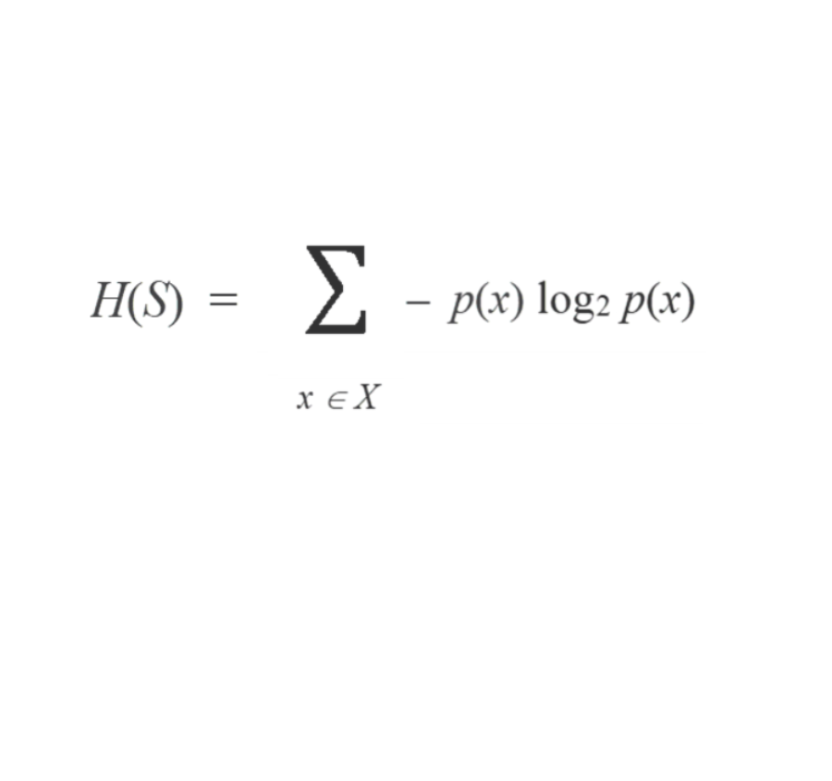

**(a) Data set to measure**

**Entropy on.**

**(b) The Set of distinct class Labels in S.**

**(c) For each class *x* in our Set of Classes *X* that we have in S.**

**(d)**

**(e)**

**(f)**

**(g)**

**Probability of Class Label x**

**( # of x’s in S ÷ size of S )**

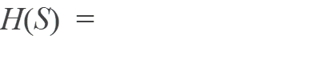

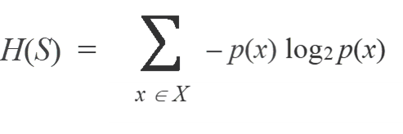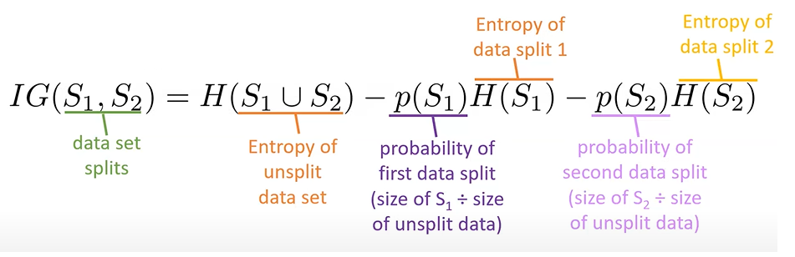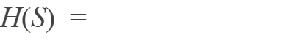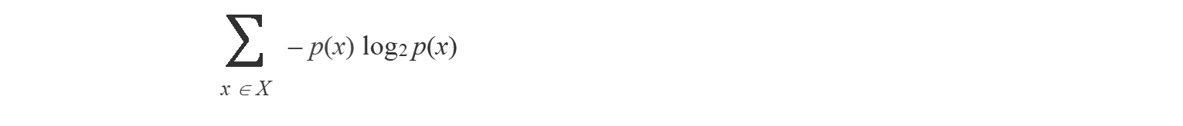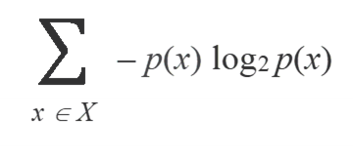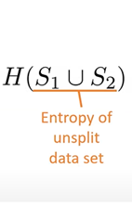

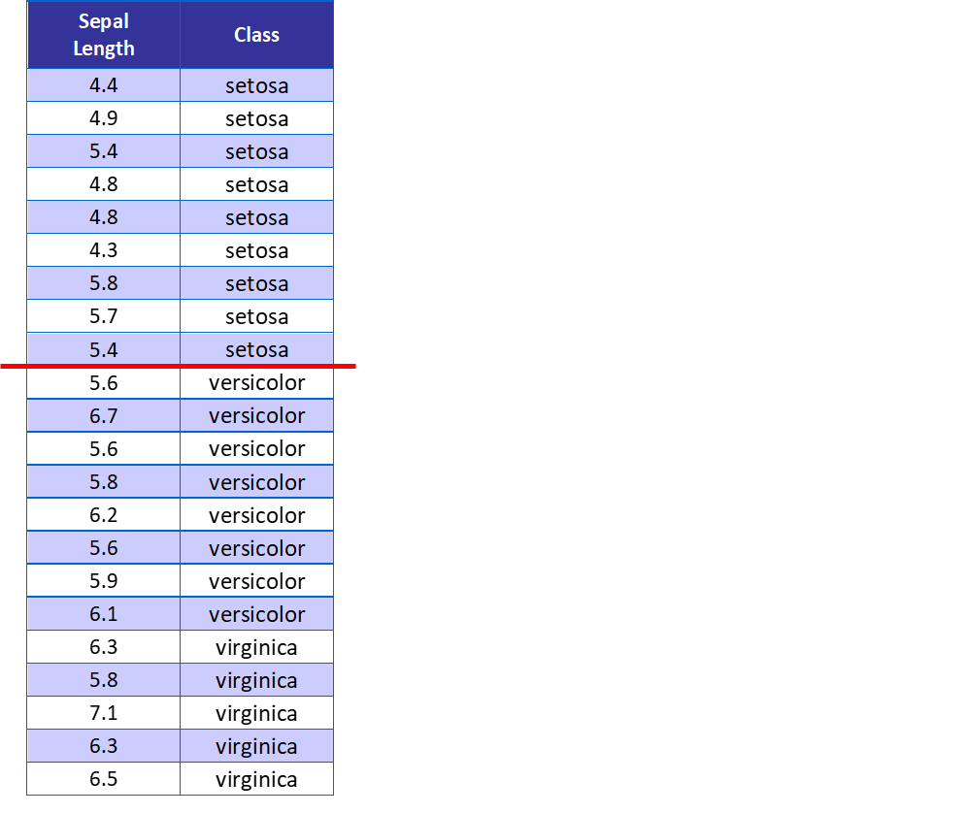



**S1**

**XS1:**

**size:**

