**4k3b BETA BARREL MEMBRANE PROTEIN**

**(BamA) Amino Acids 395-795**

**Align Executive: RMSD =**    0.342 (2273 to 2273 atoms)

**Align Executive: RMSD =**    1.352 (2996 to 2996 atoms)

**Align Native and ss H, QTY and ss H, cycles=0,**Executive: RMSD =0.362 (17 to 17 atoms)

Superimposed Native and QTY varient

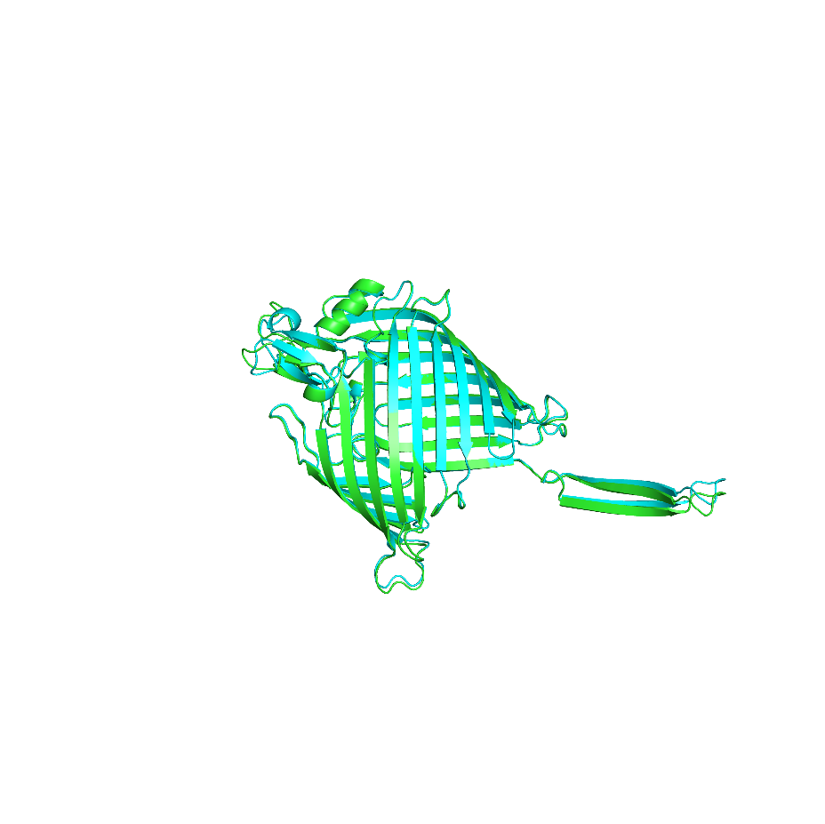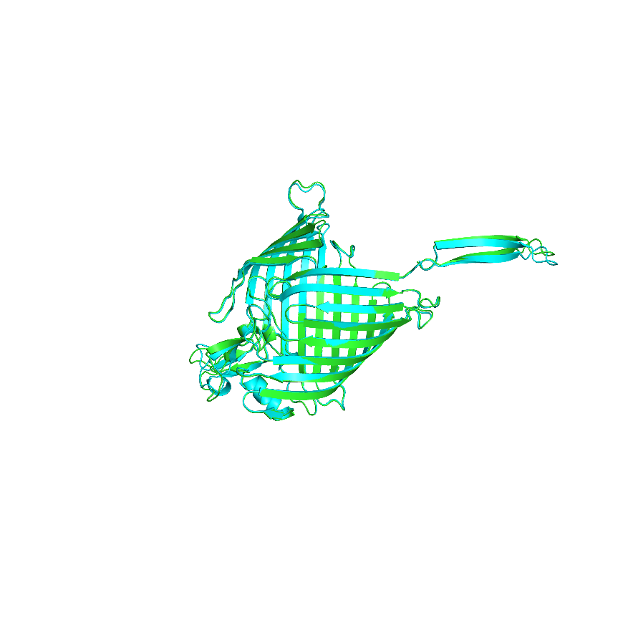

X-180 Rotation

X-90 Rotation

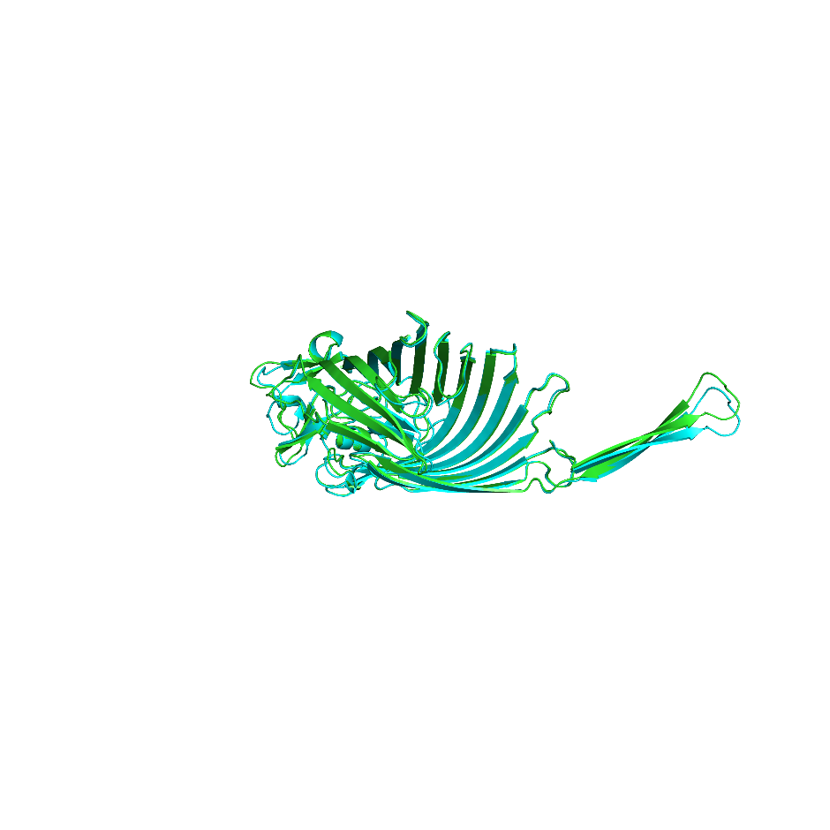

Y-180 Rotation

**ChimeraX 1.4 software for hydrophobic nature of 4K3B Beta barrel membrane protein**

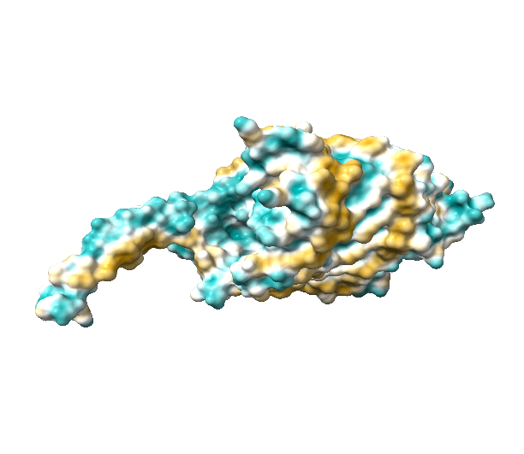 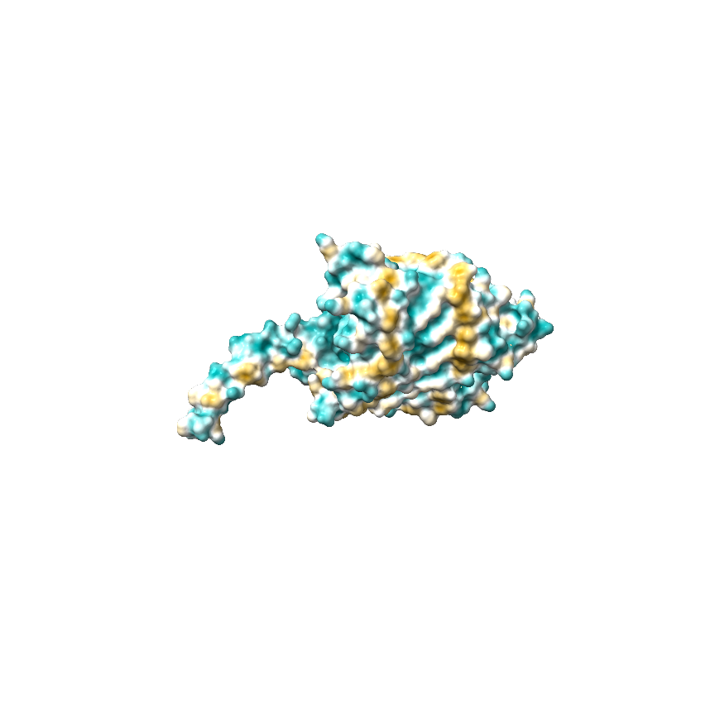

1. Native BamA (b) QTY variant BamA**QTY**

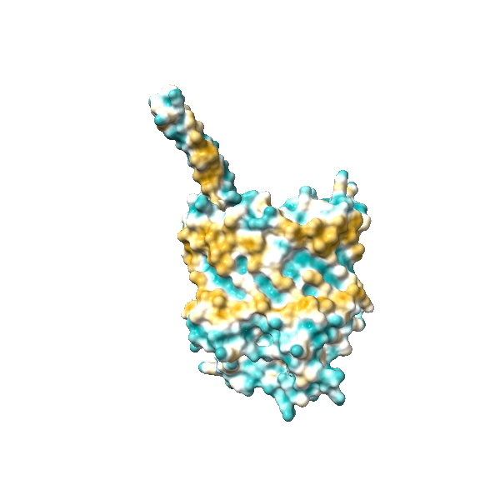 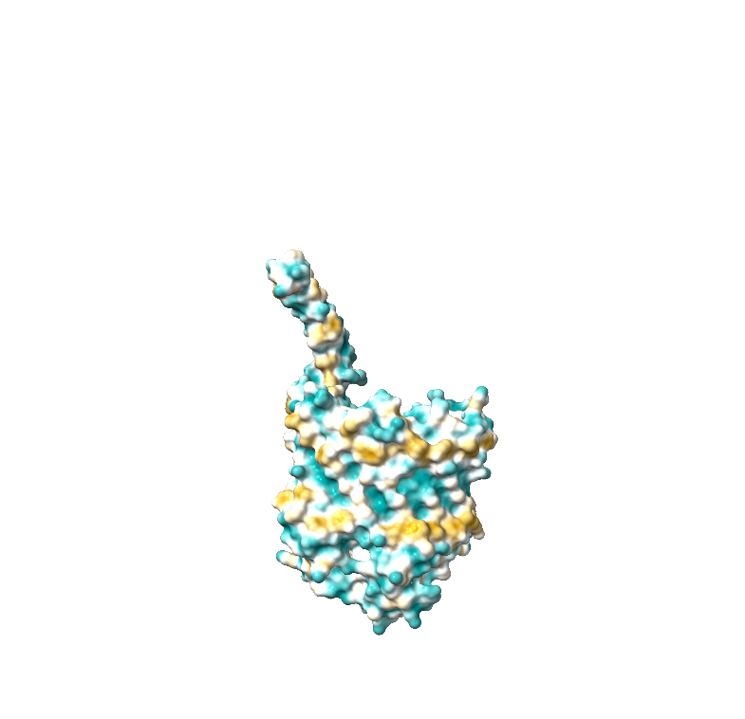

1. Native BamA (d) QTY variant BamA**QTY**

Fig1: Beta barrel membrane protein 4k3b Amino acids from 395 to 795 (BamA membrane protein)

Akash S S

BSMS chemistry , Indian institute of science education and research,Tirupati,India