#### [1Kmo](https://www.rcsb.org/structure/1Kmo) (2.00Å) Outer Membrane Transporter FecA

#### ([Fe(3+) dicitrate transport protein FecA](https://www.rcsb.org/groups/sequence/polymer_entity/P13036)) location 81-741 (661aa)

**Align Executive: RMSD =**   0.280 (4327 to 4327 atoms)

**Align Native_1Kmo and ss H, QTY_1Kmo and ss H, cycles=0,**

**Executive: RMSD** =  0.432 (46 to 46 atoms)

Superimposed Native and QTY varient

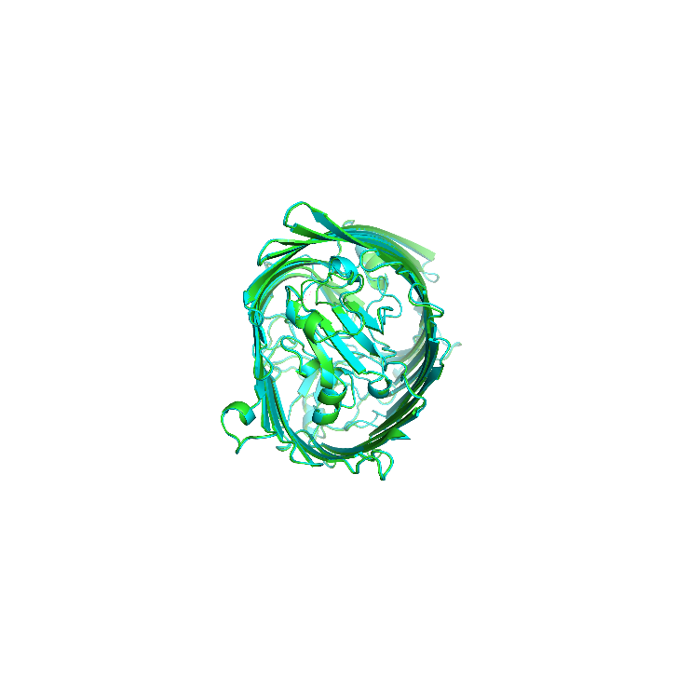 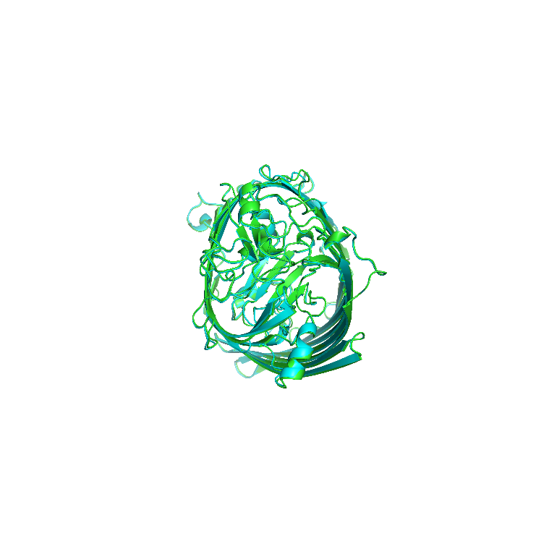

X-180 Rotation

X-90 Rotation

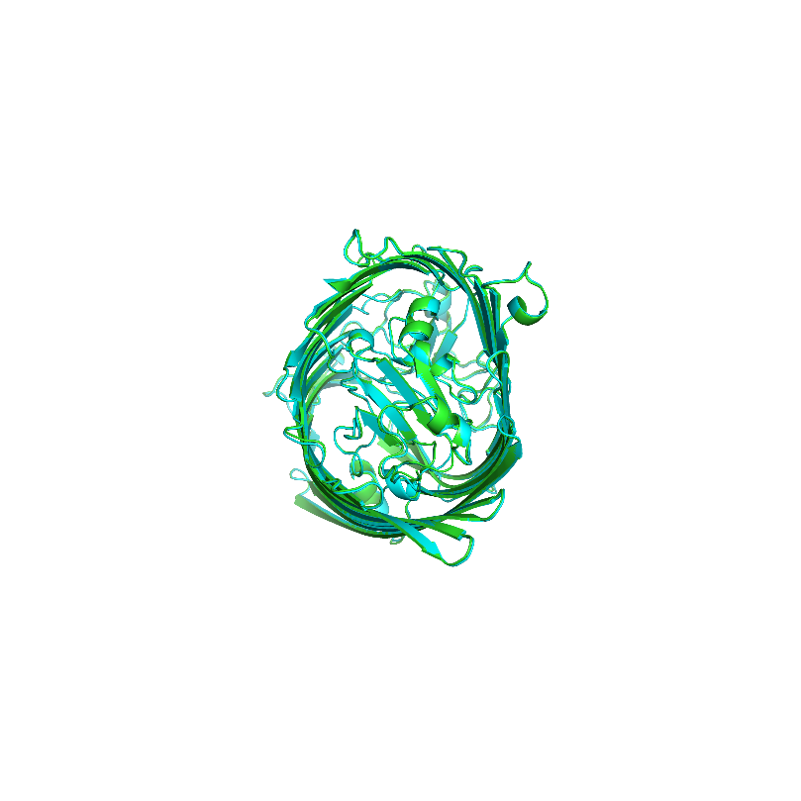

Y-180 Rotation

**Superimposed structures**

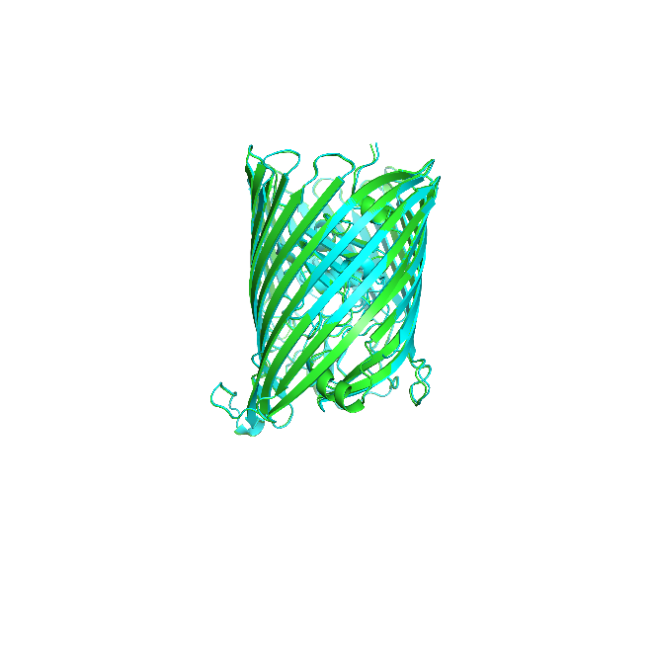 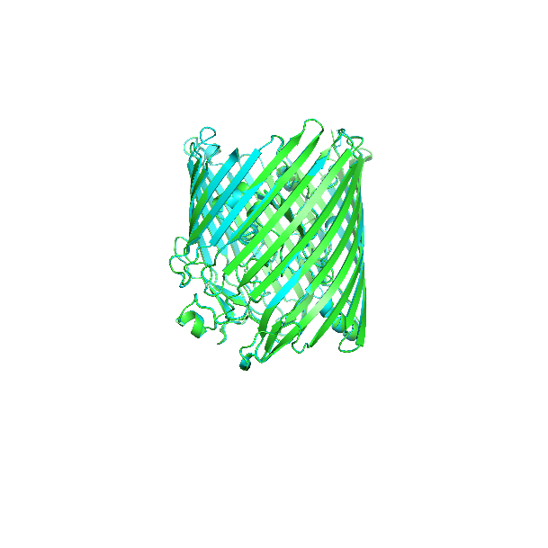

1. **(2)**

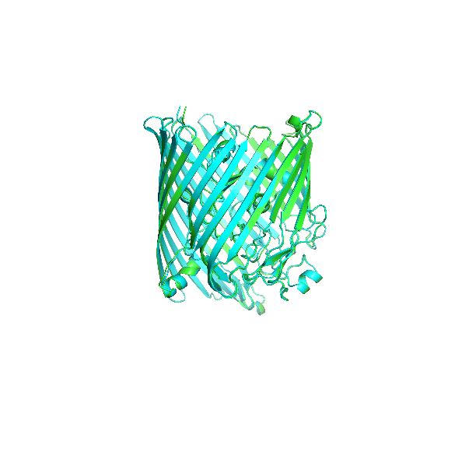 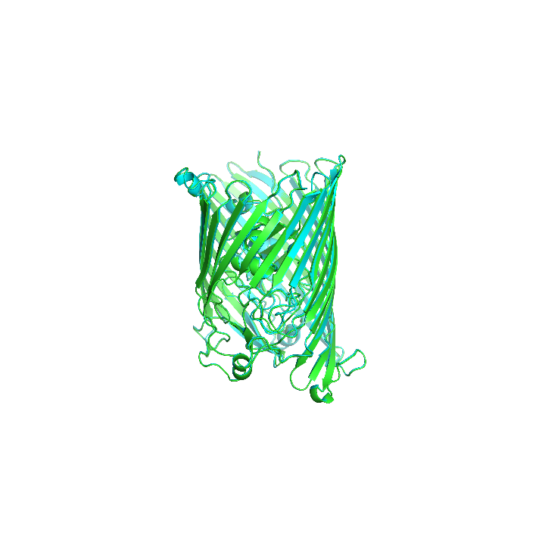

**(3) (4)**

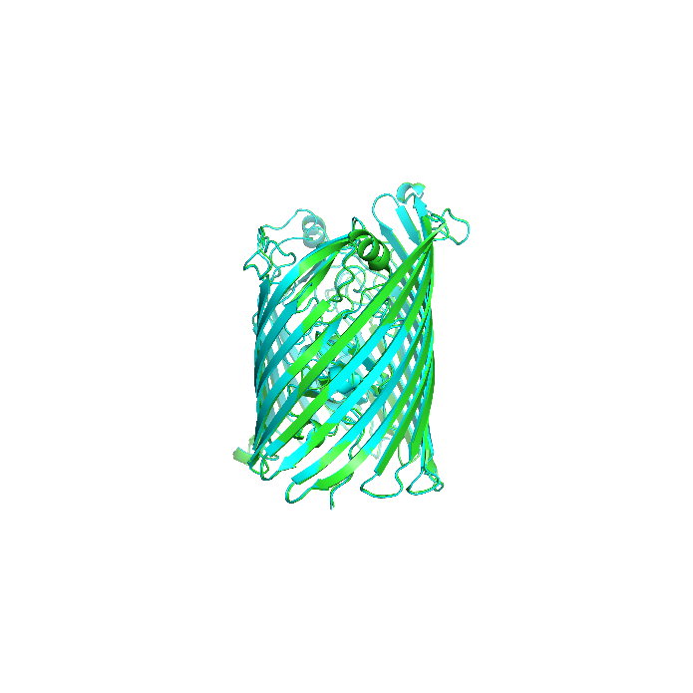 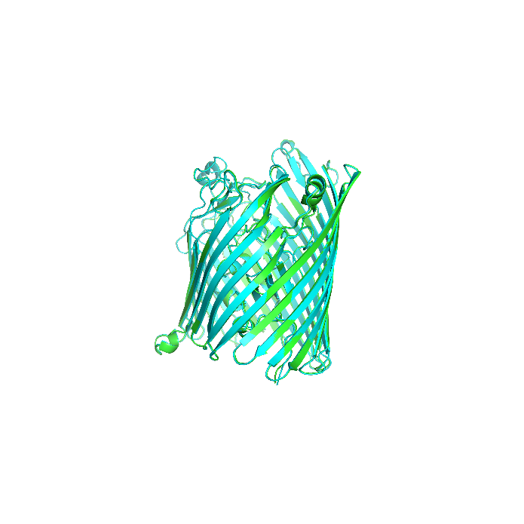

**(5) (6)**

**ChimeraX 1.4 software for hydrophobic nature of 1Kmo Outer Membrane Transporter FecA (E.Coli K12)**

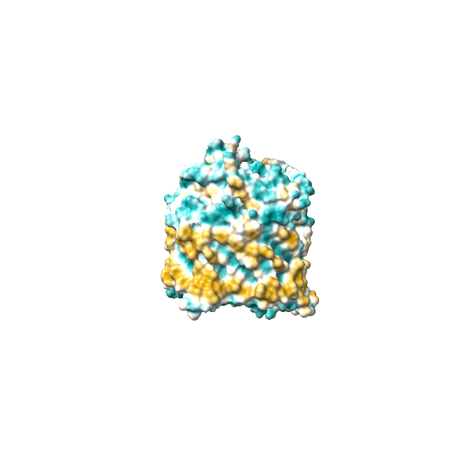 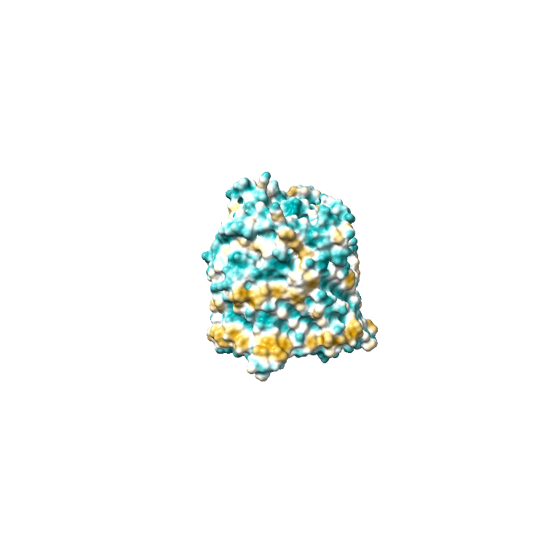

1. Native 1Kmo (b) QTY variant 1Kmo **QTY**

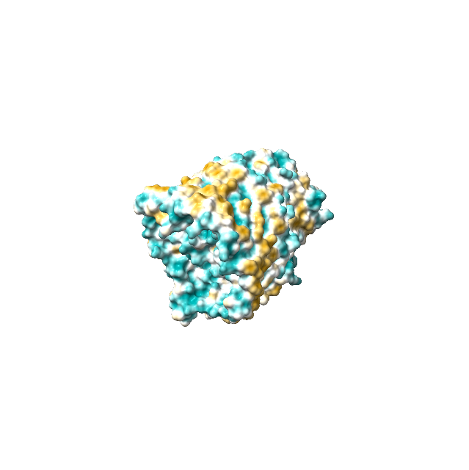 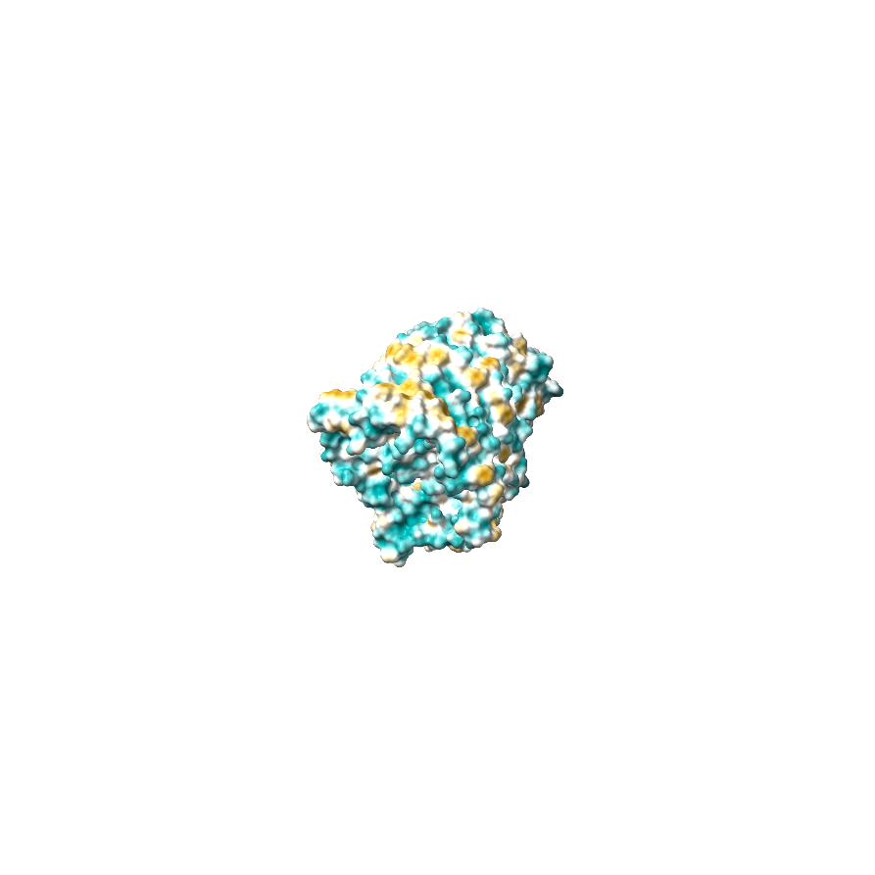

1. Native 1Kmo (d) QTY variant 6wut**QTY**

Fig1: Outer membrane transporter FecA from 81 to 741 , Fe(3+) dicitrate transport protein FecA(E.Coli K12)

Akash S S, BSMS chemistry, Indian institute of science education and research, Tirupati.

[Andrew D Ferguson](https://pubmed.ncbi.nlm.nih.gov/?term=Ferguson+AD&cauthor_id=11872840)[1](https://pubmed.ncbi.nlm.nih.gov/11872840/#affiliation-1), [Ranjan Chakraborty](https://pubmed.ncbi.nlm.nih.gov/?term=Chakraborty+R&cauthor_id=11872840), [Barbara S Smith](https://pubmed.ncbi.nlm.nih.gov/?term=Smith+BS&cauthor_id=11872840), [Lothar Esser](https://pubmed.ncbi.nlm.nih.gov/?term=Esser+L&cauthor_id=11872840), [Dick van der Helm](https://pubmed.ncbi.nlm.nih.gov/?term=van+der+Helm+D&cauthor_id=11872840), [Johann Deisenhofer](https://pubmed.ncbi.nlm.nih.gov/?term=Deisenhofer+J&cauthor_id=11872840).

[Structural basis of gating by the outer membrane transporter FecA](https://pubmed.ncbi.nlm.nih.gov/11872840/)