#### [2j1n](https://www.rcsb.org/structure/2j1n) (2.00Å) Outer membrane porin C

#### ([osmoporin OmpC](https://www.rcsb.org/groups/sequence/polymer_entity/P06996)) location 22-367 (346aa)

**Align Executive: RMSD =** 0.159 (2259 to 2259 atoms)

**Align 2J1N_QTY and ss H,2J1N_Native and ss H, cycles=0,**

**Executive: RMSD** = 0.060 (19 to 19 atoms)

Superimposed Native and QTY varient

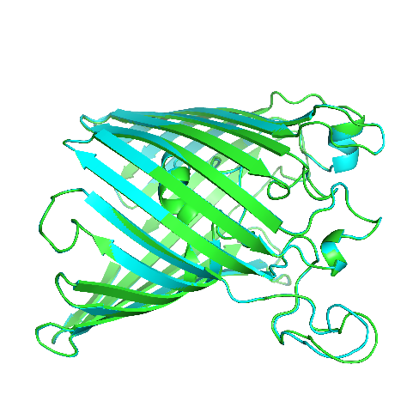 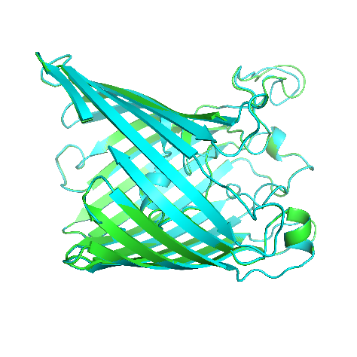

X-180 Rotation

X-90 Rotation

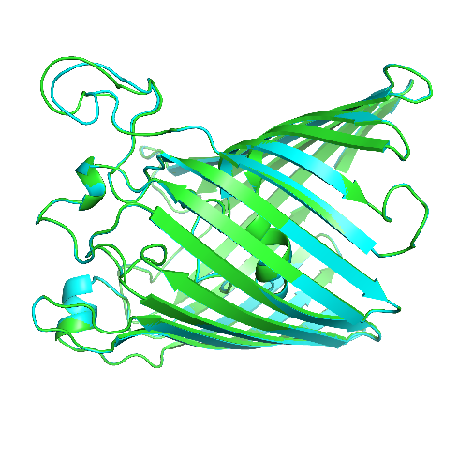

Y-180 Rotation

**ChimeraX 1.4 software for hydrophobic nature of 2j1n Mitochondrial beta-barrel outer membrane protein**

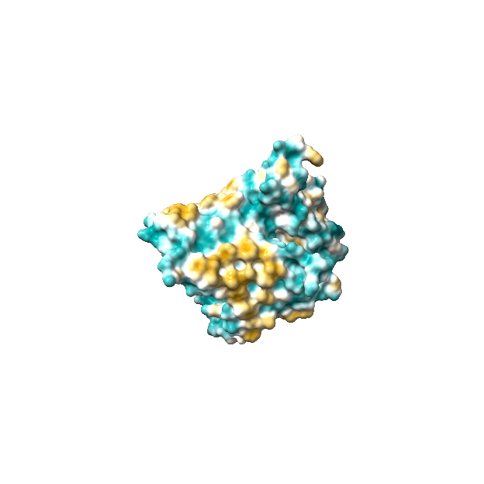 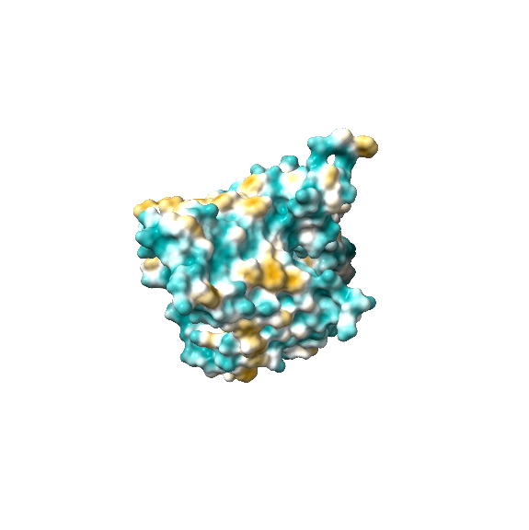

1. Native 2j1n (b) QTY variant 2j1n**QTY**

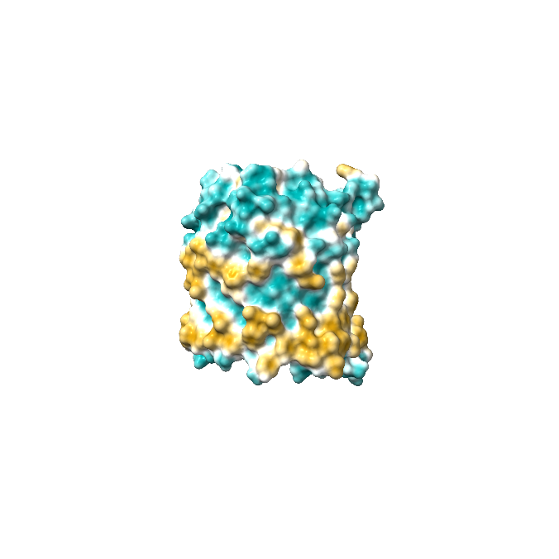 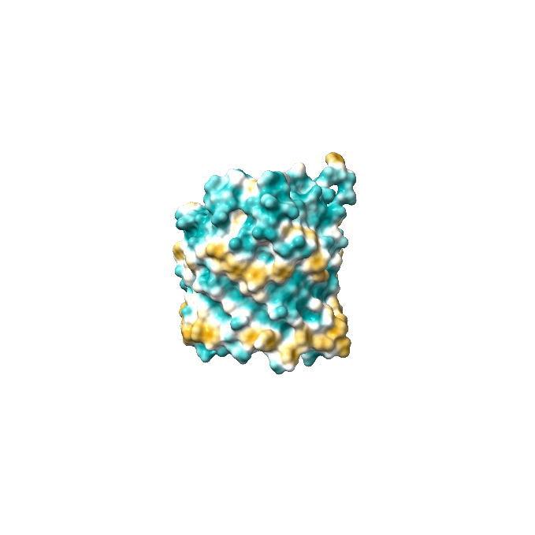

1. Native 2j1n (d) QTY variant 2j1n**QTY**

Fig1: Outer membrane porin C(ompC) , 2j1n Amino acids from 22 to 367 ,OmpC (E.Coli K12)

Akash S S, BSMS chemistry, Indian institute of science education and research, Tirupati.

[Arnaud Baslé](https://pubmed.ncbi.nlm.nih.gov/?term=Basl%C3%A9+A&cauthor_id=16949612)[1](https://pubmed.ncbi.nlm.nih.gov/16949612/#affiliation-1), [Gabriele Rummel](https://pubmed.ncbi.nlm.nih.gov/?term=Rummel+G&cauthor_id=16949612), [Paola Storici](https://pubmed.ncbi.nlm.nih.gov/?term=Storici+P&cauthor_id=16949612), [Juerg P Rosenbusch](https://pubmed.ncbi.nlm.nih.gov/?term=Rosenbusch+JP&cauthor_id=16949612), [Tilman Schirmer](https://pubmed.ncbi.nlm.nih.gov/?term=Schirmer+T&cauthor_id=16949612)

[Crystal structure of osmoporin OmpC from E. coli at 2.0 A](https://pubmed.ncbi.nlm.nih.gov/16949612/)