Assignment 2
Documentation
ICT283
Svetlana Alkhasova
7-19-2025

Rationale

Explanation of selected approach: BST function pointers + std::map + Vector
In this part you will find the explanation of my selected approach for Assignment 2. Here I will explain why I used BST with function pointer, map, and template Vector. For this assignment it was mandatory to use BST with function pointer traversals and map (I used std::map). BST allows me to keep all keys (month-year) always sorted and easy to search for them. With function pointers, I can traverse the BST and easily process each key, which makes it flexible. At the same time, using Map is an effective way to connect each key (from BST) with a set of data records. With BST and Map I also used template Vector, because BST and Map do not solve the problem of storing and managing an unknown number of weather records for each month, they only handle searching and grouping. Vector is a dynamic array I built in the first assignment for handling collections that grow or shrink. So, each entry in the map (for combination of month/year) holds a Vector of WeatherEntry structs. This allows me to: (1) add new weather records as they are read from files, (2) access records by index, which is important for calculations like mean, standard deviation, or for exporting data, and (3) avoid using STL vector directly, so it is encapsulated.
Now I will explain in more detail how all these structures work together in my code:
- BST: the main purpose of BST in my code is to store unique, sorted keys (for months).
- Map (std::map): it matches those keys to entire datasets (weather records for that month). I decided to use std::map because I faced some problems with creating my own encapsulated map.
- Vector: it holds the actual list of records for each day and hour, also it allows flexible and effective storage within each month group.
- WeatherEntry (struct): is just a simple object to store all details for one measurement like date, time, wind speed, and so on.
- Statistics (helper): in assignment 1 I had similar class called “Calculations”, but I decided to change approach for this assignment. So, it provides calculations on Vectors such as mean, std dev, sPCC correlations, and others.
With such combination of structures every piece of data is (1) effectively and fast found using map and BST; (2) stored dynamically so we never run out of space, and (3) easily processed with custom logic for filtering, sorting, and reporting.

Pros and cons of chosen combination
Pros | Cons
Each structure which I used performs its purpose (what it can do best) - BST for sorted keys, map for key-value lookup, Vector for dynamic groups of data.  BST Insert/Search: O(n) worst case, Map Lookup: O(log n), | Creating and testing my own BST and Vector is more time consuming than use the std::vector – but this is mandatory for this assignment.
BST guarantees sorted reporting and map guarantees fast retrieval.  BST InOrder: O(n), Map Lookup: O(log n) | There is a risk that BST will get unbalanced. BST insert/search is O(n) instead of O(log n) because our CSV is sorted by months.
STL data structures are encapsulated (except map). | There is some code complexity and risk if the BST and the map are not always updated together. For example, if a key gets added to one but not the other, bugs or inconsistencies could occur.
The approach is flexible and can expand to more features or different types of data. I can reuse the BST for various tasks.
Also, it enables effective implementation of statistical calculations such as mean, MAD, std dev, sPCC and so on directly on Vectors. Calculations are effective single-pass (O(m) per month).
Map (std::map<std::string, Vector<WeatherEntry>>) lets us go directly from a string key to all weather records for that month.
Retrieve all data for a month in O(log n), for n months/years.
My custom Vector<WeatherEntry> class allows me to store an unknown (and growing) number of weather entries for each month without worrying about memory limits.

Alternative approaches: linked list / static array instead of Vector
In my project, I combined a BST (with function pointers), std::map, and Vector, as explained in previous sections. However, there are other approaches that could be used for storing, grouping, and analyzing weather records. Here, I will discuss the pros and cons if instead of my own Vector I had used a linked list or static array as the internal per-key container.
- Using linked list per key for weather records: A linked list can easily grow to hold any number of weather records, and adding or removing entries is simple. However, it doesn’t allow fast access to records by their position, so finding or processing specific records takes longer compared to a Vector. Since statistical calculations need to look at many records by index, using a linked list would slow down the program. Also, linked lists use extra memory to store pointers, making them less effective.
- Using static array: A static array is fast for accessing any record because you know exactly where it is. But it has a fixed size set before running the program. If too many records come in, it can overflow, causing errors. On the other hand, if you set the array too large, it wastes memory. This makes static arrays impractical for weather data where the number of records per month varies.
Although other containers like a linked list or a static array could technically work for holding weather records per key, they would significantly reduce the efficiency and usability of my program, especially as data grows and for complex statistical operations. That is a reason why combining mandatory BST and map structures with a custom Vector is the optimal and most practical solution which I could find.

Application test plan for client program
Test # | Description (why test is needed) | Actual test data /scenario | Expected Output | Passed | Output # (see screenshots below)
1 | Program start and data load to ensure that the program loads and initializes with valid data source | Run main program with correct data_source.txt and csv files present | Menu shown, data files loaded, no errors displayed | Yes | Output 1
2 | Invalid or missing data source file to make sure that program correctly handles missing file(s) | Rename data/data_source.txt before run | Program displays an error message about missing file, then exits without crashing. | Yes | Output 2
3 | Wind stats (average, std dev) are correct calculated and formatting for month, year | From the menu, select option 1, year: 2016, month: 4 | April 2016: Average wind speed: 18.1 km/h, Std dev: 10.5 km/h | Yes | Output 3
4 | Temperature statistics (all months, one year) are in correct format, handles months with and missing data | Menu option 2, year: 2016 | 2016  January: average: 24.9 degree C, std dev: 5.3 (and so on for each month…) | Yes | Output 4
5 | Pearson correlation (sPCC) calculation correct and formatting to two decimals | Menu option 3, month: 4 | Sample Pearson Correlation Coefficients for April:  S_T: 0.43  S_R: 0.25  T_R: 0.41 | Yes | Output 5
6 | Writing stats to csv file, make sure that the output file structure is correct formatting | Menu option 4, year: 2016 => writes file | WindTempSolar.csv starts with year, each row formatted as required (including MAD), values correct | Yes | Output 6
7 | Handles invalid input (letters for month/year), the program repeats prompt to user | Enter "nNnN" instead of year, or 13 for month at year/month prompt | Asks user again for valid input, does not crash | Yes | Output 7
8 | Handles missing data for entire year/month | Test menu option 1 or 2 with year/month not present in data | Outputs "No Data" for month or year | Yes | Output 8
9 | User enters wrong number to menu (not in range from 1 to 5) | User enter number 6 in menu option | Asks user again for valid input, does not crash, ask user to enter the menu option again (select from 1 to 5 | Yes | Output 9
10 | Test menu option 5 to exit and terminate the program | Menu option 5 | Prints "Exiting the program." and program exits without error | Yes | Output 10

Output of test runs
Output 1:
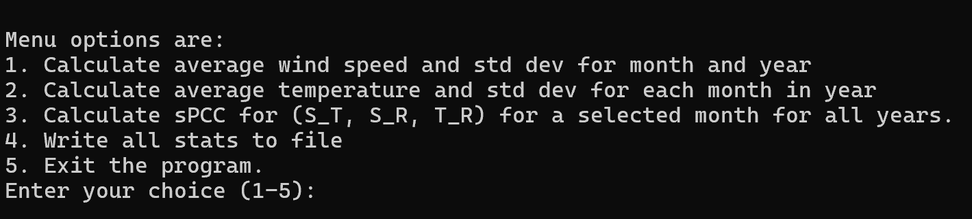
Output 2:
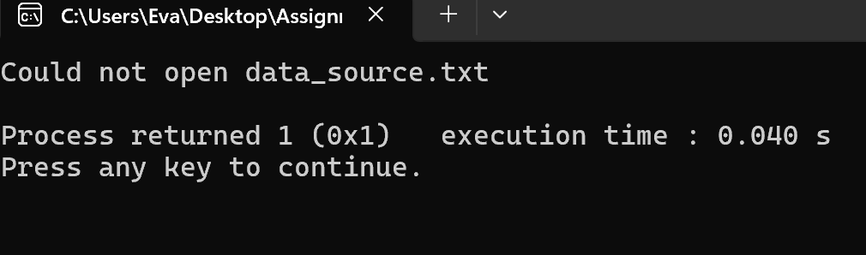
Output 3:
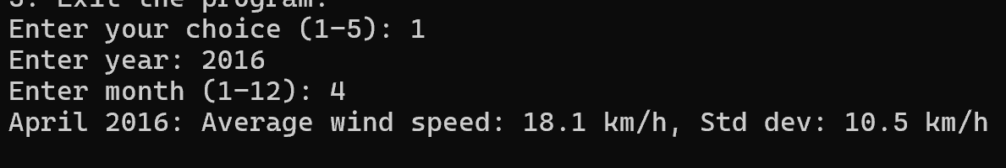
Output 4:
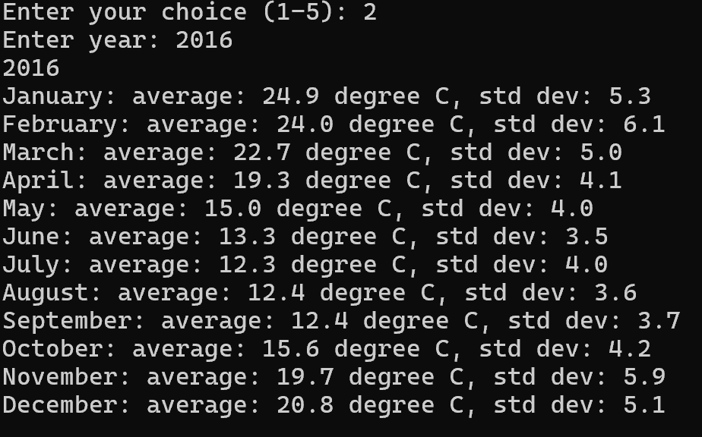
Output 5:
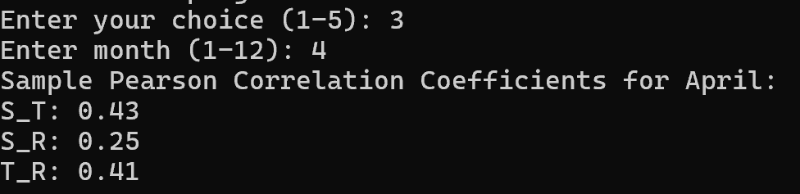
Output 6:
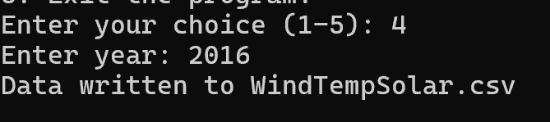
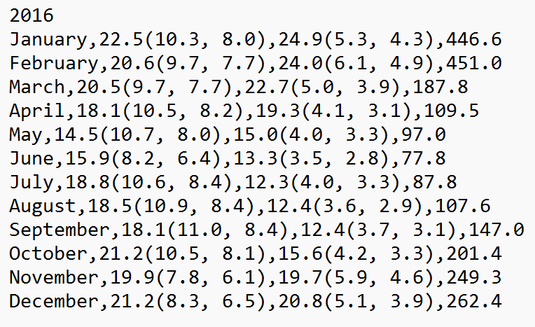
Output 7:
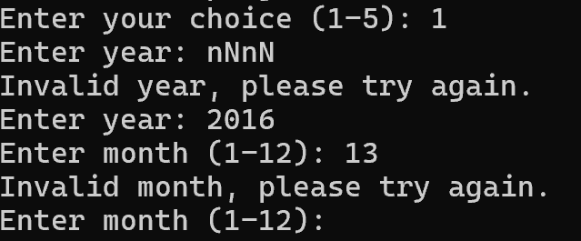
Output 8:
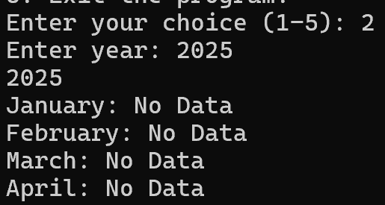
Output 9:
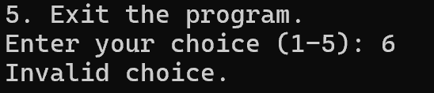
Output 10:
