AIRWAVE AIRTIME
SYSTEM PROPOSAL
23/10/2025
- UNITY SACCO LIMITED
Proposed by: EVAN NGUGI WAMBUI
To CALL CENTER DEPARTMENT

DEDICATION
I dedicate this work to the people who provided the constant foundation, patience, and unwavering belief necessary to see this project through. To Moses Kamau and Warren Kimani whose insightful guidance and critical feedback sharpened my focus and elevated the quality of this work, and in general to the call center department

ABSTRACT
The proliferation of mobile-first services requires highly reliable, scalable, airtime distribution infrastructure. This project introduces a robust Airtime Distribution System (ADS) designed to enable, bulk mobile airtime top-up operations within k-unity sacco limited and service providers. The ADS solves the challenge of manual airtime top ups via physical airtime scratch cards
The core functionality of the ADS is built around bulk top ups at scale, enabling instantaneous processing of a large number of top ups transactions across all of K-unity sacco branches. This is supported by centralized Wallet Management for secure fund oversight and comprehensive Recipient Management for defining and segmenting target groups., top ups management for detailed history of all the top ups made within the system make top up functionality via two options single top up which ids instant and bulk top ups which involves distributing virtual airtime at scale(multiple recipients) , analytics module that provides valuable insight into recipients and mobile airtime top ups distribution and finally a job queue for live updates on each bulk top up

OBJECTIVES

- General objective

The proposed ssytem aims to make mobile airtime distribution at scale a breeze, provide a cost effieient and secure way to make virtual airtime top ups and in future automate the entire process

- Specific objectives

The proposed system aims to:

- Digitize airtime distribution to enable virtual airtime top ups
- Enable airtime recipient management
- Enable airtime top up tracking history for future reference
- Provide valuable insights and reports
- Integrate payment methods to fund float balance for airtime top ups
- Provide wallet management functionality eg wallet recharge

SYSTEM REQUIREMENTS

AUTHENTICATION

Airwave airtime contains a sign up and login user interface for secure user authentication

- Sign up

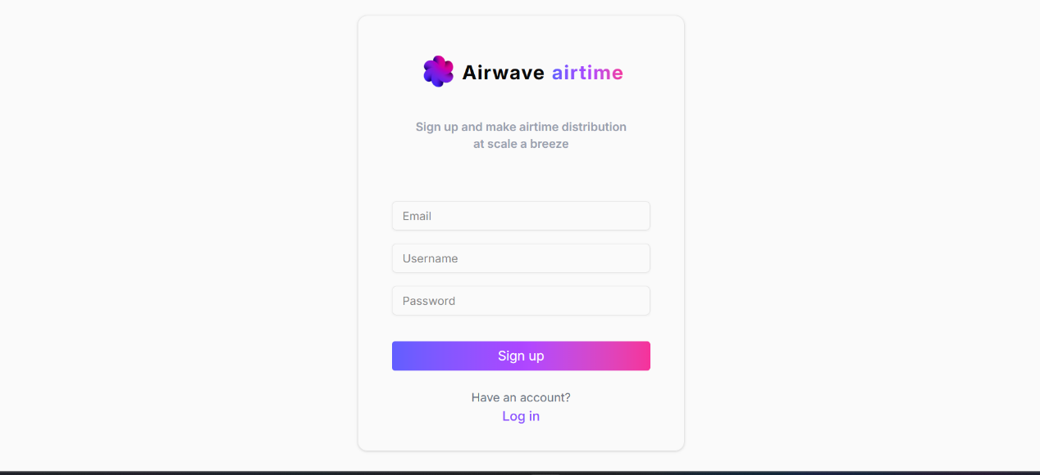

- Sign in

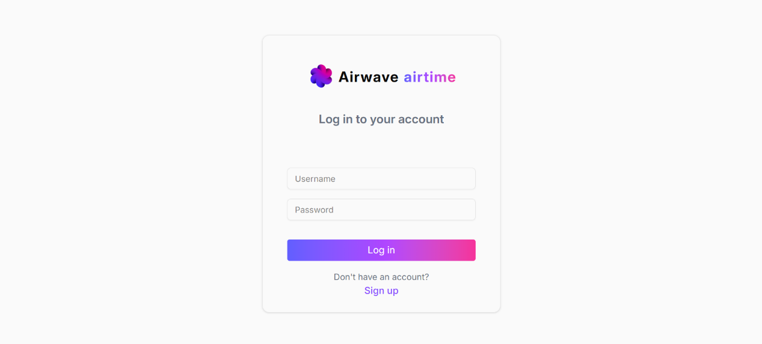
ANALTYTICS AND REPORTING

Airwave airtime performs analysis and present the the user with an informational dashboard user interface as seen below

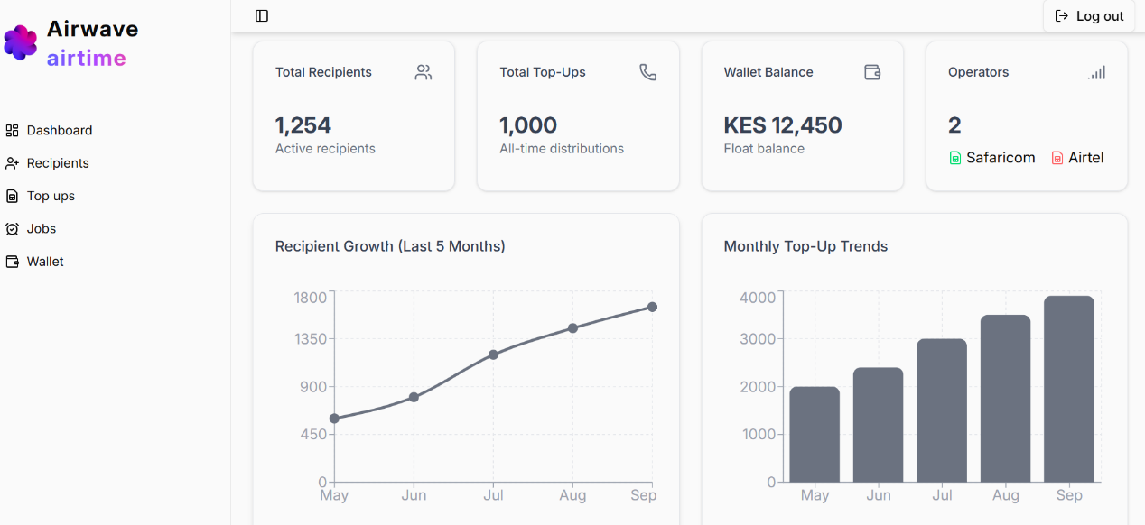

RECIPIENT MANAGEMENT

Airwave enables management of airtime recipients and includes the features such as recipient creation to register employees that receive airtime top ups , updatiing recipient details eg change in phone number and deletiing recipients eg for ex-staff

- Recipient creation user interface

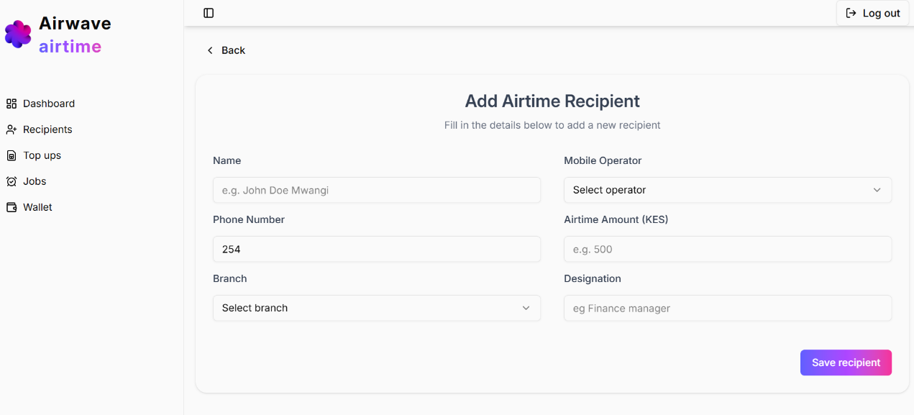

- Recipient edit user interface

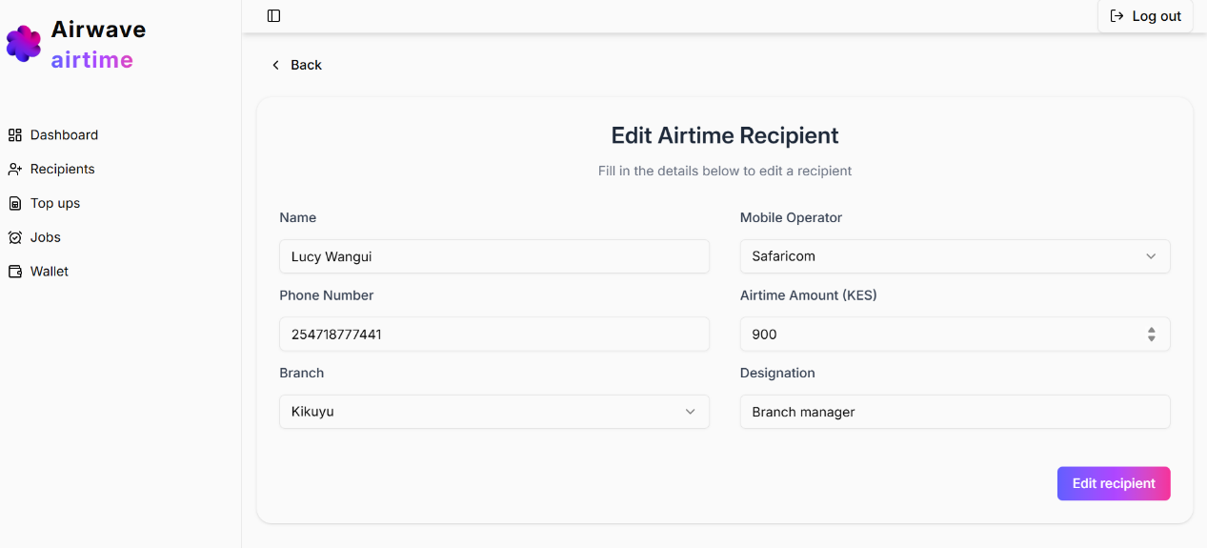

- Recipient management

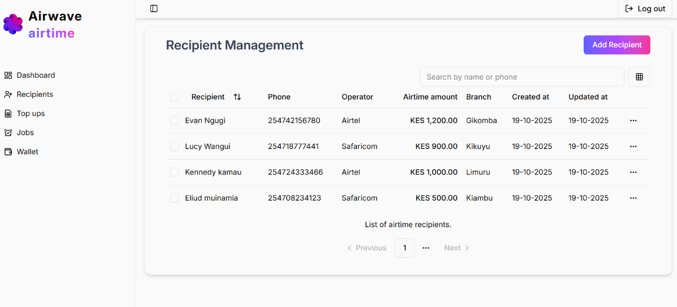

Top up management

Airwave airtime enables users to view a history of all the mobile tops with futher details such as recipient name, airtime amount, the branch top up status thus providing an audit trail of all the mobile top ups made.within the proposed system

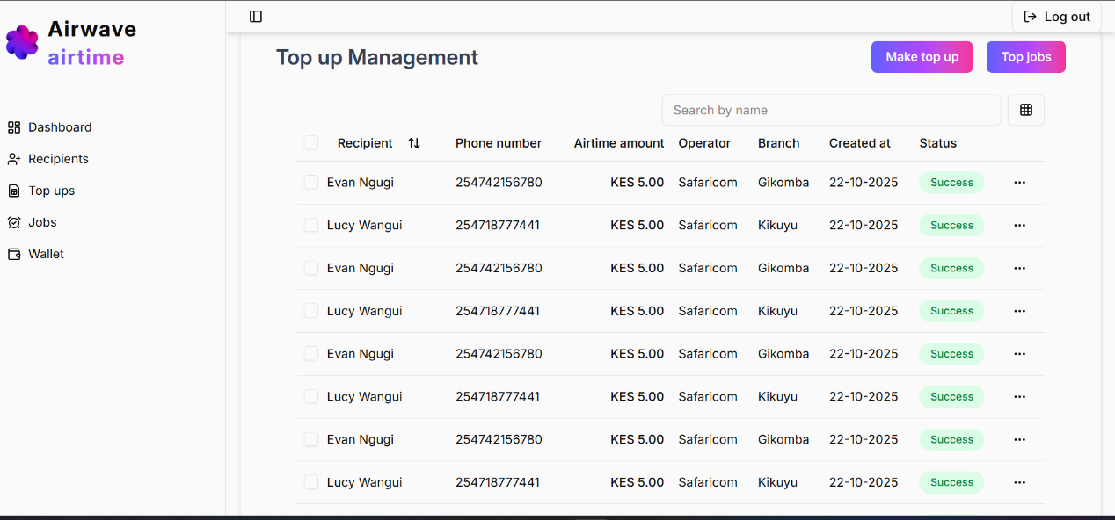

- Make top user interface

Airwave airtime provides two ways to make airtime top ups, single and bulk. Single top ups are instant eg when a recipient requires a sudden top up and meant for a single recipient, bulk top ups which is the main objective of the system delivers mobile top ups to multiple recipients across all k-unity branches

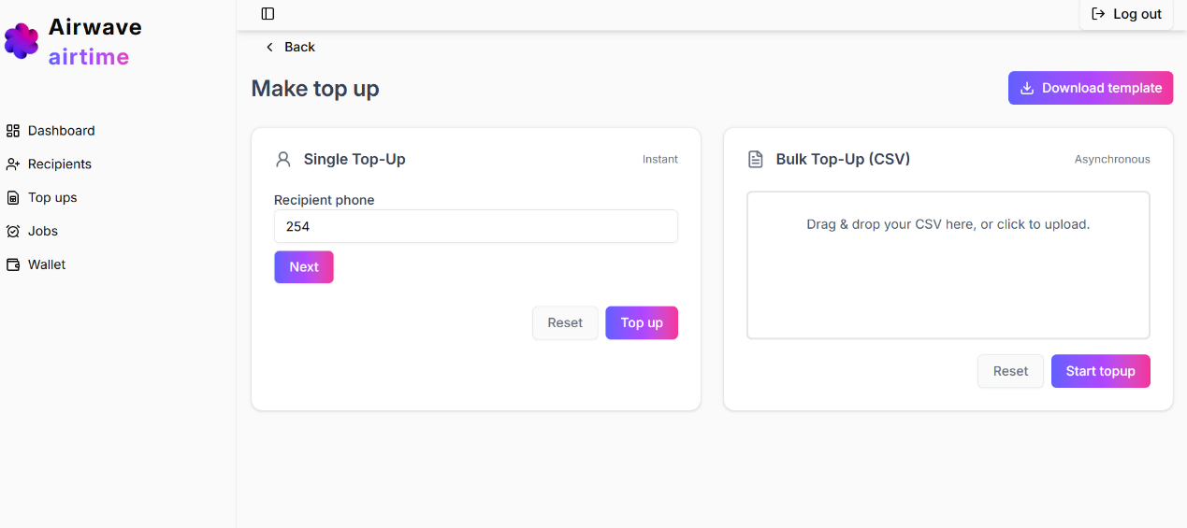

JOB QUEUE
Airwave airtime include a real time jobs queue that shows the status bulk mobile top up status as the occur through various steps eg processing , success and failed top ups

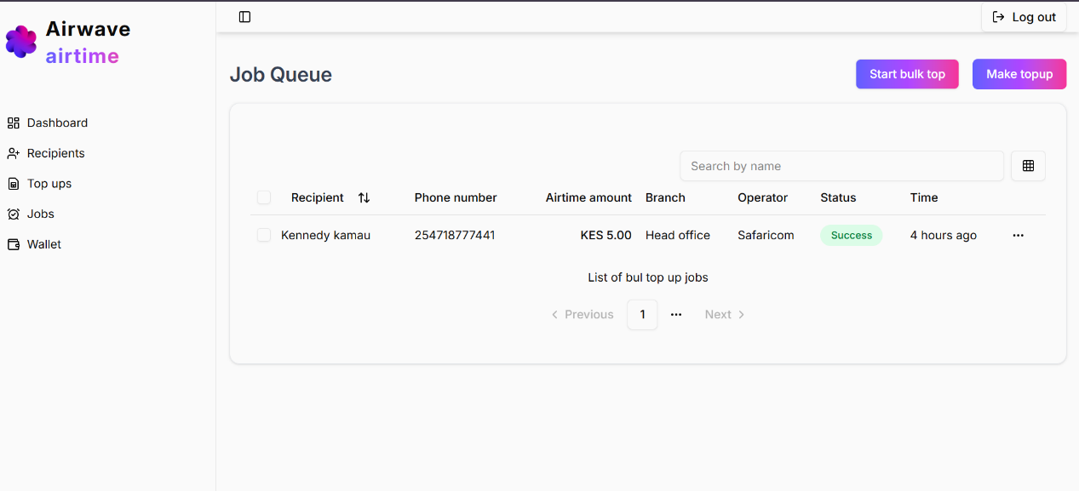

WALLET MANAGEMENT

Airwave airtime integrates a third party service called reloadly that enables both airtime top ups and wallet management activities such as adding a payment method , wallet recharge ,

