TESTS PASSED PROOF AND COVERAGE REPORT
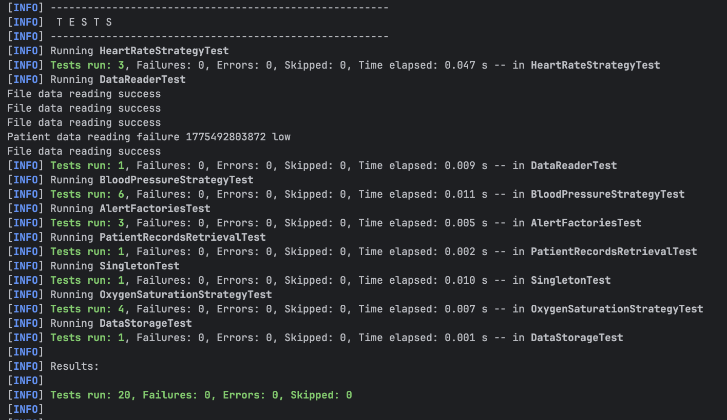
- Tests passed when running mvn clean test

- Coverage report generated
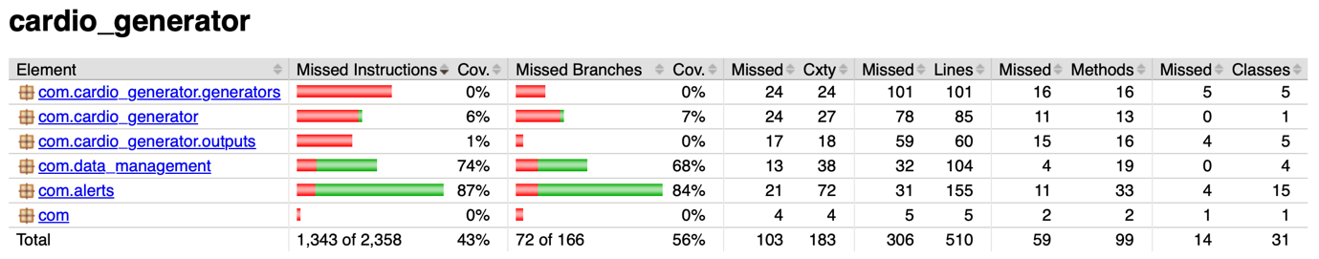

Report shows that the tests concerning packages com.alerts and com.data_management containing new classes from parts 3 and 4 were relatively comprehensive. Package com.cardio_generator.generators was not tested at all as the outputs of the methods depend on randomness and thus, it is difficult to assert a deterministic correct outcome. Maybe an output range could be checked to verify the behaviour to some extent. Nonetheless, the class would have to checked multiple times to determine with some degree of certainly that it would not produce an incorrect output as it is non-deterministic. Output strategies (in package com.cardio_generator.outputs) and HealthDataSimulator were similarly untested as they depend on network connections, file I/O, and scheduled threading which are not suitable for unit testing without mocking frameworks.

