Sample Collection and Site Description

Short Cores: The short cores in possession, labeled C1, C3, C4, and C5, are <20cm bank-top cores from modern sediments in the Great Bahama Bank, specifically near the Little Darby and Lee Stocking Islands. Samples from this region are often used to represent initial deposition of primary shallow water carbonates (Hardisty et al., 2017; Pogge von Strandmann et al., 2019; Romaniello et al., 2013; Zhang et al., 2017). Detailed information of their collection and sample locations can be found in Hardisty et al. (2017), but a brief description will be given here. Modern carbonates from the Great Bahama Bank are primarily composed of inorganic components such as ooids, grapestones, and peloids. The sediments are composed of primarily aragonite with significant, but secondary amounts of high magnesium calcite (HMC) (Hardisty et al., 2017). Samples were collected by hammering polyethylene tubing into sediment, removing and slicing the sediment into the appropriate intervals, drying the sediment in a muffle furnace at 60°C, and finally powdering them using a mortar and pestle. The C1 core is the only core that comes from an intertidal area (water depth <1m). Cores C3, C4, and C5 all come from subtidal areas. The C4 and C5 cores come from active or former ooid shoals. There were *Thalassia testudinum* beds (seagrass) where cores C3 and C5 were collected.

Clino and Unda: A number of papers have covered the mineralogy, sedimentology, and diagenesis of the Clino and Unda cores in detail (Eberli et al., 1997; Higgins et al., 2018; Kenter et al., 2001; Manfrino and Ginsburg, 2001; Melim et al., 2002, 1995; Murray et al., 2021; Swart et al., 2012; Swart and Melim, 2000; Swart and Oehlert, 2018). A summary of the relevant components will be provided here. The Clino and Unda cores were retrieved 5 km and 13.5 km away from the edge of the Great Bahama Bank (GBB), respectively, in 1990 as part of the Bahamas Drilling Project (Swart and Melim, 2000). They were collected along the Western seismic line from the platform top of the GBB and extend back to the late Miocene. The Unda and Clino cores penetrate 454 and 677 meters below mudpit datum and are covered currently by approximately 10 m of water (Eberli et al., 1997). The Clino core contains overlying platform sediments, similar to those of the modern GBB, and slope deposits (Eberli et al., 1997). The Unda core contains primarily platform margin deposits.

Mineralogy and Lithology: The Clino core contains significant LMC throughout the core, with secondary contributions of aragonite (especially <50m and between 100m and 350m) and more minor contributions of dolomite starting below 150m (Melim et al., 2001; Swart and Melim, 2000). The Unda core also contains significant amounts of LMC throughout but has lower amounts of aragonite (between 100m and 150m) and significant amounts of dolomite (nearly 100% between 275m and 350m).

The top ~100m of Clino are dubbed the layered cap and alternate primarily between sections of peloidal and skeletal lithologies with varying grain size and contains minor sections composed of coral floatstone (Manfrino and Ginsburg, 2001). Below the layered cap to about 200m, there are large sections of coral with secondary amounts of skeletal sediments. Between ca. 200m and 370m, the dominant sediment is nonskeletal, peloidal sediments. Below 370m, the sediments are primarily peloidal and skeletal mixtures (Kenter et al., 2001) (Include figure 3 in Kenter 2001 for a nice representation of this).

The top of the Unda core is quiet similar to Clino. The layered cap, approximately the top 70m, consists of alternating sections of skeletal and peloidal sediment and overlays the coral bearing section, the next 50m or so (Manfrino and Ginsburg, 2001). From approximately 110m to the bottom of the core, most sediments are peloidal and skeletal mixtures except for a brief hiatus between 290m and 360m where reefal deposits dominate (Kenter et al., 2001).

Diagenesis: The Clino core contains well documented aragonite to LMC neomorphism in meteoric and marine burial scenarios, while the Unda core captures the process of dolomitization. Both cores contain several subaerial exposure surfaces (Manfrino and Ginsburg, 2001; Swart and Oehlert, 2018). During repeated sea-level changes during the Pleistocene, meteoric fluids infiltrated into the upper portions of the cores (Melim et al., 1995; Swart and Oehlert, 2018). As a consequence of the repeated exposure to meteoric water, oxygen and carbon isotopes are isotopically depleted in the upper 108m and 135m of the Unda and Clino cores, respectively (Eberli et al., 1997; Melim et al., 1995). However, the freshwater phreatic zone may have penetrated deeper into the sediments, estimated to be 200m for the Clino core (Swart and Oehlert, 2018). The C and O isotopes covary and become more positive between 60m and 110m in Unda and 90m and 180m in Clino. The covariance is believed to be a result of higher rates of recrystallization and neomorphism due to oxidizing organic matter at the interface of the phreatic and vadose zone (Swart and Oehlert, 2018). After these zones, early and late marine burial diagenesis are the dominant diagenesis regimes (*e.g.,* marine hardgrounds, neomorphism, compaction), with periods of extensive dolomitization in Unda (discussed in section XX) (Eberli et al., 1997; Higgins et al., 2018; Melim et al., 2001).

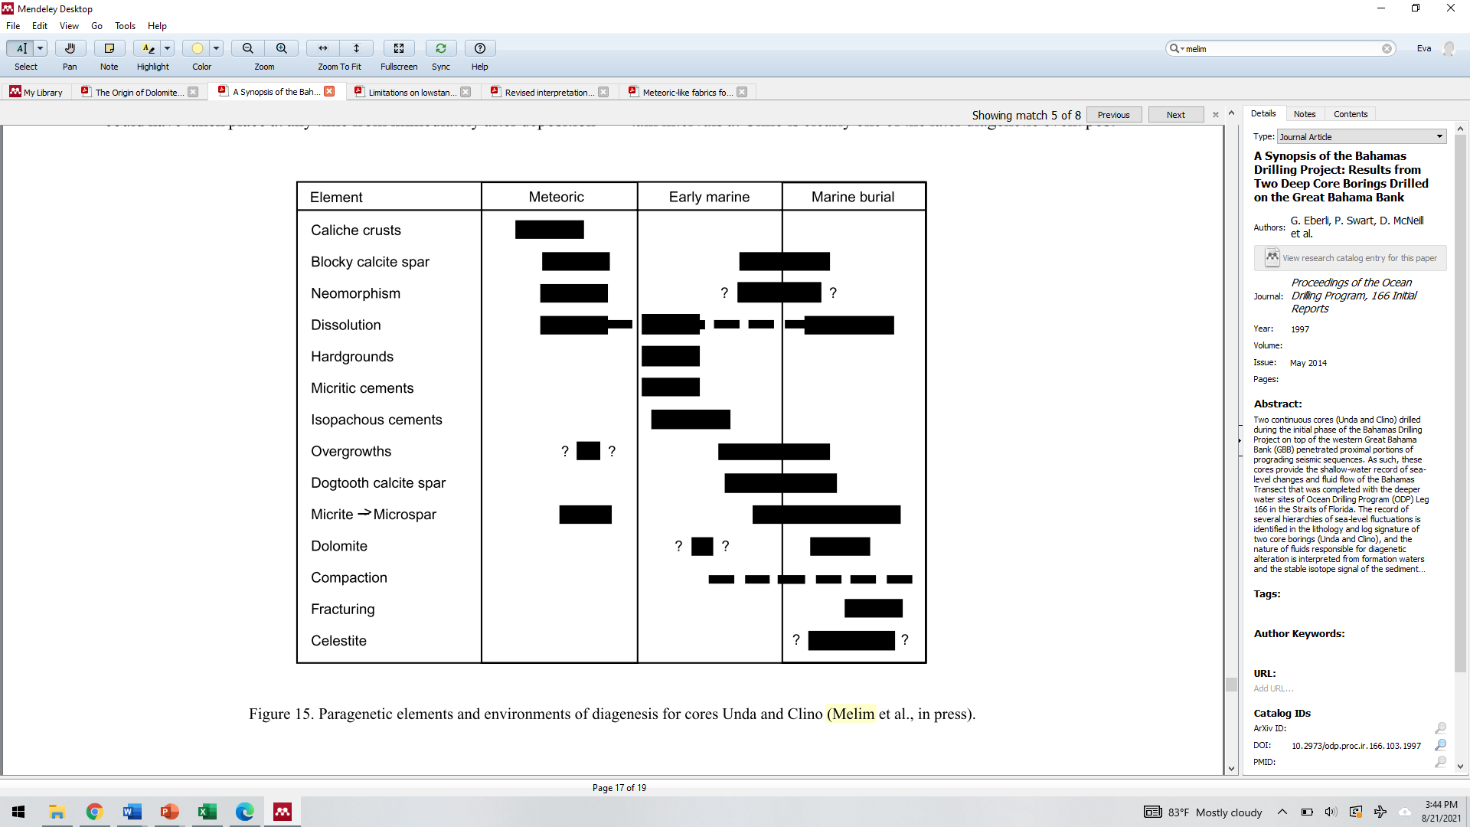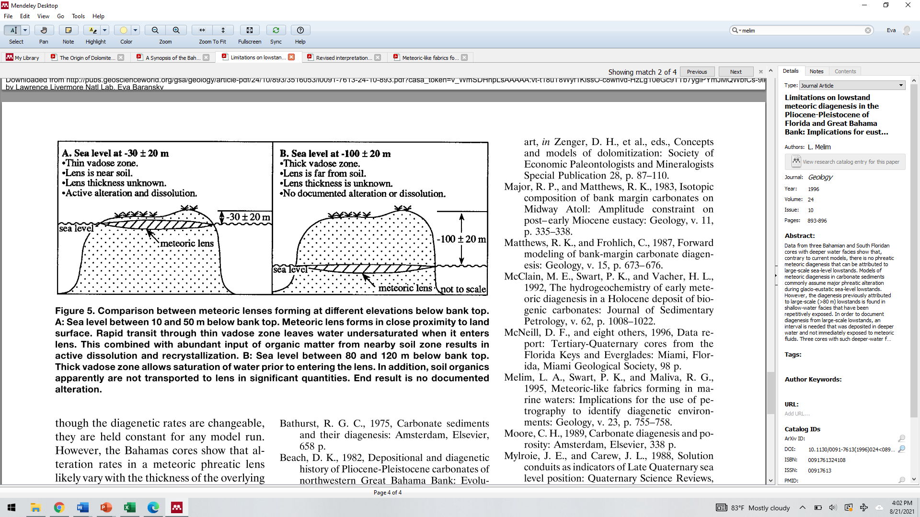

Chemistry development

Separating Ni from the carbonate matrix has proved to be a technical challenge . The available techniques to purify Ni from difficult matrices often require >3 columns and/or the use of Ni Dimethylglyoxime (DMG) which readily complexes with Ni, but is difficult to break down and can lead to low recoveries (*e.g.,* Cameron et al., 2009; Chernonozhkin et al., 2015; Gueguen et al., 2013; Little et al., 2020; Wu et al., 2019). With no previous examples yet published for the separation of Ni and carbonate to the best of our knowledge, we developed a methodology that could adequately isolate Ni.

To remove Ca and other common carbonate elements (*e.g.,* Mg), we tested three different methods. The methods were tested by first doping an aliquot of dissolved calcite with Ni (starting Ca/Ni ~105), passing the aliquot through the protocol while collecting fractions of eluate throughout, and analyzing the fractions on an Agilent 7900 ICP-MS to determine yield and Ca/Ni of the final fraction. First, we tested a method by Strelow et al. (1972) which used AG1-X8 anion resin and mixtures of oxalic acid and hydrochloric acid to separate Ni from Ca (Ni is retained on the resin in low concentrations of HCl and oxalic acid, while Ca, Sr, Na, and Mg are not retained in any mixture). While this method did remove some Ca, the amount of Ca was still quiet high relative to Ni (Ca/Ni~8000), and the Ni recovery was low (<50%).

The second method tested was based off methods from Gall et al. (2012) and Strelow, (1990) and used AG50W-X8 cation resin with an ammonium hydroxide-ammonium citrate loading solution. The differences in affinity for citrate (which elutes) or ammonia (which is retained on the resin) between elements cause Ni to be retained on the resin, while Ca, Mg, and a number of transition metals elute. This method achieved an 85% Ni recovery and a final Ca/Ni purification of 0.5 which were adequate for our analysis routine. However, because of the large amount of material required, very large quantities of loading solution (60mL) were required to prevent precipitation of a white substance. Such large loading quantities would result in higher Ni contamination, the need for expensive >60 mL Teflon containers for sample preparation, and very long elution times.

The third method tested used the first step of a protocol developed by Yang et al. (2020) to purify Ni from seawater and used NOBIAS-PA1 resin with an ammonium acetate solution (pH 6±0.2). This method effectively removed (99%) of the Ca, Na, Mg, and S in their samples and had a Ni recovery of >99%. Our tests had similar findings, with a Ca/Ni of ~0.4 and Ni recovery of >98%. Only 10 mL of loading solution was required, so significant Ni contamination from reagents and the need for large sample preparation vessels were no longer of concerns. This method appears the most appropriate to perform a bulk separation of Ni from Ca and is the first step in the purification procedure developed here.

The next challenge was to remove interfering transition metals such as Zn, Ti, Mn, and Fe. For these tests, a trace metal solution containing the anticipated trace metal composition of the Bahama carbonate samples and the post-Ca cleanup Ca concentration was passed through the test method. The method described above and developed by Gall et al. (2012) and Strelow, (1990) effectively removed Ti, V, Fe, and leftover Ca and the Ni recovery was 95%. With most of the Ca removed at this step, no precipitates were observed in a 3 mL loading solution. For these reasons, this method is used as the transition metal removal step in the purification procedure developed here.

Finally, we performed a finishing cleanup step which removed Zn, Cu and residual Fe. We used a common column for Ni-Fe separation which uses AG1-X8 anion resin and (>6M) hydrochloric acid (Gall et al., 2012; Wasylenki et al., 2015). Iron, Cu and Zn form negatively charged chloride complexes which sorb to the resin, while Ni elutes (Kraus and Moore, 1953). This effectively removes Fe, Zn, and Cu from Ni. Because of the simplicity of the column and its short duration (<15min to elute), it can be easily repeated if needed. The combination of these three columns effectively purifies Ni from a carbonate matrix and individual columns can be easily repeated if necessary to achieve adequate purification (see table XXX for full method).

Sample preparation and analysis

Approximately 0.1 to 1g of each sample was dissolved in ca. 40 mL of 1M HNO3 and allowed to react at room temperature, uncapped overnight. Additional acid was adding to ensure the complete reaction of carbonate. Samples were dried down and brought back up in 0.2 M HNO3 in centrifuge tubes. Residual undissolved material was then removed by centrifugation (X RPM for Y min) and decanting the solution. The samples were stored in 15-30 mL Teflon vials and parafilmed until sample aliquoting.

To obtain concentration data for appropriate spiking, samples were diluted to obtain a Ca concentration of 100-200 ppm for concentration analysis using an Agilent 7900 quadrupole inductively coupled plasma mass spectrometer (ICP-MS). Nickel isotopes 60 and 58 were measured using He-mode to reduce isobaric interferences (*e.g.,* CaO, others, check out interference printout in office). At least three calibrating standards were used for each run. A multi-element internal standard was used to account for beam intensity fluctuations during measurement. Doubly charged ions and oxide formation were monitored using X and Ce/CeO, respectively which were always kept below 2.5%. Beam suppression was monitored by checking the percent recovery for the internal standard elements and was always within a range of 80-120% of the original blank solution measurement.

Approximately 75 to 360 ng of Ni from each sample was aliquoted and spiked with a Ni 61-62 double spike prepared by the SESAME Lab at Indiana University (cite papers who have used this spike before and maybe add a table of the spike composition?) in a 36:64 sample-to-spike ratio, to the best of our ability. The optimal sample-spike ratio was determined using the double-spike toolbox (Rudge et al., 2009) given the double spike. Samples were then fluxed overnight at 120℃ to ensure propre equilibration with the spike. Subsequently, they were then put through the ion chromatography protocol developed here, described above and in table X. After the chemical separation, samples were analyzed for Ca, Mg, Fe, Mn, and Zn to ensure proper purification and repurified through columns as needed. Nickel recoveries ranged from 70 to 105%, except for a few outliers. The values exceeding 100% may be due to uncertainty in the ICP-MS measurement (RSD ~3-5%).

Nickel isotope analysis was performed on a ThermoScientific Neptune Plus MC-ICP-MS in combination with an apex omega coupled to an ESI introduction system (Sc-μ DX) at Lawrence Livermore National Laboratory (LLNL). We measured voltages for Fe, Ni, and Cu on masses 57, 58, 60, 61, 62, and 63. Voltages were measured on the lower end of the mass range to avoid Ca and Ar oxides interreferences on 57Fe (*e.g.,* 40Ar16OH, 40Ar17O), 58Ni (e.g., 40Ca18O, 42Ca16O, 40Ar18O, 40Ar17O1H) and 60Ni (*e.g.,* 44Ca16O, 43Ca16O1H). In addition, tuning was performed specifically to minimize oxide formation which was monitored using Ce/CeO and always kept below 1%.

All samples and bracketing standards were run at a Ni concentration of 250 ppb with an uptake rate of 50 μL/min using a jet sampler cone and X-skimmer cone in high resolution mode which resulted in a 58Ni beam of ~2V. Each sample analysis was bracketed by a blank acid measurement, for later background subtraction, and a bracketing standard spiked with same double spike and in the same proportion as the samples. Instrumental mass bias correction was performed using the double-spike correction as described in Rudge et al. (2009) and Siebert et al. (2001) which resulted in analytically indistinguishable results. Samples were measured at least twice across multiple days and runs.

We took several different approaches to monitor the quality of the data. Based on repeated measurements of double spiked NIST SRM 986 over the course of the entire analysis, the long term reproducibility of our analysis is δ60Ni=0.00±0.06‰, n=283. We also passed NIST SRM986 through the purification procedure and analyzed it along with samples. This yielded an average δ60Ni of 0.03±0.03‰, n=8. A secondary standard, Ni AAS[1], was also measured along with samples to monitor the day to day reproducibility and efficacy of the chemical purification procedure. Double spiked aliquots of Ni AAS, one which had gone through the purification protocol and one which had not, had analytically indistinguishable δ60Ni, -0.43±0.08‰, n=64 and -0.44±0.06‰, n=9, respectively. In addition, an aliquot of Ni AAS was doped with Ca, Mg, Fe, Mn, and Zn, passed through the purification protocol and measured along with samples, and, again, had an isotopic composition indistinguishable from the previously described aliquots (δ60Ni=-0.42±0.07‰, n=16). Finally, crosses of NIST SRM 986 and Ni AAS (3:1, 1:1, 1:3) were passed through chemistry and analyzed for Ni isotopic composition. The linear regression of the expected versus the measured δ60Ni for the crosses has a slope of 1.06 and an R2 of 0.89 (presented in graph Y and table X).

[mention the external data used here, how it was collected and who collected it super briefly]

Carbonates

1. Introduction to carbonate and Ni in carbonates
2. Challenges to measuring Ni in carbonate
   1. Separating Ni from Carbonate matrix
   2. Mention sensitivity tests (neeed Ca, Ti, and Fe below certain levels)

General Data Quality:

Our long term reproducibility of double spike corrected, sample standard bracketed NIST SRM 986 is δ60Ni = 0.000±0.052‰ (n=321).

Challenges

Measuring a sample on a multi-collector inductively coupled plasma mass spectrometer requires that the sample be free of impurities (i.e., any other elements or complexes besides the element of interest). Without purification, there may be isobaric interferences or matrix effects which complicate data interpretation and reliability. We determined the maximum acceptable Element/Ni for Ca, Fe, Zn and Ti by doping SRM 986 Ni standard with the interfering elements at Element/Ni between 0.01 and 1. The threshold value is designated as the greatest Element/Ni that results in a δ60Ni value within the long term 2 SD of δ60NiSRM986. For Ca, Fe, Zn, and Ti, the acceptable Element/Ni were 1, 0.1, 1, and 1 respectively. These data provided clear, quantitative goals for developing our chemical separation plan.

Separating Ni from the carbonate matrix has proved to be a technical challenge (alvarez paper?). The first obstacle is removing the abundance of Ca; the Ca/Ni of the Bahama carbonate samples were approximately 4x105. Next, residual interfering transition metals such as Fe, Zn, and Ti, which may be in equivalent or greater abundance than Ni, must be removed. Finally, if Fe is not yet adequately purified (as determined by the sensitivity tests), an additional purification step should be performed.

To remove Ca and other common seawater constituents (*e.g.,* Mg, Na), we dissolved a generic sample of calcite, aliquoted the amount we would need for isotopic analysis based on the estimated Ni content in the Bahama samples and spiked it with Ni for column tests. We first tested a method from Strelow et al., 1972 which used oxalic acid-hydrochloric acid mixtures and AG1-X8 anion resin in chloride form (Strelow et al., 1972). Elements like Ca do not sorb on the resin in any oxalic-hydrochloric mixture while Ni sorbs at very low hydrochloric acid molarities (ca. 0.1 M) and 0.05 M oxalic acid. However, the insolubility of certain oxalate complexes, such as Ca oxalates, resulted in white precipitates forming which interfered with the column’s efficiency. Ultimately, the final Ni fraction had a Ca/Ni of approximately 7900 and a Ni recovery of <50% which indicates the sample will not be rid of matrix effects or have enough Ni for the double spike technique.

Next, we attempted an augmented version of the methods within Gall et al., 2012 and Strelow, 1990 (Gall et al., 2012; Strelow, 1990) to remove Ca. By combing excess ammonia with ammonium citrate on cation AG50W-X8 resin, Ni binds to ammonia and sorbs to the resin while Ca elutes as a citrate complex. Then, Ni can be easily eluted with 3 M hydrochloric acid. Again, white precipitates, which may have been Ca citrate precipitates, formed when less than 60 mL of loading solution was added to the sample. With this method, we achieved a 85% Ni recovery and final Ca/Ni of ~0.5. This method also removed some transition metals such as Ti, Fe and, V. Unfortunately, the large initial loading requirement would pose two issues. First, using such a large amount of solution increases the amount of Ni contamination. Second, the costly >60 mL Teflon containers needed to handle the samples would slow throughput because purchasing the appropriate number of containers is financially challenging.

We looked to a third method which would ideally remove the issues mentioned above, but still achieve the >70% Ni recovery and Ca/Ni <1. Yang et al., 2020 published a novel method to purify Ni from seawater using a lesser-known resin, NOBIAS-PA1 resin, and ammonium acetate (Yang et al., 2020). They were able to effectively remove >99% of Ca, Na, Mg, and S and had a Ni recovery of >99%. Using this method, we were able to effectively remove Ca to a Ca/Ni of ~0.4 and had a Ni recovery of >98% with only 10 mL of starting solution. We decided to use this column chromatography for the bulk Ca removal step.

The next challenge was to remove the residual interfering transition metals such as Zn, Ti, and Fe. For these tests, we created a trace metal solution which resemble the anticipated trace metal composition of the Bahama carbonate samples using ICP solutions and the Ca concentration after the NOBIAS column. The method described by Gall et al., 2012 and Strelow, 1990 was able to reduce the Ti/Ni, V/Ni and Fe/Ni from 3, 2.5, and 15 to 1, 0.02, and 0.4, respectively. The Ni recovery was >95%. The method did not remove any Zn, which effectively behaved exactly as Ni on the column. We found that, after the bulk Ca removal, there were no white precipitates in 3 mL of loading solution. We decided to use this method to remove most transition metals.

Finally, we needed to remove Zn and residual Fe. To do this, we used a common column for Ni-Fe separation which uses AG1-X8 anion resin and (>6M) hydrochloric acid (Gall et al., 2012; Wasylenki et al., 2015). Iron and Zn form negatively charged chloride complexes which sorb to the resin, while Ni elutes(Kraus and Moore, 1953). Our tests showed this method was able to reduce Fe/Ni and Zn/Ni from 4.5 and 2.5 to 0.01 and 0.3, respectively. The combination of these three columns appears to be adequate to effectively purify Ni from a carbonate matrix (see table XXX for full method).

Ni AAS standard processed through the entire method has a δ60Ni = -0.43±0.05‰ (n=21) which is analytically indistinguishable from the unprocessed Ni AAS standard δ60Ni = -0.44±0.07‰ (n=16).

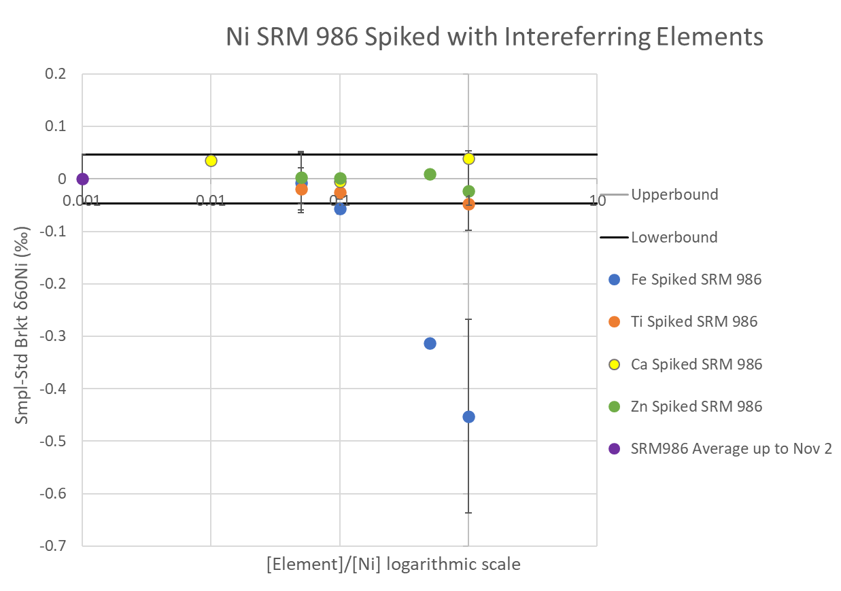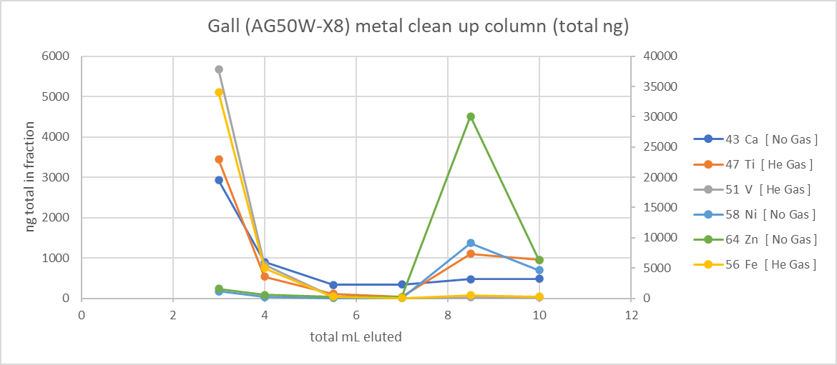

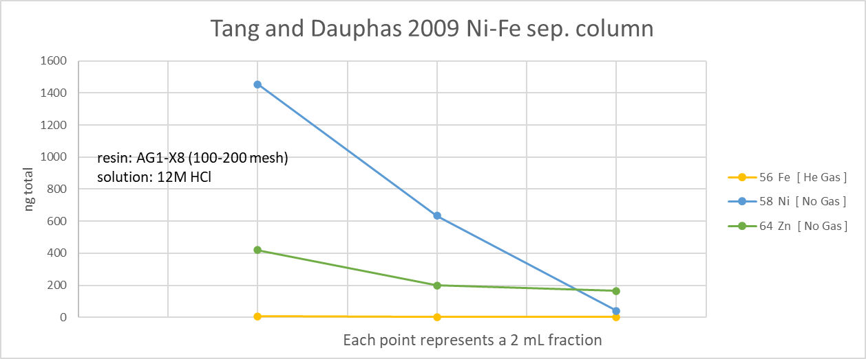

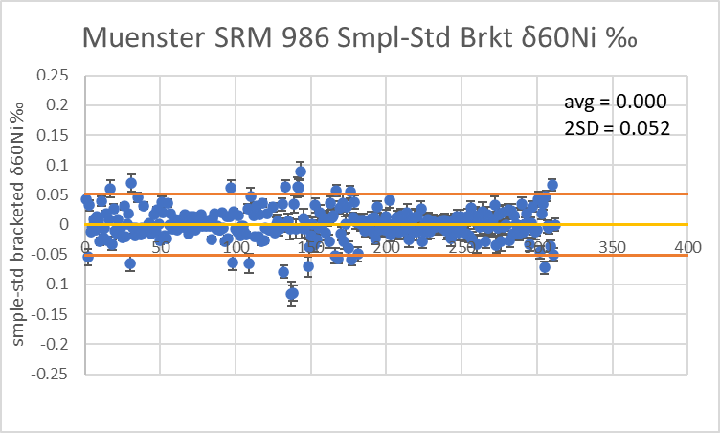





1. While Ni AAS is not a Ni isotope standard, we feel confident in at the very least, interpreting the relative differences between the different fractions described above. Furthermore, Ni AAS has been analyzed at LLNL with a Neptune MC-ICP-MS and at Northern Arizona University with a Nu III MC-ICP-MS (-0.44±0.06, n=20), and both instruments yielded the analytically indistinguishable δ60Ni values.