# Proposed Work

While the apparent marine Ni isotope imbalance seems quite complicated and will take several studies to resolve, we can begin to investigate the cause by tackling two high priority knowledge gaps. The aim of this dissertation is to investigate the following questions:

## Guiding Questions

1. Are marine carbonates an isotopically light sink of Ni? Does carbonate early diagenesis lead to release or uptake of additional Ni and how does this impact the effective Ni isotopic composition and Ni mass flux of carbonates? Finally, can carbonates be used as a faithful geologic record of Ni isotopic composition?
2. What governs the isotopic composition of Fe-Mn deposits? Can the observed variation in δ60Ni of Fe-Mn deposits be explained by differences in mineralogy or accumulation rate?

The above questions will inform the first and second chapter of the dissertation. The third and final chapter of the dissertation will be guided by the challenges and knowledge gaps described in the literature review, but will not be described in detail here.

## Hypotheses and Project Summary

1. Carbonates – sample selection and justification
2. Mn oxides – hypotheses and proposed experiments

Carbonates

Carbonates are a ubiquitous sediment across time and space and may be a nontrivial and perhaps isotopically light sink of Ni. There is clear disagreement within the community about its importance to the modern marine Ni budget, with estimates for its output ranging from 3 to 180% of the riverine input (Alvarez et al., 2021; Ciscato et al., 2018). The estimate at the lower end of that range likely underestimated the flux because only includes Ni associated with TOC in carbonates and omits any Ni which might incorporate into the inorganic component. Nickel has been experimentally found to partition moderately into abiotic and biotic calcite, suggesting the inorganic component may be important to consider as a host of Ni (Alvarez et al., 2021; Lakshtanov and Stipp, 2007; Munsel et al., 2010; Smith et al., 2020). The estimate at the higher end of the range likely overestimated the flux because of the odd sample set selection (i.e., carboniferous limestones from a single region with typically higher [Ni] than more modern carbonates) to represent the average Ni concentration of primary carbonates (Alvarez et al., 2021; Zhao and Zheng, 2014). We anticipate that the true estimation lies somewhere between these values, but, until this is resolved, we cannot accurately model the modern marine Ni budget. In addition, the available isotope data points to carbonate being isotopically light relative to seawater, but we lack measurements of any modern marine carbonates. Alvarez et al 2021compared an inferred bond length of Ni-O in calcite (2.11 Å) to the Ni-O bond length in the Ni aquo complex (2.05 to 2.07 Å) to explain why they observed isotopically lighter Ni in the solid compared to solution.

I propose to perform the first Ni isotope measurements of modern marine carbonates to obtain a representative δ60Ni for carbonates and help assess its importance to the budget. For this study, we have selected a set of well-characterized, primary to diagenetically altered shallow-water carbonates from the Great Bahama Bank. Our set includes samples from short cores (representing primary carbonates) and the Clino (representing end members for forms of meteoric diagenesis, aragonite to low magnesium calcite neomorphism, and marine burial diagenesis) and Unda cores (representing massive dolomitization).

Unfortunately, by virtue of selecting shallow-water carbonates, we are not capturing the Ni isotopic composition of pelagic carbonates which may be different. Based on the mass distribution in modern CaCO3 accumulation budgets, pelagic carbonates appear to dominate the budget (*e.g.,* Milliman 1993, Iglaseous 2002, Smith and Mackenzie 2016, Opdyke and Wilkinson 1988). However, we believe the chosen samples are an appropriate first look at δ60Ni in carbonates for several reasons. First and foremost, we have immediate access to the samples and experts. These samples, in particular the Unda and Clino cores, have a wealth of associated information detailing their mineralogy and depositional and diagenetic histories (*e.g.,* Eberli et al., 1997; Higgins et al., 2018; Melim et al., 2002; Swart and Oehlert, 2018). The extensive history and access to primary carbonates allows us to assess the influence of early marine diagenesis which may have an impact on the retained Ni in the carbonate sink. Because of the many attractive features listed for this sample set, they have been used for a number of other elements for similar purposes, and these studies interpretations can be used to inform our own (*e.g.,* Dellinger et al., 2020; Hardisty et al., 2017; Romaniello et al., 2013; Zhang et al., 2017).

Interestingly, our chosen sample set provides an opportunity to assess the fidelity of shallow-water carbonates as a record of the Ni isotopic composition of seawater. While shallow-water carbonates do not make up significant portion of the modern carbonate flux, they were perhaps more abundant in the past. The proportion of pelagic to shallow water carbonate burial has likely been steadily increasing to present values, with the dominance of pelagic carbonates perhaps being a characteristic of only the past 10-30 Ma (Nakamori, 2001; Opdyke and Wilkinson, 1988; van der Ploeg et al., 2019). In addition to the difference in relative abundance, as noted by Schrag et al. (2013) for δ13C records, shallow water carbonates are more available as a geologic record because slope and deep-basin carbonates are more often subducted and removed or extremely deformed relative to shallow water carbonates. If diagenetic processes either preserve or systematically alter the δ60Ni of the primary carbonate value, which we will be able to evaluate with the data from the proposed sample set, shallow-water carbonates may be a robust record of δ60Ni from the contemporary seawater.

1. Modern carbonates might be big and light sink of Ni, require a sizable, but less isotopically ridiculous source of Ni to balance the budget
   1. Re-present isotopic comp data
   2. Re-present flux data
   3. Mention Stipp and Munsel maybe?
   4. Mention bond length argument provided by Alvarez?
2. Sample selection - shallow water carbonates
   1. Cons
      1. not representative of the distribution of where the mass lies
         1. See “Progress Made in Study of Ocean's Calcium Carbonate Budget” for potential Ca CO3 budget 2002
            1. Carbonate shelves have a CaCO3 accumulation rate of 0.036 Pg C/yr while deep sea accumulation is estimated to be ~0.1-0.144 Pg C/yr (see referenes therein for how these estimates are calc)
            2. Large uncertainties (+/-100% for most fluxes)
         2. Milliman 1993
            1. Estimates for burial on bank-derived sediment accumulation of 0.1 b tonnes of CaCO3 with a total accumulation of 3.2 (many assumptions)
         3. Milliman and Droxler 1995
            1. Updated version of 1993 estimates
            2. Pelagic accumulation is 11x10^12 mol /yr and everything else is 21x 10^12 mol/yr (total 32). Banks and bays, and carbonate shelves are 2 and 3 respectively with uncertainties of ~100% or greater
         4. Smith and Mackenzie 2016
            1. Tropical shelves (which include visible reefs, submerged reefs, other carbonate banks and other sedimentary shelves) accumulate 15x1012 CaCO3 mol/yr with a total accumulation rate of 31x1012 CaCO3 mol/yr. “Other carbonate banks” accumulate 0.6x1012 CaCO3 mol/yr
         5. O’Mara and Dunne 2019
            1. Estimated CaCO3 flux in neritic environments by combining satellite and benthic community area data. Carbontate shelf flux is 0.037 Pg C/yr with all benthic being ~0.163 Pg C/yr
            2. Unclear if they estimate pelagic carbonates how I think they are. They write “Model output (1) confirms prediction of dominance of benthic over pelagic production in the neritic zone..” so I don’t think this is a global budget
   2. Pros
      1. very important sediment in past (and preserved)
         1. “Prior to the Mesozoic, it is thought that most carbonate sediments were deposited in shallow-water platform, shelf, and slope environments (Opdyke and Wilkinson, 1988, Boss and Wilkinson, 1991, Holmden et al., 1998, Ridgwell, 2005).” Higgins et al. 2018
         2. “Authigenic carbonate and the history of the global carbon cycle” Schrag e tal 2013
            1. “A challenge is that d13Ccarb records before the Jurassic are heavily biased toward shallow-water carbonate platforms because slope and deep-basin sections are typically consumed or highly deformed during subduction”
         3. Opdyke and Wilkinson 1988
            1. shelf carbonate areas changed from 27x106km2 to 1.4x106 km2 since the late Cretaceous
            2. “Estimates by Opdyke and Wilkinson (1988) suggest that the dominance of pelagic carbonate deposition may only extend back to 15 or 20 Ma” from Fantle 2010 EVALUATING THE Ca ISOTOPE PROXY
         4. Volk 1989
            1. I think discusses how balance of shallow water and pelagic carbonate burial may have been proportionally different in the past.
         5. “Cenozoic carbonate burial along continental margins” 2019
            1. Basically estimate less margin carbonate accumulation over time compared to Opdyke but still support them being more important in the past relative to pelagic (only skimmed this paper without really paying attention, must go back and reread)
            2. Supports long term decline in marginal carbonate burial (as does Opdyke)
         6. Caldeira 1991 “Continental-pelagic carbonate partitioning and the global carbonate-silicate cycle"
            1. “Approximately 60% to 80% of carbonate accumulation occurs in deep-water environments (Opdyke and Wilkinson, 1988; Wilkinson and Walker, 1989), but deep-water carbonate currently makes up only 7% or 8% of the total carbonate rock mass (Budyko et al., 1987; Wilkinson and Walker, 1989). If pelagic carbonate cycles about eight times more rapidly than continental carbonate (Wilkinson and Walker, 1989),”
         7. Nakamori 2001
            1. Need to read this
            2. 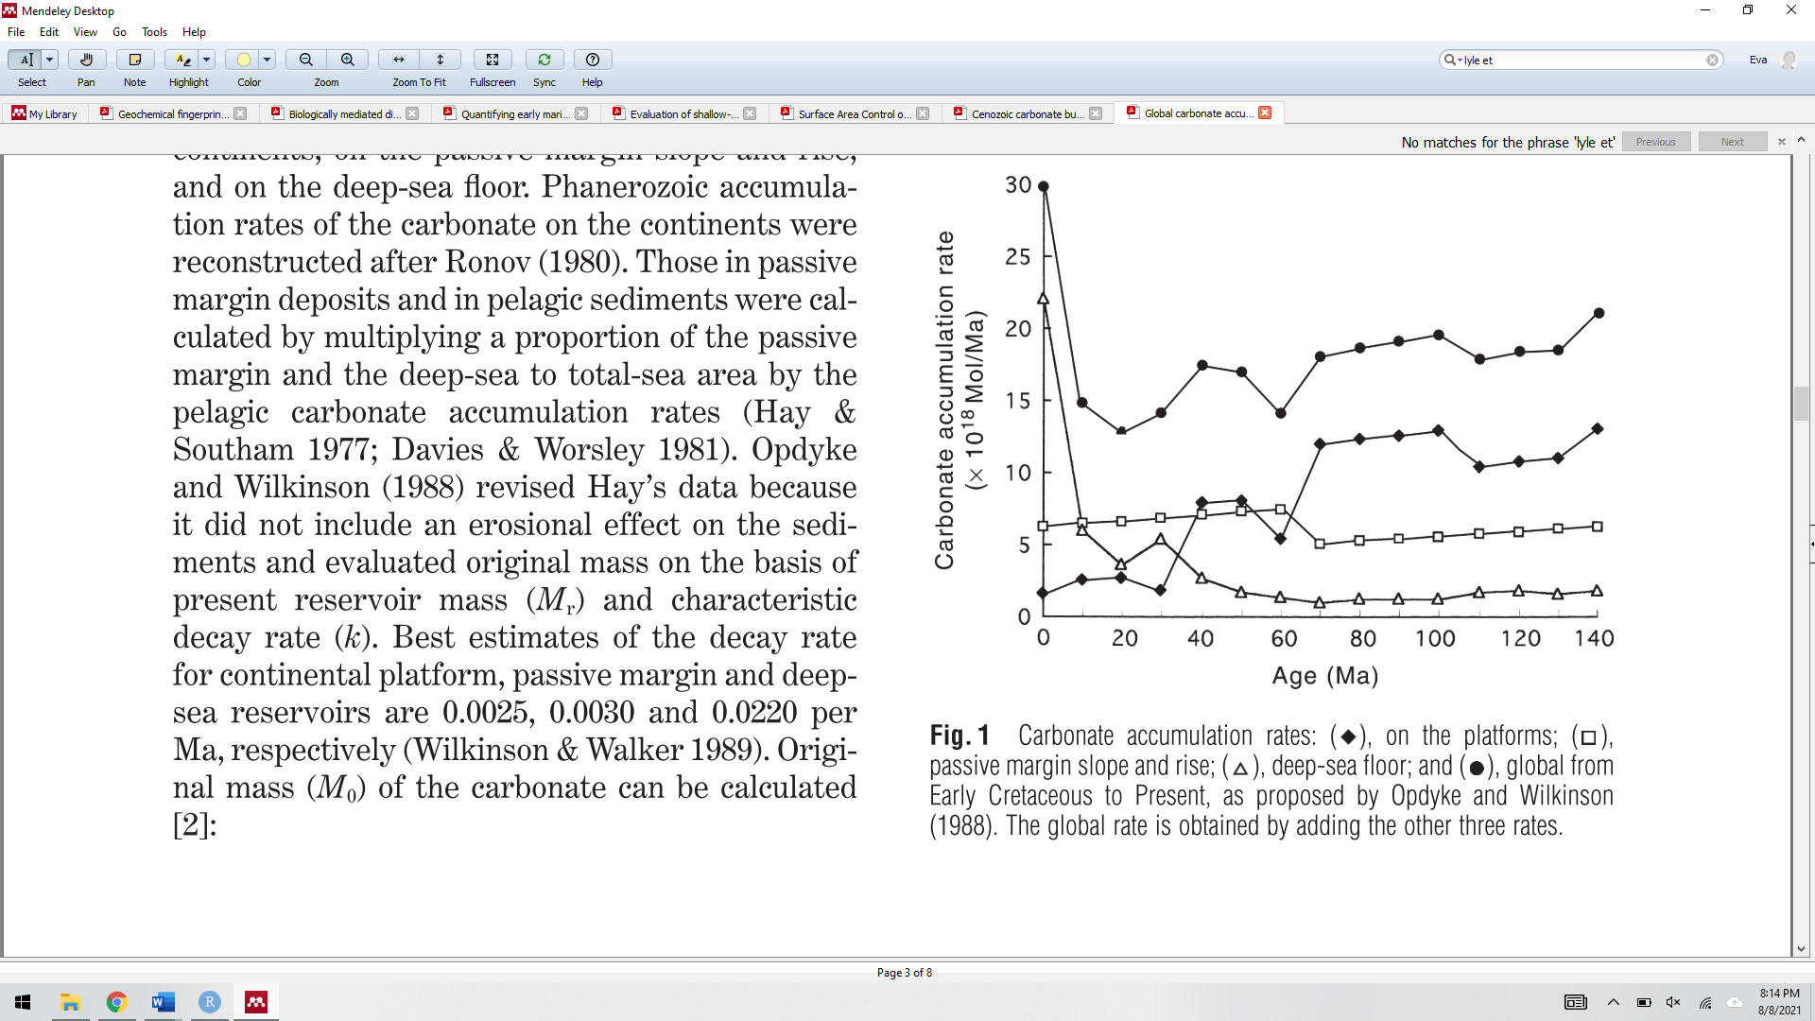
            3. 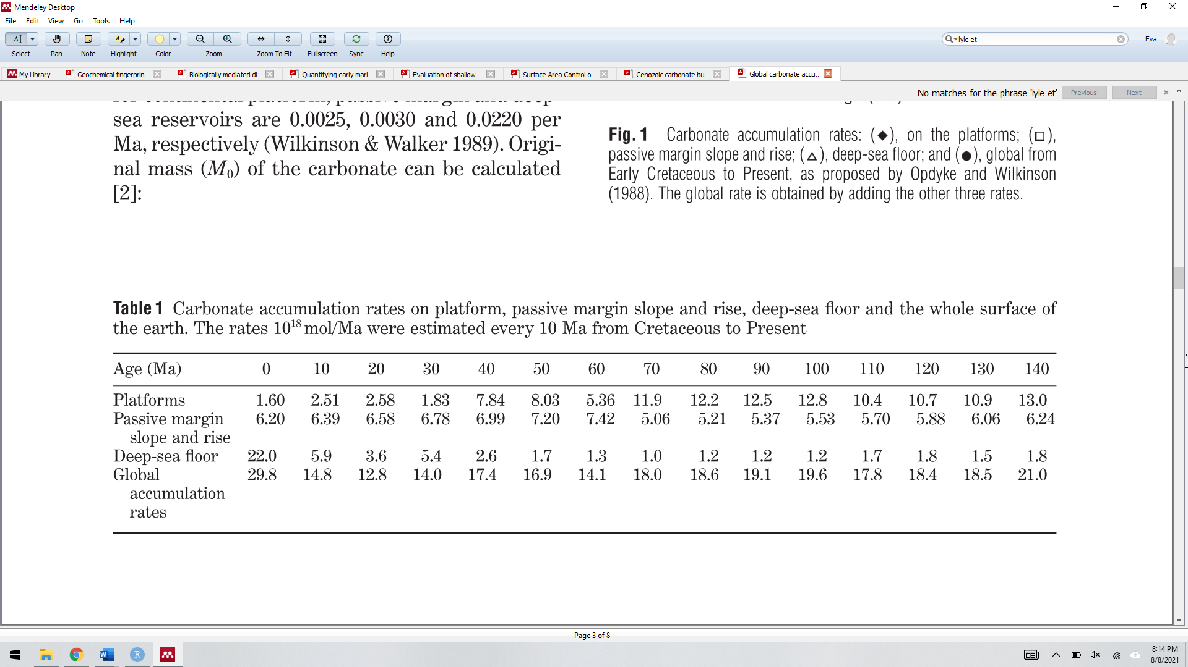
            4. I think they basically fixed the model estimates from Opdyke 1988 because they were all relative to a single time period and that single time period was incorrect (too high).
      2. early diagenesis may strongly affect the primary Ni signal, and our sampleset has a large set of literature documenting it’s diagentic past.
      3. Provides opportunity to assess the fidelity of carbonates as a record of dNi
3. Proposed work
   1. Develop chemistry for and analyze set of the GBB carbs
   2. Choose nonexperimental route to study the effect of diagenesiss on the long term burial of Ni (should this be included here?)

**Mn oxides**

As discussed above, several studies aimed to determine δ60/58Ni for Mn-rich sediments, perhaps largest sink of Ni, but the results so far are extremely puzzling. Nickel is enriched in Fe-Mn deposits relative to seawater (ca. 106 Ni mol/g Fe-Mn deposits/ Ni mol/g seawater) (e.g., Li and Schoonmaker, 2003) and primarily associated with Mn phases, rather than Fe (e.g., Peacock and Sherman, 2007). The δ60/58Ni of Mn-rich deposits span the entire known natural range of Ni isotopic compositions (ca. -1.8 to 2.5‰) and, inexplicably, appear to be sometimes isotopically heavier and sometimes isotopically lighter than the solution from which they precipitate (Gall et al., 2013; Gueguen et al., 2020, 2016; Gueguen and Rouxel, 2021; Little et al., 2020; Vance et al., 2016). In addition to identifying the isotopic composition of Ni’s largest sink, obtaining a mechanistic understanding of Ni isotope fractionation with Mn oxides will allow us to determine the feasibility of the hypothesized heavy benthic flux, which relies on a specific interpretation of Ni isotopic fractionation associated with Mn oxide redox cycling. Without better knowledge of the main marine Ni sink, correctly modeling the marine Ni cycle is likely impossible.

We will experimentally investigate three of the most promising explanations for the variability in Mn oxide sediments. The primary mineral of focus will be on birnessite, the dominant Mn phase in natural marine Fe-Mn precipitates (Peacock, 2009).

**H1:** Surface sorbed Ni is isotopically lighter than incorporated Ni within birnessite. Nickel can be structurally incorporated into Mn vacancy sites in birnessite or sorbed on {001} surface sites (triple corner sharing) or edge sites (double corner sharing) (Simanova et al., 2015). A Ni-birnessite sorption study indicated Δ60/58Nisolution-birnessite positively correlates with the ratio of surface-sorbed to incorporated Ni, suggesting that sorbed Ni is isotopically lighter than incorporated Ni (Sorensen et al., 2020). Experimental results suggest Ni migrates very slowly into the vacancy sites (30% incorporation after 408 h) (Peacock, 2009). In natural Fe-Mn crusts, the majority of Ni is structurally incorporated (Peacock and Sherman, 2007), but the degree of structural incorporation within sediments like the relatively ephemeral Mn oxide particles in the Black Sea is unknown. If surface-sorbed and incorporated Ni have different Δ60/58Nisolution-birnessite,differences in the proportions of sorbed to incorporated Ni would impact the δ60/58Ni of Mn-rich sediments.

**Proposed Work 1**: To test this hypotheses, I will differentiate between the fractionations of surface-sorbed Ni versus structurally incorporated Ni within birnessite by performing Ni sorption experiments with synthetic, triclinic birnessite (*i.e.,* no or very few available vacancy sites for incorporation and therefore only or mostly surface-sorbed Ni) and highly crystalline, hexagonal birnessite (*i.e.,* many available vacancy sites for Ni incorporation and therefore a combination of sorbed and incorporated Ni). While my experimental design cannot differentiate between the potentially different isotopic behaviors of triple and double corner sharing Ni, the difference between total sorbed and incorporated Ni is a necessary first step in assessing the importance of coordination on the variation of δ60/58Ni in Mn-rich sediments. I need to ensure proper characterization of the substrate, as the experiment relies on being able to control the absence or presence (and quantity) of vacancy sites within the precipitated birnessite. The poorly crystalline nature of birnessite, especially triclinic birnessite, makes it a bad candidate for characterization solely via powder X-ray diffraction(Post, 1999). To adequately characterize my substrates, I plan to use Raman spectroscopy, which is a useful technique for disordered materials because it can provide both local and longer-range structural information. Dr. Jeffrey Post has agreed to collaborate on this project and will measure my substrates using Raman spectroscopy at the Smithsonian National Museum of Natural History.

**H2:** Kinetic fractionation leads to isotopically lighter Ni sorbed to Mn oxides than equilibrium fractionation. Mn-rich sediments have a wide range of accumulation rates and, depending on the rate, may capture different isotope fractionations (kinetic, equilibrium or a mix thereof). Experiments varying in duration from 67 hours to 27 days found that Δ60/58Nisolution-birnessite decreased progressively over time, which suggests equilibrium had not yet been reached, and short-term experiments may be recording an initial kinetic effect (Wasylenki et al., 2019). If kinetic and equilibrium fractionations are distinct, the δ60/58Ni of fast-accumulating versus slow-accumulating Mn-rich sediments may record different Ni isotope offsets from dissolved Ni in the water column

**Proposed Work 2:** To address H2 and robustly calculate the equilibrium and kinetic fractionations, I propose to perform three-isotope (62Ni-60Ni-58Ni) experiments. Currently, the three-isotope experiment is considered to be the most rigorous approach to determining equilibrium isotope fractionation(Frierdich et al., 2014). In this method, a typical sorption experiment is performed, but the solution is doped with a small amount of significantly enriched 62Ni solution with a slightly different δ60/58Ni (Fig. 2A). The extreme exchange of 62Ni between solid and solution tracks the percent of isotope mixing, while the subtle change in δ60/58Ni­tracks isotope fractionation. At 100% mixing, the system is assumed to be at equilibrium, and the difference between δ60/58Ni­solution andδ60/58Ni­solid equals Δ60/58Nisolution-solid. If we cannot attain 100% mixing in a reasonable time, the δ60/58Ni­solid and δ60/58Ni­solution data can be extrapolated to 100% mixing (Fig. 2B). If kinetic and equilibrium fractionations differ, we will observe two trends (like in Fig. 2B) and can discriminate between the first (kinetic) and second (equilibrium) trends’ fractionation values.

**H3:** Diagenetic transformation of birnessite to todorkite leads to isotopically heavy Ni being released from solid.

two explanations for the observed 60/58Ni variation in Mn-rich sediments: (1) the initial δ60/58Ni could be roughly the same across sediments, but diagenesis (Mn redox cycling and/or transformation to todorokite) perhaps redistributes Ni isotopes and (2) natural variations could be a consequence of variable initial δ60/58Ni. The first explanation has an added “conceptual” benefit in that this process could provide an input of Ni to the ocean and address the mass balance issue. Suboxic diagenesis of Mn oxides appears to release Ni into porewater, however, corresponding isotope data does not conclusively suggest this Ni is isotopically heavy relative to solid or has any isotope effect at all (Fig XX) (Gueguen and Rouxel, 2021; Little et al., 2020)[insert sentences about (1) the isotope data does not seem to necessarily agree with this, although the conc data might]. Experimental transformation from birnessite to todorokite showed a 50% release of the Ni originally associated with birnessite (~1 wt%), and natural data roughly corroborates this trend (Atkins et al., 2016). However, the rate and extent of this transformation is largely unknown, as well as the Ni isotopic fractionation it may impart. Thus far, only three todorokite rich nodules have been measured for Ni isotopic composition (δ60/58Ni~ -0.22 to 0.01); they tentatively appear to be isotopically lighter than measured phyllomanganate rich nodules (0.28 to 1.06, n =3) and suggest isotopically heavy Ni may be released, although further investigation is clearly warranted. [Does not explain difference between hydrogenetic Fe-Mn crust and black sea sediments]

If the natural variations is due to variable initial δ60/58Ni, what mechanisms might control the variation? Based on natural and experimental observations, there are two readily apparent working hypotheses. First, the variation could be due to differences in Ni coordination environment. Nickel can be structurally incorporated into Mn vacancy sites in birnessite, the dominant Mn phase in natural marine Fe-Mn precipitates (Peacock, 2009), or sorbed on {001} surface sites (triple corner sharing) or edge sites (double corner sharing) (Simanova et al., 2015). A Ni-birnessite sorption study indicated Δ60/58Nisolution-birnessite positively correlates with the ratio of surface-sorbed to incorporated Ni, suggesting that sorbed Ni is isotopically lighter than incorporated Ni (Sorensen et al., 2020). Experimental results suggest Ni migrates very slowly into the vacancy sites (30% incorporation after 408 h) (Peacock, 2009). In natural Fe-Mn crusts, the majority of Ni is structurally incorporated (Peacock and Sherman, 2007), but the degree of structural incorporation within sediments like the Black Sea particles is unknown. If surface-sorbed and incorporated Ni have different Δ60/58Nisolution-birnessite,differences in the proportions of sorbed to incorporated Ni would impact the δ60/58Ni of Mn-rich sediments. Second, Mn-rich sediments have a wide range of accumulation rates and, depending on the rate, may capture different isotope fractionations (kinetic, equilibrium or a mix thereof). Experiments varying in duration from 24 hours to 27 days found that Δ60/58Nisolution-birnessite decreased progressively over time, which suggests equilibrium had not yet been reached, and short-term experiments may be recording an initial kinetic effect (Fig. 1)(Sorensen et al., 2020; Wasylenki et al., 2019). If kinetic and equilibrium fractionations are distinct, the δ60/58Ni of fast-accumulating versus slow-accumulating Mn-rich sediments may record different Ni isotope offsets from dissolved Ni in the water column.

Organic Matter paragraph?

# Progress Thus Far