[嵌入式系統設計](https://flipclass.stust.edu.tw/course/13883)第十二次作業

班級:五專資工三甲

姓名:陳紋誼

學號:5A9G0006

指導老師:吳建中 老師

1. 題目

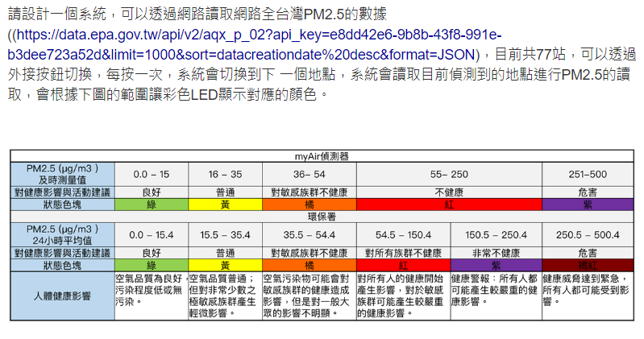

1. 程式

#include <Arduino.h>

#include <WiFi.h>

#include <WiFiMulti.h>

#include <HTTPClient.h>

#include <ArduinoJson.h>

#include <analogWrite.h>

#define USE_SERIAL Serial

#define LED_R 16

#define LED_G 4

#define LED_B 17

#define button 21

WiFiMulti wifiMulti;

int pm25;

int Data = 1, counter = 0;

void RGB(int R, int G, int B) {

analogWrite(LED_R, R);

analogWrite(LED_G, G);

analogWrite(LED_B, B);

}

void ISR() {

counter = (counter + 1) % 77;

}

void setup() {

attachInterrupt(button, ISR, FALLING);

//pinMode(button, INPUT);

pinMode(LED_R, OUTPUT);

pinMode(LED_G, OUTPUT);

pinMode(LED_B, OUTPUT);

USE_SERIAL.begin(115200);

USE_SERIAL.println();

USE_SERIAL.println();

USE_SERIAL.println();

for (uint8_t t = 4; t > 0; t--) {

USE_SERIAL.printf("[SETUP] WAIT %d...\n", t);

USE_SERIAL.flush();

delay(1000);

}

wifiMulti.addAP("WY1010", "20041010311");

}

void loop() {

int j = 0;

// wait for WiFi connection

if ((wifiMulti.run() == WL_CONNECTED)) {

HTTPClient http;

USE_SERIAL.print("[HTTP] begin...\n");

// configure traged server and url

http.begin("https://data.epa.gov.tw/api/v2/aqx_p_02?api_key=e8dd42e6-9b8b-43f8-991e-b3dee723a52d&limit=1000&sort=datacreationdate%20desc&format=JSON"); //HTTP

USE_SERIAL.print("[HTTP] GET...\n");

// start connection and send HTTP header

int httpCode = http.GET();

// httpCode will be negative on error

if (httpCode > 0) {

// HTTP header has been send and Server response header has been handled

USE_SERIAL.printf("[HTTP] GET... code: %d\n", httpCode);

// file found at server

if (httpCode == HTTP_CODE_OK) {

String payload = http.getString();

DynamicJsonDocument doc(12288);

DeserializationError error = deserializeJson(doc, payload);

if (error) {

Serial.print("deserializeJson() failed: ");

Serial.println(error.c_str());

return;

}

for (JsonObject field : doc["fields"].as<JsonArray>()) {

const char* field_id = field["id"]; // "site", "county", "pm25", "datacreationdate", "itemunit"

const char* field_type = field["type"]; // "text", "text", "text", "text", "text"

const char* field_info_label = field["info"]["label"]; // "測站名稱", "縣市名稱", "細懸浮微粒濃度", "資料建置日期", "測項單位"

}

const char* resource_id = doc["resource_id"]; // "c1f31192-babd-4105-b880-a4c2e23a3276"

const char* extras_api_key = doc["__extras"]["api_key"]; // "e8dd42e6-9b8b-43f8-991e-b3dee723a52d"

bool include_total = doc["include_total"]; // true

const char* total = doc["total"]; // "77"

const char* resource_format = doc["resource_format"]; // "object"

const char* limit = doc["limit"]; // "1000"

const char* offset = doc["offset"]; // "0"

const char* links_start = doc["_links"]["start"];

const char* links_next = doc["_links"]["next"];

for (JsonObject record : doc["records"].as<JsonArray>()) {

const char* record_site = record["site"]; // "大城", "富貴角", "麥寮", "關山", "馬公", "金門", "馬祖", "埔里", "復興", ...

const char* record_county = record["county"]; // "彰化縣", "新北市", "雲林縣", "臺東縣", "澎湖縣", "金門縣", "連江縣", "南投縣", ...

const char* record_pm25 = record["pm25"]; // "5", "6", "8", "7", "11", "9", "14", "3", "23", "10", ...

const char* record_datacreationdate = record["datacreationdate"]; // "2022-11-24 11:00", "2022-11-24 ...

const char* record_itemunit = record["itemunit"]; // "μg/m3", "μg/m3", "μg/m3", "μg/m3", "μg/m3", ...

pm25 = record["pm25"].as<int>();

if (j == counter) {

Serial.print("counter："); Serial.println(counter);

Serial.print("測站："); Serial.println(record_site);

Serial.print("縣市："); Serial.println(record_county);

Serial.print("PM2.5："); Serial.println(pm25);

Serial.print("資料建置日期："); Serial.println(record_datacreationdate);

Serial.print("測項單位："); Serial.println(record_itemunit);

if (pm25 <= 500 && pm25 >= 251) {

Serial.println("PM2.5值251~500，紫燈");

RGB(140, 0, 255);

} else if (pm25 >= 55) {

Serial.println("PM2.5值55~250，紅燈");

RGB(255, 0, 0);

} else if (pm25 >= 36) {

Serial.println("PM2.5值36~54，橘燈");

RGB(255, 85, 0);

} else if (pm25 >= 16) {

Serial.println("PM2.5值16~35，黃燈");

RGB(255, 255, 0);

} else {

Serial.println("PM2.5值0.0~15，綠燈");

RGB(0, 255, 0);

}

Serial.println("\n");

}

j++;

}

}

} else {

USE_SERIAL.printf("[HTTP] GET... failed, error: %s\n", http.errorToString(httpCode).c_str());

}

http.end();

}

delay(5000);

}

1. 程式說明

可以到網址抓空汙大數據，將臺南的PM2.5抓出，按一次按鈕，系統會切換到下一個地點，讀取目前偵測到的地點的PM2.5，根據範圍讓彩色LED顯示對應的顏色。

1. 執行結果

影片連結： <https://youtu.be/FeRw0mGzh8g>