[嵌入式系統設計](https://flipclass.stust.edu.tw/course/13883)第二次作業

班級:五專資工三甲

姓名:陳紋誼

學號:5A9G0006

指導老師:吳建中 老師

1. 題目



1. 程式

// C++ code

//

void setup()

{

for(int i=1;i<=7;i++){

pinMode(i, OUTPUT);

}

pinMode(12, INPUT);

pinMode(13, INPUT);

Reset();

ShowNum(0);

}

int Adata,Bdata,data1,data2=1;

int time = 1,sum=0;

void loop()

{

Adata = digitalRead(12);

Bdata = digitalRead(13);

if(Adata == 0 && data1 == 1){

sum++;

if(sum > 9){

sum = 0;

}

Serial.println(sum);

Reset();

ShowNum(sum);

}else if(Bdata == 0 && data2 == 1){

sum--;

if(sum < 0){

sum = 0;

}

Serial.println(sum);

Reset();

ShowNum(sum);

}

if(Adata == 0){

time++;

}

if(Adata == 1){

time = 0;

}

if(time == 50){

sum = 0;

time = 0;

Serial.println(sum);

Reset();

ShowNum(sum);

}

delay(100);

data1 = Adata;

data2 = Bdata;

}

void Reset(){

for(int i=1;i<=7;i++)

digitalWrite(i,LOW);

}

void ShowNum(int F){

switch(F){

case(0):

digitalWrite(1,HIGH);

digitalWrite(2,HIGH);

digitalWrite(3,HIGH);

digitalWrite(4,HIGH);

digitalWrite(6,HIGH);

digitalWrite(5,HIGH);

break;

case(1):

digitalWrite(2,HIGH);

digitalWrite(3,HIGH);

break;

case(2):

digitalWrite(2,HIGH);

digitalWrite(4,HIGH);

digitalWrite(5,HIGH);

digitalWrite(7,HIGH);

digitalWrite(1,HIGH);

break;

case(3):

digitalWrite(2,HIGH);

digitalWrite(3,HIGH);

digitalWrite(4,HIGH);

digitalWrite(7,HIGH);

digitalWrite(1,HIGH);

break;

case(4):

digitalWrite(2,HIGH);

digitalWrite(3,HIGH);

digitalWrite(6,HIGH);

digitalWrite(7,HIGH);

break;

case(5):

digitalWrite(1,HIGH);

digitalWrite(3,HIGH);

digitalWrite(4,HIGH);

digitalWrite(6,HIGH);

digitalWrite(7,HIGH);

break;

case(6):

digitalWrite(1,HIGH);

digitalWrite(3,HIGH);

digitalWrite(4,HIGH);

digitalWrite(5,HIGH);

digitalWrite(6,HIGH);

digitalWrite(7,HIGH);

break;

case(7):

digitalWrite(1,HIGH);

digitalWrite(2,HIGH);

digitalWrite(3,HIGH);

break;

case(8):

for(int i=1;i<=7;i++)

digitalWrite(i,HIGH);

break;

case(9):

digitalWrite(1,HIGH);

digitalWrite(2,HIGH);

digitalWrite(3,HIGH);

digitalWrite(4,HIGH);

digitalWrite(6,HIGH);

digitalWrite(7,HIGH);

break;

}

}

1. 程式說明

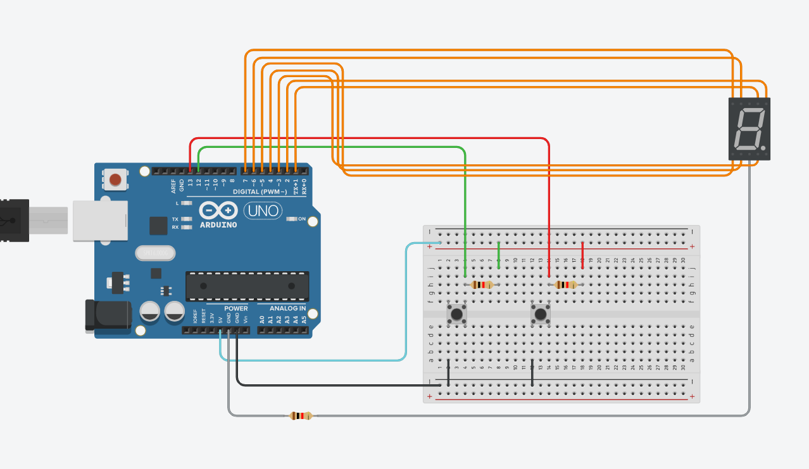

按下A按鈕的同時總數+1，七段顯示器數值顯示目前的總數值，如果總數值超過9則輸出0，按下B按鈕-1，七段顯示器數值顯示目前的總數值，如果總數值為負數則輸出0，利用if判斷式即時偵測A按鈕的狀態，當A按鈕備嘗案5秒後，清除目前的總數為0並輸出。設計兩個函數，一個可以將前一次的顯示結果清除，一個利用switch case控制要顯示的數字。

1. 執行結果

