[嵌入式系統設計](https://flipclass.stust.edu.tw/course/13883)第九次作業

班級:五專資工三甲

姓名:陳紋誼

學號:5A9G0006

指導老師:吳建中 老師

1. 題目

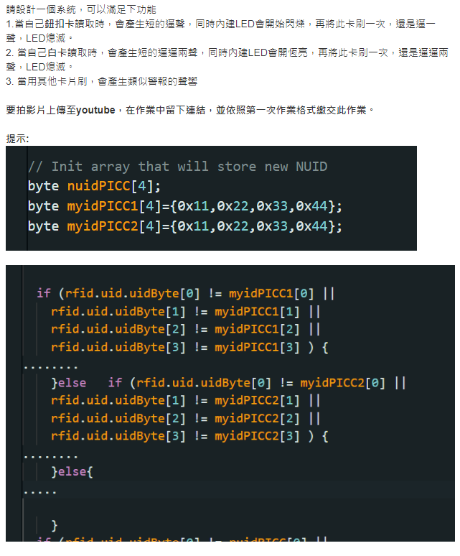

1. 程式

#include <SPI.h>

#include <MFRC522.h>

#define SS_PIN 5

#define RST_PIN 27

MFRC522 rfid(SS_PIN, RST_PIN);

int buzzPin = 4;

byte nuidPICC[4];

byte myidPICC1[4] = {0xDA,0xD4,0x16,0xCB}; //白卡

byte myidPICC2[4] = {0xD5,0x3A,0xCE,0x65}; //藍卡

void setup() {

Serial.begin(9600);

SPI.begin(); // init SPI bus

rfid.PCD_Init(); // init MFRC522

Serial.println("Tap an RFID/NFC tag on the RFID-RC522 reader");

pinMode(buzzPin, OUTPUT);

digitalWrite(buzzPin, LOW);

pinMode(LED_BUILTIN, OUTPUT);

}

int LED = 2;

void loop() {

if (rfid.PICC_IsNewCardPresent()) { // new tag is available

if (rfid.PICC_ReadCardSerial()) { // NUID has been readed

MFRC522::PICC_Type piccType = rfid.PICC_GetType(rfid.uid.sak);

Serial.print("RFID/NFC Tag Type: ");

Serial.println(rfid.PICC_GetTypeName(piccType));

// print UID in Serial Monitor in the hex format

Serial.print("UID:");

for (int i = 0; i < rfid.uid.size; i++) {

Serial.print(rfid.uid.uidByte[i] < 0x10 ? " 0" : " ");

Serial.print(rfid.uid.uidByte[i], HEX);

}

Serial.println();

rfid.PICC_HaltA(); // halt PICC

rfid.PCD_StopCrypto1(); // stop encryption on PCD

if(rfid.uid.uidByte[0] == myidPICC1[0] &&

rfid.uid.uidByte[1] == myidPICC1[1] &&

rfid.uid.uidByte[2] == myidPICC1[2] &&

rfid.uid.uidByte[3] == myidPICC1[3] ){

digitalWrite(buzzPin, LOW);

delay(100);

digitalWrite(buzzPin, HIGH);

delay(100);

digitalWrite(buzzPin, LOW);

delay(100);

if(LED == 0){

LED = 2;

digitalWrite(LED_BUILTIN, LOW);

return;

}

LED = 0;

digitalWrite(LED_BUILTIN, HIGH); //白卡恆亮

}else if(rfid.uid.uidByte[0] == myidPICC2[0] &&

rfid.uid.uidByte[1] == myidPICC2[1] &&

rfid.uid.uidByte[2] == myidPICC2[2] &&

rfid.uid.uidByte[3] == myidPICC2[3] ){

digitalWrite(buzzPin, LOW);

delay(100);

digitalWrite(buzzPin, HIGH);

delay(100);

if(LED == 1){

LED = 2;

digitalWrite(LED_BUILTIN, LOW);

return;

}

LED = 1; //藍卡閃爍

}else{

LED = 2;

digitalWrite(LED_BUILTIN, LOW); //其他警報

for(int i = 0;i < 10;i++){

digitalWrite(buzzPin, LOW);

delay(100);

digitalWrite(buzzPin, HIGH);

delay(100);

}

}

}

}

digitalWrite(buzzPin, HIGH);

if(LED == 1){

digitalWrite(LED_BUILTIN, HIGH);

delay(500);

digitalWrite(LED_BUILTIN, LOW);

delay(500);

}

//Serial.print(LED);

}

1. 程式說明

讀取藍卡時，會產生短逼聲， LED開始閃爍，再刷一次，逼一聲LED熄滅。讀取白卡時，會產生短的逼逼兩聲， LED會恆亮，再刷一次，逼逼兩聲LED熄滅。讀取其他卡片時，會產生類似警報的聲響(10次快速逼逼)。在白卡和藍卡的判斷式裡再多加一個判斷式，判斷卡片是否刷了第二次，式的話就熄滅。在辨識卡片的迴圈外面用判斷式判斷LED是否要閃爍。

1. 執行結果

影片連結：<https://youtu.be/JQqOO09npgc>