JavaScript HW3

班級:五專資工三甲

姓名:陳紋誼

學號:5A9G0006

1. 題目

1. 截圖

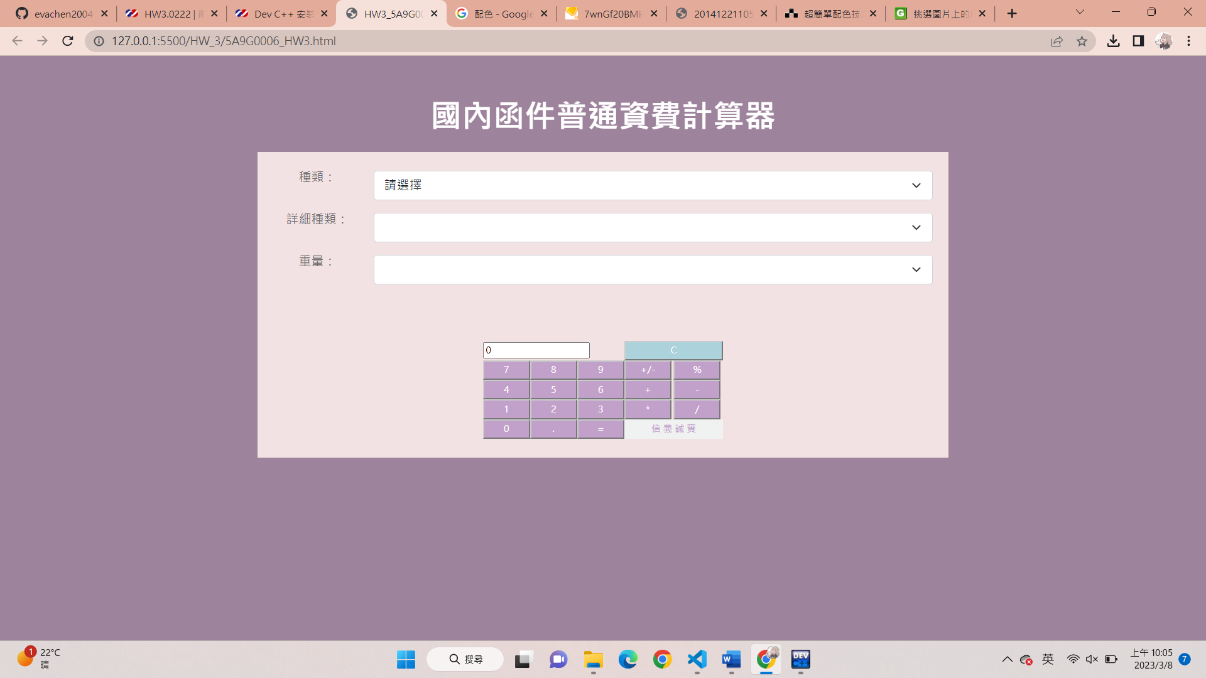

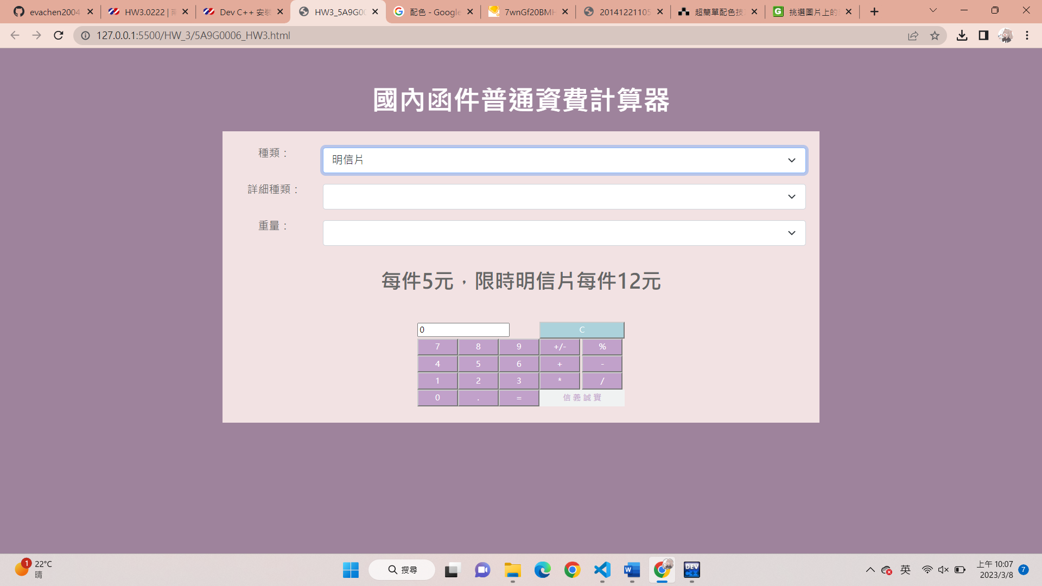

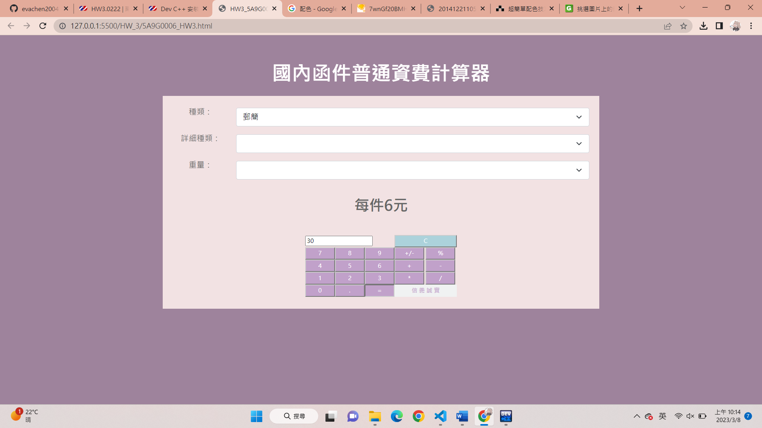

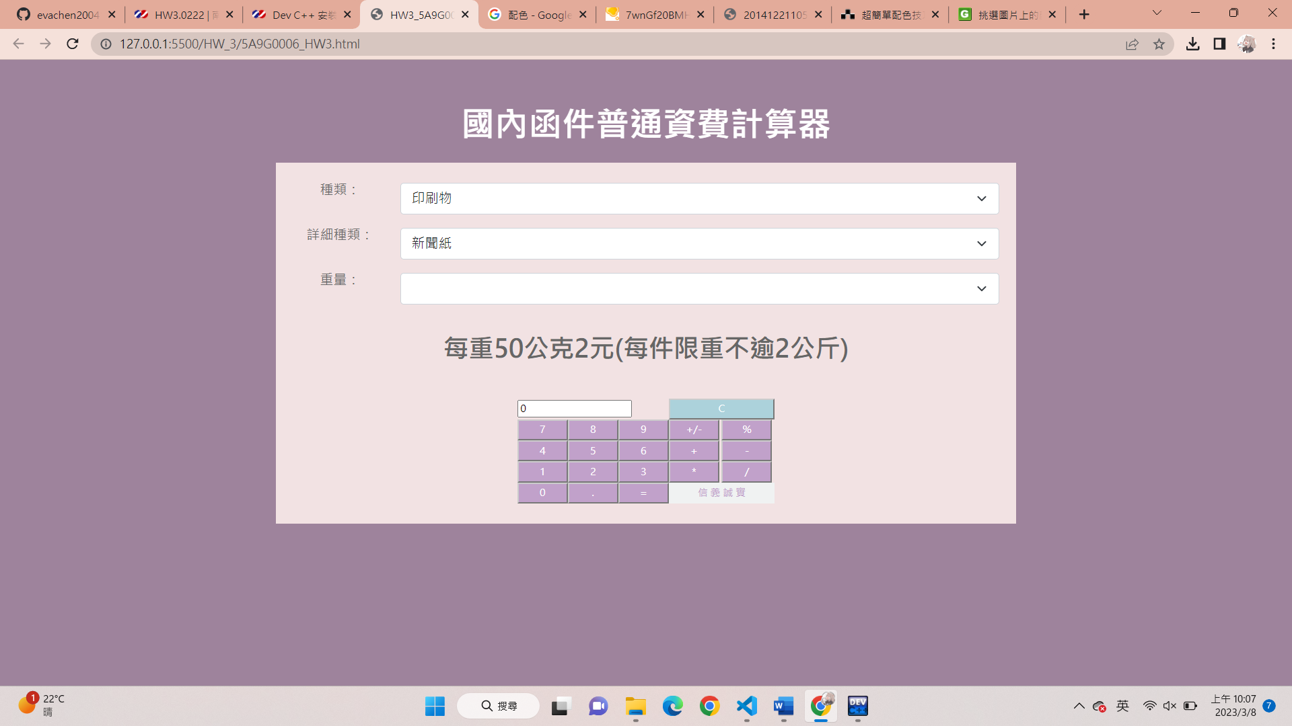

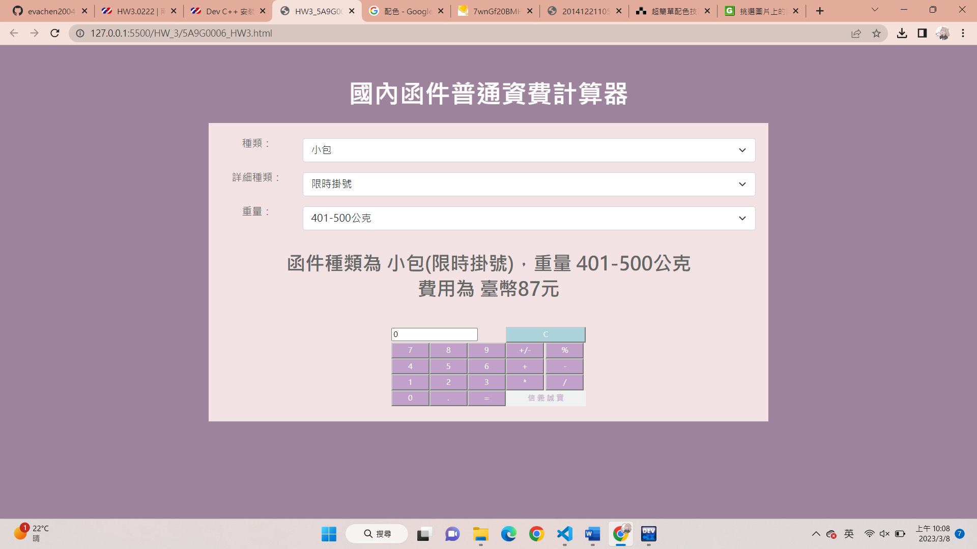

1. 說明

使用者可以選擇函件的種類以及重量，計算器就會算出需要的金額，也可以使用下面的計算機計算非重量為單位的函件寄送費用。

程式碼會先偵測使用者選擇的大種類，再到該大種類的資料二維陣列依詳細種類以及重量，找出使用者的函件所需費用，當每個下拉式選單的選擇被更改時，該function就會記憶被選擇的選項，帶給下一個function使用方便找到所需費用的位置，最後就會輸出所有的資訊。

.css裡放了計算機的顏色樣式。

1. .html程式

<!doctype html>

<html>

<link href="css.css" type="text/css" rel="stylesheet" />

<link href="https://cdn.jsdelivr.net/npm/bootstrap@5.0.0/dist/css/bootstrap.min.css" rel="stylesheet"

integrity="sha384-wEmeIV1mKuiNpC+IOBjI7aAzPcEZeedi5yW5f2yOq55WWLwNGmvvx4Um1vskeMj0" crossorigin="anonymous">

<head>

<meta charset="utf-8">

<title>HW3_5A9G0006</title>

<SCRIPT type="text/javascript">

/* 普通資費表 */

//定義種類陣列與資料

CountyName = new Array("信函", "印刷物", "小包", "明信片", "郵簡")

//定義信函陣列與資料

//詳細種類陣列

LetterZone = new Array("普通", "限時", "普通掛號", "限時掛號", "普通掛號附回執(回執為平信)", "限時掛號附回執(回執為平信)")

//重量陣列

LetterWeight = new Array("不逾20公克", "21-50公克", "51-100公克", "101-250公克", "251-500公克", "501-1000公克", "1001-2000公克")

//價錢陣列

LetterPrice = new Array(6)

LetterPrice[0] = new Array("8", "16", "24", "40", "72", "112", "160")

LetterPrice[1] = new Array("15", "23", "31", "47", "79", "119", "167")

LetterPrice[2] = new Array("28", "36", "44", "60", "92", "132", "180")

LetterPrice[3] = new Array("35", "43", "51", "67", "99", "139", "187")

LetterPrice[4] = new Array("43", "51", "59", "75", "107", "147", "195")

LetterPrice[5] = new Array("50", "58", "66", "82", "114", "154", "202")

//定義印刷物陣列與資料

//詳細種類陣列

PrintZone = new Array("普通", "限時", "普通掛號", "限時掛號", "普通掛號附回執(回執為平信)", "限時掛號附回執(回執為平信)", "新聞紙", "雜誌")

//重量陣列

PrintWeight = new Array("不逾20公克", "21-50公克", "51-100公克", "101-250公克", "251-500公克", "501-1000公克", "1001-2000公克")

//價錢陣列

PrintPrice = new Array(6)

PrintPrice[0] = new Array("6", "6", "11", "16", "32", "56", "88")

PrintPrice[1] = new Array("13", "13", "18", "23", "39", "63", "95")

PrintPrice[2] = new Array("26", "26", "31", "36", "52", "76", "108")

PrintPrice[3] = new Array("33", "33", "38", "43", "59", "83", "115")

PrintPrice[4] = new Array("41", "41", "46", "51", "67", "91", "123")

PrintPrice[5] = new Array("48", "48", "53", "58", "74", "98", "130")

//定義小包陣列與資料

//詳細種類陣列

PacketZone = new Array("普通", "限時", "普通掛號", "限時掛號", "普通掛號附回執(回執為平信)", "限時掛號附回執(回執為平信)")

//重量陣列

PacketWeight = new Array("不逾100公克", "101-200公克", "201-300公克", "301-400公克", "401-500公克", "501-600公克", "601-700公克", "701-800公克", "801-900公克", "901-1000公克")

//價錢陣列

PacketPrice = new Array(6)

PacketPrice[0] = new Array("12", "24", "36", "48", "60", "72", "84", "96", "108", "120")

PacketPrice[1] = new Array("19", "31", "43", "55", "67", "79", "91", "103", "115", "127")

PacketPrice[2] = new Array("32", "44", "56", "68", "80", "92", "104", "116", "128", "140")

PacketPrice[3] = new Array("39", "51", "63", "75", "87", "99", "111", "123", "135", "147")

PacketPrice[4] = new Array("47", "59", "71", "83", "95", "107", "119", "131", "143", "155")

PacketPrice[5] = new Array("54", "66", "78", "90", "102", "114", "126", "138", "150", "162")

//初始種類選擇選單

function initCounty() {

document.zipCodeForm.type.length = CountyName.length + 1

for (i = 0; i < CountyName.length; i++) {

document.zipCodeForm.type.options[i].value = CountyName[i]

document.zipCodeForm.type.options[i].text = CountyName[i]

}

document.zipCodeForm.type.options[CountyName.length].value = CountyName.length

document.zipCodeForm.type.options[CountyName.length].text = "請選擇"

document.zipCodeForm.type.selectedIndex = CountyName.length

}

//當種類改變時

function changeZone() {

selectedCountyIndex = document.zipCodeForm.type.selectedIndex

//alert(CountyName[selectedCountyIndex])

if (CountyName[selectedCountyIndex] == "信函") {

document.zipCodeForm.detailType.length = LetterZone.length

for (i = 0; i < LetterZone.length; i++) {

document.zipCodeForm.detailType.options[i].text = LetterZone[i]

}

document.zipCodeForm.detailType.selectedIndex = 0

} else if (CountyName[selectedCountyIndex] == "印刷物") {

document.zipCodeForm.detailType.length = PrintZone.length

for (i = 0; i < PrintZone.length; i++) {

document.zipCodeForm.detailType.options[i].text = PrintZone[i]

}

document.zipCodeForm.detailType.selectedIndex = 0

} else if (CountyName[selectedCountyIndex] == "小包") {

document.zipCodeForm.detailType.length = PacketZone.length

for (i = 0; i < PacketZone.length; i++) {

document.zipCodeForm.detailType.options[i].text = PacketZone[i]

}

document.zipCodeForm.detailType.selectedIndex = 0

} else if (CountyName[selectedCountyIndex] == "明信片") {

alert("每件5元，限時明信片每件12元")

document.getElementById("js").innerHTML = "每件5元，限時明信片每件12元"

} else if (CountyName[selectedCountyIndex] == "郵簡") {

alert("每件6元")

document.getElementById("js").innerHTML = "每件6元"

}

}

//當詳細種類改變時

function chageDetailType() {

selectedDetailTypeIndex = document.zipCodeForm.detailType.selectedIndex

if (CountyName[selectedCountyIndex] == "信函") {

document.zipCodeForm.weight.length = LetterWeight.length

for (i = 0; i < LetterWeight.length; i++) {

document.zipCodeForm.weight.options[i].text = LetterWeight[i]

}

document.zipCodeForm.weight.selectedIndex = 0

} else if (CountyName[selectedCountyIndex] == "印刷物") {

if (PrintZone[selectedDetailTypeIndex] == "新聞紙") {

alert("每重50公克2元(每件限重不逾2公斤)")

document.getElementById("js").innerHTML = "每重50公克2元(每件限重不逾2公斤)"

} else if (PrintZone[selectedDetailTypeIndex] == "雜誌") {

alert("每重50公克3元(每件限重不逾2公斤)")

document.getElementById("js").innerHTML = "每重50公克3元(每件限重不逾2公斤)"

} else {

document.zipCodeForm.weight.length = PrintZone.length

for (i = 0; i < PrintZone.length - 1; i++) {

document.zipCodeForm.weight.options[i].text = PrintWeight[i]

}

document.zipCodeForm.weight.selectedIndex = 0

}

} else if (CountyName[selectedCountyIndex] == "小包") {

document.zipCodeForm.weight.length = PacketZone.length

for (i = 0; i < PacketZone.length; i++) {

document.zipCodeForm.weight.options[i].text = PacketWeight[i]

}

document.zipCodeForm.weight.selectedIndex = 0

}

}

//當重量改變時

function changeWeight() {

selectedWeightIndex = document.zipCodeForm.weight.selectedIndex

if (CountyName[selectedCountyIndex] == "信函") {

document.getElementById("js").innerHTML = "函件種類為 信函(" + LetterZone[selectedDetailTypeIndex] + ")，"

document.getElementById("js").innerHTML += "重量 " + LetterWeight[selectedWeightIndex]

document.getElementById("js").innerHTML += "<br>費用為 臺幣" + LetterPrice[selectedDetailTypeIndex][selectedWeightIndex] + "元"

} else if (CountyName[selectedCountyIndex] == "印刷物") {

document.getElementById("js").innerHTML = "函件種類為 印刷物(" + PrintZone[selectedDetailTypeIndex] + ")，"

document.getElementById("js").innerHTML += "重量 " + PrintWeight[selectedWeightIndex]

document.getElementById("js").innerHTML += "<br>費用為 臺幣" + PrintPrice[selectedDetailTypeIndex][selectedWeightIndex] + "元"

} else if (CountyName[selectedCountyIndex] == "小包") {

document.getElementById("js").innerHTML = "函件種類為 小包(" + PacketZone[selectedDetailTypeIndex] + ")，"

document.getElementById("js").innerHTML += "重量 " + PacketWeight[selectedWeightIndex]

document.getElementById("js").innerHTML += "<br>費用為 臺幣" + PacketPrice[selectedDetailTypeIndex][selectedWeightIndex] + "元"

}

}

/* 普通資費表END */

/* 計算機 */

enterNumFlag = false

tempOper = "" //暫存運算符號

calculatorNum = 0 //暫存計算值

//輸入數字

function enterNum(Num) {

if (enterNumFlag) {

calculatorForm.outAns.value = Num

enterNumFlag = false

} else {

if (calculatorForm.outAns.value == "0") {

calculatorForm.outAns.value = Num

}

else {

calculatorForm.outAns.value += Num

}

}

}

//輸入運算符號

function enterOper(operation) {

outAns = calculatorForm.outAns.value

if (!(tempOper != "=" && enterNumFlag)) {

enterNumFlag = true

if (tempOper == "+") {

calculatorNum += parseFloat(outAns)

}

else if (tempOper == "-") {

calculatorNum -= parseFloat(outAns)

}

else if (tempOper == "/") {

calculatorNum /= parseFloat(outAns)

}

else if (tempOper == "*") {

calculatorNum *= parseFloat(outAns)

}

else {

calculatorNum = parseFloat(outAns)

}

calculatorForm.outAns.value = calculatorNum

tempOper = operation

}

}

//正負數互轉

function invert() {

calculatorForm.outAns.value = parseFloat(calculatorForm.outAns.value) * -1

}

//百分比計算

function percent() {

calculatorForm.outAns.value = (parseFloat(calculatorForm.outAns.value) / 100) * parseFloat(calculatorNum)

}

//輸入小數點

function enterDot() {

tempAns = calculatorForm.outAns.value

if (enterNumFlag) {

tempAns = "0."

enterNumFlag = false

} else {

if (tempAns.indexOf(".") == -1) tempAns += "."

}

calculatorForm.outAns.value = tempAns

}

//清除

function clearAll() {

calculatorNum = 0

tempOper = ""

calculatorForm.outAns.value = "0"

enterNumFlag = true

}

/* 計算機END */

</script>

</head>

<body onLoad="initCounty()" style="padding-top: 3%;background-color: rgb(158, 131, 156);">

<p style="font-size: 40px;font-weight: bolder;text-align: center;color: rgb(255, 255, 255);">國內函件普通資費計算器</p>

<div class="container">

<div class="row justify-content-md-center">

<div class="col-md-2"></div>

<div class="col-md-8" style="background-color: rgb(242, 226, 227);">

<form name="zipCodeForm">

<table class="table table-borderless" align="center" valign="center"

style="background-color: rgb(242, 226, 227);table-layout:fixed;text-align: center;">

<tr>

<td style="width: 15%"></td>

</tr>

<tr>

<td style="width: 15%;font-size: 16px;">種類： </td>

<td><select name="type" onChange="changeZone()" size="1" class="form-select"

aria-label="Default select example"></select></td>

</tr>

<tr>

<td style="width: 15%;font-size: 16px;">詳細種類： </td>

<td><select name="detailType" onChange="chageDetailType()" size="1" class="form-select"

aria-label="Default select example"></select></td>

</tr>

<tr>

<td style="width: 15%;font-size: 16px;">重量： </td>

<td><select name="weight" onChange="changeWeight()" size="1" class="form-select"

aria-label="Default select example"></select></td>

</tr>

<tr>

<td style="width: 15%"></td>

</tr>

<tr>

<td COLSPAN=2>

<p id="js" style="font-size: 30px;font-weight: bolder;text-align: center;line-height: 40px;"></p>

</td>

</tr>

</table>

</form>

<center>

<form name="calculatorForm">

<table cellpadding="0" cellspacing="1">

<tr>

<td colspan="3"><input name="outAns" type="Text" value="0" class="ansText"></td>

<td colspan="2"><input type="Button" value="C" onclick="clearAll()" class="BtnC">

</td>

</tr>

<tr>

<td><input type="Button" value="7" onclick="enterNum(this.value)" class="Btn"></td>

<td><input type="Button" value="8" onclick="enterNum(this.value)" class="Btn"></td>

<td><input type="Button" value="9" onclick="enterNum(this.value)" class="Btn"></td>

<td><input type="Button" value="+/-" onclick="invert()" class="Btn"></td>

<td><input type="Button" value="%" onClick="percent()" class="Btn"></td>

</tr>

<tr>

<td><input type="Button" value="4" onclick="enterNum(this.value)" class="Btn"></td>

<td><input type="Button" value="5" onclick="enterNum(this.value)" class="Btn"></td>

<td><input type="Button" value="6" onclick="enterNum(this.value)" class="Btn"></td>

<td><input type="Button" value="+" onclick="enterOper(this.value)" class="Btn"></td>

<td><input type="Button" value="-" onClick="enterOper(this.value)" class="Btn"></td>

</tr>

<tr>

<td><input type="Button" value="1" onclick="enterNum(this.value)" class="Btn"></td>

<td><input type="Button" value="2" onclick="enterNum(this.value)" class="Btn"></td>

<td><input type="Button" value="3" onclick="enterNum(this.value)" class="Btn"></td>

<td><input type="Button" value="*" onclick="enterOper(this.value)" class="Btn"></td>

<td><input type="Button" value="/" onClick="enterOper(this.value)" class="Btn"></td>

</tr>

<tr>

<td width="50"><input type="Button" value="0" onclick="enterNum(this.value)"

class="Btn"></td>

<td width="50"><input type="Button" value="." onclick="enterDot()" class="Btn"></td>

<td><input type="Button" value="=" onClick="enterOper(this.value)" class="Btn"></td>

<td colspan="2" class="oText">信 義 誠 實</td>

</tr>

</table>

</form>

</center>

<br>

</div>

<div class="col-md-2"></div>

</div>

</div>

</body>

</html>

1. .cs程式

TD {

FONT-SIZE: 12px;

COLOR: #666666;

LINE-HEIGHT: 16px;

}

.Btn {

FONT: 12px;

COLOR: #FFFFFF;

BACKGROUND: rgb(193, 161, 202);

WIDTH: 60px;

HEIGHT: 25px;

BORDER-COLOR: #CCCCCC;

}

.BtnC {

FONT: 15px;

COLOR: #FFFFFF;

BACKGROUND: rgb(172,210,219);

WIDTH: 126px;

HEIGHT: 25px;

BORDER-COLOR: #CCCCCC;

}

.ansTExt {

FONT: 12px;

TEXT-ALIGN: right;

WIDTH: 183;

}

.oText {

FONT: 12px;

COLOR: rgb(193, 161, 202);

TEXT-ALIGN: center;

BACKGROUND: rgb(240,242,242);

}