**Team 3,**

**Supermarket Management System Application in Java**

**Prepared by Ilze Sarna & Eva Gailite**

1. **Introduction**

This Software Requirements Specification aims to describe the Functionality, External Interfaces, Attributes, and Design Constraints imposed on Implementation of the software system described throughout the rest of the document.

The aim of this document is to gather, describe and give in-depth insight in clear terms, the system’s primary uses and required functionality, including information that provides a descriptive statement of user requirements that can be used as a reference in further development of the software system.

* 1. **Purpose**

The Supermarket Management System is a desktop application that provides warehouse services for business owners and online shopping for customers.

The application helps more effectively organize warehouse operations for placing/maintaining goods and helps reach out to customers who want to shop remotely.

The system provides an easy solution for customers to buy the products without going to the physical store. The system is easy to use with a user-friendly interface.

* 1. **Intended Audience and Intended use**

This project is a prototype for the Supermarket Management System application and has been implemented under the guidance of the Accenture Java Bootcamp instructor.

This project is useful for business owners and clients who want to shop remotely.

* 1. **Project Scope**

The Supermarket Management System applications aim is to ease supermarkets operations, make them more effective and easier to complete, as well as increase sales volumes, and advance warehouse processes.

The application is designed to provide automation support for the process of placing goods for sale and facilitating the actual sale for business owners and allows the customers to add/remove desired products to their shopping basket and complete the checkout through online shopping.

1. **Overall Description**
   1. **User class and Characteristics**

The Supermarket Management System application consists of three different user types - administrator, sales manager, and customer. It will not allow administrators and sales managers to be customers.

The administrator will be a hard-coded user and only a single administrator will exist. The system allows multiple sales managers to exist, who must be created by the administrator. The administrator has access to reports, user details, create a sales manager, create/delete/update goods.

The system also allows a sales manager to manage the inventory with the possibility to update necessary information about the goods.

The System will allow any user to create an account to become a customer. The Customers can search, select and add goods to a shopping cart. Then, provided they have goods in their shopping cart, check out goods in the shopping cart and decrement the stock amounts. The system also will not allow users to retrieve passwords or edit their user details.

The system will not have full credit card processing capabilities. There will be no actual goods ordering and order completion, however, the system will provide the customer with a receipt and it will log the transaction details.

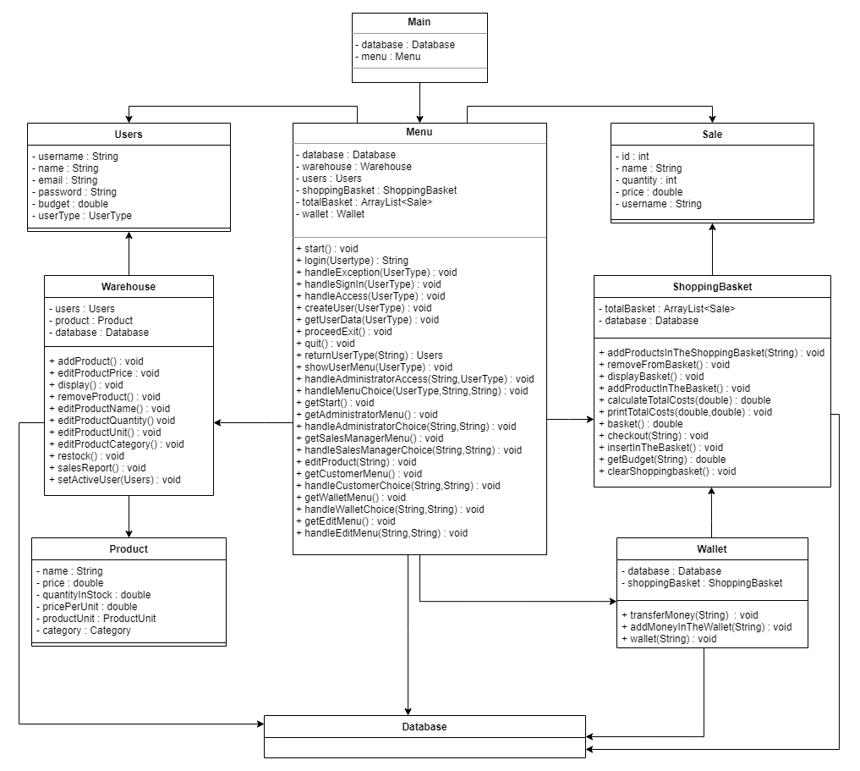

*UML diagram*

* 1. **Design and Implementation Constraints**

This project is developed with JavaFX using IntelliJ and MySQL as database management systems. Project language is only in English. Login and password is used for the identification of users. Only registered users will be authorized to use the services.

* 1. **Assumption Dependencies**

We assume that the Supermarket Management System application will be running on a properly working database system with an Internet connection that allows this system to perform all communications with clients.

Assumptions:

* The administrator account’s username and password will be hardcoded.
* There will be only one administrator.
* The sales manager account’s username and password may be hardcoded or created by the administrator.
* The administrator and sales manager cannot be a customer.
* Sales managers and customers cannot edit their account information.

1. **System Features and Requirements**
   1. **Functional Requirements**

Functional requirements are the primary requirements that are to be fulfilled by the application. Their fulfillment allows the user to use the application.

The functional requirements for the application are different for the different types of users. The Functional requirements are divided into the following three parts - administrator, sales manager, and customer functional requirements.

* + 1. **Administration Functional requirements**

The administrator will be able to do following functions:

* Log in in the system.
* Create new products.
* Edit products name/quantity/price/unit/category.
* Remove products.
* View information about all products.
* View sales report.
* View information about all users in the system.
* Create a new sales manager user.
* Log out from the system.
  + 1. **Sales Manager Functional requirements**

The sales manager will be able to do following functions:

* Log in in the system.
* Restock products by adding quantity.
* Edit products name/quantity/price/unit/category.
* Change product price.
* View all information about sales orders.
* View information about all products.
* View sales report.
* Log out from the system.
  + 1. **Customer Functional requirements**

The customer will be able to do following functions:

* Log in in the system.
* View balance.
* Withdraw money from the account.
* Deposit money in the account.
* View payments.
* Add product in the shopping basket.
* View shopping basket.
* Remove product from the shopping basket.
* Checkout.
* View order history.
* Log out from the system.
  1. **External Interface Requirements**
     1. **User Interface**

The user interface of this program is simply done with a mouse and on-screen buttons. The only requirement to use the user interface is the ability to read plain, non-technical English and the ability to use a mouse.

In the system, there will be various interfaces according to the user type. The common interface for all users will be the Login page as this appears firstly after launching an application.

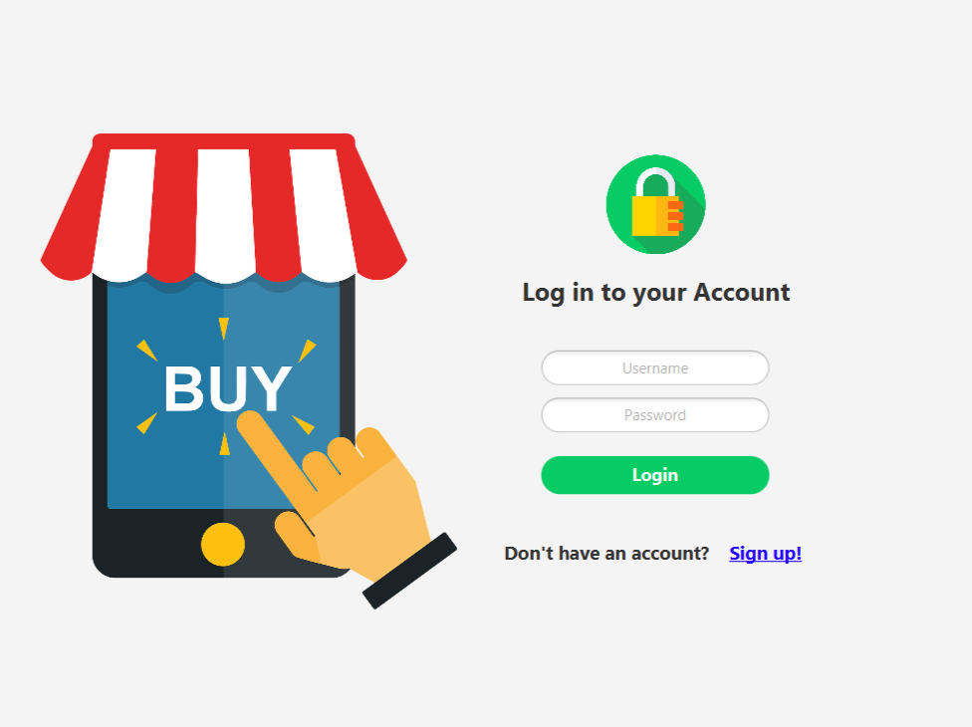

*Screenshot from the potential design of the Login page*

* + - 1. **Administrator Interface**

Administrator interface will have several buttons:

1. Create product:
   1. To create a product administrator must provide following information - product name, quantity, price, product unit and category.
   2. Information will be displayed in the table view.
2. Edit product:
   1. The administrator may choose to edit product name, quantity, price, product unit or category.
   2. Product may be removed.
3. View products:
   1. Information about all products will be displayed in the table view.
4. Sales reports:
   1. Information about reports summaries will be provided in the table view.
5. Users:
   1. Information about all users will be displayed in the table view.
   2. Administrator may create a sales manager, the administrator must provide the following information - username, password, name, email, user type.
6. Logout:
   1. If the user selects the Log out button then users will be logged out from the account and will be directed back to the Login page.

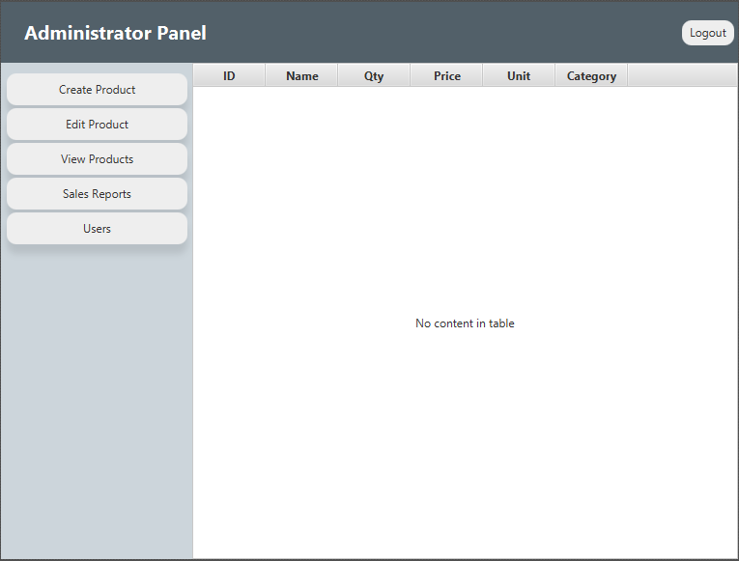

*Screenshot from the potential design of the administrator panel*

* + - 1. **Sales Manager Interface**

Sales manager users interface will have several buttons:

1. Restock products:
   1. Users must enter a quantity which will be added to the existing product quantity.
2. Edit product:
   1. users may choose to edit product name, quantity, price, product unit or category.
3. Price change:
   1. Users must enter a new price to change it.
4. View sales:
   1. Information about all orders will be provided in the table view.
5. Sales reports:
   1. Information about reports summaries will be provided in the table view.
6. View products:
   1. Information about all products will be displayed in the table view.
7. Logout:
   1. If the user selects the Log out button then users will be logged out from the account and will be directed back to the Login page.
      * 1. **Customer Interface**

The System provides various interfaces for customer users:

1. Login page:
   1. Users have to enter their username and password to access the system.
   2. In case users don’t have an account, they have to select a button to sign up.
   3. After successful credentials validation, users will be directed to the Supermarket page.
2. Sign up page:
   1. In case users press the sign-up button, they must fill the registration form and provide a username, password, name, email and budget to create a customer account.
   2. If some fields are left unfilled, the system will warn users about unfilled registration forms.
   3. Usernames are unique for the whole system. The system will display a warning message if the user enters an already taken username.
   4. To complete registration and create an account users must press the Sign in button.
   5. After successful account creation, the users will send back to the Login page.
3. Supermarket page:
   1. There will be a screen displaying all goods available for sale.
   2. Users must select the desired product, choose the quantity and select the button added to cart to insert the product in the shopping basket.
   3. If the users select the account button then another screen of the user account will be opened.
   4. If the users select the shopping basket button then another screen of the shopping basket will be opened.
   5. If the user selects the Log out button then users will be logged out from the account and will be directed back to the Login page.
4. Shopping basket:
   1. There will be a screen with all added products while using the supermarket page.
   2. Users can change the quantity and remove products from the shopping basket using buttons.
   3. If the user selects the checkout button another screen of billing information will be opened.
   4. To return back, users must select the return button.
5. User account:
   1. Users can withdraw money from the account by selecting the withdraw button.
   2. There will be displayed the user's current budget.
   3. Users can deposit money to the account by selecting the deposit button.
   4. Users can view payments by selecting the payments button.
   5. Users can view order history by selecting the history button.
   6. To return back, users must select the return button.
6. Checkout:
   1. There will be a displayed screen with order and payment details to proceed with the checkout.
   2. Will be provided billing information such as list of products, their quantities, price per unit and total amount, total amount with VAT and without VAT.
   3. If the user's balance is equal to or bigger than the total amount with VAT, payment will be accepted and the system will display order details.
   4. If users won’t have enough money in the balance, payment will be rejected and the order will be canceled.
   5. To return back, users must select the return button.

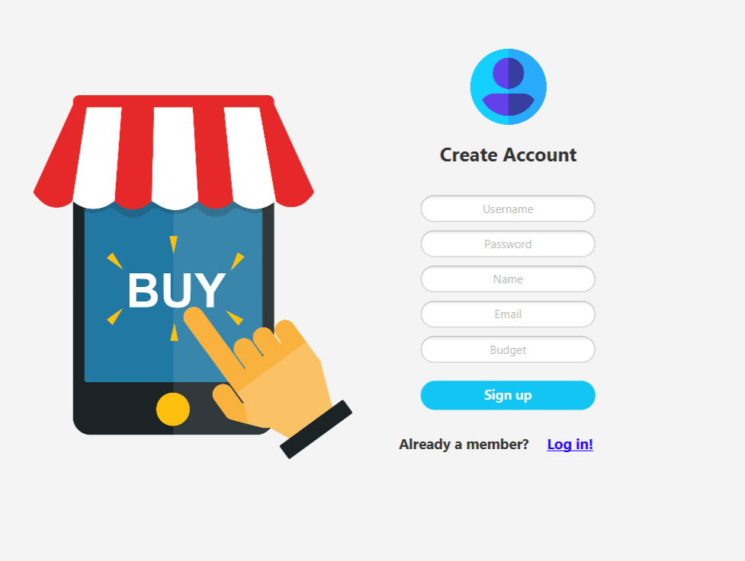

*Screenshot from the potential design of the Sign Up page*

* 1. **System Features**
     1. **Database management System perspective**

The system is based on a relational database with its store management and selling functions. The Supermarket database system stores the following information:

* Products - includes the information about goods availability along with the stock details, name, price per unit, product unit, and the category.
* Orders - it includes the information about customer name, order number, product information such as name and price, quantity. Information will be used for keeping the records of the customer orders for the purpose of statistics and history or for any other kind of information.
* Users - it includes username, password, name, email, budget, and user type. Information will be used for user verification and for the purpose of statistics and customer payments or for any other kind of information.
* Customer balance - it includes customer details, withdrawal or deposit amount along with bank account. This information will be used to store and overview all customer payments.
  + 1. **Database management System Features**

The major features of the supermarket database system as shown in the below entity-relationship model.

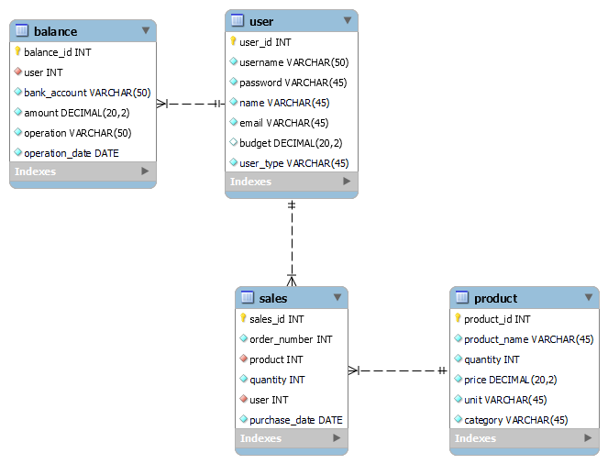

*ER diagram*