June 8, 2026
To: Mr. Al-Farham E. Sarabi
CEO/President
AmberCash Ph Micro Lending Corp.

Through: Helen Baliuag Macapas
Assistant Vice President
Main Office-Thread

Subject: Request for Certificate of Employment and 3 Months Pay slips

Greetings of peace,
I am writing to formally request a copy of my Certificate of Employment (COE) and my pay slips covering the last three months.
These documents are needed for buying a new motorcycle. Having these official records will help me complete the necessary process smoothly.
I would appreciate it if these documents could be released to me as soon as possible. Please let me know if there are any forms to fill out or additional requirements, I need to submit to process this request.
Thank you for your usual assistance and support.
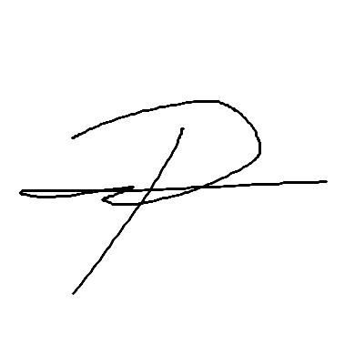
Respectfully yours,

EMMANUEL C. PONCE (001142)
Branch Manager
IT- Department

