June 22, 2026
To: Mr. Al-Farham E. Sarabi
CEO/President
AmberCash Ph Micro Lending Corp.

Through: Helen Baliuag Macapas
Assistant Vice President
Main Office-Thread

Subject: Request for Salary Advance – Motorcycle Purchase

Greetings,
I am writing to formally request a salary advance in the amount of Sixty-five thousand pesos (₱65,000.00). This amount will be used to purchase a motorcycle, which I intend to use primarily for my daily commute to work and for official work-related errands when required.
Having my own motorcycle will allow me to arrive at work on time, perform field assignments more efficiently, and respond promptly to urgent tasks. This will ultimately contribute to better productivity and reliability in my role.
I propose that this advance be deducted from my monthly salary, equal installments, starting from July 2026 until the full amount is fully settled. I am willing to sign an agreement or any required document to formalize this arrangement.
I appreciate your kind consideration of my request. I am happy to discuss this further or provide additional details if needed.
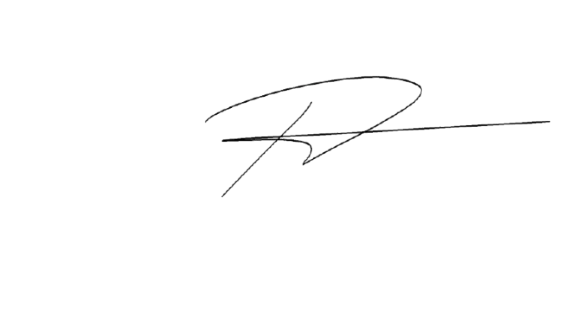
Thank you very much.
Respectfully yours,

EMMANUEL C. PONCE (001142)
Branch Manager
IT- Department



