BEEE LAB

LAB EVALUATION

REPORT

AIM:

To design a luminous intensity meter, such that when light falls on the LDR (Light Dependent Resistor) is sensed and displayed on the serial monitor when the switch is pressed.

COMPONETS USED:

1. Audriuno
2. Switch
3. LDR
4. Wires
5. Resistors

CODE:

int sensorValue=0;

void setup()

{

pinMode(12, OUTPUT);

Serial.begin(9600);

int reading = digitalRead(12);

}

void loop()

{

int reading = digitalRead(12);

if (reading ==HIGH)

{

digitalWrite(12,HIGH);

}

else

{

digitalWrite(12,LOW);

}

sensorValue= analogRead(A0);

Serial.println(sensorValue);

}

TINKERCAD VIEW

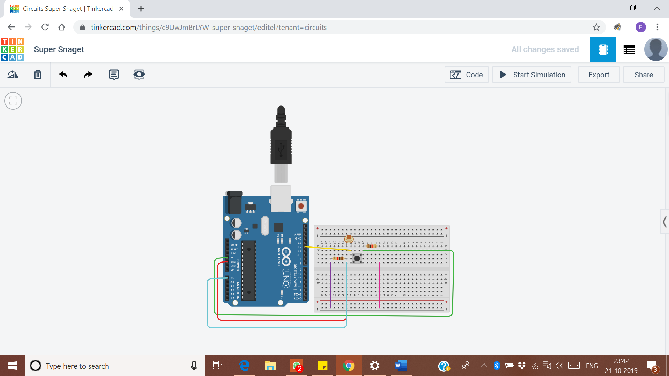

THEORY

CONCEPT:

Light intensity refers to the strength or amount of light produced by a specific lamp source. It is the measure of the wavelength- weighted power emitted by a light source

The major requirements were to properly know the components that we used, which includes  
1. LDR (Light dependent Resistor)

2. Arduino

Also, some basic components were used and there connecting concept were to be known like

1.switch

2. Breadboard (to know which pins are connected)

LEARNING AND OBSERVATIONS:

Learnings-

This project is a good way to learn the use of all the major components involved with making a circuit.

Also while experimenting (creating both the code and Circuit) I learnt that if in a circuit the wiring and the components are not correctly joint or intact with each other the result/ outcome would not be the desired one.

Observation-

The LDR responding to the light intensity being provided to it.

Problems and troubleshooting:

1.Loose connection of cables. - Rechecked them when the circuit didn’t work.

2.Loose connections of LDR device. - Rechecked

3.Error in programming or coding.

Precautions:

While unplugging the USB from the port pull the plug and not the cable.

Connections should be tight and according to the coding done on Arduino software.

Handle the apparatus like ARDUINO BOARD, LDR and breadboard carefully.

Learning Outcomes:

How to prepare report on the project made.

How to work on Tinkercad.

Working with Arduino.

Preparing code for the given task.