

University of Oklahoma

School of Aerospace and Mechanical Engineering

Spring 2025

AME 4832

Micro and Nanomaterials Laboratory

**Report #: 4**

**Title:** Mechanical Property Characterization of Epoxy and Nanocomposites

|  |  |  |  |
| --- | --- | --- | --- |
|  |  | **Author:** | Evan Blosser |
|  |  | **Submission Date:** | 03/12/2025 |
|  |  | **Lab partners:** | Bella Redd |
|  |  | Lawrence (Lance) Sisson |
|  |  | Ben Hews |
|  |  | Jackson Golden |
|  |  |  |

|  |
| --- |
| **The Integrity Pledge**  On my honor, I affirm that I have neither given nor received inappropriate aid in the completion of this exercise.  Name: Evan Blosser  Date: 03/12/2025 |

1. **Objectives**

This lab focuses on the Americans Society for Testing and Materials (ASTM) International’s testing for Reinforced Plastics and Electrical Insulating Materials Designation: D790 – 10 [1]. Pieces of previously manufactured carbon fiber, NEAT epoxy bars, as well as 0.5% & 1.0% Nanoclay bars were tested using the D790-10 to analyze their flexural properties.

1. **Background/Introduction**

The mechanical behavior varies from various types of composites and nanomaterials, as seen in the lab, these varying types show the differences within them being either ductile or brittle [2]. This along with the varying advantages of improved strength, stiffness, elongation, etc. there is numerous differences and subsequently applications for various composite and nanomaterials [3].

Nanoclay can be embedded in matrices like Epoxy to improve mechanical and barrier properties [4]. It is used as a low-cost fiber emerging on the current market for its versatility [4]. In fact, many polymers that it is used with gain increased mechanical and physical properties as the Nanoclay is a reinforcement agent [4]. As discussed in lecture, and during the manufacturing of these materials in the initial laboratories, processes can be refined to refine the material being manufactured. In both cases degassing for extended times can yield less air pockets within the epoxy that creates the matrix of the manufactured material. This along with thorough mixing, utilizing high end industrial manufacturing equipment like autoclaves, and any other process refinement could increase the fiber matrix bond while minimizing void creation.

1. **THEORY** 
   1. 3-Point Bending Test
      1. *Explain ASTM Standard*

This test utilized the following Instron 3345 with the 3-Point Bend attachments, as this machine also has 4-Point and a pull test setup. Utilizing the 3-point attachment pieces were placed within the apparatus one at time, allowing the middle point (cross head) to barely touch the surface of the sample bars before testing began.

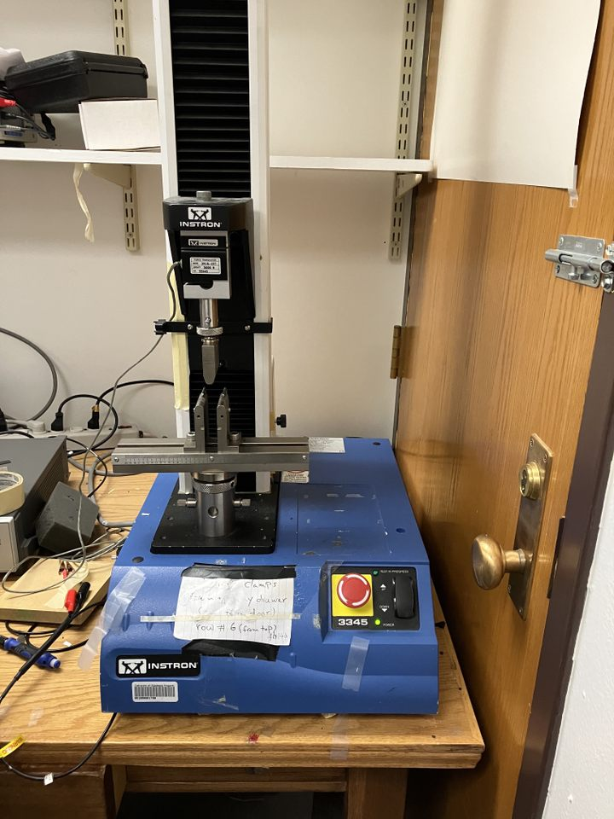

Not shown is the plexiglass shield that can also be placed over for any additional protection during the sample breaking process.

* + 1. *Sample Size Calculation*

The sample size was a total of 3 pieces for each of the bars to be tested, as discussed in the materials section later, these are Carbon Fiber, Nanoclay, and Neat epoxy bars. Defined in section 8 of the D790 testing the desired sample set was 5, yet for the purposes of testing the chosen 3 suffice [1]. Each set of samples consisted of 3 bars split into what will be referred to though this report as group 1, 2, and 3. Dimensions for this set of samples were set by the cutting instruction given by the D790 testing within section 7 [1].

* + 1. *Cross head speed calculation*

The rate of crosshead motion is calculated using the following formula:

where R is the crosshead motion in millimeters per minute. The terms L & d are the beams length and depth, or width, respectively. The rate of straining denoted by Z is the setting applied during testing. These values are reported below, after 3 initial calculations 1.3 mm/min was chosen after averaging. This excludes the carbon fiber as it needed a slower speed of 0.7 mm/min. solving the above equation as:

However, as the test specimens were not ideal, some exceeding set strain limits of section 10.1.17 of the D790 testing, the rate was increased to 0.1 mm/min for this laboratory.

* + 1. *Stress-strain Calculation*

The calculations performed for the stress and strain are as follows:

*Flexure Stress:*

*Flexure Strain:*

*Modulus of Elasticity:*

For lab calculations it was found that the units of stress as:

Whereas for strain: , it can be seen both have the millimeter dimension squared, thus canceling out and leaving this as a dimensionless parameter describing the strain through the stress. As the Flexural Modulus is defined as the slope as discussed in the laboratory lecture, noting that slope is rise over run defined for this application as (, the formulation holds that the Flexural Modulus is thus in MPa.

1. **Experimental/METHODOLOGY** 
   1. Materials

The Carbon Fiber & Nanoclay samples were created within the previous labs. The Carbon Fiber shown top left, Neat epoxy bottom left, 0.5% Nanoclay on the top right, and subsequently 1.0% Nanoclay on the bottom right.

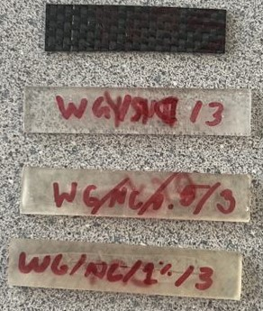

Below is a table listing their dimensions:

|  |  |  |  |  |  |  |  |  |
| --- | --- | --- | --- | --- | --- | --- | --- | --- |
| **Sample** | **Length (mm)** | **Thick (mm)** | **D (mm)** | **Support Span (mm)** | **Width (mm)** | **R (mm/min)** | **Selected R (mm/min)** | **L/d** |
| Neat Epoxy | 65.02 | 2.902 | 7 | 50 | 13.3 | 1.436 | 1.3 | 17.23 |
| Neat Epoxy | 64.55 | 3.48 | 7 | 50 | 13.81 | 1.197 | 1.3 | 14.368 |
| Neat Epoxy | 64.62 | 2.789 | 7 | 50 | 13.44 | 1.494 | 1.3 | 17.928 |
| Nanoclay (0.5%) | 65.08 | 2.295 | 7 | 50 | 13 | ... | 1.3 | 21.78 |
| Nanoclay (0.5%) | 65.03 | 2.641 | 7 | 50 | 13.37 | … | 1.3 | 18.932 |
| Nanoclay (0.5%) | 64.75 | 2.553 | 7 | 50 | 13.17 | … | 1.3 | 19.58 |
| Nanoclay (1.0%) | 64.18 | 2.77 | 7 | 50 | 12.51 | … | 1.3 | 18.051 |
| Nanoclay (1.0%) | 64.51 | 2.732 | 7 | 50 | 12.85 | … | 1.3 | 18.302 |
| Nanoclay (1.0%) | 64.8 | 2.816 | 7 | 50 | 12.99 | … | 1.3 | 17.755 |
| Carbon Fiber | 51.78 | 1.421 | 3.65 | 25.6 | 12.3 | … | 0.7 | 18.015 |
| Carbon Fiber | 51.78 | 1.602 | 3.65 | 25.6 | 12.27 | … | 0.7 | 15.98 |
| Carbon Fiber | 51.8 | 1.525 | 3.65 | 25.6 | 12.7 | … | 0.7 | 18.14 |

* 1. Methods

The methods used are outlined within the D790 Flexure Testing within section 10 [1]. This dictates what was described above with crosshead speed calculation along with the addition of section 10.1.6 which outlines the application of the Instron 3345 for loading the specimen and applying the load via the cross head.

* + 1. *3-point bending test (test parameters)*

From the table above the length is used to find the middle point of each, with the support span as 50 mm for the Nanoclay & Neat bars, and 25.6 mm for the Carbon Fiber, the crosshead speed was selected as described above as per section 10 of the d790 test [1].

1. **Results and Discussion**

This portion may divert in analysis, as the main group-3 samples were processed within Excel, using the standard format to create the graphs shown later. The creation of a (.csv) file handling and data processing Jupyter notebook coded in Python using the standard Pandas & SciPy packages for data handling and curve fit analysis respectively. Here there can be a further analysis conducted on the handling of the data streamlined versus performing analysis individually.

The following is the results of Python data processing, unfortunately the peak detection was not as accurate as it could have been given the time. However, this serves to provide a table of averages over the 12 total data files. It can be seen that the data for Group-3 Carbon Fiber (Dry) was not as accurate as it could have been. This was mitigated as Group-3’s data was reprocessed by hand as described within the laboratory lecture. The source code can be found at the following GitHub repository: <https://github.com/evan-a-blosser-1/AME4832-Lab-4> . Or clone the repository using the terminal command:

* git clone https://github.com/evan-a-blosser-1/AME4832-Lab-4.git

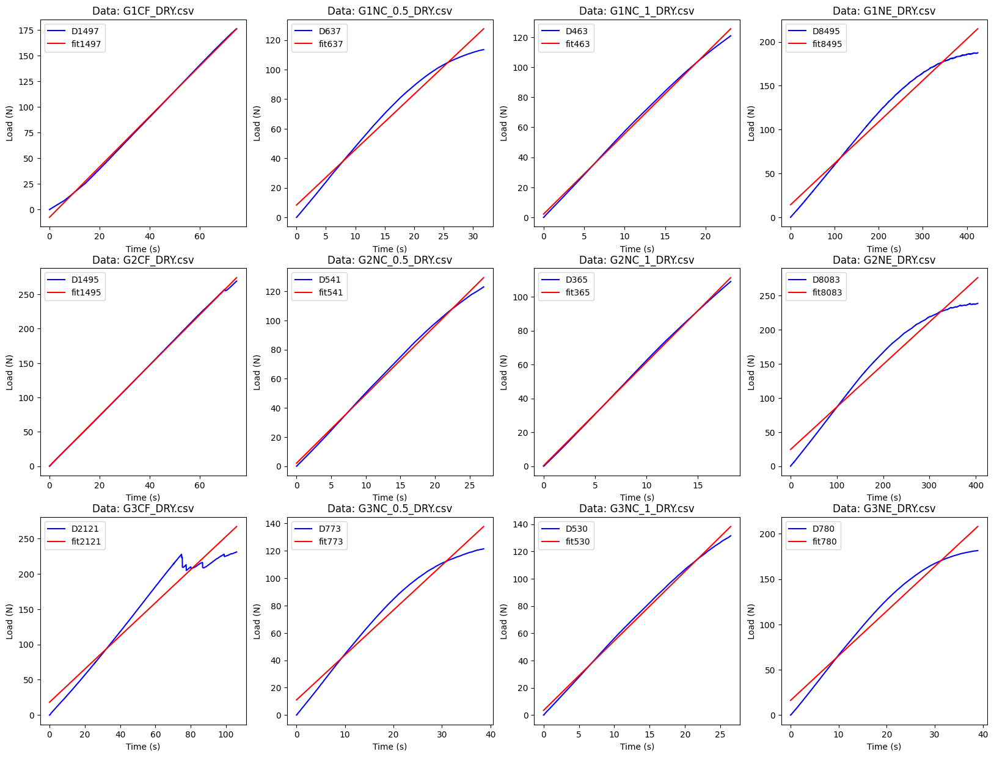**Results of PROCESSING_CENTER.py:**

The following table shows the results of both Excel and Python in analyzing the data for the Flexural modulus along with the stress and strain at break. The bottom of the table shows these averaged values, while noting a separation line for the python average initially and Excel average proceeding this.

|  |  |  |  |
| --- | --- | --- | --- |
| **File** | **Flex. Modulus (Mpa)** | **Stress (Mpa)** | **Strain** |
| G1CF_DRY.csv | 2.456079549 | 272.4657597 | 0.011363143 |
| G1NC_0.5_DRY.csv | 3.751351313 | 124.3601792 | 0.053082469 |
| G1NC_1_DRY.csv | 5.343510674 | 94.60456502 | 0.038584394 |
| G1NE_DRY.csv | 0.472251777 | 125.5646537 | 0.064096845 |
| G2CF_DRY.csv | 3.667426692 | 301.3223154 | 0.012787498 |
| G2NC_0.5_DRY.csv | 4.712460372 | 99.01872315 | 0.045080856 |
| G2NC_1_DRY.csv | 6.097667893 | 85.45652354 | 0.030416405 |
| G2NE_DRY.csv | 0.622939829 | 106.9725999 | 0.073134789 |
| G3CF_DRY.csv | 2.348114424 | 300.3244931 | 0.017277718 |
| G3NC_0.5_DRY.csv | 3.283397946 | 106.1715646 | 0.064416969 |
| G3NC_1_DRY.csv | 5.097333541 | 95.80722889 | 0.044166144 |
| G3NE_DRY.csv | 4.926580707 | 130.2517053 | 0.065000077 |
|  |  |  |  |
| Carbon Fiber Avg | 2.823873555 | 291.3708561 | 0.013809453 |
| NanoClay 0.5% Avg | 3.915736544 | 109.8501557 | 0.054193431 |
| NanoClay 1.0% Avg | 5.512837369 | 91.95610582 | 0.037722314 |
| Neat Avg | 2.007257438 | 120.929653 | 0.067410571 |
| **Excel Analysis** |  |  |  |
| G3CF_DRY.csv | 0.2003 | 296.0894 | 0.012186 |
| G3NC_0.5_DRY.csv | 0.1432 | 106.1686 | 0.064501 |
| G3NC_1_DRY.csv | 0.1859 | 95.80723 | 0.044166 |
| G3NE_DRY.csv | 0.1275 | 125.7123 | 0.086415 |
|  |  |  |  |
| Carbon Fiber Avg | 2.107935414 | 289.9591584 | 0.012112214 |
| NanoClay 0.5% Avg | 2.869003895 | 109.8491675 | 0.054221442 |
| NanoClay 1.0% Avg | 3.875692856 | 91.95610619 | 0.037722266 |
| Neat Avg | 0.407563869 | 119.4165179 | 0.074548878 |

As the discussion of accuracy arises, by examining the coefficient of determination, defined as within mathematical expression. This is the ratios of the sum of squared residuals RSS and the total sum of squares TSS, or ; however, this expression can take other forms it does define the accuracy of the linear regression [6]. It is shown below that the average of Python was almost a hundredth in accuracy over Excel. This was do to defining the curves within Excel at the exact point of break, thus the Neat epoxy had the least accurate best fit. This can be refined yet did give the Stress & Strain at break so it can be left at a pick your poison way of working analysis on accuracy.

|  |  |
| --- | --- |
| **File** | **Rsqr** |
| G1CF_DRY.csv | 0.998821319 |
| G1NC_0.5_DRY.csv | 0.975958044 |
| G1NC_1_DRY.csv | 0.997817168 |
| G1NE_DRY.csv | 0.96944205 |
| G2CF_DRY.csv | 0.999731341 |
| G2NC_0.5_DRY.csv | 0.996794219 |
| G2NC_1_DRY.csv | 0.999360164 |
| G2NE_DRY.csv | 0.957305506 |
| G3CF_DRY.csv | 0.942968238 |
| G3NC_0.5_DRY.csv | 0.967376274 |
| G3NC_1_DRY.csv | 0.996253831 |
| G3NE_DRY.csv | 0.965342738 |
|  |  |
| Python Average | 0.980597574 |
|  |  |
| G3CF_DRY.csv | 0.9995 |
| G3NC_0.5_DRY.csv | 0.967 |
| G3NC_1_DRY.csv | 0.9964 |
| G3NE_DRY.csv | 0.8688 |
|  |  |
| Group-3 Python Avg. | 0.96798527 |
| Group-3 Excel Avg. | 0.957925 |

The results for stress and strain at break show that the 0.5% Nanoclay is closer to the optimal mixture ratio as the 1.0% mixture bars lead to a poor stress result. Examining the breaks we see the Neat epoxy and Nanoclay had clean breaks in the middle, with the 0.5% Nanoclay having a triple break. This could indicate the brittleness of the Epoxy with the addition of the Nanoclay as fiber reinforcement to the matrix. The Carbon Fiber yielding and broke during the test, yet did not shatter as the other test specimens. Most likely owing to the weave fiber’s strength as the epoxy matrix yielded first. As discussed in the first days of lecture this is to be expected as the matrix or epoxy would define the strength characteristics of the embedded fibers. The Carbon Fiber also showed the highest strength parameters during testing as expected. Showing the validity of the strength, the carbon fibers added to the epoxy, which was used to form the Neat epoxy defined as the control for testing. This control shows both the strength that Carbon fiber provides, as well as the mixture ratio necessary to properly create Nanoclay from the initial Neat epoxy while maximizing the strength.

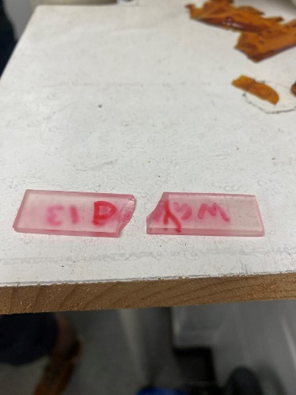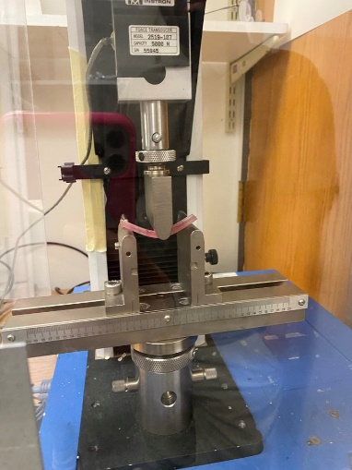

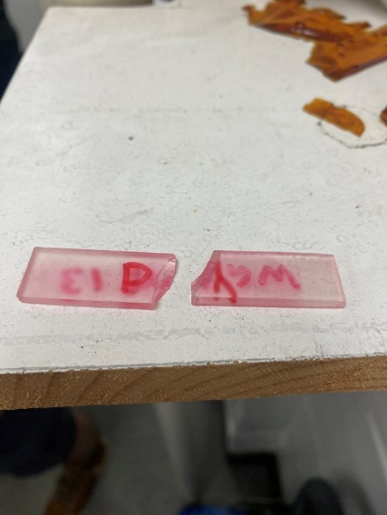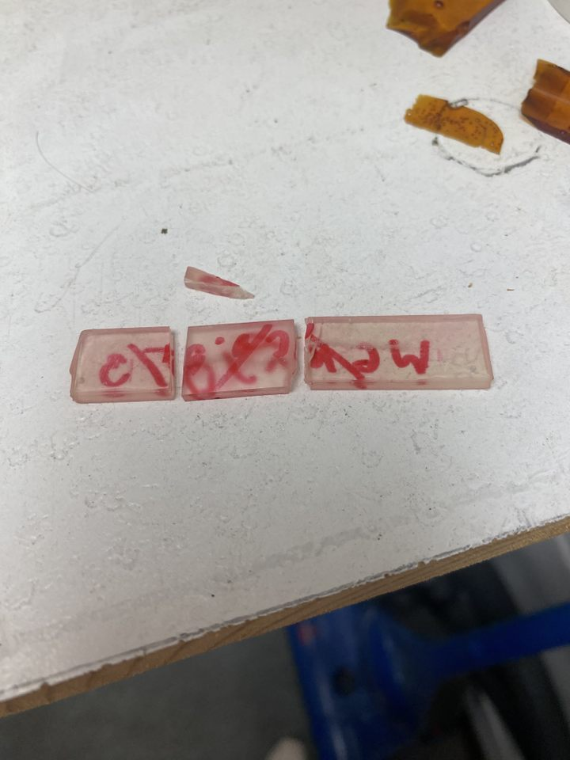

Below is the Carbon Fiber:

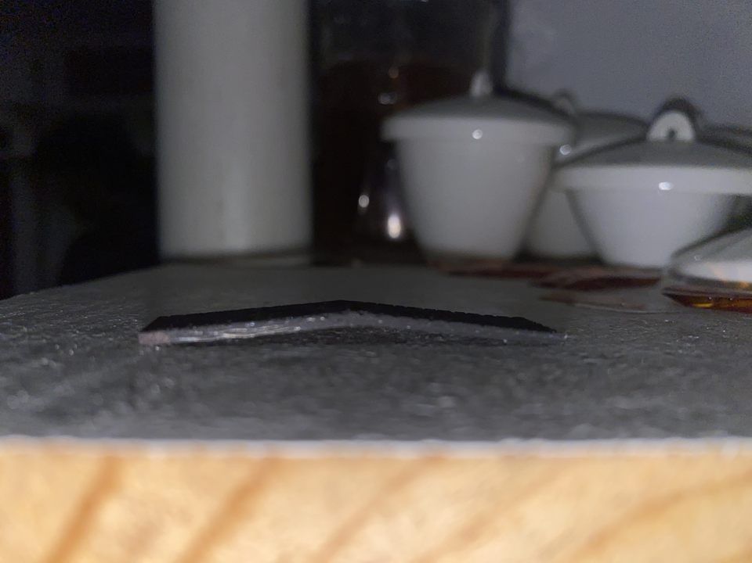

1. **Conclusion**

This laboratory defined the D790 Flexural testing for previously manufactured pieces of Carbon Fiber, Nanoclay, and Neat epoxy. The results show that the Nanoclay acts as a viable filler, reducing strength of the initial Neat epoxy matrix by a small margin. Thus, as described by literature does act as a new low-cost fiber. As also shown the mixture ratio of Nanoclay is crucial as the 1.0% seemed to lessen the strength of the manufactured material. Thus, optimizing this mixture ratio would allow for optimal strength parameters for the Nanoclay.

It can also be noted that as expected the Carbon Fiber had an immense pressure being applied to it before break, resulting in substantial stress and strain at break values. At approximately 290 MPa as compared to the 90-120 MPa range of the Nanoclay and Neat epoxy. Showing the viability of the manufactured Carbon Fiber.

1. **References**

**[1] ASTM-D790-10_Flexure Testing**

**[2] Difference Between Brittle and Ductile Materials – Their Examples** [**https://mechanicalbasics.com/difference-between-brittle-and-ductile-materials/**](https://mechanicalbasics.com/difference-between-brittle-and-ductile-materials/)

**[3]** **Nanocomposites_Lecture**

**[4] M. N. Uddin, M. T. Hossain, N. Mahmud, S. Alam, M. Jobaer, S. I. Mahedi, and A. Ali, “Research and applications of nanoclays: A review,” SPE Polymers, vol. 5, pp. 507–535, July 2024**

**[5] Lab_2_Nanoclay_Calculations**

**[6] Coefficiant of Determination “https://www.scribbr.com/statistics/coefficient-of-determination/”**