**Context**

The number of website hits appears generally to increase over time. I removed three outliers (circled below in the graph below left) because were significantly higher than any of the neighboring data points. The graph below right depicts the percent change in website hits from the previous period rather than the raw numbers.

 

**Tests for Presence of Unit Roots**

I next tested for the presence of unit roots to determine whether the raw number of website hits or the percentage change was more appropriate for the model. Both the Dickey-Fuller and Phillips-Perron tests indicate there are no unit roots present (p < 0.0001). I therefore used the raw data rather than the percent change in web hits I calculated.

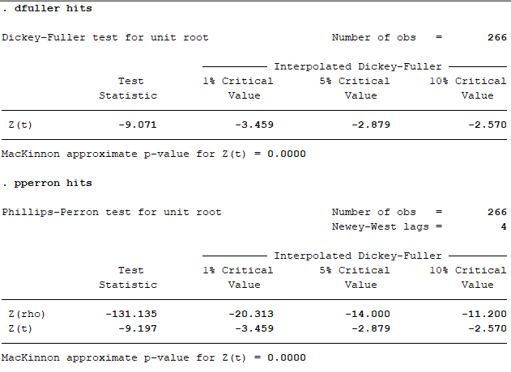

**Model Results**

I found that an ARIMA(1, 0, 1) model best fit the data. As noted in the table below, all coefficients are significant, and this model had the highest log likelihood of the models I tested and returned the lowest AIC and BIC values.

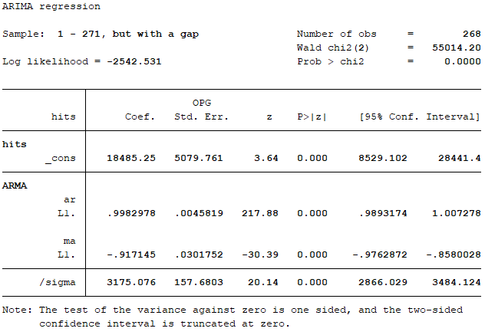

I tried other models with a stochastic trend, without a moving average filter, and adding additional autoregressive lags. All models without a moving average component exhibited autocorrelation in the lags, even with the presence of a stochastic filter. Models with moving average filters above 1 also resulted in the model no longer being significant.

**Model Specification Tests**

The correlogram of autocorrelations and partial autocorrelations correlogram indicated that the autocorrelations in the lags of the residuals were not significant and fell entirely within the bounds of the 95 percent confidence interval. It is worth noting that some lagged residuals above 15 showed significant autocorrelation, though I dismissed these as random. The graphs on the following page illustrate that these autocorrelations are consistent with a well-specified model.

 

Other tests of the residuals are also consistent with an appropriately specified model. The residuals have a mean of 0 (see graph below left), a Durbin-Watson statistic of 1.88, and it passed both the Shapiro-Wilk and Skewness/Kurtosis tests for normality (p > 0.2 and p > 0.15, respectively). The graph below right also illustrates that the residuals appear to follow a normal distribution.

 

Finally, I tested the forecast accuracy of each model by computing the mean forecast error and mean absolute deviation. The ARIMA(1, 0, 1) model had the highest forecast accuracy of all those tested.

