2026 Long Pond Monitoring Report
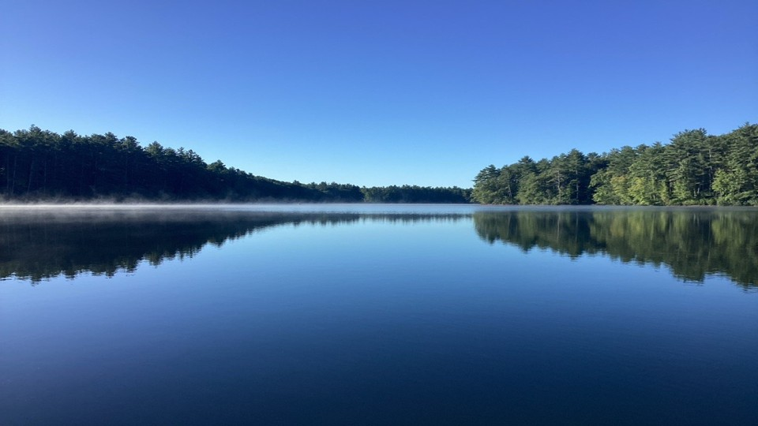
DCR-DWSP Environmental Quality Section, Quabbin/Ware Region
October 2026

Site description
Long Pond is an oligotrophic, dimictic water body that experiences winter ice cover, spring and fall turnover, and limited stratification during both summer and winter. Located in Rutland, Massachusetts (71°58’45” W, 42°26’55” N), the 177-acre pond comprises three basins of varying sizes and depths connected by culverts (Figure 1). The lower basin, the subject of monitoring for the purposes of this report, covers approximately 81.6 acres. The area surrounding Long Pond is owned by MA Department of Conservation and Recreation (DCR), the Commonwealth of Massachusetts, and the town of Rutland. The area is comprised primarily of vacant wooded land. The western edge of the water body is bound by the Midstate Trail, a scenic footpath open to the public year-round.
Recreational use of the waterbody is restricted to shore fishing and boating, though boats using motors greater than 25 horsepower are required to be permitted and may only operate from the last Monday of May (Memorial Day) to September 30th. Swimming is not permitted.
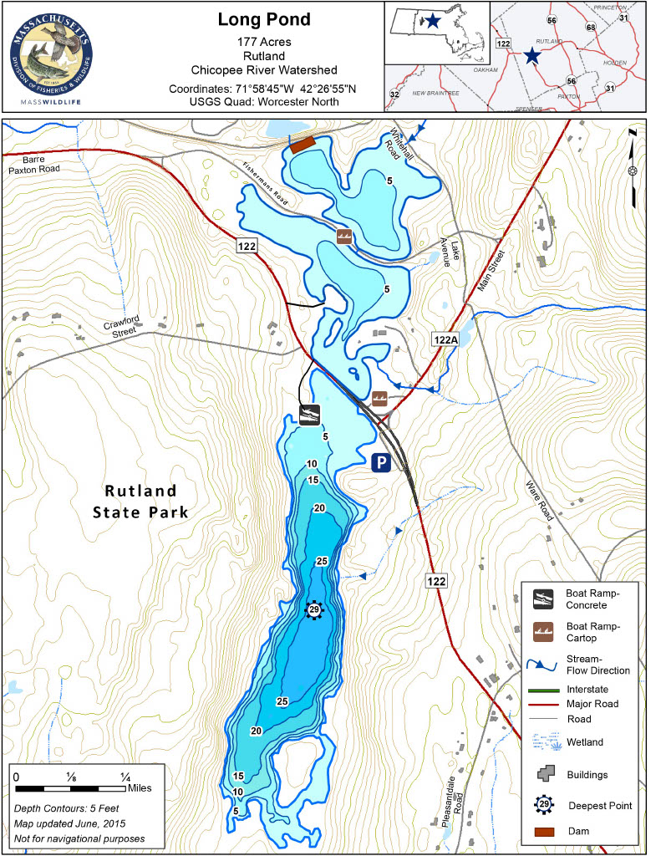
Figure 1. Contour/bathymetry map of Long Pond and surrounding area.

Methods

Monitoring description/Objectives
The objective for this collaborative monitoring effort across Environmental Quality and Ranger staff section was to establish a comprehensive picture of water quality within Long Pond and the potential impacts of recreation in the waterbody. The southernmost basin was the primary subject of monitoring activities in the 2026 season. Monitoring was led by Environmental Quality Section Aquatic Biology staff in partnership with DWSP Ware River Ranger staff who provided boat operations and logistical support. In 2026, monitoring was performed over four dates – once per month in the period of June through September. Monitoring activities included field notes of site and weather conditions, collection of water quality profiles using a YSI EXO 2 sonde at two sites within the lower basin, as well as inspecting and photographing five shoreline sites designated as vulnerable to erosion (Figure 2). Recreational uses were monitored by Ware River Ranger staff during routine site inspections and documented within ranger record keeping workflows.
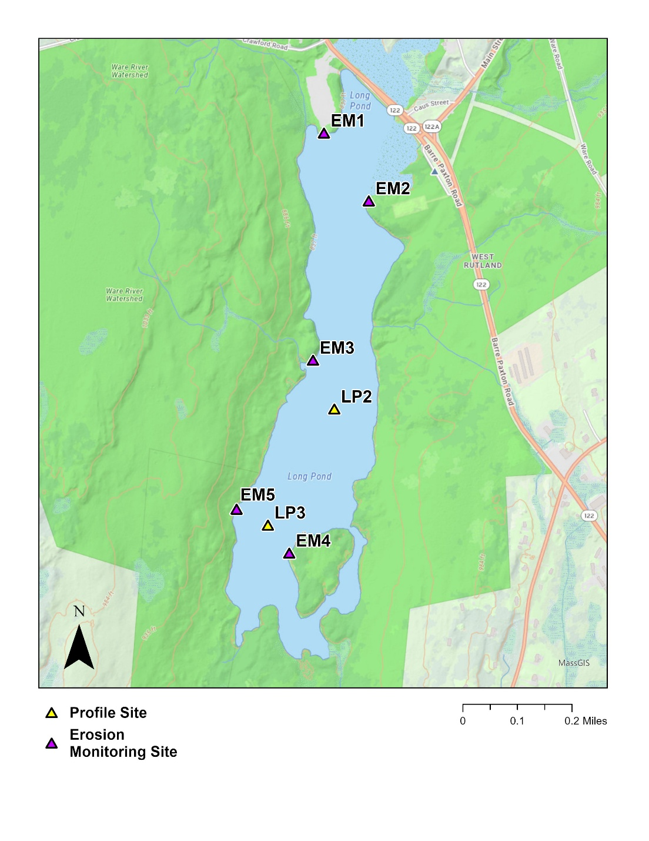

Figure 2. Map of DWSP Long Pond Monitoring Sites. Depicts sites for water quality profiling and erosion monitoring, designated and enumerated as LP2, LP3, and EM1-5 respectively. Map layout was created by Michael Virgillio.

Water Quality Profiles
Water quality profiles were collected at 0.5m intervals down to a depth of 1m above the maximum depth at the three sites. Maximum depth was estimated using a Humminbird-brand sonar depth finder device present on the boat used for sampling. A weighted surveying tape was used as an additional check for max depth. All sensors on the multiparameter sonde used for depth profile collection were recalibrated after each visit to the site within the monitoring period.

Aquatic Invasive Species Survey
Entire littoral zone visual meandering (no set survey point) surveys are conducted in teams of two or greater, each person canvasing opposite shoreline littoral zones via kayaks. GPS points are collected primarily for AIS using an iPad and ESRI applications QuickCapture and FieldMaps, but native species points may be collected as time allows. Data collected through these applications (in addition to GPS location) include: pictures (optional), species, biovolume (scale of 1-4), and density (single/trace/sparse/moderate/dense). A BadElf GPS tracker is also utilized to collect survey tracks for each surveyor. Specimens may be collected if ID in field proves difficult, or if a particular specimen is in good shape to add to the EQ herbarium (epoxy or pressed collections).

Results

Recreational Use
Overall counts and monitoring by Ware River rangers were increased for 2026. Motorboat use across most categories was highest in the months of June and July, suggesting an earlier shift from peak use during July and August the previous year. Boats with small motors and cartop boats continued to be the most observed during the survey period. Participation in the self-certify program for both cartop boats (~48% vs ~21%) and trailered boats (~72% vs ~55%) rose significantly compared to the previous year, likely resulting from changes in form language and the increased ranger presence at the site. Large motorboats comprise ~21% of motorized boats documented (66/315 boats). Of the vessels requiring permits, ~9% were found to be operating without permits during the monitoring period.
Table 1. Reported boat use on Long Pond during the monitoring period (source: DWSP Ware River Rangers inspection logs)

Aquatic Invasive Species
Long Pond contains several populations of invasive plant species (hereafter referred to as AIS) within the water column and along the shoreline. AIS surveys have been performed by DWSP-Quabbin Environmental Quality staff annually since 2010 and 2014 for the lower basin and upper basins respectively, excluding 2019 and 2020. The upper basin was also not surveyed in 2023 and 2025 due to time and staffing constraints. The 2025 survey noted the presence of fanwort (Cabomba caroliniana), variable-leaf milfoil (Myriophyllum heterophyllum), common reed (Phragmites australis), purple loosestrife (Lythrum salicaria), and Chinese mystery snail (Cipangopaludina chinensis) (Appendix Figure 7). Historically, swollen bladderwort (Utricularia inflata), and true forget-me-not (Myosodis scorpiodes) were also observed within these two basins, but they have not been observed within the past few years (Table 2a & 2b). Of note in the 2025 season, fanwort was the most widespread AIS within the lower basin, present in all but the deepest points. Considering this plant was first observed here in 2021, its expansion has been explosive – most likely a result of boat props fragmenting the plants, from which new populations can become established. As a result of this widespread and dense coverage, adverse effects on native macrophyte community composition, fauna, and water quality parameters are likely but require more research to determine trends.

Table 2a & 2b: AIS and date of first observation for the Upper Basin (top table) and Main Basin (bottom table) of Long Pond. Data has been sorted by first observation date.
2a: Long Pond – Upper Basin
AIS | First Obs. Date
Variable-leaf Milfoil | 08/13/2010
Purple Loosestrife | 08/19/2013
True Forget-me-not | 07/27/2015
Common Reed | 09/07/2018
Fanwort | 08/15/2024

2b: Long Pond – Lower Basin
AIS | First Obs. Date
Variable-leaf Milfoil | 08/13/2010
Purple Loosestrife | 08/19/2013
True Forget-me-not | 07/23/2014
Chinese Mystery Snail | 06/17/2016
Swollen Bladderwort | 09/28/2017
Common Reed | 09/07/2018
Fanwort | 08/06/2021

Water Quality Data Summary
Water quality results varied by depth and season, but overall little variability was observed across the three profile collection sites. During the monitoring period, the mean temperature and dissolved oxygen across sites in Long Pond were 24.22 °C and 7.33 mg/L, respectively (Table 3). 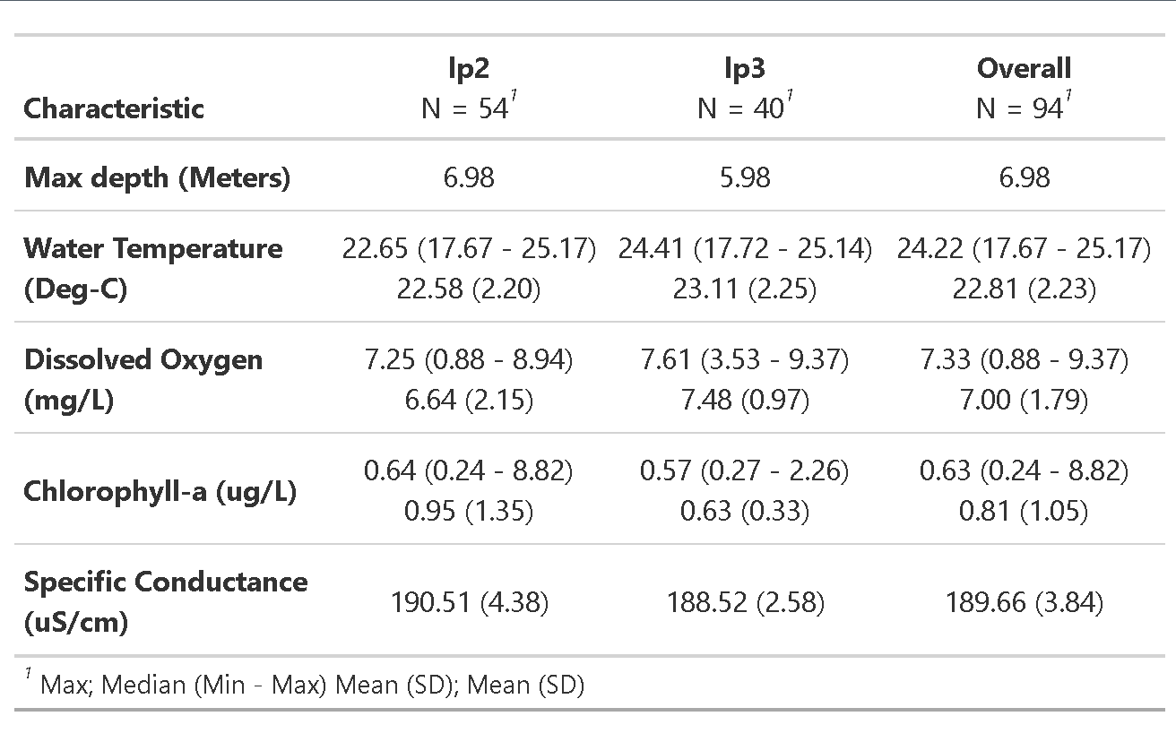
Table 3. Summary statistics of measured parameters across the sites surveyed. Water temperature, dissolved oxygen, and Chlorophyll-a are summarized using median, minimum, and maximum values in the top row, with mean and standard deviation provided in the bottom. Due to low variability, specific conductance is reported only as mean and standard deviation.
Water temperatures were highest across sites in August, reaching a maximum of 25.17°C (Figure 3). All monitored sites exhibited a defined thermocline in the monitoring period.
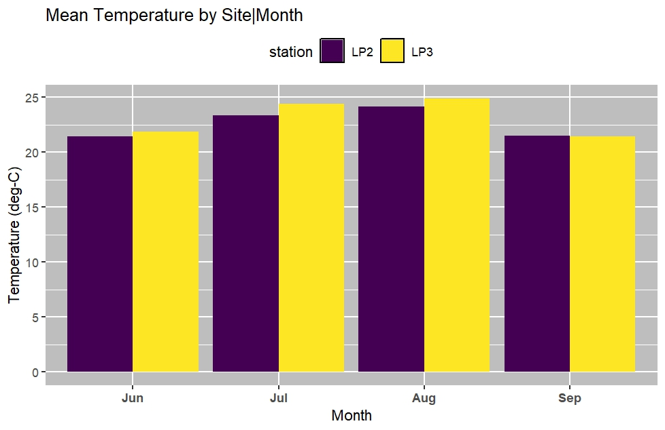
Figure 3. Mean temperatures by site and month.
Mean concentrations of dissolved oxygen were lowest in July and August across all sites. This is an expected seasonal pattern coinciding with increased temperatures within the water column (Figure 4). Mean dissolved oxygen concentrations at site LP2 were below the 6 mg/L reference for the months of July and August.
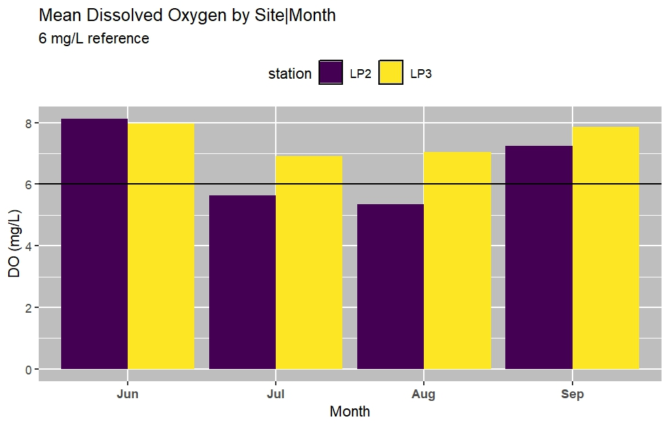
Figure 4. Mean dissolved oxygen by site and month. Reference line of 6mg/L indicates the minimum mean DO concentration for supporting warm-water fish according to EPA guidelines (EPA, 2021).
Aggregated chlorophyll-a values across the sampling period were lowest overall at site LP3 and highest at site LP2. Elevated mean chlorophyll-a values during June and July may be attributed to increased growth of aquatic plants and algal communities (Figure 5).
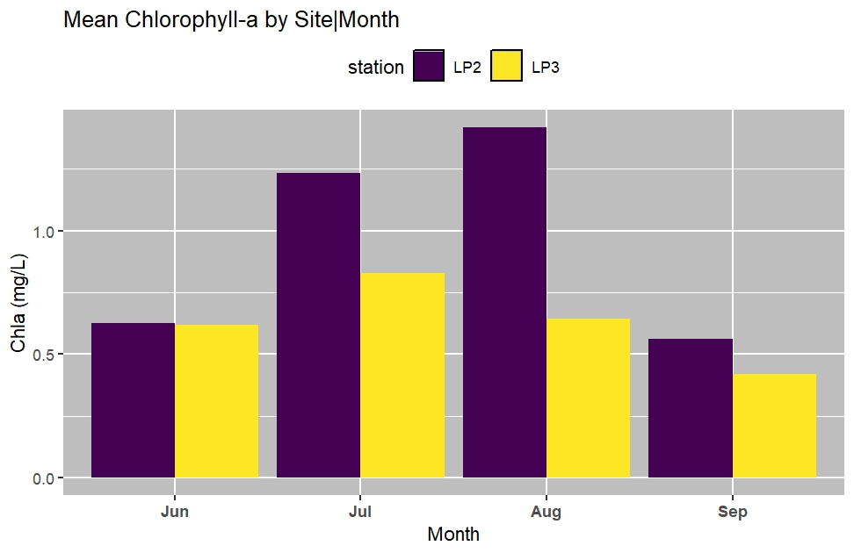
Figure 5. Mean Chlorophyll-a by site and month.

Discussion
The lower basin of Long Pond exhibited temperature and dissolved oxygen patterns characteristic of dimictic lakes, with peak temperatures in July and August and corresponding decreases in dissolved oxygen due to warmer water.
In contrast, chlorophyll-a exhibited greater variability both within sites and throughout the sampling season. As expected, concentrations increased in June and July with warmer water temperatures. However, levels declined unexpectedly at site LP3 in August. LP2 consistently showed higher concentrations than the other locations, potentially due to dense macrophyte growth in this area that may have affected the sensor readings.
No identifiable changes were detected during erosion monitoring in 2026. Continued monitoring may be warranted to assess the potential impact of high-horsepower boats on shoreline erosion.

Appendix
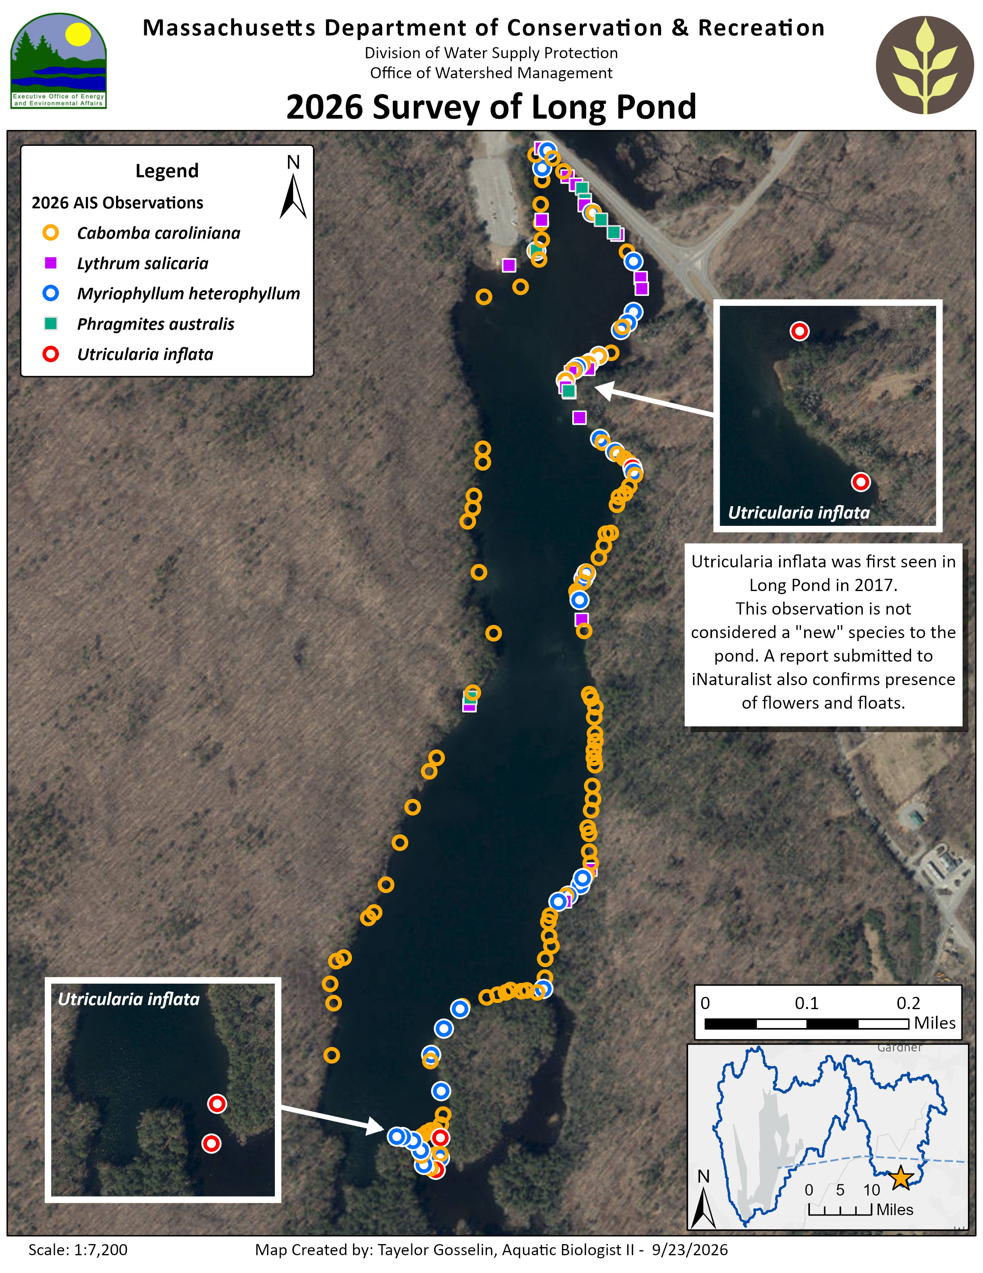
Figure 7. Points depicting GPS locations of different aquatic invasive species observed in Long Pond during the DWSP-Quabbin EQ survey on August, 20th 2026.

