Analysis of the Earth’s Supply of Crude Oil
MATH 222 – Introduction to Dynamical Systems

Written by: Evan Scheuermann
Research Partners: Lucy Haynes and Jake Scheidelman
March 8, 2026

Table of Contents
Table of Contents 2
Defining the Problem 3
Part One: Preliminary Analysis 4
Part Two: Refining the Model 5
Crude Oil Reserves and Refinement 5
Variability in Fuel Efficiency 7
Variability in Total Vehicles and Nuances in Types 8
Part Three: Combining the Models 12
Part Four: Further Refinement 16
Conclusion 17
Group Evaluation 18
Appendix 19
References 20

Defining the Problem
Crude oil is arguably one of the most important natural resources in modern times. It has fueled innovation and economic growth for centuries and now is used in a wide variety of applications. From cosmetic supplies to plastic to nylon to gasoline, this substance is incredibly versatile. Our society has become increasingly reliant on petroleum, but given its finite nature it is crucial that we know how long it will last.
Between issues with pinpointing the exact supply of crude oil and the highly dynamic nature of its consumption, determining its lifespan is quite difficult. Thus, implementing a mathematical model will help account for the relevant factors as they change over time, ultimately leading to a reasonable estimation of its lifespan. We will be forced to make assumptions to create this model, but by taking care in such we can minimize the error that ensues.
Determining how long the Earth’s crude oil will last has two major components. First, estimating the total supply available for use, and second, modeling consumption of this resource over time. Although there are fairly accurate estimations of how much crude oil exists, these numbers are still subject to quite a bit of error. Furthermore, the development of international politics and other socioeconomic issues over time may get in the way of being able to fully utilize this resource, and the impact of these factors is especially hard to predict. Regarding consumption, dynamic modeling techniques will be used to account for changes in trends over time. This should address issues including, but not limited to, increased popularity of electric vehicles, improvements in fuel efficiency, popularity of public transportation, changes in transportation needs, and more. Accounting for the plethora of factors that affect crude oil’s lifespan and making the right assumptions, so that error is minimal, are the key aspects in creating an accurate model of this resource.

Part One: Preliminary Analysis
Given the complexity of this problem, an initial rough estimate will serve as a starting point before creating a detailed model. In doing so, we will assume that:
- The volume of the Earth’s crust represents the total supply of crude oil
  - The volume, assuming Earth is perfectly spherical, can be obtained using the average thickness of the crust (17.5 km) and an estimate of the Earth’s diameter (12,750 km) (Wikipedia Contributors, 2020; USGS, 2019)
- Crude oil is purely used for automotive gasoline (with a 40% conversion rate) (Freudenrich, 2001)
- Vehicles only use gasoline as their fuel source
- The number of vehicles on Earth right now (~1.645 billion) will remain constant (Hedges, 2025)
- Vehicles drive 10,000 miles per year
- All vehicles have fuel efficiency of 25 miles per gallon
These assumptions are awfully naïve. Assuming that the whole planet’s crust is made of oil and that it can be extracted entirely are among several of these claims that are dangerously strong. In addition, most of these figures have been rounded significantly, which will generate even more error in the calculations. Thus, this preliminary estimation will contain a significant error term.
The calculations begin with estimating the volume of the Earth’s crust. Once this figure is defined and converted to barrels, we determine how many gallons of gasoline each barrel of oil will yield after refinement, resulting in the total number of gallons of gasoline available for use. After that, we estimate how many gallons of gasoline are used per year by multiplying the number of vehicles by the amount of distance driven per vehicle per year and then dividing by fuel efficiency. Finally, dividing the total number of gallons of gasoline by the yearly consumption of gas produces the initial estimation: approximately 1,431,319,316.93 years (~1.43 billion) (see Appendix, Figure 1). This figure is surprisingly large considering that, even without acknowledging the damaging effects of natural gas consumption on the environment, it is arguable that the Earth may no longer be inhabitable after that amount of time (Wikipedia Contributors, 2019).
The predicted longevity of the supply of oil is largely due to the erroneous assumption about the Earth’s crust. This is a gross overestimate of how much oil exists and is available for refinement. Although some of our other assumptions are fighting against overestimation, like every vehicle running solely on gas for the rest of time, the claim about the available supply of oil is likely far more impactful on the estimation than the forces in the other direction. Thus, we expect that, in refining our model, the predicted lifespan of crude oil will decrease dramatically in comparison to this initial estimation.

Part Two: Refining the Model
Given the preliminary analysis of the problem, we can now address the assumptions made in part one. The three major aspects that first demand improvement are the estimation of available crude oil and how much gasoline it yields, the lack of consideration for variable fuel efficiency, especially over time, and how many cars and other vehicles there are, also in relation to time. The first part of this section will refine the prediction of total gasoline available for consumption. Considering how the Earth’s crust is very far from being purely made up of crude oil, we expect that refining the estimation will lead to a drastic decrease in the lifespan of crude oil, perhaps by an entire order of magnitude. The second part of this section will allow us to account for variable fuel efficiency. Given the increasing popularity of electric vehicles and constantly improving fuel efficiency of gas-powered vehicles, we expect refining this aspect will have a lengthening effect on the lifespan of crude oil. Finally, the third section will address the assumption that there is a constant number of only gas-powered vehicles. This section will model how different types of vehicles become more or less popular over time and how trends in public transportation may vary with time, especially as the world population continues to grow. We expect the improvements made in this section to lengthen the estimated lifespan of crude oil too, as the assumption made in part one did not account for the increasing popularity of electric vehicles, among other things.

Crude Oil Reserves and Refinement
The assumption made in part one regarding the supply of oil is a gross overestimate but also fails to acknowledge other nuances pertaining to recovery and refinement. The best estimates available today predict that there was approximately 6 trillion barrels of total oil existent in the Earth’s crust (Oil and Gas Reserves, 2025). Of that, only about half of this is recoverable, which is split in half again due to the refinement process for gasoline. This number is further reduced considering the substantial amount of oil that has already been consumed, about 1.3 trillion barrels (Geiger, 2019). The effect of these reductions is displayed below in figure 1.
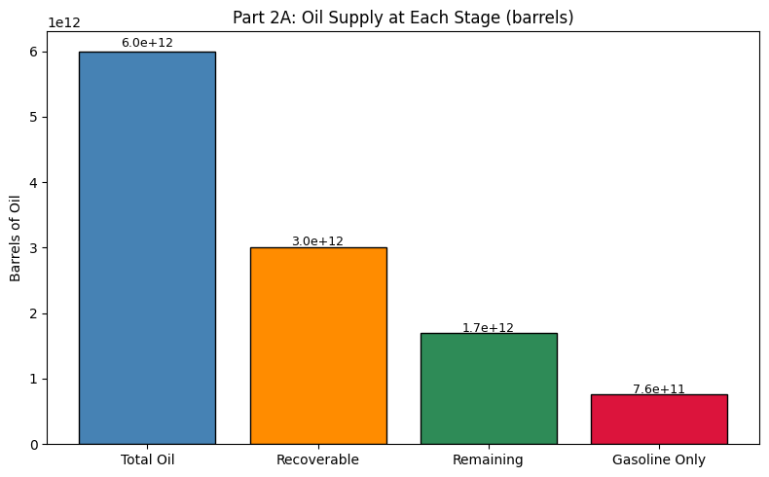
Figure 1: Total Barrels of Oil and Gas at Each Stage
Converted to gallons, our new estimate of total gasoline remaining today is about 32 trillion gallons (see Appendix, Figure 2). This is an astonishing difference from the original prediction, which estimated total gallons of gasoline available to be about $9.42×{10}^{20}$ gallons. This decrease of seven orders of magnitude is far greater than we had hypothesized and makes a massive difference on the lifespan of oil. Given the rate of consumption predicted in part one, implementing this new estimate of oil reserves leaves us with only ~55.55 remaining years of oil use. Assuming nonnegligible oil consumption began sometime in the late 19th century, this would imply that the total lifespan of crude oil is just two centuries. In comparison to the original prediction (~1.43 billion years), this improvement has made an enormous impact on our estimation.
Though the total supply of oil reserves has been significantly improved, it still makes some assumptions and thus, still contains some degree of error. Most importantly, the estimations of total crude oil are based on what we know about the Earth, but this information is not exhaustive and may be faulty. The recoverability factor, determined by physical, economic, and technological constraints, may also be incorrect. Improvements in these areas in the future may yield a greater amount of recoverable oil, which would have a noticeable impact on the overall estimate. Furthermore, since the amount of oil previously consumed is also an estimation, the error contained in that term will inherently show up in our predictions as a result. Despite the effects of each of these assumptions, our improved estimate of oil reserves will serve as a significantly more accurate basis for the rest of the model.

Variability in Fuel Efficiency
In part one, we assumed that every vehicle drove 10,000 miles per year and that they all had the same fuel efficiency of 25 mpg. This is far from reality and fails to recognize the enormous variation that truly exists. To improve upon this assumption, we split the total number of vehicles into seven distinct categories being SUVs, semi-trucks, transit buses, motorcycles, cars, pickup trucks, and electric/hybrid vehicles. These categories each contain much less variation in fuel efficiency and yearly mileage than compared to before, which will improve the overall accuracy of predicted gas consumption over time. In addition, this section models the change in fuel efficiency over time for each of the categories, as new technology continues to improve efficiency for most of these vehicles, but at varying rates. The model of changing fuel efficiency by category is shown below in figure 2.
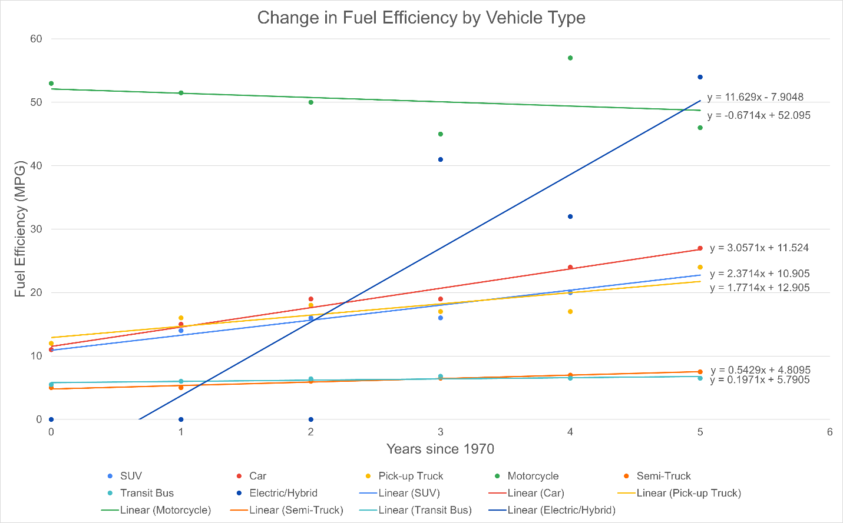
Figure 2: Change in Fuel Efficiency by Vehicle Type Over Time
This chart displays vastly different fuel efficiency between categories, as well as the overall improvements over time. Although the relationships seen on the graph seem to be represented well using linear regression, it is unrealistic that fuel efficiency will continue to improve at a constant rate; that is, linear growth becomes increasingly unrealistic as time goes on since fuel efficiency is bounded by physical limitations. Regardless, applying the dynamic fuel efficiency model to our total gas estimate from part one, we get a new estimated lifespan of about 5.7 billion years. This agrees with the hypothesis that modeling fuel efficiency would increase the total lifespan of crude oil.
As mentioned, fuel efficiency cannot grow linearly. This assumption causes fuel efficiency to get very high in the future, meaning that gas consumption will approach zero, which is unrealistic. Although, this model also assumes that there is a constant proportion of electric vehicles. Since electric vehicles use much less crude oil and are rapidly increasing in popularity, not accounting for this will, to some extent, counteract the effect of assuming linear growth in fuel efficiency. More importantly, these assumptions are both increasingly problematic further in the future, but since the advancements in section 2A have drastically decreased how much gas is available in the first place, this will inherently decrease how far into the future we will have to predict. In addition, the next section will address changes in the number of electric vehicles over time, so once all three sections are combined in part three, the assumptions made in this section will have much less of an impact on the accuracy of our overall estimation.

Variability in Total Vehicles and Nuances in Types
In order to estimate the number of vehicles over such a long time period, finding a correlated variable that is easier to predict helps improve accuracy. We see that, given the US vehicle and population data, these two variables have a correlation coefficient of about .935, a very strong relationship. Despite this high correlation, using population as an explanatory variable creates an issue since there is quite a bit of uncertainty regarding the carrying capacity of humans on Earth. Thus, we will assume it is around 11 billion (somewhat of a middle ground regarding our best estimates) but slowly decreasing over time. The long term decrease not only helps to address diminishing resources but also helps to decrease the estimated number of vehicles, as such a large amount of people likely exists alongside more urban life and thus more shared transportation. The long-term prediction of population is visualized below in figure 3, with historical data and official estimates up to 2100 laid on top of our logistic model (United States Census Bureau, 2026).
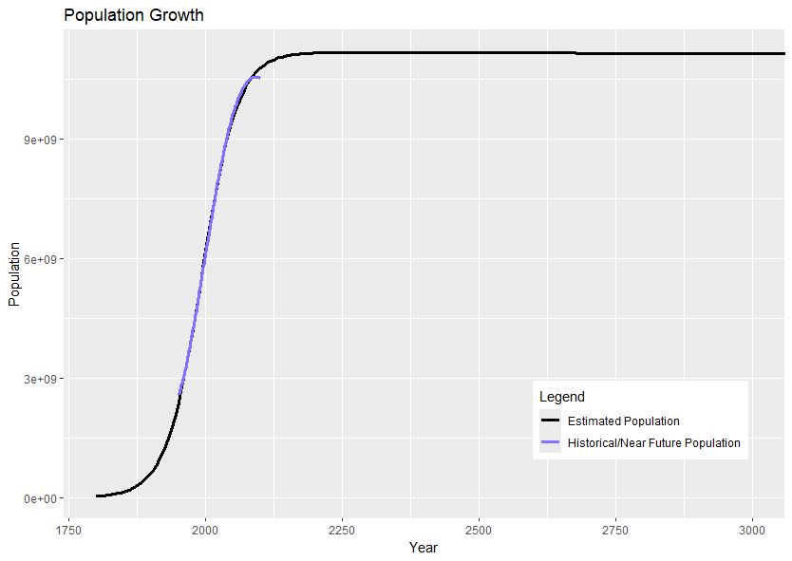
Figure 3: Historical and Estimated World Population Growth
The number of vehicles in the world is far from constant and additionally, electric vehicles have been rapidly gaining popularity, which is completely ignored in part one. States like California have already passed legislation that expects to phase out combustion vehicles completely within a few decades (California Air Resources Board, 2022). Although California is ahead of the curve in this regard, the shift towards electric vehicles is a global trend. Thus, this model will incorporate the growing popularity of electric vehicles by maintaining the rate of change of the proportion of electric vehicles to total vehicles registered in the US based on the past few years (US Department of Energy, n.d.). This is an assumption that is fairly reasonable to make, although could be potentially misrepresentative of the future. Electric vehicles may be adopted sooner or later than expected, or at differing rates over time. Tractor trailers may need much longer to convert to electric power. It is hard to know the answers, but this assumption should still lead to a fairly accurate prediction. Figure 4 displays this exchange, demonstrating a complete swap just before 2300. Electric vehicles still use crude oil to produce the energy they run on, but since they are significantly more efficient, this will drastically decrease how much crude oil is needed to power vehicles in general (Kirk, 2024).
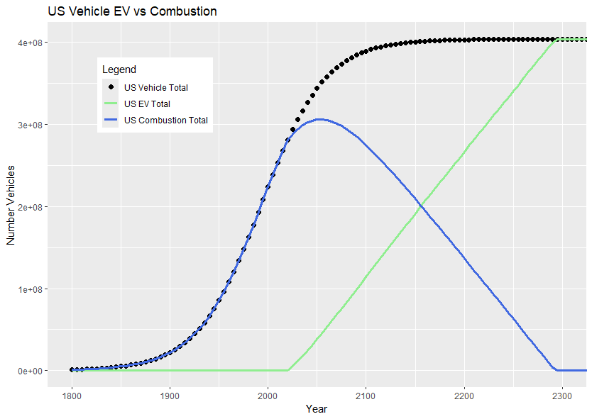
Figure 4: Estimated Growth of Total Vehicles and the Swap from Combustion to Electric
Aside from the swap from combustion to electric, the improvements made in this section also divide the total number of vehicles on the road up into six major categories, in the same way the Bureau of Transportation Statistics (BTS) splits up highway registered vehicles. The categories are light-duty vehicle (short wheelbase), motorcycle, light-duty vehicle (long wheelbase), truck (single-unit 2-axle 6-tire or more), truck (combination), and bus (Schmitt et al., 2025). By separating out these categories, we can better model fuel efficiency since there is quite a significant difference between motorcycles and tractor trailers, for example. Again, some assumptions must be made to proceed. Due to a lack of reliable international vehicle data and a relatively small number of years of data within the US, we will assume that the rest of the world has the same proportion of these categories and that these proportions will remain constant. We will also assume that the proportion of vehicles in the US compared to the rest of the world will stay constant, using estimates made for 2024 (Hedges, 2025). Due to these assumptions, although figures 4 and 5 show the change in vehicles in the US over time, it is inherently the same relationship that occurs on the global level, just on a different scale.
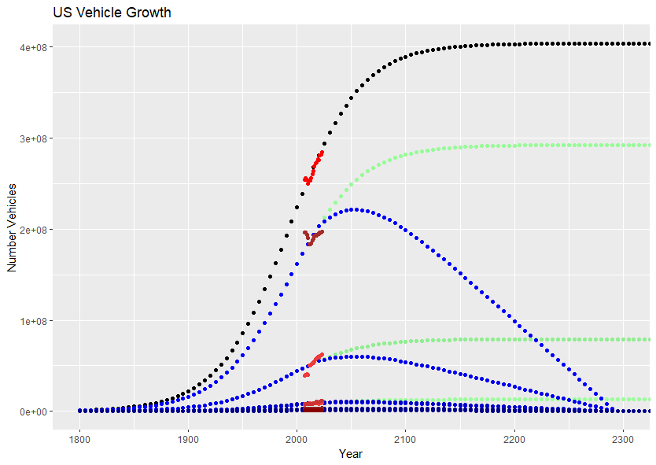
Figure 5: Estimated Growth in Total Vehicles in the US, Broken into Six Categories
In figure 5, we see the estimated change in each category of vehicles (blue/green) and in aggregate (black) compared to the actual data collected by the BTS (red). The blue represents total number of each category of combustion powered vehicles and the switch to green represents the total number of each of these vehicles once electric vehicles were introduced. Over time, we see that the total number of vehicles in the world (not visualized on these plots) tops over two billion before slowly retreating (see Appendix, Figure 3). This is close to a 50% increase compared to the constant assumed in part one, a significant difference affecting our overall estimation.
With an improved model of how the number of vehicles changes over time, we can update our estimate of the lifespan of oil. The model is altered to make 1,000-year time steps, instead of five-year time steps, to improve efficiency. This yields a new estimate of ~4.23 billion years, almost three times longer than the original estimate made in part one. This result agrees with our hypothesis, which expected that a more accurate model of the number of vehicles over time would increase the lifespan of crude oil, but not to the extent of a whole order of magnitude.

Part Three: Combining the Models
The three major assumptions that were addressed in part two each had a significant impact on the total estimated longevity of crude oil. Since these assumptions were addressed in isolation, the resulting changes indicate that each of the respective assumptions did indeed introduce a fair amount of error to our basic model in part one. Thus, implementing all three of the improvements together should yield a much more accurate estimation than part one. We expect that the cumulative effect of the three changes will be a shortened lifespan of crude oil by several orders of magnitude, mainly due to the huge decrease in available oil seen in section 2A, along with insight into how consumption might change over time.
To start integrating the new improvements into our model, the new estimation for total gasoline had to be substituted for the old one. The only issue was that the new estimation represents how much gasoline remained in 2020, whereas the original estimation represented the total supply of gasoline. Thus, the data for the other two sections had to be truncated to ensure the proper alignment of time when calculating our final estimation. With this set, the next task was to combine the fuel efficiency model with the vehicle count model. Since these two models used slightly different categories, the ones from section 2B were mapped to the most reasonable fit in section 2C. All the categories in section 2C were assigned exactly one category from section 2B except for light vehicle, long wheelbase and truck (6+ tires). SUVs and pickup trucks both have fuel efficiency ratings that put them closest to light vehicle, long wheelbase, so their fuel efficiency was applied to this new category in a proportional manner (based on the vehicle totals found in section 2B). Since none of the section 2B categories reasonably applied to truck (6+ tires), this category was best represented by constants. This is less of an issue than before, though, because we now have separate categories, which allows us to choose constants that better represent this specific category’s yearly mileage and fuel efficiency. In addition, this category represents a relatively small portion of the total number of vehicles, making its impact on overall accuracy even smaller. With the categories properly mapped to fit the section 2C model, we then created a few new variables in the data frame to represent yearly gas consumption per category and then summed them up to get total yearly gas consumption, which is displayed below in figure 6.
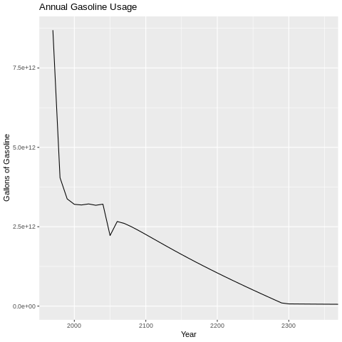
Figure 6: Total Annual Gasoline Usage (1970-2350)
The odd behavior seen around 2050 is due to the switch from combustion powered vehicles to electric vehicles interacting with the changes in fuel efficiency.
With a few more minor changes to the code, the three sections from part two were all aligned based on time, allowing us to determine how many years of gasoline use remained given our improved estimations. The new and improved estimation is, starting in 2020, 140 remaining years (visualized below in figure 7).
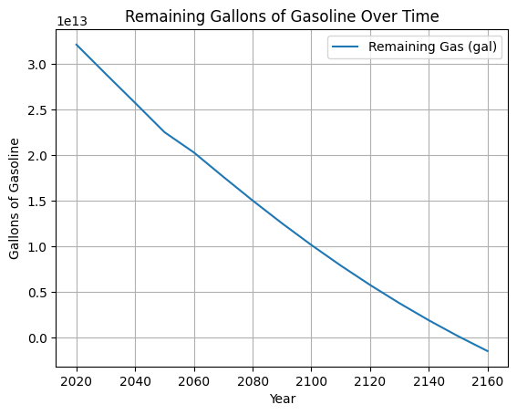
Figure 7: Estimated Remaining Gasoline Reserves
Assuming nonnegligible oil consumption began sometime in the late 19th century, this suggests that the total lifespan of crude oil based on gasoline consumption is just shy of three centuries. The drastic difference between this and the estimation made in part one is far greater than we originally anticipated. It is a difference of seven orders of magnitude and, more importantly, suggests that running out of oil is an imminent concern.
A surprising result of the work done thus far is that our improved model suggests oil will run out at almost the exact same time as it expects electric vehicles to outnumber combustion vehicles. Though our model still relies on plenty of assumptions, it does line up with similar work done by professionals in the field. In fact, our model is arguably generous in its estimation. With that said, this observation regarding electric vehicles suggests some possible preliminary elements for a solution to running out of oil. Electric vehicles make far more efficient use of crude oil, which, in addition to helping mitigate certain environmental concerns, could allow us to prolong the lifespan of crude oil by a significant amount. The plot shown below in figure 8 is a rough visualization of what it might look like if we were 50 years ahead in terms of progress towards being fully electric. It displays a hypothetical remaining lifespan of oil (700 years) that is five times longer than before.
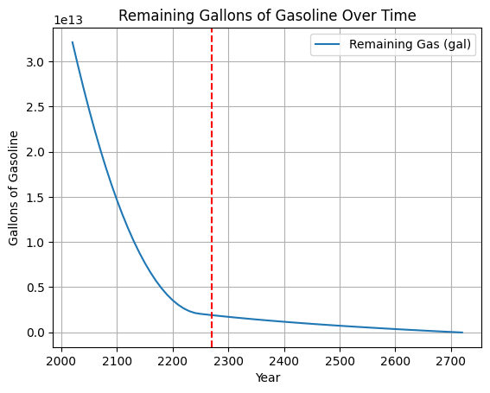
Figure 8: Adjusted Estimated Gasoline Reserves
Although this does inherently benefit from 50 years of fuel efficiency improvements as well, the contribution of that is almost negligible compared to the effect of going fully electric. The red dashed line displays the point at which our model expects more than 90% of all vehicles to be fully electric. This is right about when the curve dramatically flattens out. It is no coincidence that the area under the curve after this point is far less than before, as this area represents aggregate oil consumption and displays how much more efficient electric vehicles truly are.

Part Four: Further Refinement

Conclusion

Group Evaluation

Appendix
- Calculating an initial estimate under naïve assumptions:
$${Volume}_{crust}=\frac{4}{3}π\left({\left(\frac{12750}{2}\right)}^{3}-{\left(\frac{12750}{2}-17.5\right)}^{3}\right)≈8.91×{10}^{9} {km}^{3}$$
$$Total Gasoline=\left({Volume}_{crust}\right)\left(\frac{6,289,810,770.4 {barrel}_{oil}}{{km}^{3}}\right)\left(\frac{2 {barrel}_{gas}}{5{ barrel}_{oil}}\right)\left(\frac{42 gallon}{barrel}\right)≈9.42×{10}^{20} gallons$$
$$Yearly Consumption=\left(1.645×{10}^{9} vehicle\right)\left(\frac{10,000 mile}{vehicle}\right)\left(\frac{gallon}{25 mile}\right)≈6.58×{10}^{11} {gallons}/{year}$$
$$Crude Oil Lifespan=\left({gallons}_{total}\right)\left(\frac{year}{gallons}\right)≈1.43×{10}^{9} years$$
- $Remaining Gasoline=42*\left({Oil}_{recoverable}-{Oil}_{consumed}\right)*{yield}_{gasoline}$
$${Remaining Gasoline}_{2020}=42*\left(3×{10}^{12}-1.3×{10}^{12}\right)*.45≈3.2×{10}^{13} gallons$$
- Sample data displaying the observation year, estimated total number of vehicles in the world, and estimated number of light-duty vehicles (short wheelbase), motorcycles, light-duty vehicles (long wheelbase), trucks (single-unit 2-axle 6-tire or more), trucks (combination), and buses in the world, respectively.
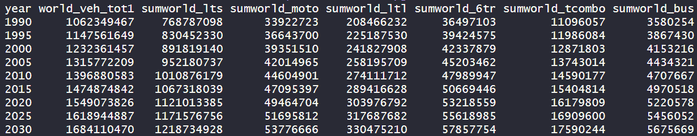

References
California Air Resources Board. (2022, August 25). California moves to accelerate to 100% new zero-emission vehicle sales by 2035 | California Air Resources Board. California Air Resources Board. https://ww2.arb.ca.gov/news/california-moves-accelerate-100-new-zero-emission-vehicle-sales-2035
Freudenrich, C. (2001, January 4). How Oil Refining Works. HowStuffWorks. https://science.howstuffworks.com/environmental/energy/oil-refining1.htm
Geiger, J. (2019, August 20). How Much Crude Oil Has The World Really Consumed? OilPrice.com. https://oilprice.com/Energy/Crude-Oil/How-Much-Crude-Oil-Has-The-World-Really-Consumed.html
Hedges, J. (2018). US VIO Vehicle Registration Data 2018, Fast Quote on Car Data. Hedges & Company. https://hedgescompany.com/automotive-market-research-statistics/auto-mailing-lists-and-marketing/
Hedges, J. (2025, October 26). How many cars are there in the world in 2021? Stats by country. Hedges & Company. https://hedgescompany.com/blog/2021/06/how-many-cars-are-there-in-the-world/
Kirk, K. (2024, January 29). Electric vehicles use half the energy of gas-powered vehicles. Yale Climate Connections. https://yaleclimateconnections.org/2024/01/electric-vehicles-use-half-the-energy-of-gas-powered-vehicles/
Oil and Gas Reserves. (2025). Penn State College of Earth and Mineral Sciences. https://courses.ems.psu.edu/earth104/node/1298
Online Conversion - Volume Conversion. (n.d.). Www.onlineconversion.com. https://www.onlineconversion.com/volume.htm
Schmitt, R., Shaw, J., DiJoseph, P., & Stacy, M. (2025). Transportation Statistics Annual Report 2025. ROSA P. https://doi.org/10.21949/w2zr-3a26
United States Census Bureau. (2026). International Database. Census.gov. https://www.census.gov/data-tools/demo/idb/#/dashboard?dashboard_page=country&COUNTRY_YR_ANIM=2026
US Department of Energy. (n.d.). Alternative Fuels Data Center: TransAtlas. Afdc.energy.gov. https://afdc.energy.gov/transatlas#/
USGS. (2019). Inside the Earth [This Dynamic Earth, USGS]. Usgs.gov. https://pubs.usgs.gov/gip/dynamic/inside.html
Wikipedia Contributors. (2019, April 25). Future of Earth. Wikipedia; Wikimedia Foundation. https://en.wikipedia.org/wiki/Future_of_Earth
Wikipedia Contributors. (2020, January 30). Earth’s crust. Wikipedia; Wikimedia Foundation. https://en.wikipedia.org/wiki/Earth%27s_crust
World Bank. (2025). Population, Total. The World Bank; World Bank Group. https://data.worldbank.org/indicator/SP.POP.TOTL

This number represents the total gallons of gasoline predicted in part one, but since it was such a gross overestimate, subtracting out the 1.3 trillion barrels of crude oil that we have already used still leaves us with a number of gallons that rounds to $9.42×{10}^{20}$. This alone displays how incredibly erroneous the previous assumption regarding accessible oil reserves was.

