Templand filmstrip manual
This manual provides a description of creating, playing and changing a filmstrip:
- How to create a new filmstrip.
- How to open a filmstrip.
- Manipulating a filmstrip.

How to create a new filmstrip
- From File menu item choose new or hit Ctrl + N it will create a new tab.
- Now you need to load a Surface (*.OBJ) or a Form (*.FRM) so that you can create a filmstrip. In the tree view on the right. The following are both ways explained.
  - To load already saved Form right click on Form item in the tree view on the right and choose Load.
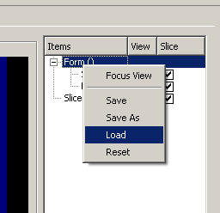
Choose a saved Form file and click ok. Form now loaded and surface can be seen.
  - Another way is to “Import Surface” and save the Form from the same menu above. Saving the Form is an optional step because later if you want to create a filmstrip you will have to save the Tableau (*.LTB) file (which internally saves the Form as well).
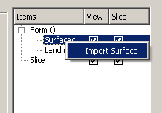
- Now that you have a Form with Surface it is time to Add frames (tableaus) to our filmstrip. To do so you need to click on the Add  button in the bottom left side of the current tab. Do not forget to save the filmstrip so you can view it later.
How to open a filmstrip
There are two ways to open a filmstrip, on its own or in the current tab:
- To open a filmstrip in a new tab on its own by choosing “Open File” or Ctrl + O.
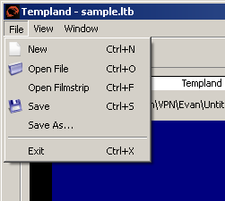
- Another useful way is to open a filmstrip in the current opened tab, is by choosing “Open Filmstrip” or Ctrl + F from the main File menu. The filmstrip name will appear in the combo box 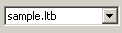 on the very bottom left corner of the tab. You can choose which filmstrip you want to view or edit from the combo box.

Manipulating a filmstrip
Control | Description
 | Appends new frame (Tableau) at end of filmstrip.
 | Replaces the current frame in filmstrip with new one.
 | Deletes the current frame.
 | Positions the current frame one step to left or right in filmstrip. Think of it as moving a frame up and down in a list.
 | Slider controls indicating which frame is being displayed in the filmstrip.
 | Moves Frame index to the previous frame in filmstrip.
 | Moves Frame index to the next frame in filmstrip.
 | Moves frame index to previous step. Number of steps in a frame is determined by setting value.
 | Moves frame index to next step. Number of steps in a frame is determined by setting value.
 | Plays or resumes filmstrip backwards.
 | Plays or resumes filmstrip forwards.
 | Pauses filmstrip player.
 | Stops filmstrip player.
 | Interpolates the frames making it possible for user to step into frame steps by Step next and previous buttons.
 | Controls the speed of filmstrip player. The higher the value the slower the filmstrip.
 | Contains all filmstrips loaded in the current tab.
 | Displays the current frame index in filmstrip.

