http://sourceforge.net/projects/tdm-gcc/files/TDM-GCC%20Installer/tdm-gcc-4.8.1-3.exe/download

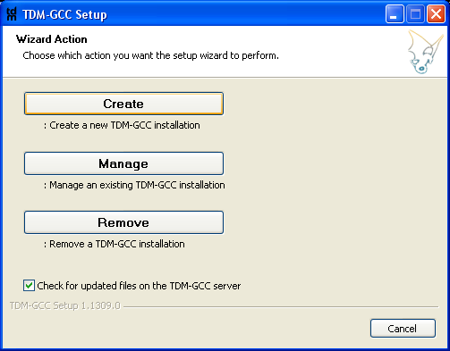
(You might want to deselect ‘Check for updated files on the TDM-GCC server to really end up with version 4.8.1-3’)
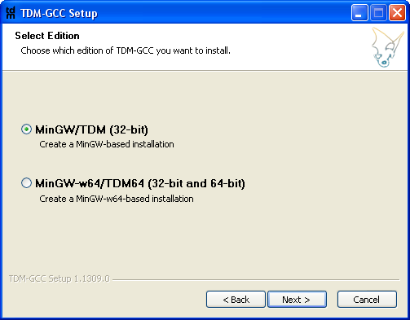
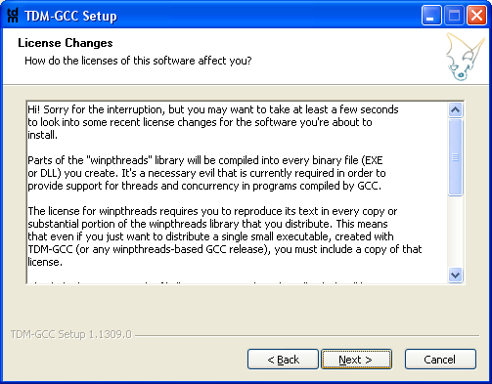
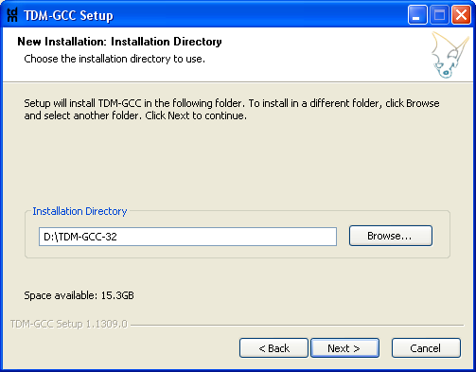
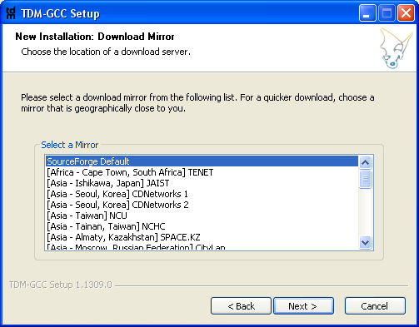
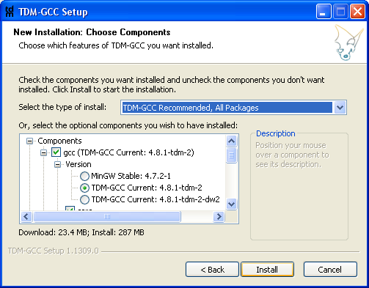

Once installed, copy the provided TDM-GCC-shell.bat file to the install folder (where mingwvars.bat is located). Create a shortcut on the desktop so that you have instant access to a TDM-GCC enabled shell.

MSYS:
http://sourceforge.net/apps/trac/mingw-w64/wiki/MSYS
Get “The all-in-one package on the MinGW-w64 download page”

browse to
http://sourceforge.net/projects/mingw-w64/files/External%20binary%20packages%20%28Win64%20hosted%29/MSYS%20%2832-bit%29/
and get MSYS-20111123.zip

After installation, your folders could look like this:
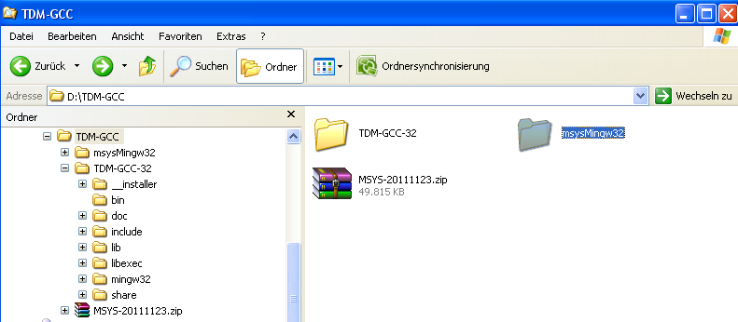
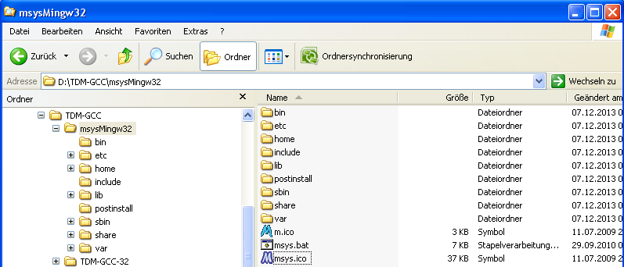
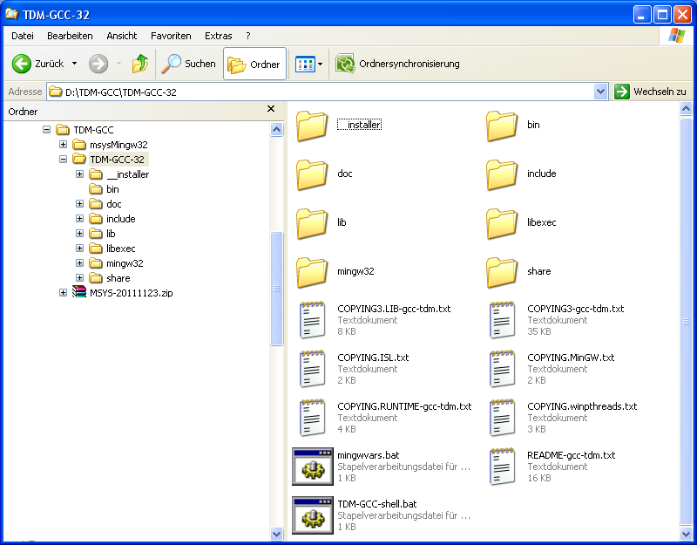
Note that for convenience I created a TDM-GCC-shell.bat script which I use for opening the ming-shell (just create a shortcut on the Desktop to run it directly by double-clicking it).
It includes the following line:
%COMSPEC% /k mingwvars.bat

and is stored in the TDM-GCC installation directory (on my computer it is in the folder 'D:\TDM-GCC\TDM-GCC-32\'; from that directory, you should see the direct subfolders 'bin', 'doc', 'include', ...). In the very same directory, the file mingwvars.bat contains the following lines:
@echo.
@echo Setting up environment for using MinGW with GCC from %~dp0.
@set PATH=%~dp0bin;%PATH%

