Abstract—This report outlines how we implemented a Convoluted Neural Network (CNN), applying deep learning principles to classify images of Cats and Dogs. We implemented the CNN using the TensorFlow [1] library and image processing library OpenCV [2]. We achieved a success rate of (insert success later) using our methodology outlined in the paper.
“PawSitive”: Cats vs Dogs Classification Using Convoluted Neural Networks and Deep Learning (April 2017)
Kaggle: PawSitive
Evan Knox (McGill University, 260502120, evan.knox@mail.mcgill.ca)
Kristine A. Juhl (McGill University, 260760431 kristine.juhl@mail.mcgill.ca)

INTRODUCTION
CLassification of images is one of the many new problems tasked to engineers and computer scientists in the 21st century. Motivations include medical imaging, sports, GIS and a wide range of other fields. The motivation of our project is to find a computational method to correctly classify images of cats and dogs.
Figure 1 Common images of household cat [2] and dog
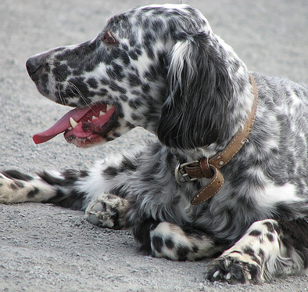
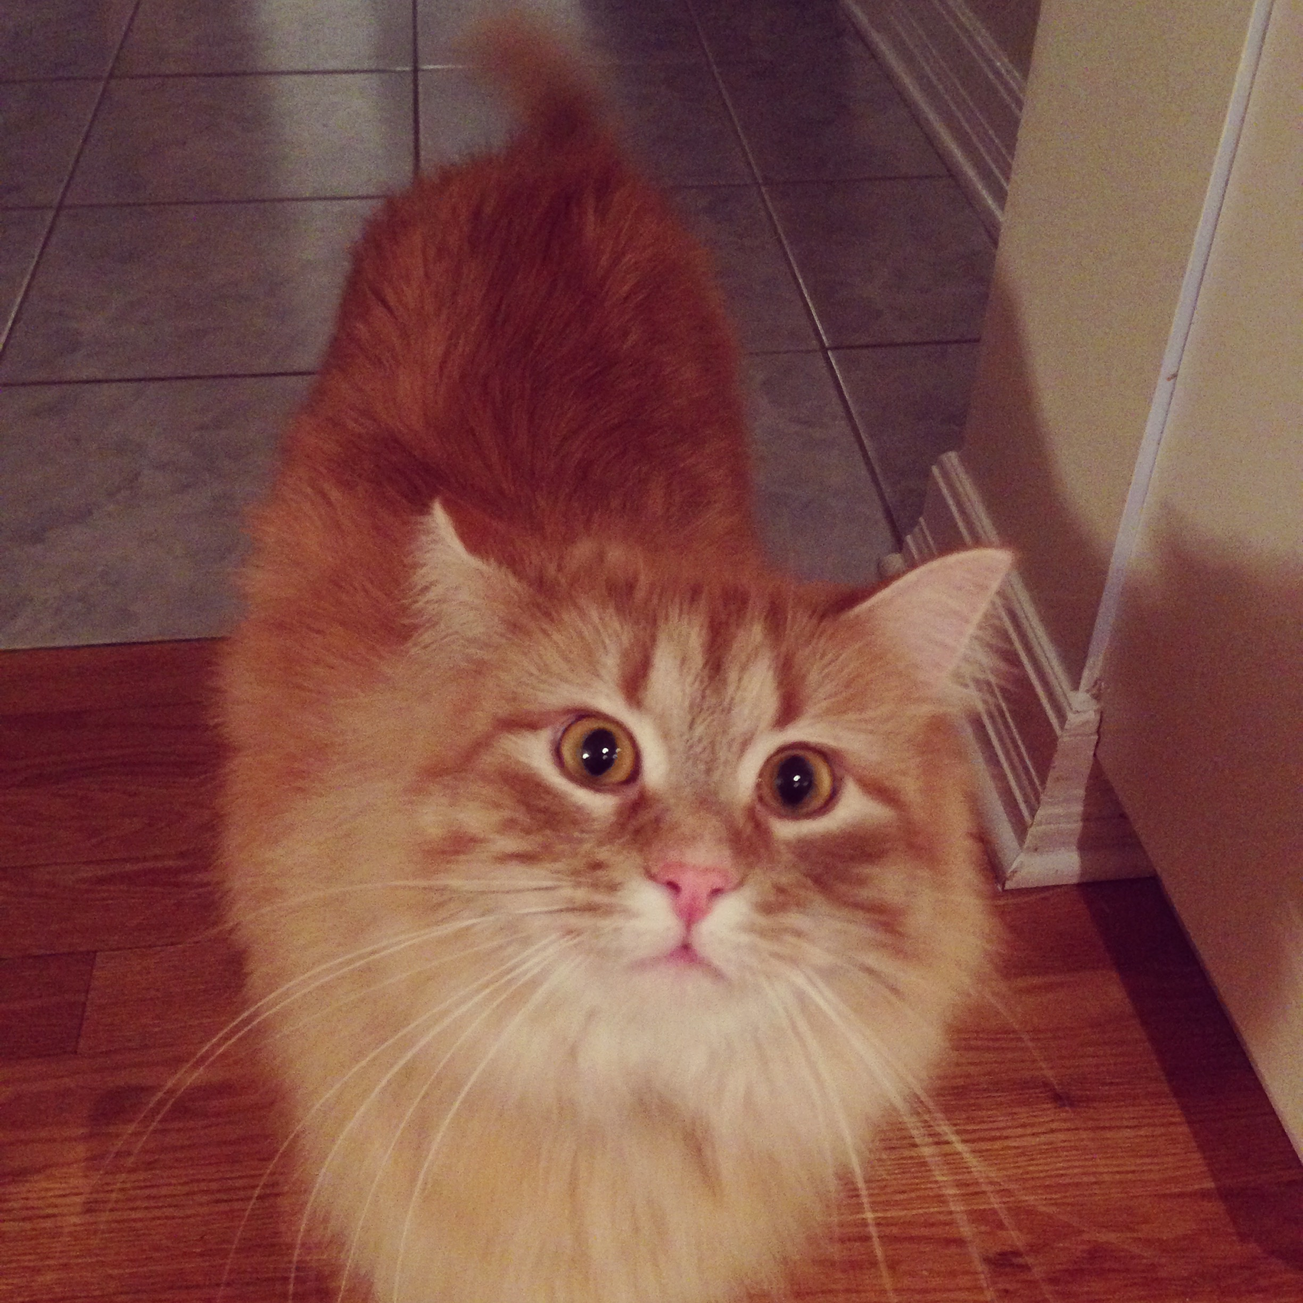
To do this, we used a Convoluted Neural Network, which we implemented through Google’s TensorFlow [1] open source library. Our approach was as follows:
- Search through the literature to find the best possible algorithm for image classification.
- Acquire a large training set of known images of Cats and dogs
- Compute SIFT Feature blah blah blah We don’t do that right?!
- Feed the training set of images to the convoluted neural network
- After n iterations, save the network and weights
- Run the test set of images on the network and measure the performance.

Problem Representation: Feature Design and Selection
Up until 2012 the common approach for image classification was based on a “bag-of-features”-approach \cite{csurka2004}. As images are represented by a great number of pixels, it can be important to find an alternative representation of the images that captures the important features of the image.
As an initial test for this project, the SIFT-descriptors \cite{lowe1999} and Local Binary Patterns (LBP) \cite{wang1990} was clustered into 50 bins each using a K-Means algorithm and thereby creating a binary feature matrix. These features capture local image features and texture of image areas, respectively, and have both been found useful for image classification. Other possible features include Harris Corners \cite{harris1988}, Difference-of-Gaussians (DoG) \cite{marr1980}, Histograms-of-Oriented-Gradients (HoG) \cite{dalal2005} and many more.

After 2012 the common approach for image classification drastically changed after Convolutional Neural Networks were introduced to the field \cite{mit}.
Since then the focus in the field has been to improve on the architecture and layout of the CNN and thereby achieve better accuracy on classification tasks.
The CNN takes the raw pixel values in RGB space as input and automatically finds higher order features based on the architecture and weights in the image.
Bla bla bla (Add comments on what this system does)

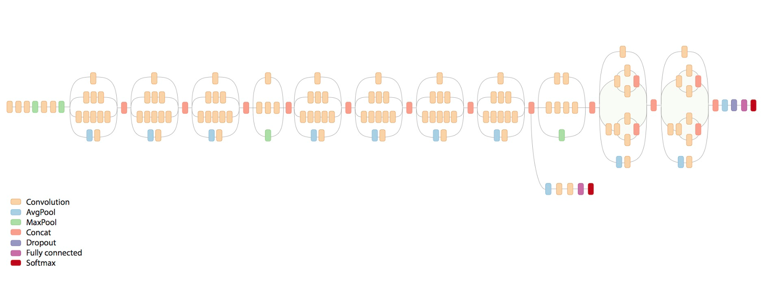
FROM COMP551:
Inception is a massive 48 layer CNN. Similar to VGG, it uses a parallel combination of 1x1, 3x3, and 5x5 convolutional filters. The use of the 1x1 reduces (or bottlenecks) the number of features. This reduces the number of parameters, and therefore, the number of operations. Inception V3 has around 30 million parameters, and performs $1/10^{th}$ the number of operations of that of VGG 16 \cite{inc2015}.
Figure 2 Schematic Diagram of the Inception-V3

Algorithm Selection and Implementation
After researching the success of various classification methodologies (KNN, SVM and CNN) we determined that a Convoluted Neural Network (CNN) [3], would yield the greatest overall success on the project.
The structure of our CNN is based on the successful Inception [3] Neural Network designed by google. The overall architecture of network can be seen in Figure 2.
As CNNs typically have a large network with many weights to train, training from scratch can take many months dependent on the available computational power. Furthermore the provided dataset is fairly small and training such a large network based on a small training set increases the risk of overfitting.
As these problems are common in the field of Machine Learning Google Tensorflow decided to release library and code for training the Inception-V3 model yourself. Among many other features this library allows the user to do transfer learning – retraining or finetuning the network to the classification task at hand.

- Architecture of the network (ie. Classifier in the end)
- Retraining/fine-tuning in Google TensorFlow. – Change the final number of labels in the final layer, restore weights from pretrained network except for the last layer. Learningrate (Should be low as we are fine-tuning).
- Importing to python and testing

Testing
- Training graphs
- Results from Kaggle
- Results on tests outside kaggle – if we ever make errors where do we make them?

Discussion
CNN Pros:
- Learns the features based on the data
- No need for specifying ie. number of clusters

CNN cons:
- Reduced interpreteability. What is actually important for recognizing cats from dogs?

Suggestions for further work:
- Cropping away background (but background can also be useful?)
- Random change of brightness, contrast and angle rotation of training images.

References

[1] | Google Inc, "TensorFlow: Large-scale machine learning on heterogeneous systems,," 2015. [Online]. Available: http://tensorflow.org/. [Accessed 30 04 2017].
[2] | E. Knox, "Image of Gatsby," Ottawa, 2016.

 

