[1]

“PawSitive”: Cats vs Dogs Classification Using Convoluted Neural Networks and Deep Learning(April 2017)

Kaggle: TEAM_NAME

Evan Knox (McGill University, 260502120, evan.knox@mail.mcgill.ca)

Kristine A. Juhl (Norway University, STUDENTNUMBER,YOUR.EMAIL@HERE)

*Abstract*—This report outlines how we implemented a Convoluted Neural Network (CNN), applying deep learning principles to classify images of Cats and Dogs. We implemented the CNN using the TensorFlow [1] library and image processing library OpenCV [2]. We achieved a success rate of (insert success later) using our methodology outlined in the paper.

# INTRODUCTION

C

Lassification of images is one of the many new problems tasked to engineers and computer scientists in the 21st century. Motivations include medical imaging, sports, GIS and a wide range of other fields. The motivation of our project is to find a computational method to correctly classify images of cats and dogs.

Figure Common images of household cat [2] and dog

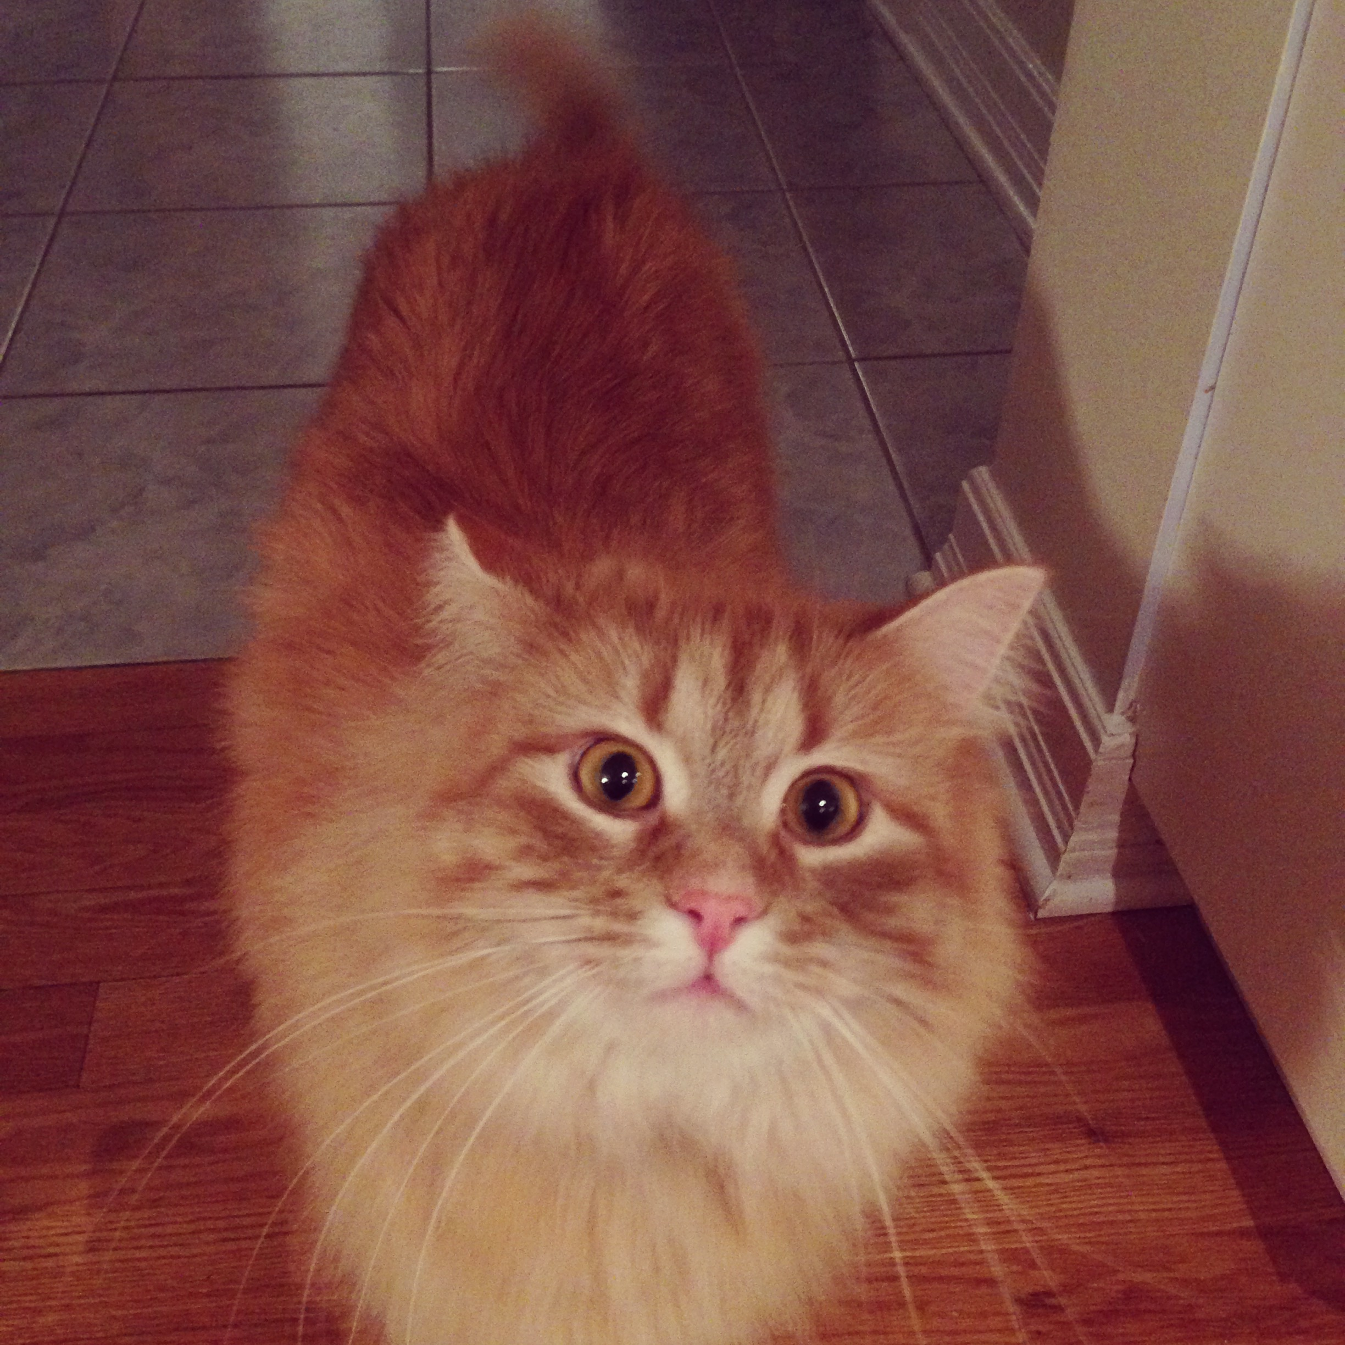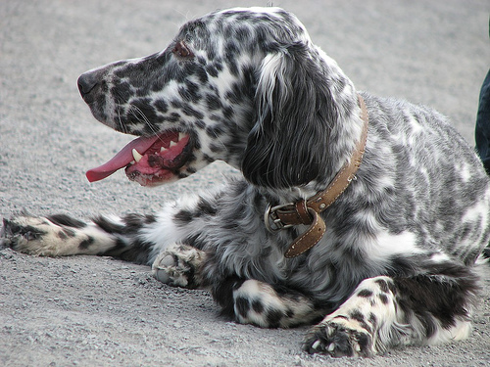

To do this, we used a Convoluted Neural Network, which we implemented through Google’s TensorFlow [1] open source library. Our approach was as follows:

1. Acquire a large training set of known images of Cats and dogs
2. Compute SIFT Feature blah blah blah
3. Feed the training set of images to the convoluted neural network
4. After n iterations, save the network and weights
5. Run the test set of images on the network and measure the performance.

# Problem Representation: Feature Design and Selection

We considered 3 kinds of features, but ended up choosing WHATEVER WE CHOSE features. We evaluated HOG, SIFT and RAW PIXEL features in our image.

# Algorithm Selection and Implementation

After researching the success of various classification methodologies (KNN, SVM and CNN) we determined that a Convoluted Neural Network (CNN) [3], would yield the greatest overall success on the project. The structure of our CNN is based off of the successful Inception [3] Neural Network designed by google.

# Testing

# Discussion

# References

|  |  |
| --- | --- |
| [1] | Google Inc, "TensorFlow: Large-scale machine learning on heterogeneous systems,," 2015. [Online]. Available: http://tensorflow.org/. [Accessed 30 04 2017]. |
| [2] | E. Knox, "Image of Gatsby," Ottawa, 2016. |

1.