CS510: Computer Vision

Project 1: Hybrid Image Synthesis

Student: Shu-Ping Chu

1. Intro to Hybrid Image Synthesis

The purpose of this computer vision project1 is to build a hybrid image that combine with two different image into one mixed image, and result in two different scenes by look at the image up-close and few meters further away. In order to accomplish the hybrid image synthesis, I’ve follow the paper A. Oliva, A. Torralba, P.G. Schyns (2006). Hybrid Images, process steps to implement the hybrid image algorithm. The algorithm would have two simple steps, for example, translate original image into smooth and sharp image, then combine both smooth and sharp image in order to create hybrid image.

2. Procedure

Af first stage, I applied Gaussian 33x33 filter with first input image, then the program will generate the smooth image. The low pass filter will eliminate the high frequency component, and result the image in blurred eventually. Once increment the sigma value from the filter, the more blurred image will present. After that, the program will produce the sharp image from second input image by subtract input and smooth image, which the program will remove low frequency component from the image. As a result, the output image will only can see the edge of the input image. Finally, the program combine with these two output image such as, smooth and sharp image, and create a final hybrid image result.

3. Profiling test

In Gaussian filter, I use the 33x33 size with sigma from 2.65 to 26.65 incrementally to generate the smooth image. As we can see, the more sigma increase, the more blurred image we will get. For example, the human’s face is becoming unclear, the detail of facial feature is becoming vague. However, once the sigma increase until a certain value for example, from value 18.65 to 26.65, the filter seems like reach to the limit, which might be hard to clearly to see by human eyes without zoom in or resize the image.

**Low pass filter**

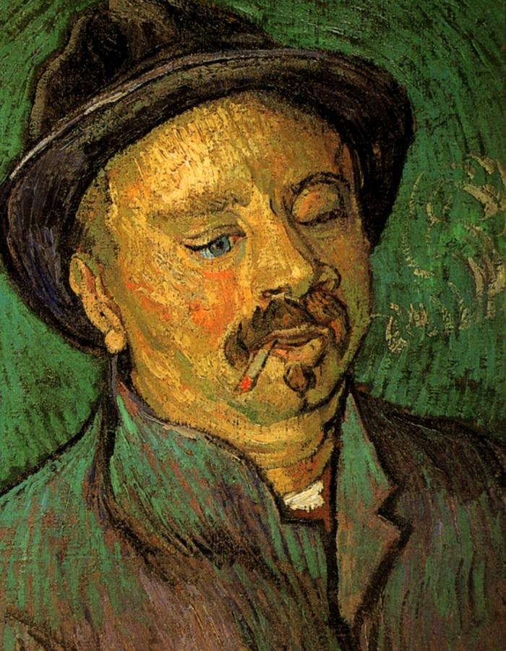 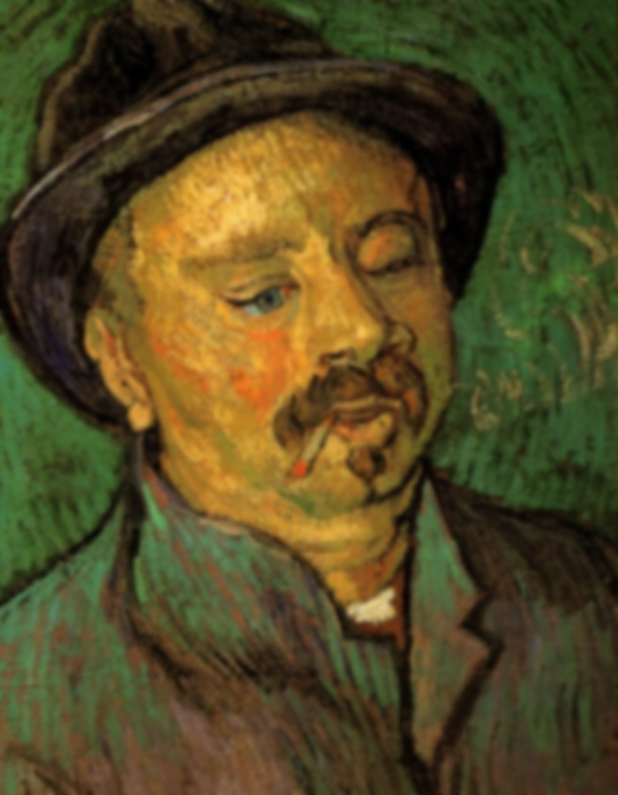 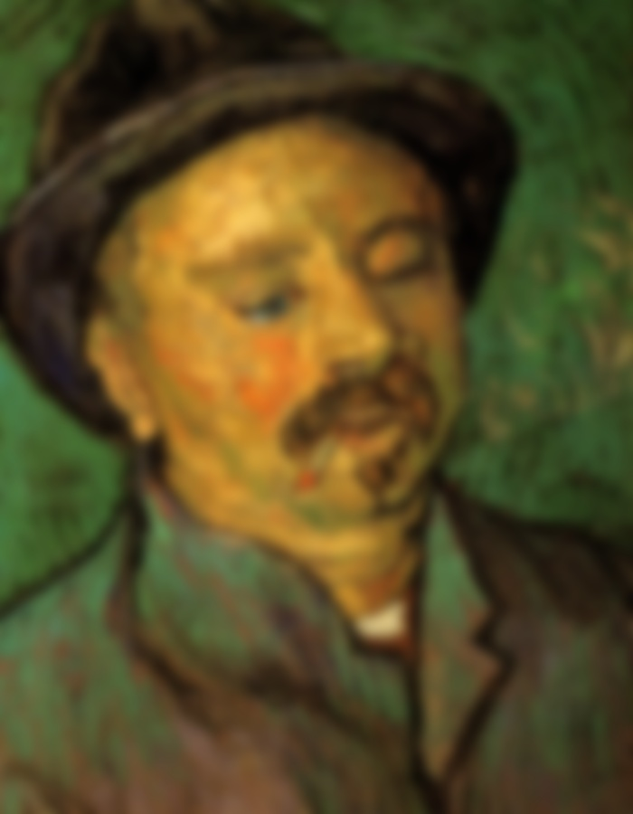 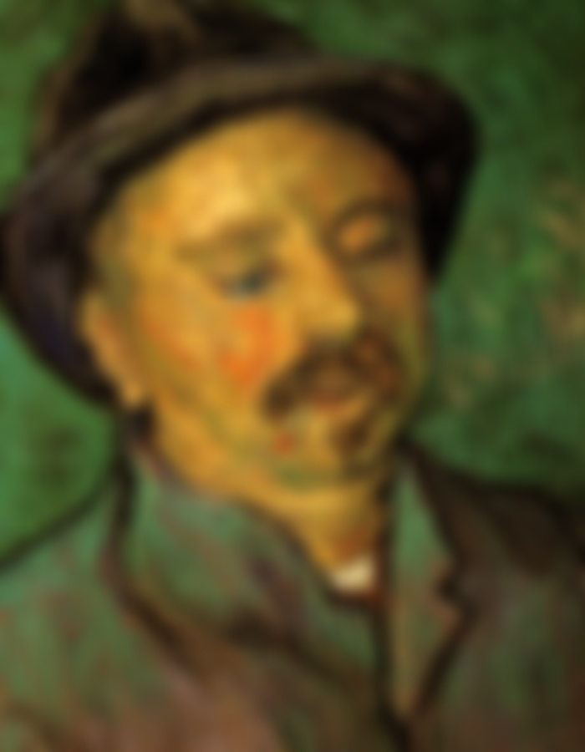

Original (Man face) Sigma:2.65 Sigma:6.65 Sigma:10.65

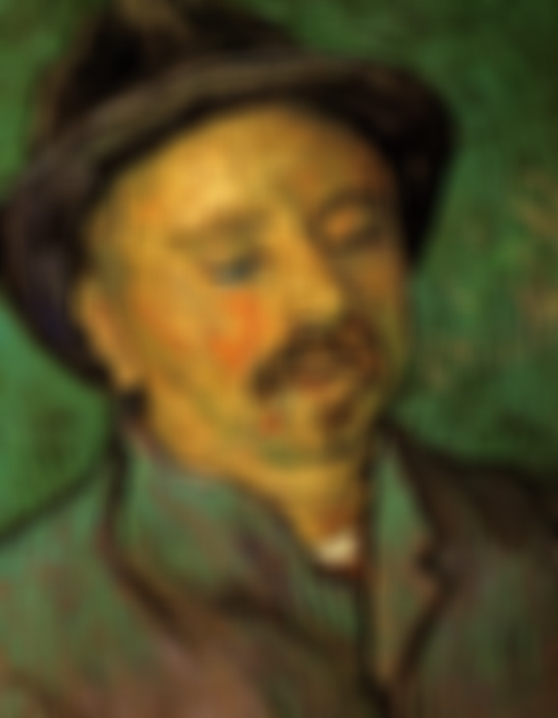 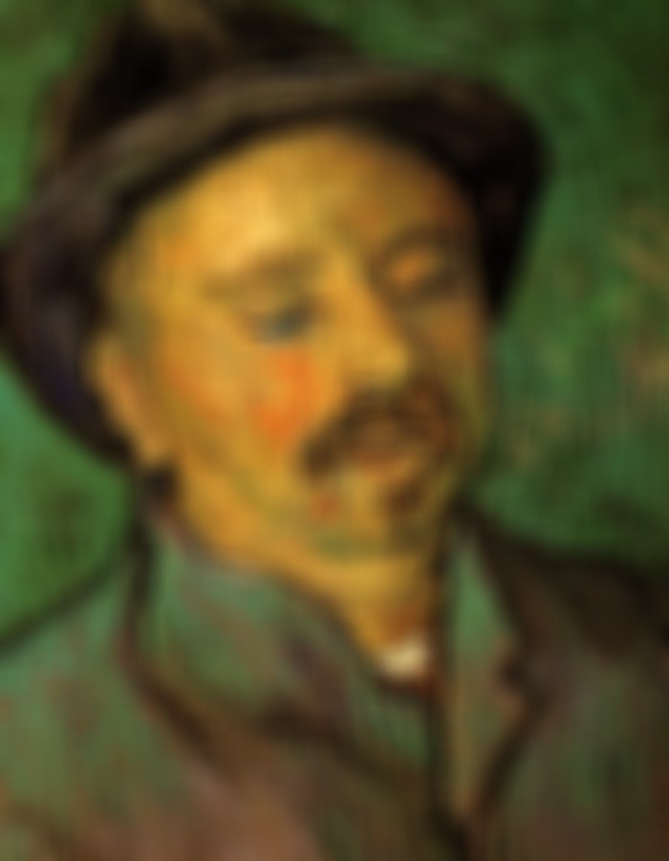 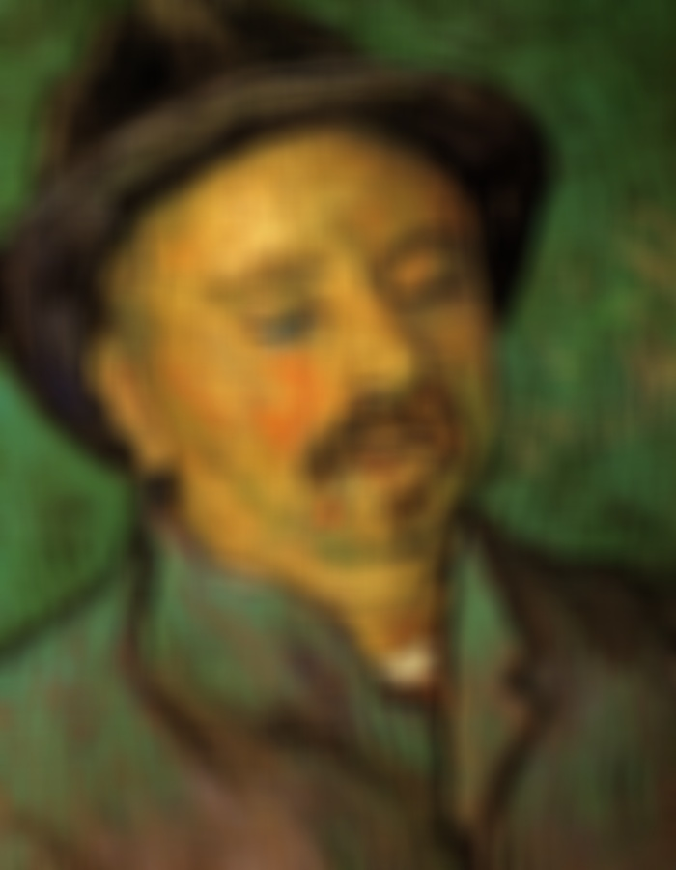

Sigma:14.65 Sigma:18.65 Sigma:22.65

**Zoom-in**



Sigma:26.65

**Here is another example for low pass filter:**

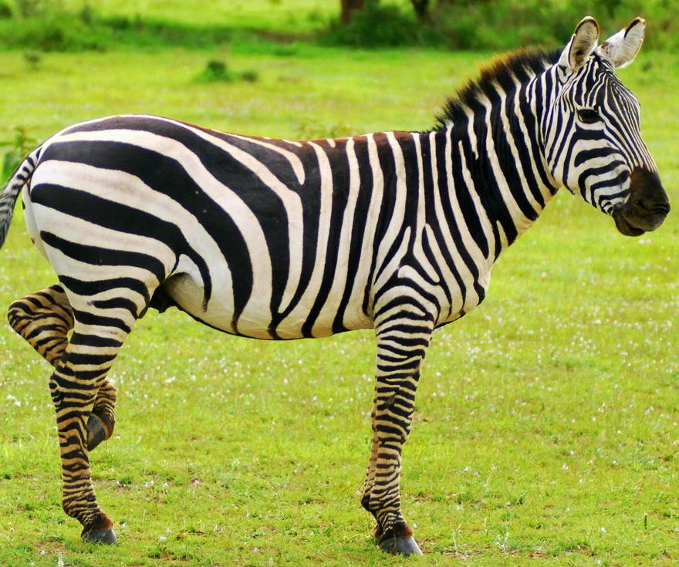 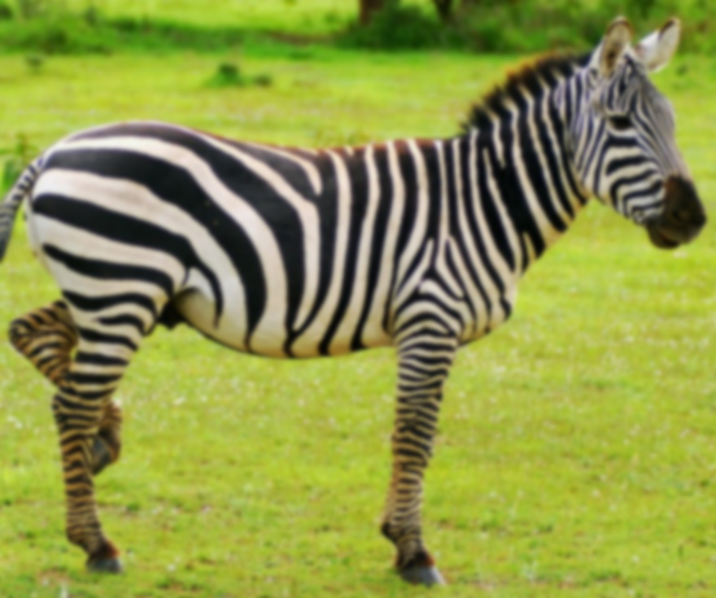 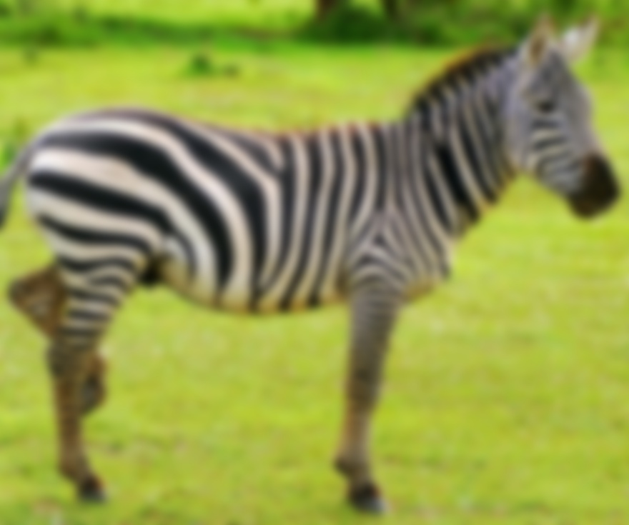 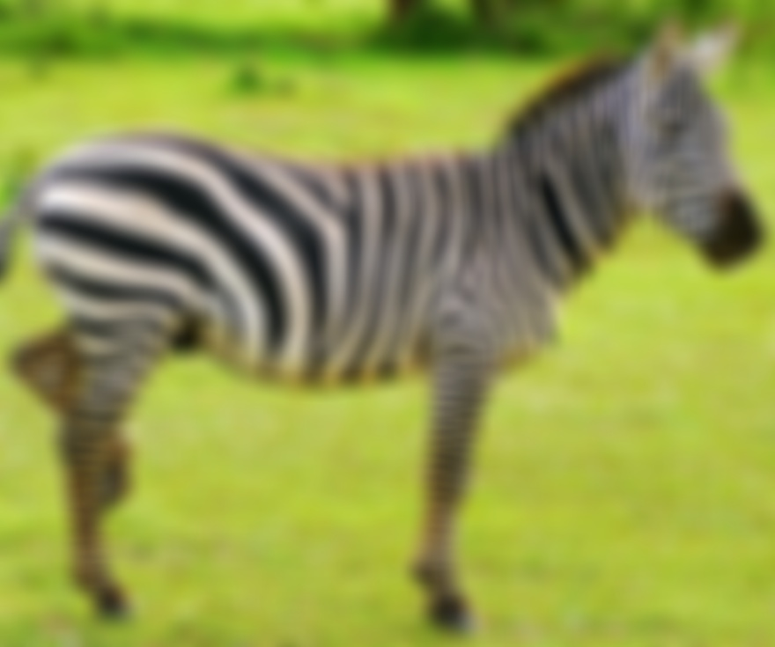

Original (zebra) Sigma:2.65 Sigma:6.65 Sigma:10.65

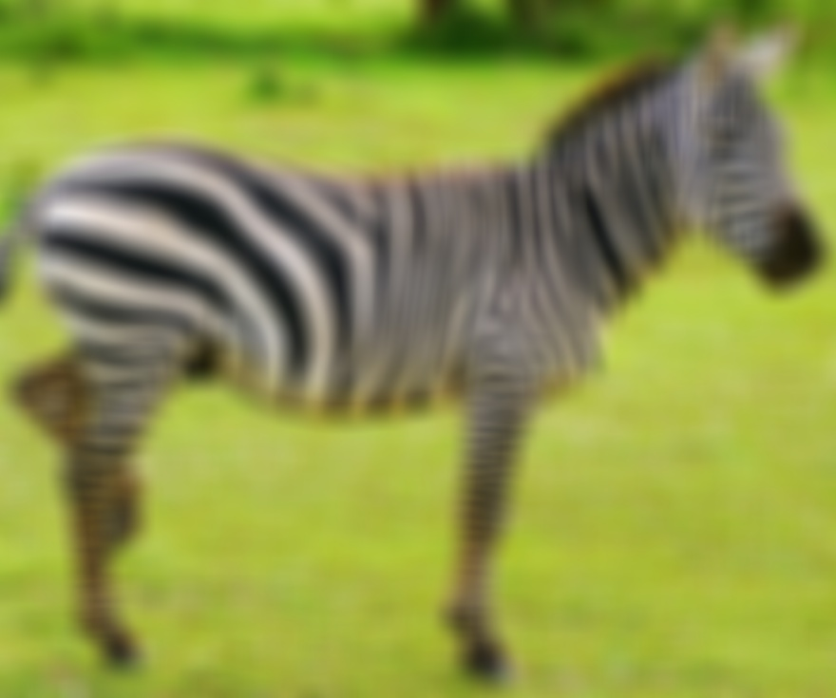 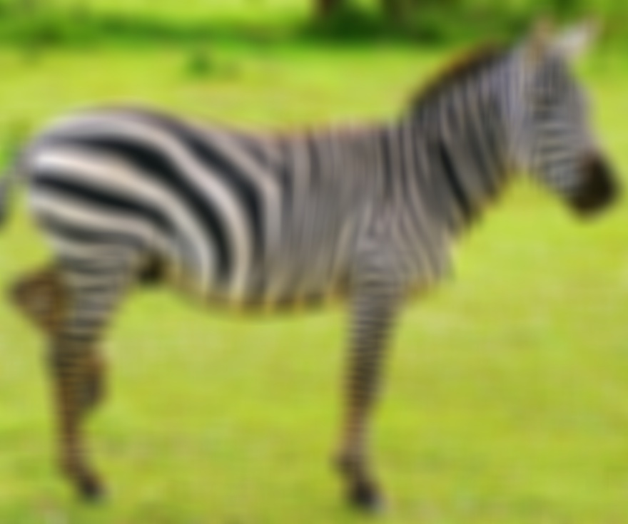 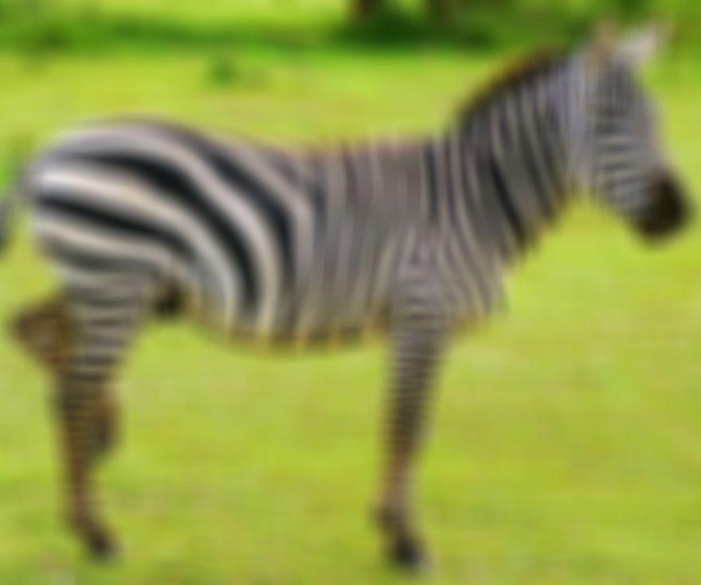

Sigma:14.65 Sigma:18.65 Sigma:22.65

**Zoom-in**



Sigma:26.65

For the second part of sharp image profiling test, the following result is represented with different sigma value increasingly. The Gaussian filter size is still 33x33 with all the test.

High pass filter

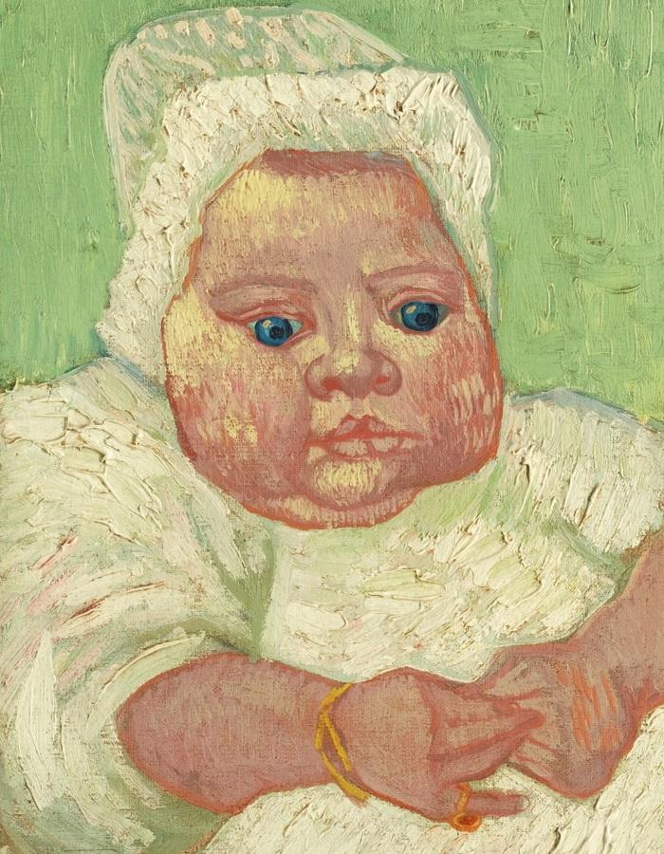 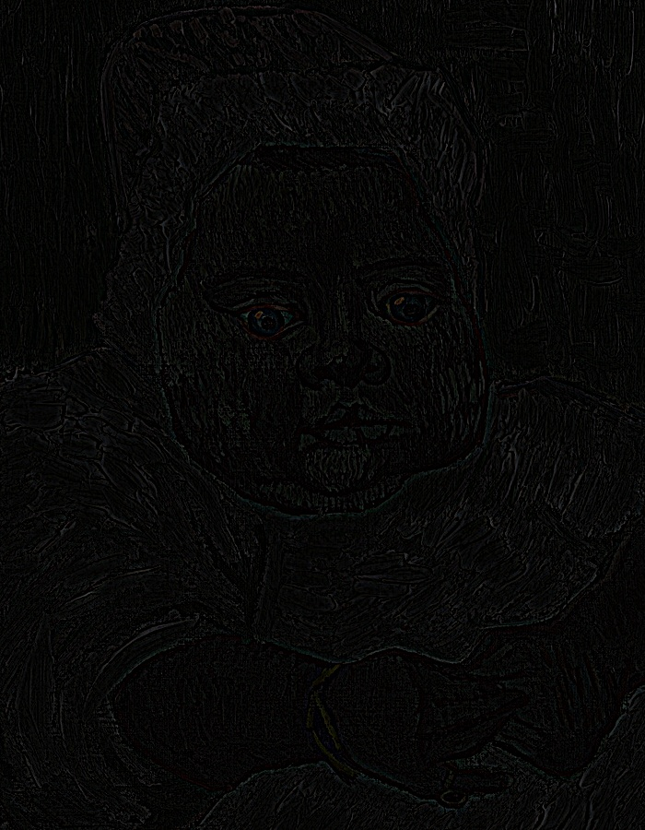

Original (baby face) Sigma:2.65

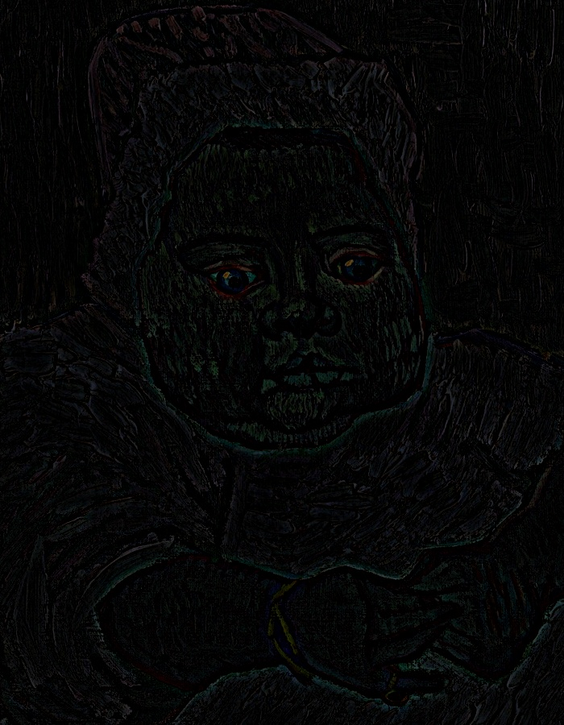 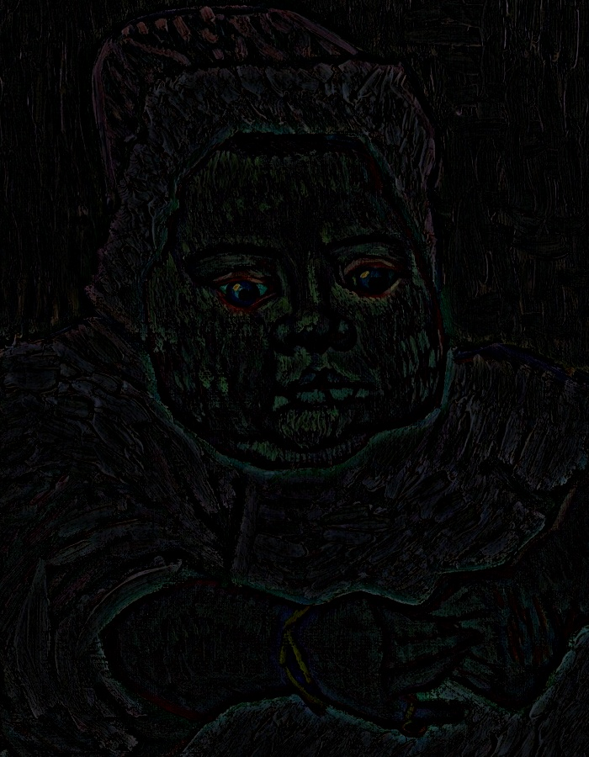

Sigma:6.65 Sigma:12.65

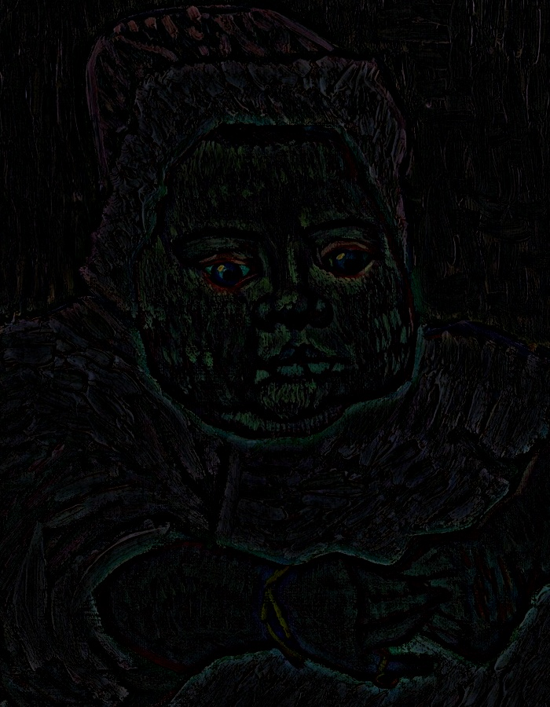 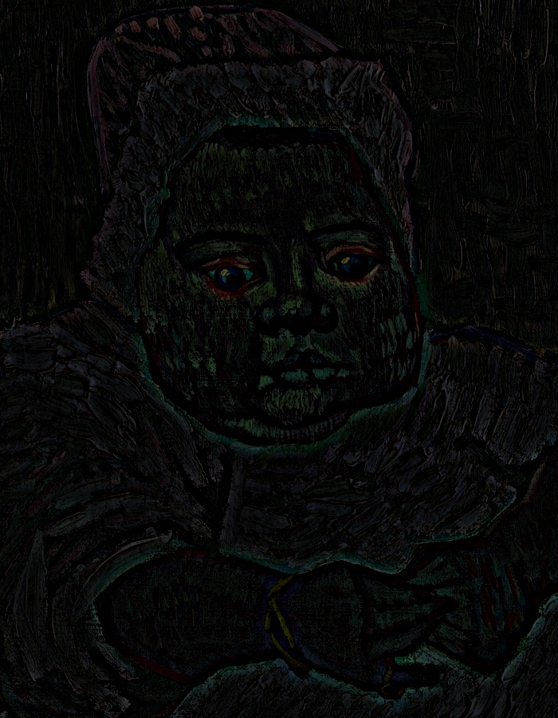

Sigma:18.65 Sigma:24.65

**Another example for the sharp image:**

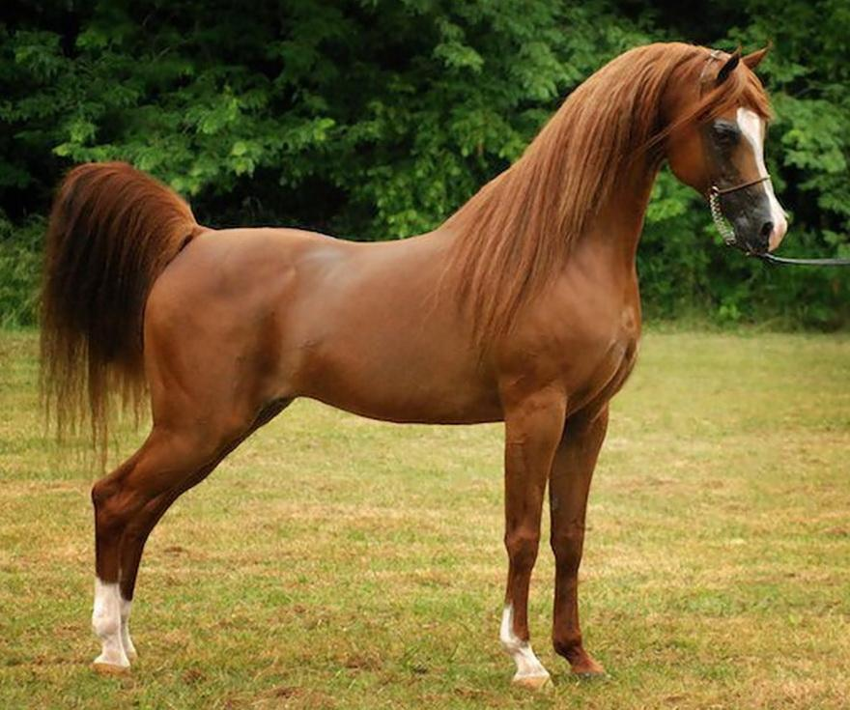

Original (horse)

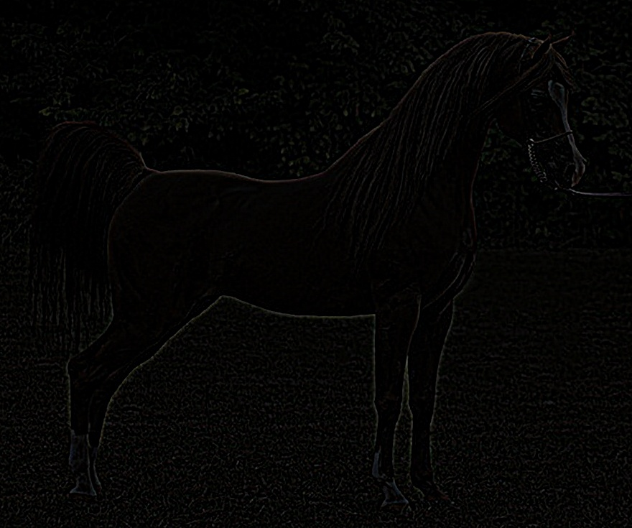 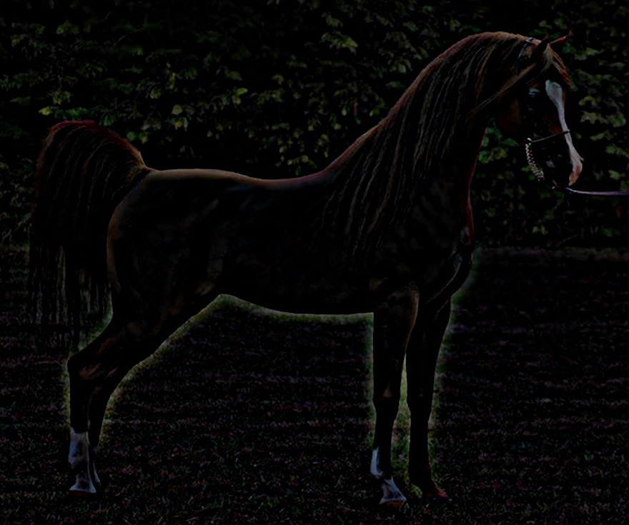

Sigma:2.65 Sigma:18.65

Base of the above test result for sharp image, which present differently when compared with the result of smooth image. As we can see, when we increase the sigma, the image will become more clearly, the blurriness area was subtracted by the Gaussian filter. The high sigma we gave, the more edge of characters would represent.

**Finally, the last step is to combine two images into hybrid image**

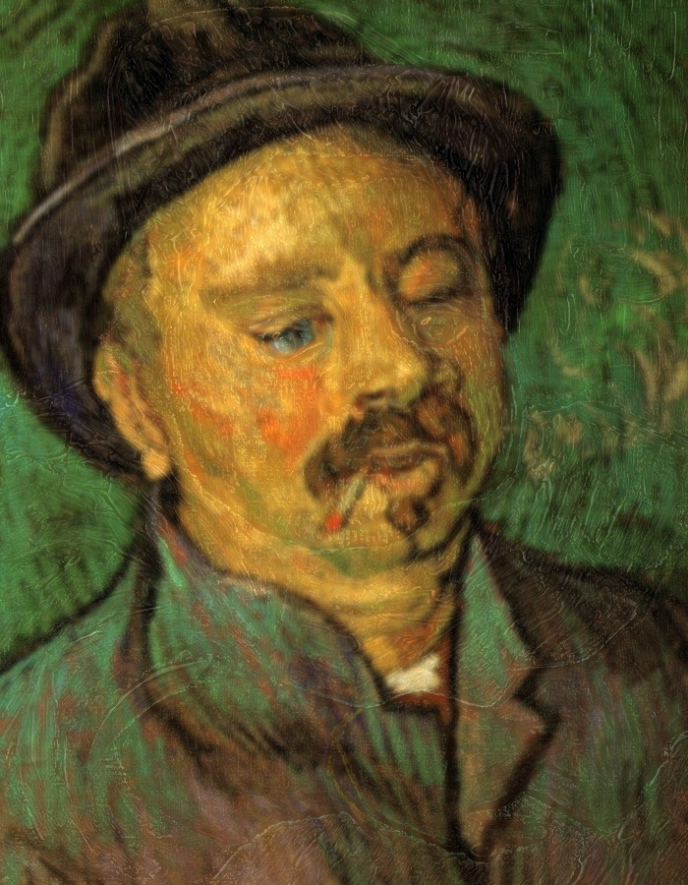 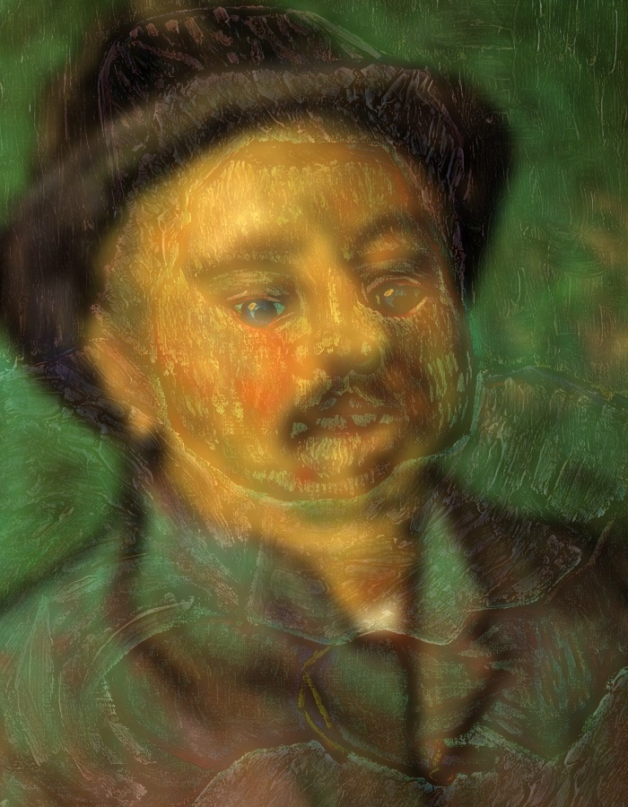

Sigma: 2.65 Sigma: 8.65

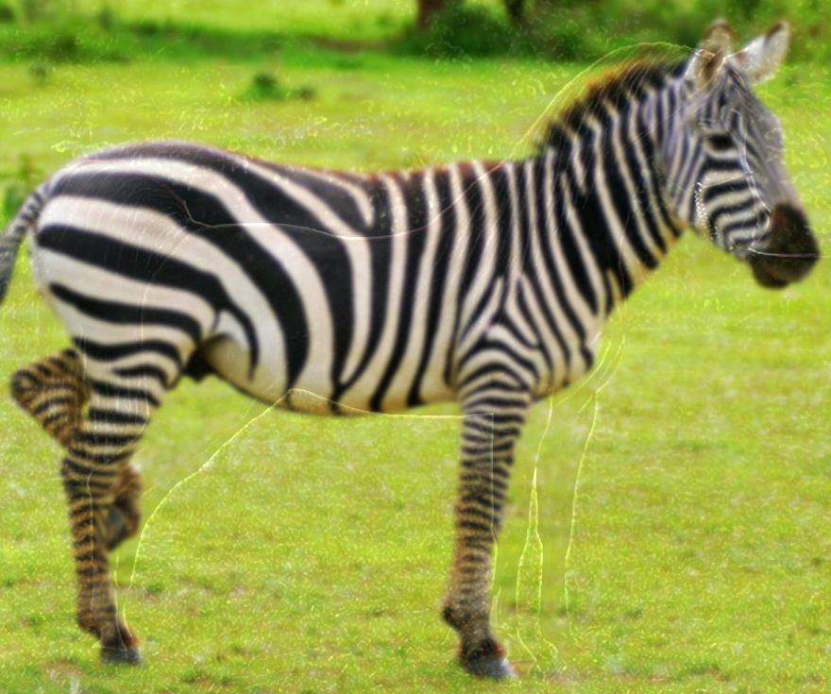 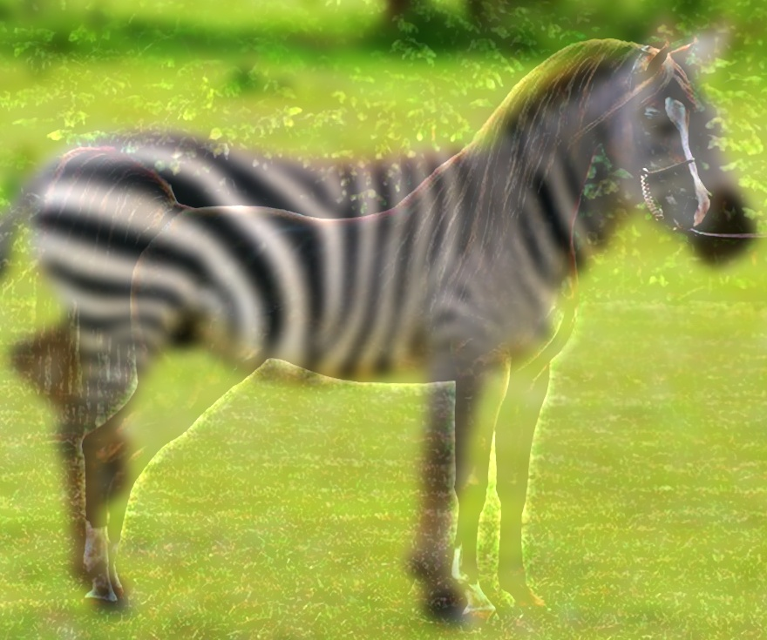

Sigma: 2.65 Sigma: 8.65

In conclusion, the above hybrid image are generated by my Hybrid Image Synthesis program. Both original image of hybrid image are shows at Profiling test section, and here are the hybrid images after I run the different sigma which are 2.65 and 8.65. As a result, when run with low sigma for example 2.65, it’s hard to see two different characters display in the same image. However, once we run with sigma 8.65, we can easily to see there are two different characters shows in the picture. For example, when we see it close, we see the baby’s face and horse, on the other hand, if we see few meters away, we will see the man’s face and zebra.