資料庫系統專題報告

海大書局

組別：22組

組員：

00957202 吳秉宸

00957205 吳翊楷

0086A021 謝翔宇

一、系統功能介紹

這個Web專門給海大書局查詢目前的所有書籍與訂單和買家資訊，且提供新增、刪除、修改資訊的功能，而每本書籍、買家和訂單都有獨一無二的ID。

二、SQL DDL & 範例資料

(一) Storage table

CREATE TABLE Storage(

BookID bigint(15) NOT NULL AUTO_INCREMENT,

BookName varchar(255) NOT NULL,

Price int,

Classification varchar(255),

StoreNumber int,

PRIMARY KEY (BookID)

);

| BookID | BookName | Price | Classificition | StoreNumber |
| --- | --- | --- | --- | --- |
| 1 | Hamen | 150 | 宗教類 | 0 |
| 2 | How to Lose | 3000 | 科學類 | 1000 |
| 3 | 7414.ac | 888 | 歷史類 | 110 |

[BookID] 紀錄各書籍的編號,是Primary Key。

[BookName] 記錄各書籍名稱。

[Price] 記錄各書籍價錢。

[Classification] 記錄個書籍種類。

[StoreNumber] 紀錄書籍庫存量。

(二) Buyer table

CREATE TABLE Buyer(

BuyerID bigint(15) NOT NULL AUTO_INCREMENT,

BuyerName varchar(225) NOT NULL,

BuyerPhone varchar(225),

BuyerAddress varchar(225),

PRIMARY KEY (BuyerID)

);

| BuyerID | BuyerName | BuyerPhone | BuyerAddress |
| --- | --- | --- | --- |
| 1 | Stanley | 0972067777 | 台北市松山區南京西路  1段123號1234樓之7 |
| 2 | Trump | 0972065555 | 新竹縣尖石鄉玉峰村14鄰司馬庫斯2號 |
| 3 | Winy | 0972066464 | 台北市松山區南京東路  5段230號14樓之6 |

[BuyerID] 紀錄買家的編號,是Primary Key。

[BuyerName] 紀錄買家姓名。

[BuyerPhone] 紀錄買家電話。

[BuyerAddress] 紀錄買家地址。

(三) Deal table

CREATE TABLE Deal(

DealID bigint(15) NOT NULL AUTO_INCREMENT,

BookID varchar(225),

BuyerID bigint(15),

DealAmount int,

PRIMARY KEY (DealID),

FOREIGN KEY (BookID) REFERENCES Storage

FOREIGN KEY (BuyerID) REFERENCES Buyer

);

| DealID | BookID | BuyerID | DealAmount |
| --- | --- | --- | --- |
| 1 | 3 | 3 | 100 |
| 2 | 2 | 1 | 1 |
| 3 | 1 | 3 | 1 |

[DealID] 紀錄訂單編號，是Primary Key。

[BookID] 紀錄書籍的編號，是Foreign Key

[BuyerID] 紀錄買家編號，是Foreign Key

[DealAmount] 紀錄購買書籍的數量。

三、SQL DML

首頁：

書籍種類(Storage Classification)(已完成)

storage_classification.php

SELECT distinct Classification

FROM Storage;

書籍銷售排行榜(Top 10 Popular Storage)(已完成)

popular_storage.php

SELECT BookName

FROM storage,deal;

WHERE storage.BookID =deal.BookID;

GROUP BY BookID

ORDER BY sum(DealAmount) desc

查詢資訊：

顯示全部書籍資訊(總攬)(已完成)

display_all_books.php

SELECT *

FROM Storage;

依書籍種類顯示部分書籍(選擇書籍種類)(已完成)

show_selected_classification.php

SELECT *

FROM Storage;

WHERE Classification = ‘種類’

a = [種類為使用者輸入的內容]

查詢訂單連絡電話(Order_search_phone)(已完成)

show_deal_phonenumber.php

SELECT DealID, BuyerPhone

FROM Deal, Buyer;

WHERE Deal.BuyerID = Buyer.BuyerID

(Where Deal.BuyerID = Buyer.BuyerID)

修改資訊：

<Storage>

新增書籍資訊

add_new_book.php(已完成)

INSERT INTO Storage table(

BookID,BookName,Price,Classification,StoreNumber)

values( ,'How to win’,100,玄學類,1)

a = [BookName]

b = [Price]

c = [Classification]

d = [StoreNumber]

修改書籍資訊 edit_book_information.php(已完成)

UPDATE Storage

SET [Attribute] = [value]

WHERE BookName = [‘book_name’];

a = [Attribute]

b = [value]

c = [book_name]

刪除書籍資訊 DONE

delete_book.php

DELETE FROM Storage

WHERE BookName = [book_name];

a = [book_name]

////////////////

<Buyer>

新增買家資訊 DONE

add_new_buyer.php

INSERT INTO Buyer ( BuyerID,BuyerName,BuyerPhone,BuyerAddress)

values( ,'Kim',‘0972060000’,‘朝顯人名共和國中正路一號’)

a = [BuyerName]

b = [BuyerPhone]

c = [BuyerAddress]

修改買家資訊 (已修改)

edit_buyer_information.php

UPDATE Buyer

SET [Attribute] = [value]

WHERE BuyerID = [‘BuyerID’];

a = [Attribute]

b = [value]

c = [BuyerID]

刪除買家資訊 DONE

delete_buyer.php

DELETE FROM Buyer

WHERE BuyerID = [‘BuyerID’];

a = [‘BuyerID’]依使用者輸入

//////////////////

<Deal>

新增訂單資訊 DONE

add_new_deal.php

INSERT INTO Deal(

DealID,BookID,BuyerID,DealAmount)

values( ,3,1,20)

a = [BookID]

b = [BuyerID]

c = [DealAmount]

修改訂單資訊 <目前只能改數量>

edit_deal_information.php

UPDATE Deal

SET [Attribute] = [value]

WHERE DealID = [‘DealID’];

a=[Attribute]

b=[value]

c=[DealID]

刪除訂單資訊 (已完成)

delete_deal.php

DELETE FROM Deal

WHERE DealID = [‘DealID’];

ａ = [DealID]

四、網站架構

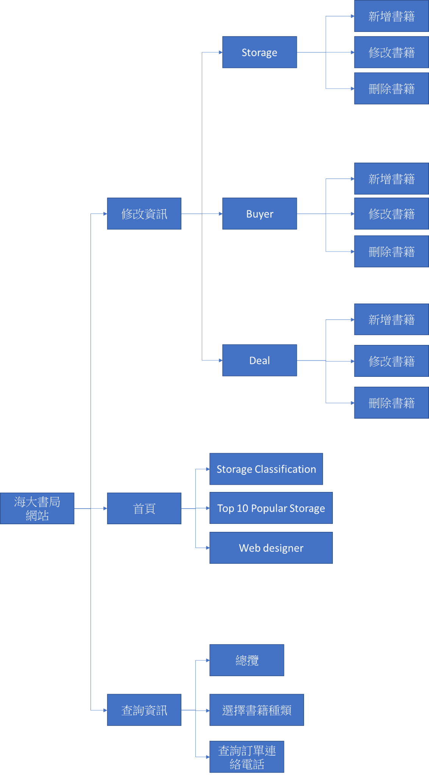

五、網頁的初步畫面設計

(一)首頁

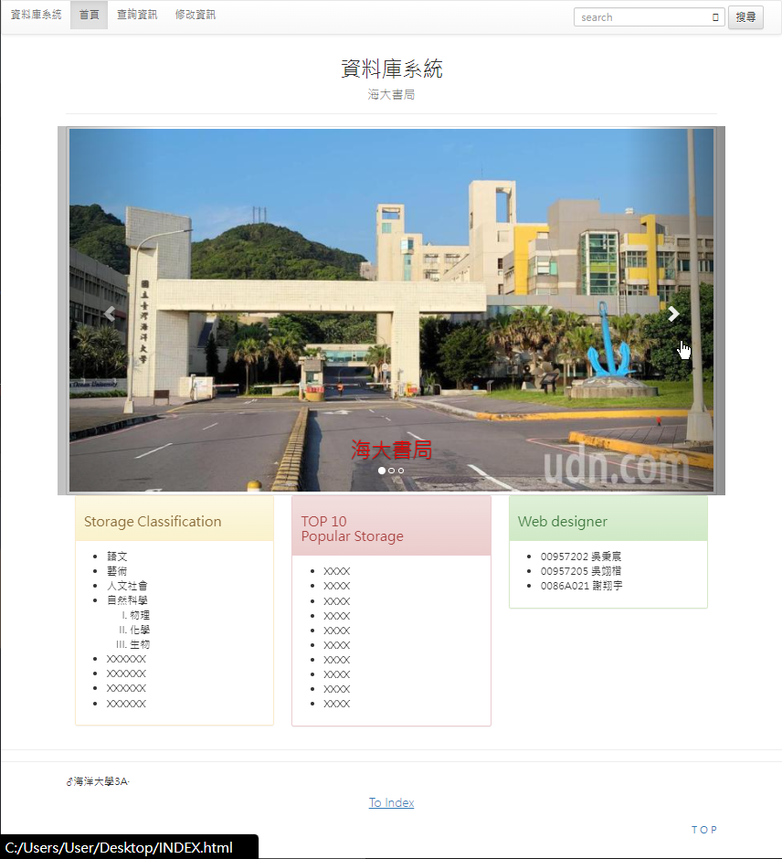

(二)查詢資訊

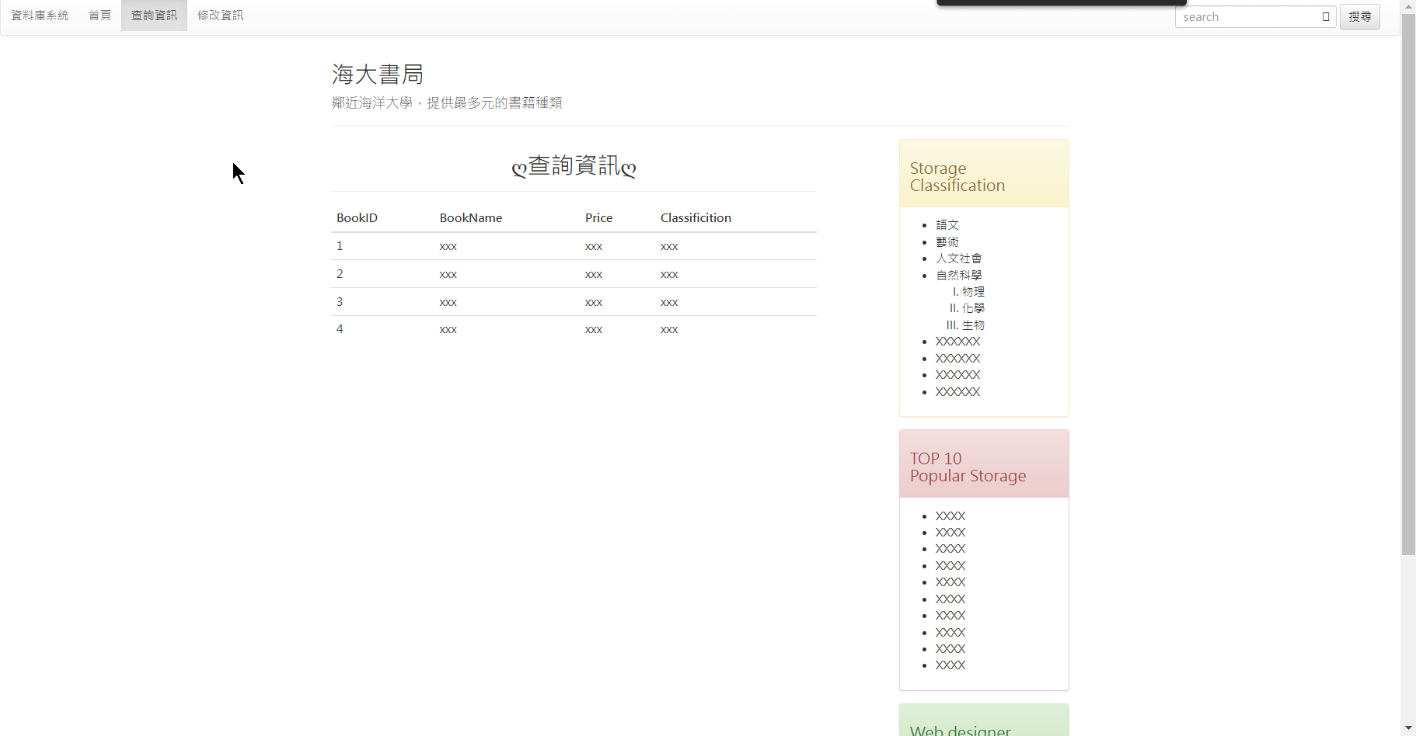

(三)修改資訊(上方可新增，下方則可以刪除or修改)

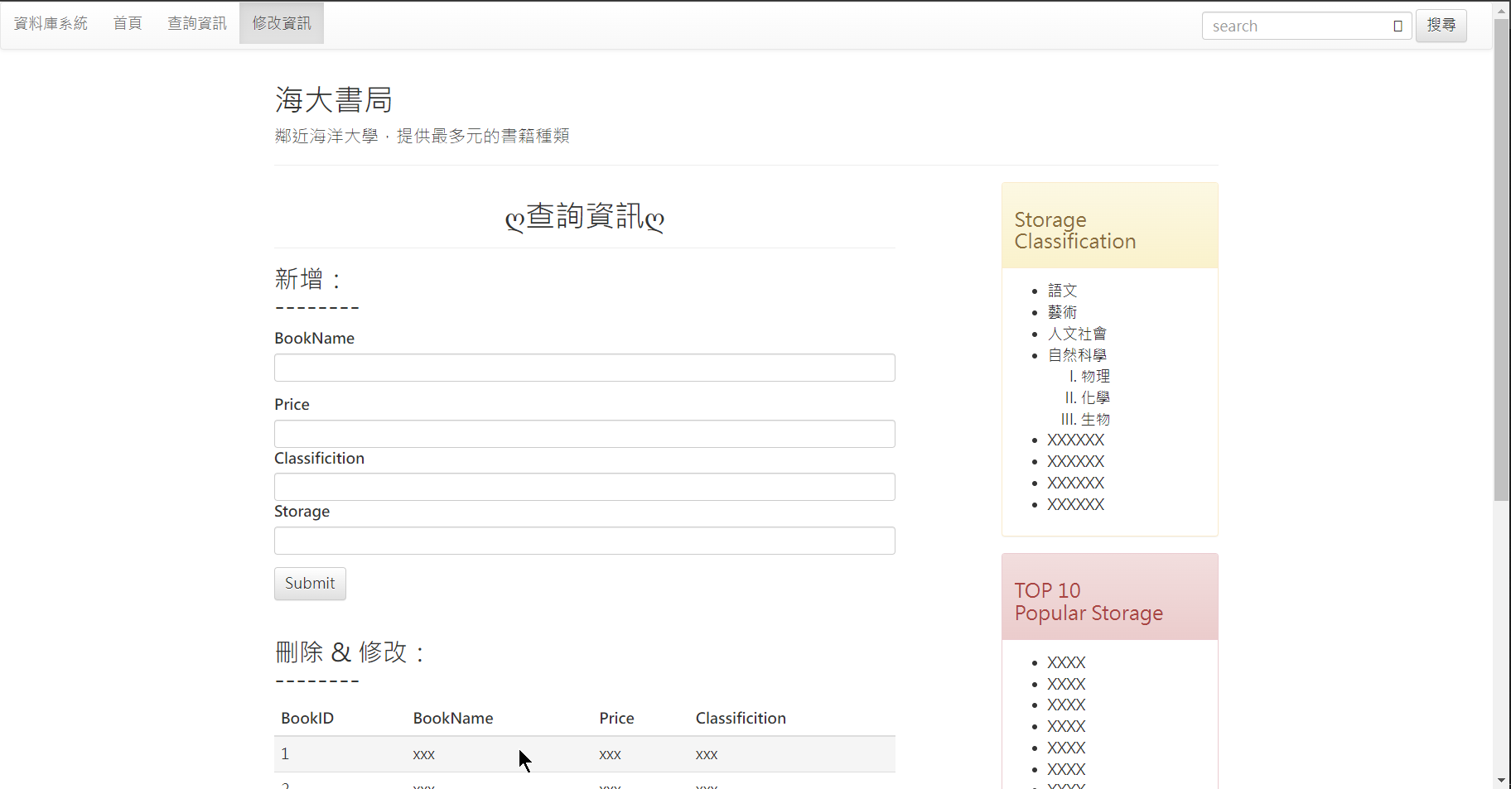

六、工作規劃

1.吳翊楷負責建立資料庫

2.謝翔宇負責首頁、查詢資訊

3.吳秉宸負責前端設計、修改資訊