**MAE 6790 Final Project**

**Wenbo Lou, wl654**

**Abstract**

**Introduction and Numerical method**

The purpose of this project is to plan a path for a mobile sampling vehicle to detect the methane emission along the oil fields production sites over a desired region of interest. The designed path needs to obey the road system as shown in figure 1, and should maximize the measurement value of methane concentration, while minimizing the cost of using the vehicle, such as the energy cost. In specific, the vehicle’s dynamic constraint is stated with equation 1 below,

|  |  |  |
| --- | --- | --- |
|  | $$\dot{q}\left(t\right)= \begin{matrix}\dot{x_{t}} \\ \dot{y_{t}} \\ \dot{θ_{t}}\end{matrix}= \begin{matrix}v\left(t\right)cos⁡θ(t) \\ v\left(t\right)sinθ(t) \\ ω(t)\end{matrix}$$ | () |

where $v and ω$ are the control inputs. The maximum speed of the vehicle is $10km/h$. The initial position of the vehicle is located at $x_{0}=0, y_{0}=5000$, as indicated in figure 1.

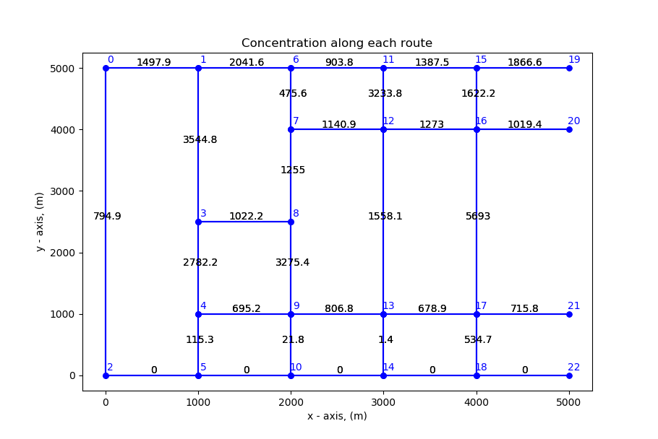

Figure 1. Graph representation of the road system of the oil production field. The nodes are indicated by the blue dots and are labelled accordingly. The concentration of each road is the result of summation of concentration field along the road assuming all wells leaks at high rate, according to the concentration field in figure 2.

Let C denoted the methane concentration in parts-per-million $[ppm]$. The instantaneous measurement can be assumed equal to C, which is a function of the sensor position $\vec{x}$ and time $t$. Assuming all wells are leaking at same high rate, the concentration field shown in figure 2 can be determined using a forward Gaussian dispersion model. The instantaneous cost of operating the robot is assume to be proportional to linear speed $v$. When the concentration field is assumed to remain constant over a period $[t_{0}, t_{f}]$, the sensor objective function can be described as,

|  |  |  |
| --- | --- | --- |
|  | $$J= \int_{t_{o}}^{t_{f}}{\{w_{c}C\left[x\left(t\right), t\right]+w_{d}v[x\left(t\right), t]\}}$$ | () |

where $w_{c}and w_{d}$ are two constant weights to be chosen, which described the trade-off between the measurement value and the cost of operating the sensor vehicle. The final time is assumed to be $T_{f}= \left\{t_{f} \right| 30 mins, 45 mins, 120 mins, 240 mins\}$.

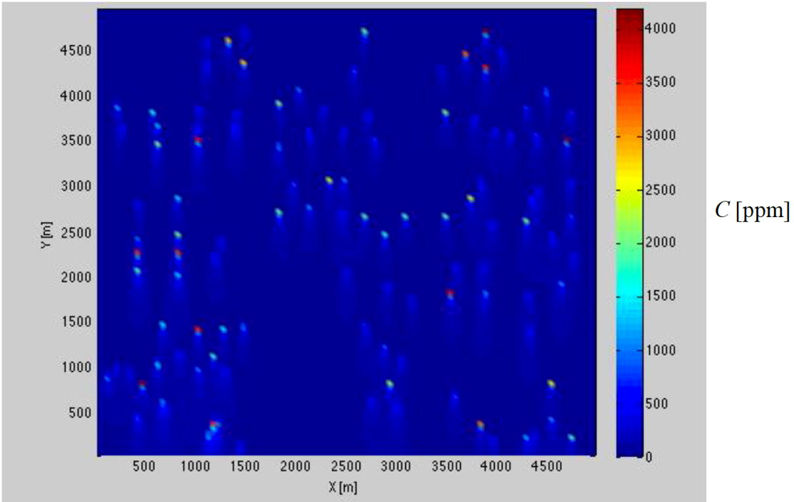

Figure 2. Concentration field generated by forward Gaussian dispersion model assuming all wells leaks at high rate.

The optimal path is first obtained for the concentration field with all well leaks. Then, the same path is tested against the concentration field with only 10% of the wells leaks for the performance in terms of the cost function described by equation 2.

The approach to this problem is by constructing an undirected connected graph $G (N, E)$ from the road system, treating the intersection of roads as nodes $(N)$ on the graph, while the edges $(E)$ are described by the roads connecting the intersections. The labels of the nodes used for this project $(labelled 0 to 22)$ are indicated in figure 1. In figure 1, the accumulated concentrations along the edges are also indicated, which are part of the cost function in equation 2. Then, the natural approach would be searching the graph with different weight on the edges for the maximum cost path. Two graph search methods are attempted to find the maximum cost path, and each has its assumptions and advantages.

1. *Depth-first search*:

The first searching method attempted is the depth-first search method. It’s assumed that the velocity is constant between every two nodes $(N_{i}, N_{j})$, and therefore the cost function in equation 2 can be integrated and expressed as,

|  |  |  |
| --- | --- | --- |
|  | $$J=\sum{w_{c}C_{k}+w_{d}d_{k}}, for k=\{edges in the path found\}$$ | () |

where $d_{k}$ is the length edge $k$, $C_{k}$ is the total concentration along edge $k$, which is shown in figure 1, and the total cost is sum of cost of each edge for the path found. To implement the depth-first search algorithm, the search needs to have a terminal condition, which is defined by the simulation time $t_{f}$. However, to avoid choosing the vehicle speed between every two nodes, which would hugely increase the search space, the maximum distance that the vehicle could cover within the simulation period is used as the terminal condition instead, which can be expressed as,

|  |  |  |
| --- | --- | --- |
|  | $$D_{max}= v_{max}*t_{f}$$ | () |

where $v_{max}=10 km/h$ is the maximum speed of the vehicle. Such simplification could stretch the search and overestimate the number of edges that could be travelled within the time limit, and therefore overestimate the total cost. However, by reducing the search space, the time complexity is also greatly reduced compared to other methods.

**Result**

The average speed is chosen to be $5 km/h$, and the trade-off parameters are chosen to be $w_{d}=1 and w_{c}=-1000$, to balance the value of measurement and the cost of operation the vehicle. Figure 3 shows the optimal path found using the depth-first search method for different terminal time, with all wells leak.

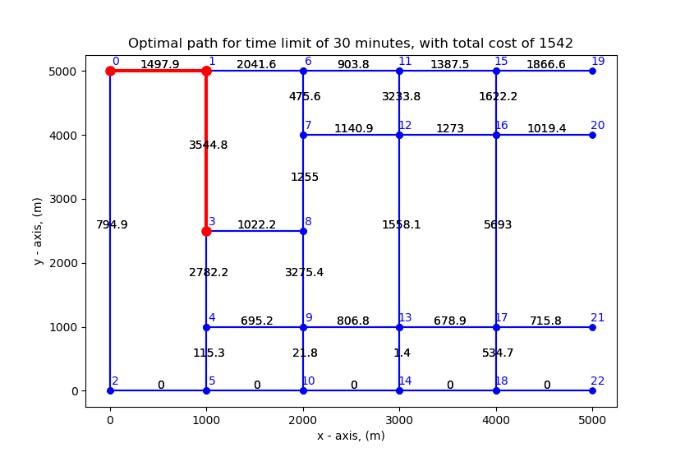 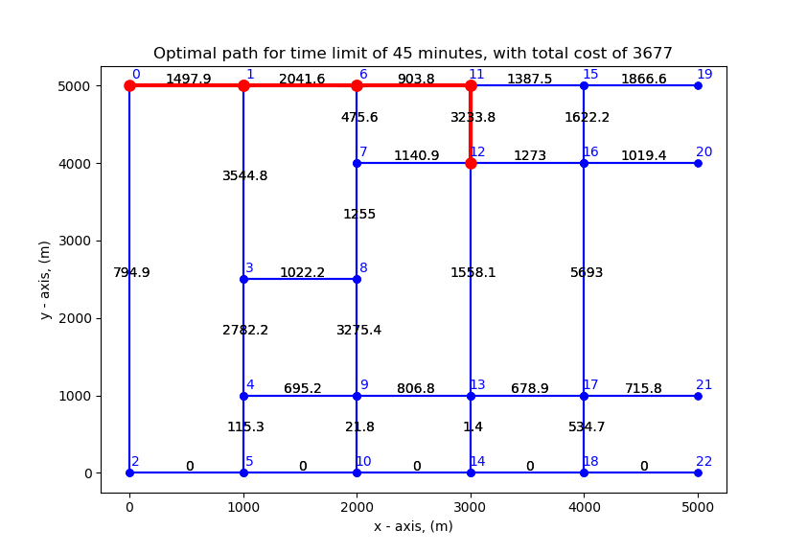

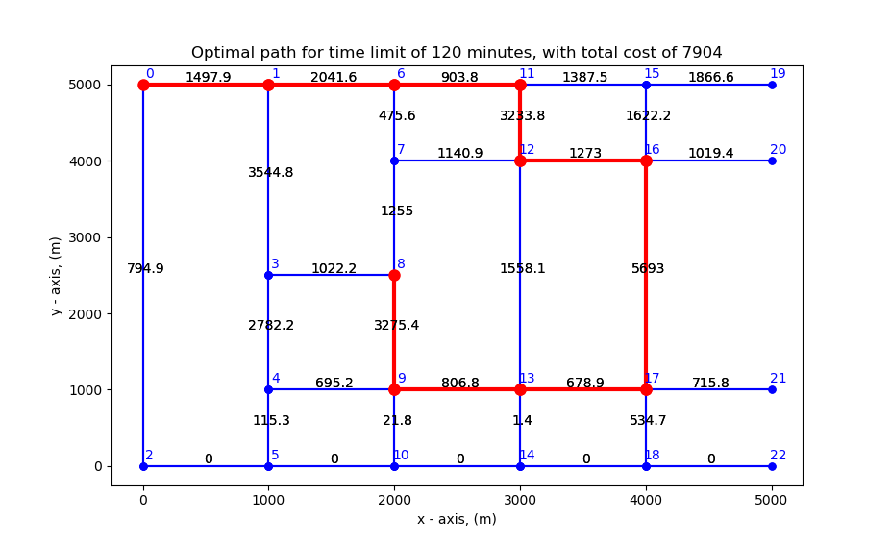 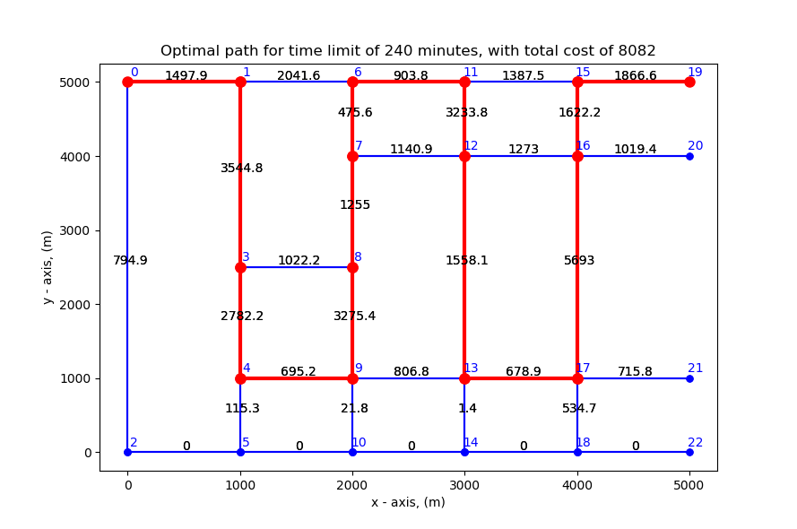

Figure 3. The optimal paths for time limits of 30 mins, 45 min, 120 min, and 240 mins respectively.

The searched paths are then evaluated for the concentration field when only 10 percent of the wells leak.