OBJECTIVES

• Understand the design and operation of a common-source (CS) amplifier.

EQUIPMENT

- 2 each: 2N7000 NMOS FET
- Multiple capacitors
- Various resistors
- Breadboard and various wires
- Digilent Analog Discovery (DAD) Board
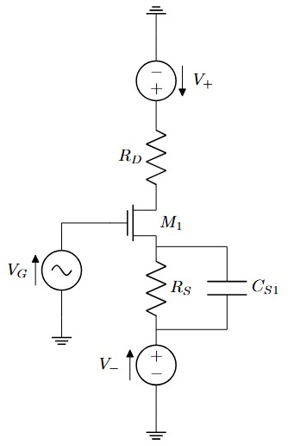
INTRODUCTION

Figure 1
–

MOSFET amplifi
er

- Drain Resistance
In this lab we will manipulate the drain resistor (R_{D}=220 Ω) in circuits like the one above to perform certain functions. For this lab, this includes measuring drain current (I_{D}) and serving as the load resistor in a common-source amplifier.
- Testing/Tools
We will test the circuits two ways:
- With the waveform generator as a DC voltage source
- With a sine wave superimposed on a DC bias voltage.
We will use the scope in two ways as well:
- As a DC voltmeter
- In XY mode to plot V_{out} vs. V_{in}
- Structure
We will first characterize the current-voltage behavior of your MOSFET and then choose a good operating point for the circuit as an amplifier. Then we will characterize the circuit as an amplifier. Finally, we will add a circuit using a negative power supply to set a more stable bias current and characterize the improved circuit. All the circuits will be built using variations on same setup in figure

In-Lab

Part 1: DC-Degenerated Common-Source Amplifier (20 Points)
The amplifier requires a carefully selected DC bias voltage to be added to the input signal. A different FET would likely require a different value. To make the current less dependent on MOSFET parameter variations, we can use a circuit like the one shown below using the negative power supply and a “degeneration” resistor R_{S1} = V_{SS} / I_{DQ} (previous current)
- Build the following circuit in Figure 2 on your breadboard using a 2N7000 Transistor and a R_{S1} = 680 Ω., R_{D} = 220 Ω. (4 Points)
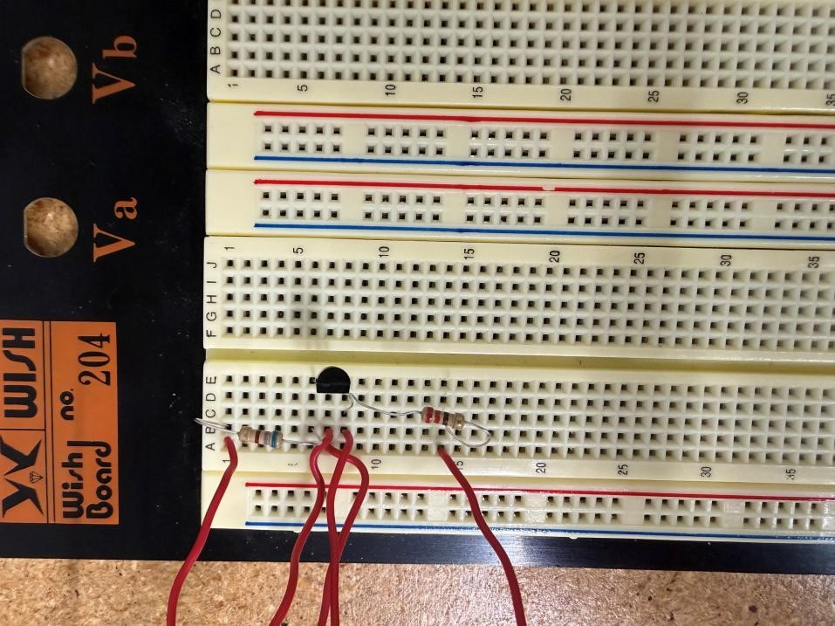
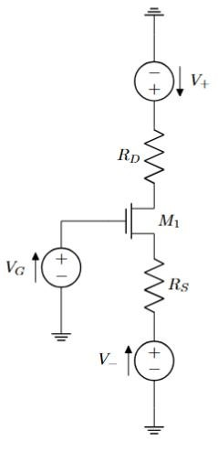
Figure 2 – Common-source amplifier with degeneration.

- Measure the effect of R_{S1} on the voltage transfer curve. Set up WaveGen1 to supply a 10 kHz sinusoid with peak to peak voltage from 1 V to 4 V. Set up the scope in XY mode with Channel 1 (V_{G}) on the x-axis and Channel 2 (V_{D}) on the y-axis. Adjust the input offset and amplitude and the scope sensitivities to get a nice VTC display and insert a screenshot. (2 Points)
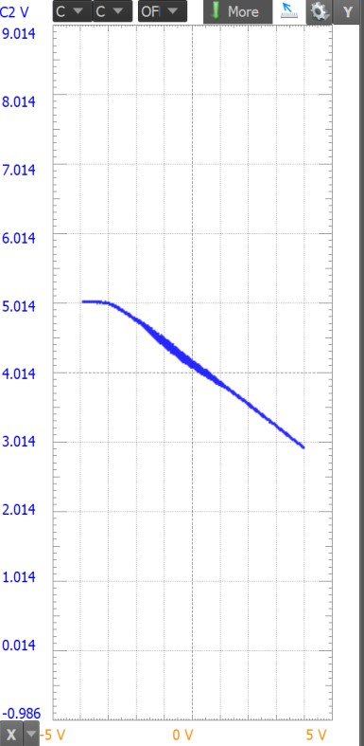

- Using the same setup, swap your 2N7000 for a different one and plot the resulting VTC. Compare the sensitivity to swapping the FET. How does including R_{S} affect the sensitivity to the FET parameters compared to when it wasn’t included in the prelab? (2 Points)
It makes the switch of the FETS not different as it did in the pre-lab.

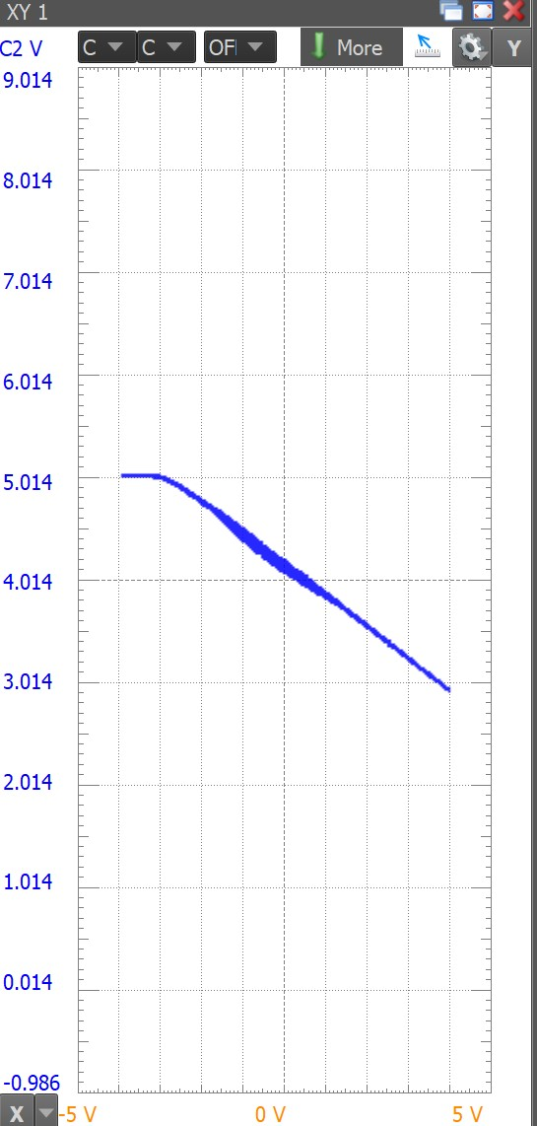

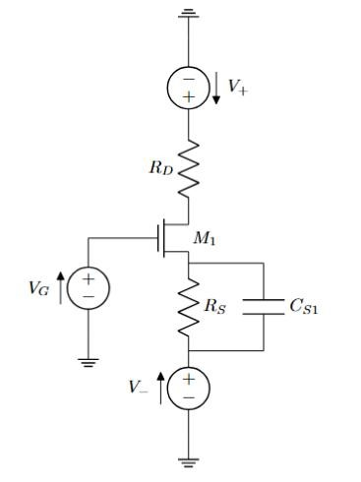
Figure 3 – Common-source amplifier with degeneration (with Bypass capacitor).
- Including R_{S} reduces (degenerates) the voltage gain. To reobtain the voltage gain, add a large-valued bypass capacitor C_{S1} in parallel with R_{S1}. We’ll make C_{S1}’s value and the input frequency large enough that C_{S1} won’t have time to charge or discharge much during half cycles of the input. Add C_{S1} = ~22 uF. Electrolytic capacitors are polarized; connect the + terminal of your capacitor to the higher voltage, not to V_{SS}. Obtain your VTC. (4 Points)
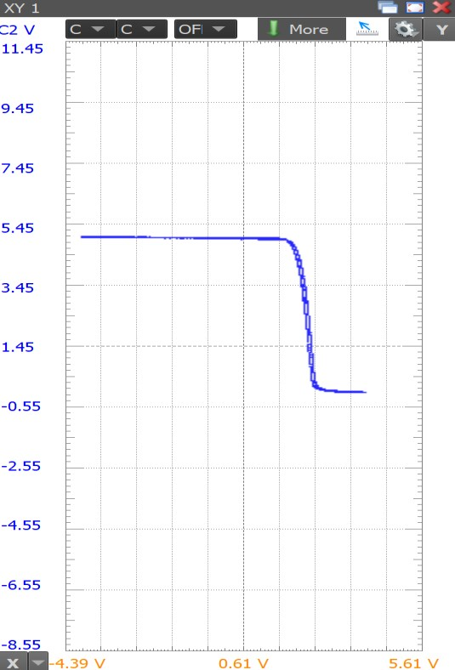

- With WaveGen1, apply a 50 mV 10 kHz sine wave with DC offset = V_{GQ} and for V_{G}. * If the output signal doesn’t look sinusoidal, reduce the input signal amplitude. Measure the amplitudes of the input and output sinusoids v_{o} and v_{i}. Save these waveforms for your report. Compute the voltage gain A_{v} = v_{o} / v_{i}. (4 Points)
Vi = 55.147mVpp, Vo = 342.69mVpp, Av = 342.69/55.147 = 6.21

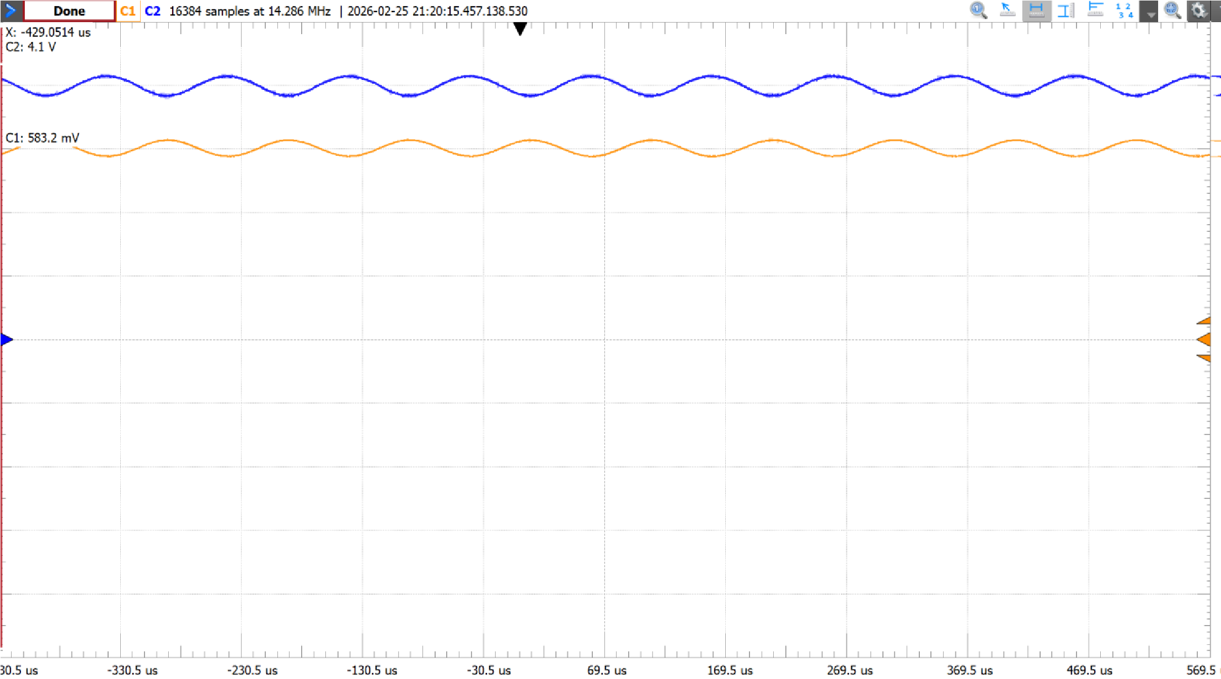

- Use the network analyzer to obtain the frequency response of the circuit. Identify the frequency (f_{z}) at which the gain enhancement due to the capacitor begins and the frequency f_{L} where the gain reaches its maximum (mid-band) value. Also note the upper cutoff (-3dB) frequency f_{H}. (3 Points)
Fz = Around 25Hz
FL = Around 500Hz
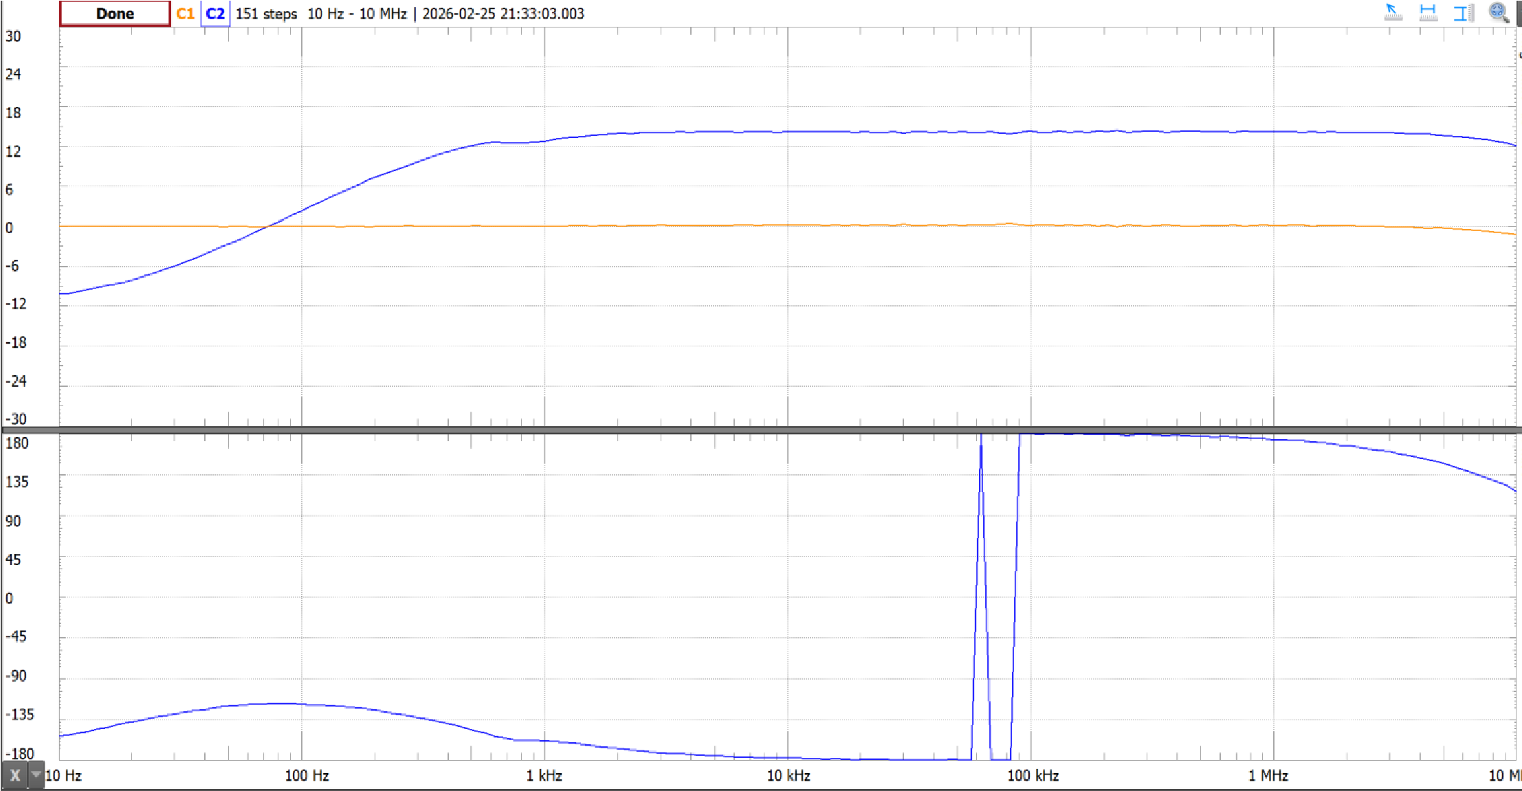
FH = Around 7-8MHz

- What would happen to frequencies f_{Z} and f_{L} if you used a higher-value capacitor for C_{S1}. (1 Point)
They will both go to lower frequencies as we increase C_{S1}

Part 2: AC-Coupled Common-Source Amplifier (3 Points) (Optional)
In this part, the amplifier is modified to use AC coupling at both the input and output while establishing the MOSFET’s DC gate bias with a resistor voltage divider. This configuration allows the amplifier to process small AC signals without disturbing the chosen operating point. This improves signal integrity and makes the circuit more practical for real-world applications.
- Build the following circuit in Figure 3 on your breadboard using a 2N7000 Transistor, R_{S1} = 680 Ω,
R_{D} = 220 Ω, C_{D1} = 1 uF, C_{G1} = 1 uF, and CS₁ = 22 uF. Choose values for R_{B1} and R_{B2} to set V_{G} = V_{GQ}, while keeping their parallel combination > 100 kΩ. (1 Point)
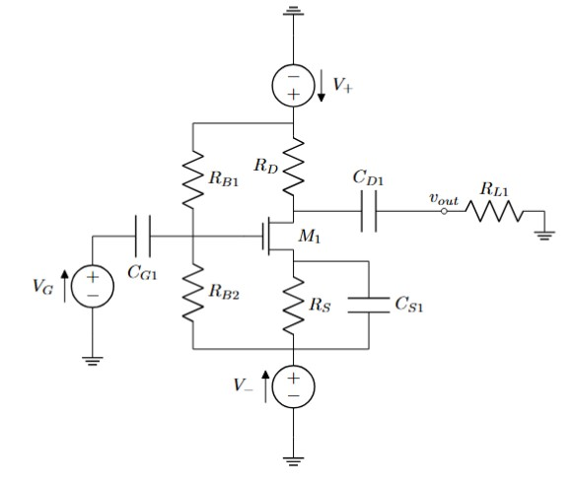
Figure 4 – AC-coupled common-source amplifier.
- Put WaveGen1 in DC mode and slightly shift V_{G} while observing V_{G} and V_{D}. If it’s working right, the circuit should return to your operating point after every change. Apply a 50 mV 10 kHz sine wave for
VG. As before, if the output signal doesn’t look sinusoidal, reduce the input signal amplitude. (1 Point)

- Measure the amplitudes of the input and output sinusoids. Take note of these waveforms for your report. Compute the mid-band voltage gain. (1 Point)

