Objectives

- The objective of this lab is to understand several building blocks commonly used in transistor circuit design and to learn about their limitations.
- Reinforce concepts learned in the design of common-source, common-gate, and common-drain amplifiers by applying them to analyze building blocks such as the differential pair and the current mirror.

Equipment

- CD4007UBE transistor array ICs
- Breadboard and various wires
- Various resistors
- Digilent Analog Discovery (DAD) Board

Introduction

In this lab we will be using the CD4007UBE transistor array. Each CD4007UBE array contains three NMOS and three PMOS transistors. They are arranged in NMOS/PMOS pairs as shown below. Each NMOS/PMOS pair is connected slightly differently, which constrains how we can connect the transistors. Use the following layout in figure 1 below to build your circuits.
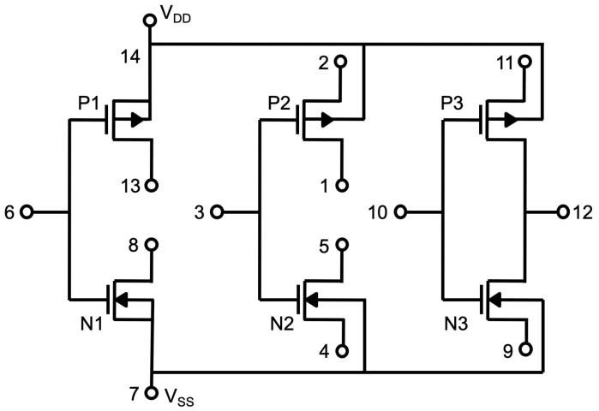
Figure 1 – CD4007UBE Layout
We will only use a few transistors on each chip. The other FETs we will leave “floating” (disconnected). However, on each chip, pins 14 and 7 must always be connected to the positive and negative supply voltages V_{DD} and V_{SS} respectively. These pins are internally connected to the sources of transistors N1 and P1, as well as to the substrates of the other MOSFETs in the chip. The biasing is required so that all of the transistors are isolated by reverse-biased PN junctions. In this lab, we will connect the circuits from the prelab to create op-amp functionality using MOSFETs.

In-Lab

Part 1: Differential Pair with Active Load (10 Points)
*Measure all the currents and voltages using the lab equipment and not the DAD board.
* Use the lab equipment for the supplies unless directed otherwise by your TA.

- Remove the R_{D} resistors from your differential pair and R₂ and R_{X} from your current mirror, and connect the two circuits as shown below:
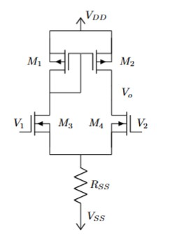
Figure 2 – Differential Pair with Active Load

Insert a picture of your breadboard. (1 Point)
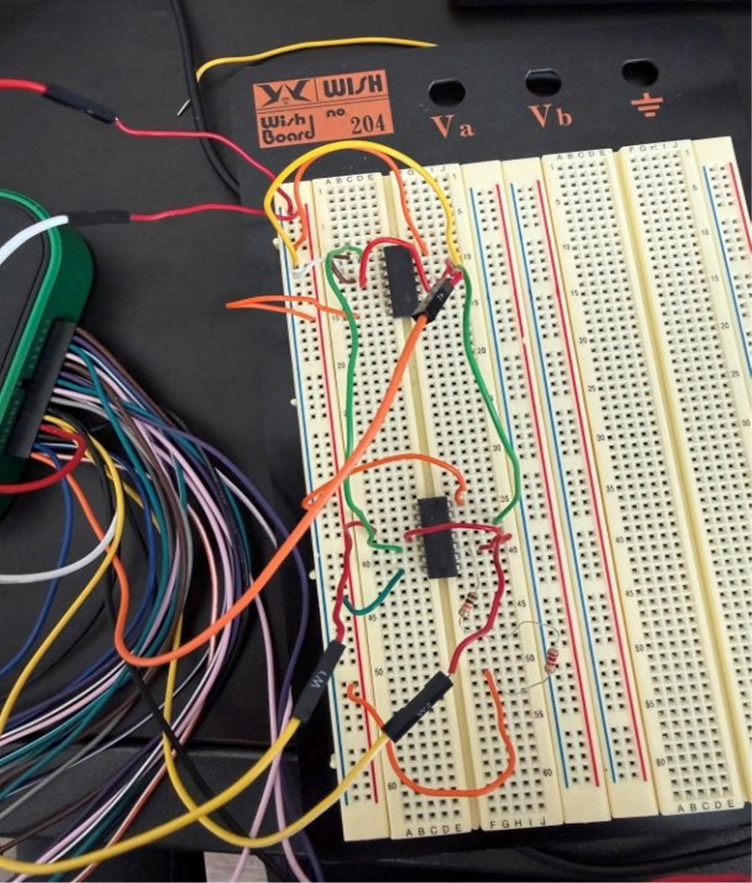

- Using the power supplies, apply the same DC voltages V1 and V2 used for biasing in Part 2 (II). Measure Vo (DC). Are transistors P3 and N3 both operating in the active region? (1 Point)
Yes, they are since the voltage is coming through

- Try to find a combination of DC voltages whose average is approximately 0 V, and so that V_{o} is approximately equal to the measured drain voltage of P2, (Vo should be in the range of approximately 1 V to 3 V). As in Pre-Lab Part 2 III, this differential voltage is the offset voltage V_{OS}. Record your measured V_{OS}. (2 Points)

V1= -20mV
V2= 20mV
Vos=(-20mv) – (20mv)= -40mV
Vo = 1.6V

- Connect the circuit as shown below. Set V_{Y} equal to drain voltage of P₂. Use R_{X} = 1 kΩ as a current sensing resistor (ammeter). Measure V_{X} and use the measured value of R_{X} to find the output current I_{out} = V_{X}/R_{X}. Adjust the DC value of V_{in} = V_{OS} so that I_{out} = 0. Add a 50 mV, 1 kHz sine wave to V_{in} and measure the transconductance G_{M} as the ratio of the amplitude of I_{out} to the amplitude of V_{in}. (2 Points)

V_{xpp} = 83.374mV, amplitude = 41.687mV
V_{OS} = -40mV
I = 41.687mv/1k ohm = 41.687uA
GM = 41.687uA/50mV = 834uS

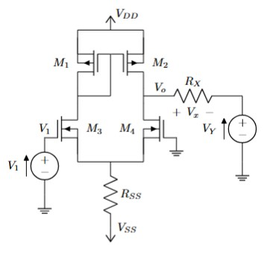
Figure 3 – Differential Pair with Active Load with impedance matching

- Using the same connection and without changing the DC bias, increase the amplitude of the 1 kHz sine wave input signal and plot I_{out} vs. V_{in} as an XY plot. (2 Points) * Scope > View > Add XY Plot.
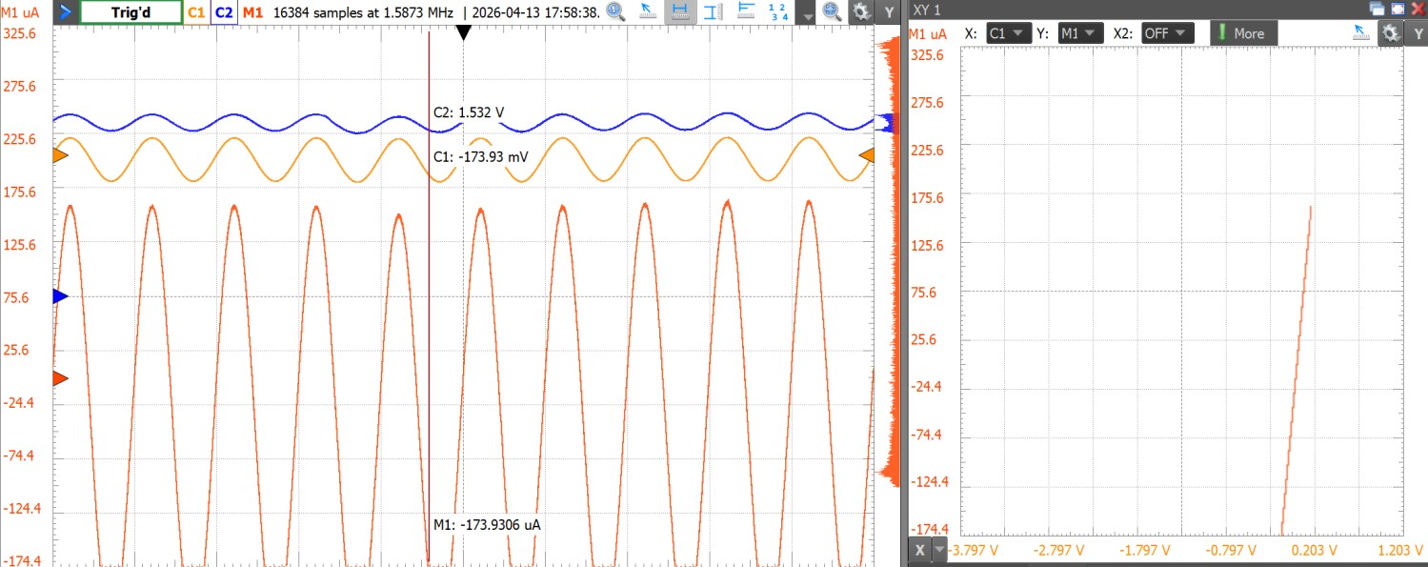
200mV amplitude

- Using the same connection and without changing the DC bias, turn off the sine wave input signal and add a 400 mV 1 kHz sine wave to V_{Y}. Measure the output resistance as the ratio of the amplitude of V_{o} to the amplitude of I_{out}. (2 Points)

V_{op} = 0.81067V

V_{xpp} = 30.723mV

R_{out} = 1k * 0.81607 / 0.030723 = 26.4kohm

Part 2: Op-Amp Functionality (10 Points)
- Connect the circuit as a voltage follower, as shown below, and observe how it biases itself automatically. Record the DC offset voltage (V_{o} – V_{in}). Add a 1 kHz 100 mV sine wave to V_{in} and measure the voltage gain as the ratio of the amplitude of V_{o} to the amplitude of V_{in}. (3 Points)
V_{OS} = 1.586-1.5V=0.086V = 86mV
V_{inpp} = 232.87mV, Vopp = 229.18mV
A_{V} = 229.18/232.87 = 0.98
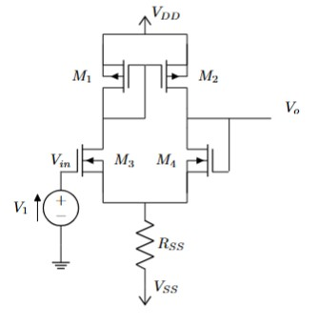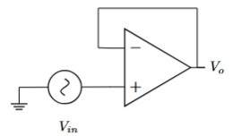

Figure 4 – Single-Ended Differential Amplifier with an Active Load

- Connect the circuit as a non-inverting amplifier using R₁ = 1 MΩ, R₂ = 2.2 MΩ. Verify that your circuit behaves as a nearly ideal op amp. * Verify by observing the theoretical and experimental gain.
(3 Points)
Theoretical gain = 1 + R2/R1 = 1 + 2.2Mohm/1Mohm = 3.2
Experimental gain = Vo/Vi = Vopp/Vinpp = 515.39mV / 226.53mV = 2.28 (gain)
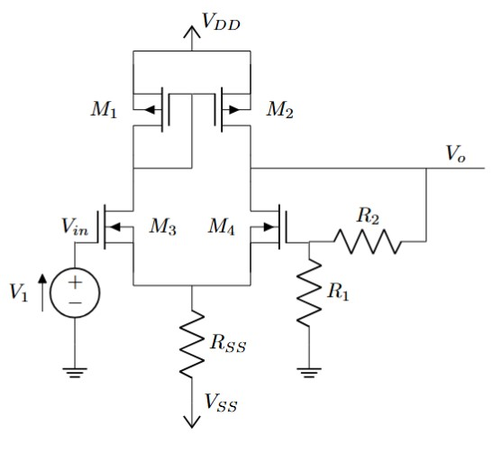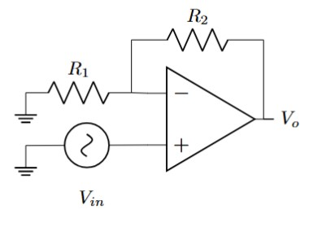
Figure 5 – Non-Inverting Amplifier connection
III. Now that you have connected the circuit as a voltage follower and a non-inverting amplifier design an inverting amplifier using R₁ = 1 MΩ, R₂ = 2.2 MΩ. Verify that your circuit works as a nearly ideal op amp. (4 Points)
V_{inpp} = 123.23mV
V_{op} = 226.34mV
Av = 226.34/123.23 = 1.84 = -1.84
Av = -R1/R2 = -2.2Mohm/1Mohm=-2.2
Close to ideal, better than the non-inverting

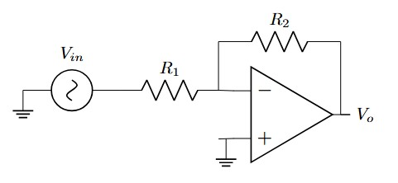
Figure 6 – Inverting Amplifier Connection

