REQUIREMENTS NOT MET
N/A
PROBLEMS ENCOUNTERED
N/A
HOMEWORK EXERCISES
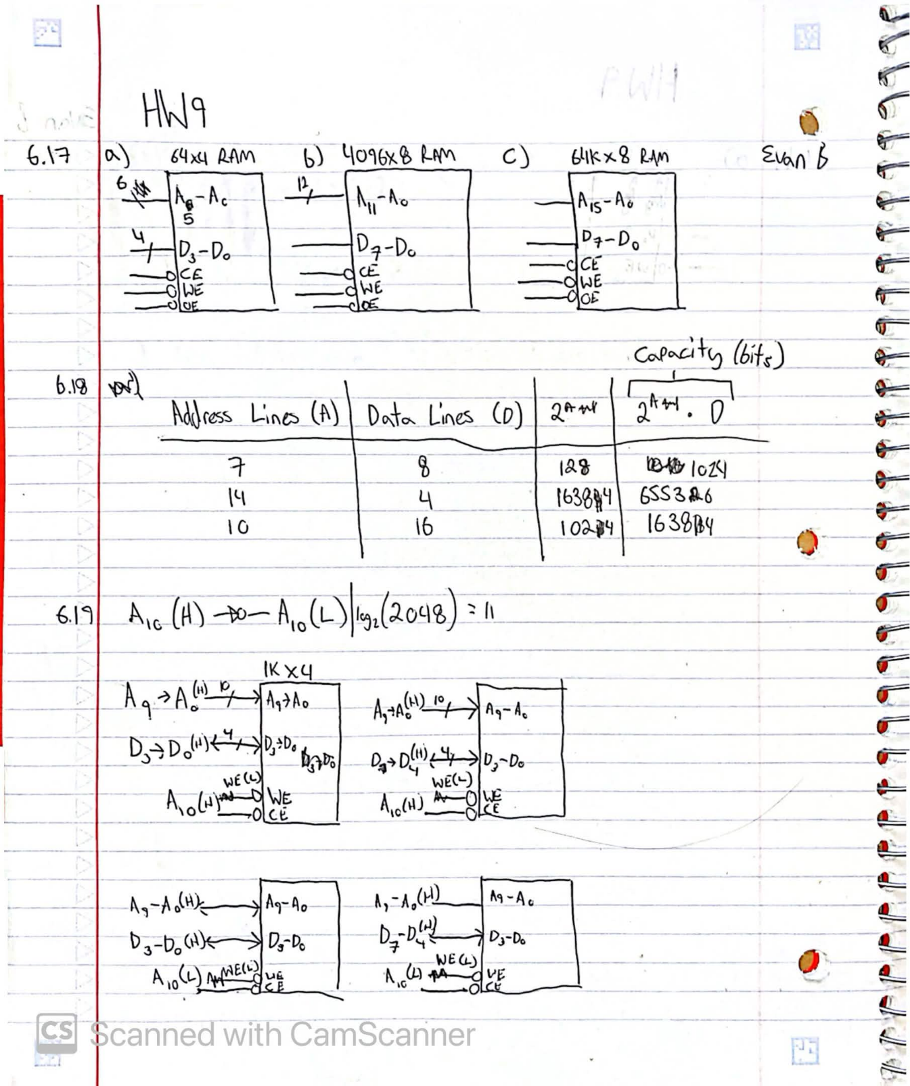
Figure 1: Homework 9 Q 6.17 - 6.19
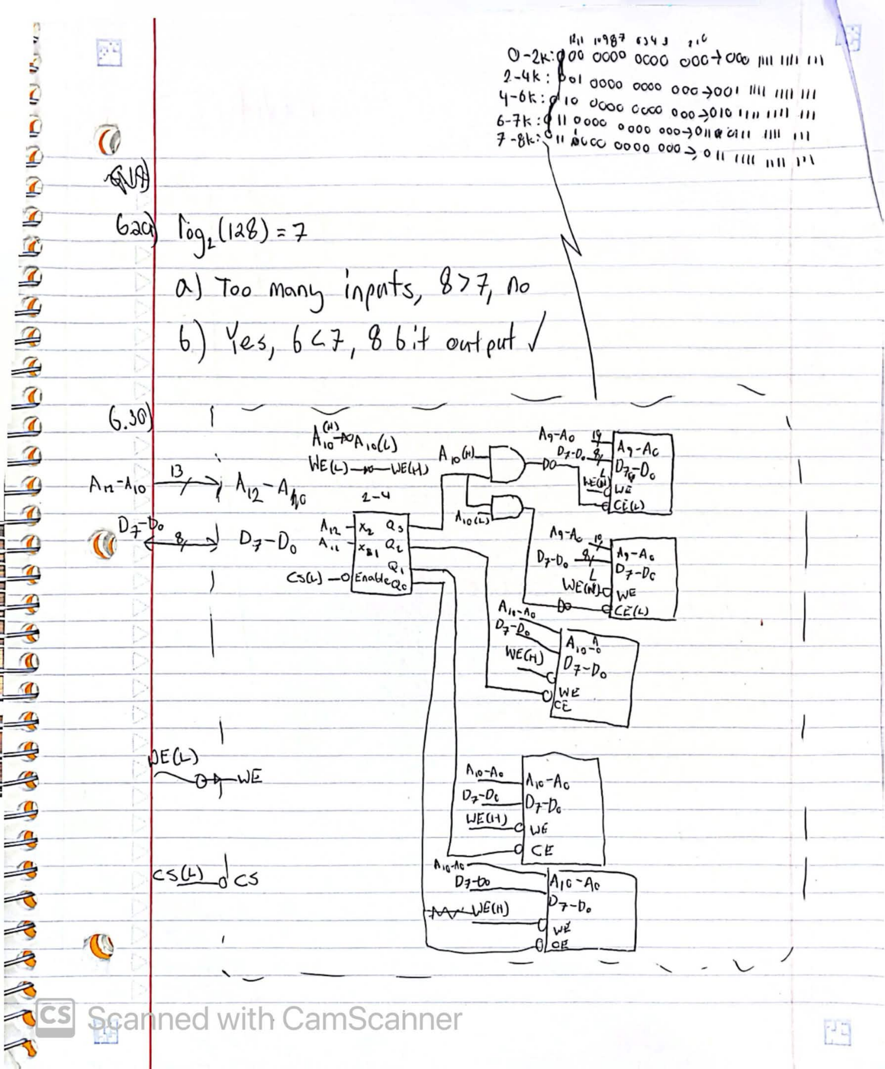
Figure 2: Homework 9 Q 6.29 & 6.30

