Objectives
- To review basic operational amplifier applications and explore some of their limitations.
Equipment
- Breadboard and various wires/jumper
- Various resistors
- Digilent Analog Discovery (DAD) Board
- Capacitors (10 pf, 22 pf, 56 pf, 100 pF or similar values)
- LM741CN Op Amp
- CA3130EZ Op Amp
Introduction
- Essential Terminology: These terms will be bolded throughout the lab.
  - C_{C}: Compensation Capacitor, this prevents oscillations in the CA3130 Output.
  - β: Feedback Factor, be careful, there are multiple β’s you will encounter in electrical engineering!
  - mVpp: Millivolt peak to peak. This is double the value of amplitude.
  - Saturation: In the context of op-amps, saturation occurs when the output voltage exceeds the op-amp supplies (V₊ and V₋).
  - V_{OS}: DC Voltage offset error intrinsic to an op-amp. This is a non-ideality.
  - A_{OL}: Open Loop gain of an op-amp. Ideally this is infinite, allowing an engineer to control the closed loop gain via negative feedback.
  - Decade: In the context of a log scale, this multiplies a value by a factor of 10. In this lab, that is the frequency. Example: On the frequency axis, it could read out 10 Hz, 100Hz, 1000Hz, etc.

- The Network Analyzer:
  - This program is a feature of the DAD Board and automatically plots the frequency response of a system. You can control the minimum and maximum frequency that is processed.
  - Usually, we use a logarithmic scale for the frequency.
  - To make sure your signals are doing what you expect, you should open a small scope window (View > Time) when the network analyzer is active.
  - The following will go in depth on how the Network Analyzer Functions (Supplemental)
    - It first applies a sine wave with amplitude V₁ (V) and frequency f_{min} (Hz).
    - There is a wait time to allow the output of the amplifier to settle.
    - The scope then records the output waveform and calculates the gain V_{o}/V₁ and the phase difference between V_{o} and V₁.
    - The gain and phase measurements are plotted on the screen and the frequency of the input is incremented. This process is repeated until the input frequency reaches f_{max}.
    - You have control over f_{min}, f_{max}, and the amplitude of the input V₁.
Pre-Lab
Part 1: AC Limitations of Op Amps (10 Points)
- Bandwidth Limitations:
Review the formula discussed in class that predicts the -3dB bandwidth of an op amp-based amplifier. Where $A_{OL}×β$ is the DC loop gain and $f_{1}$is the open-loop pole frequency of the op amp. The LM741 op amp typically has a bandwidth of $f_{CL}=$ 1.5 MHz when connected as a voltage follower….
$$f_{CL}=f_{1}×A_{OL}×β$$
In other words, the Gain Bandwidth Product of 1.5 MHz means:
(amplifier’s gain) $×$ (amplifier’s bandwidth) < 1.5 MHz
and
(Gain Bandwidth Product) / (amplifier’s gain) = (amplifier’s bandwidth)
e.g. 1 MHz / (gain of 25) = 40 kHz bandwidth

For this section we are building a non-inverting amplifier with R₁ = 1 kΩ and R₂ = 55 kΩ such that the gain should be 56 V/V.
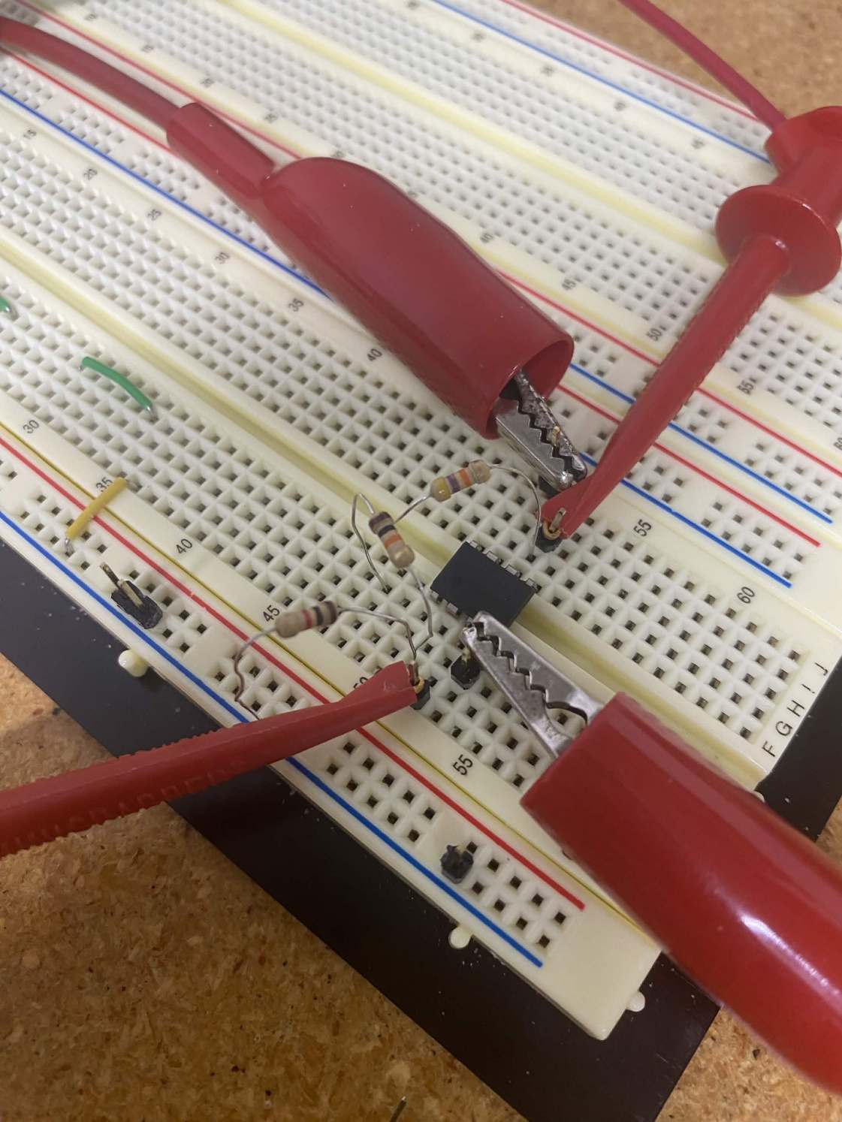

- Using the function generator, create an input signal of 100 mV_{pp} at 1 kHz. Observe the output on the scope and take a picture. What gain are you getting? (2 Points)
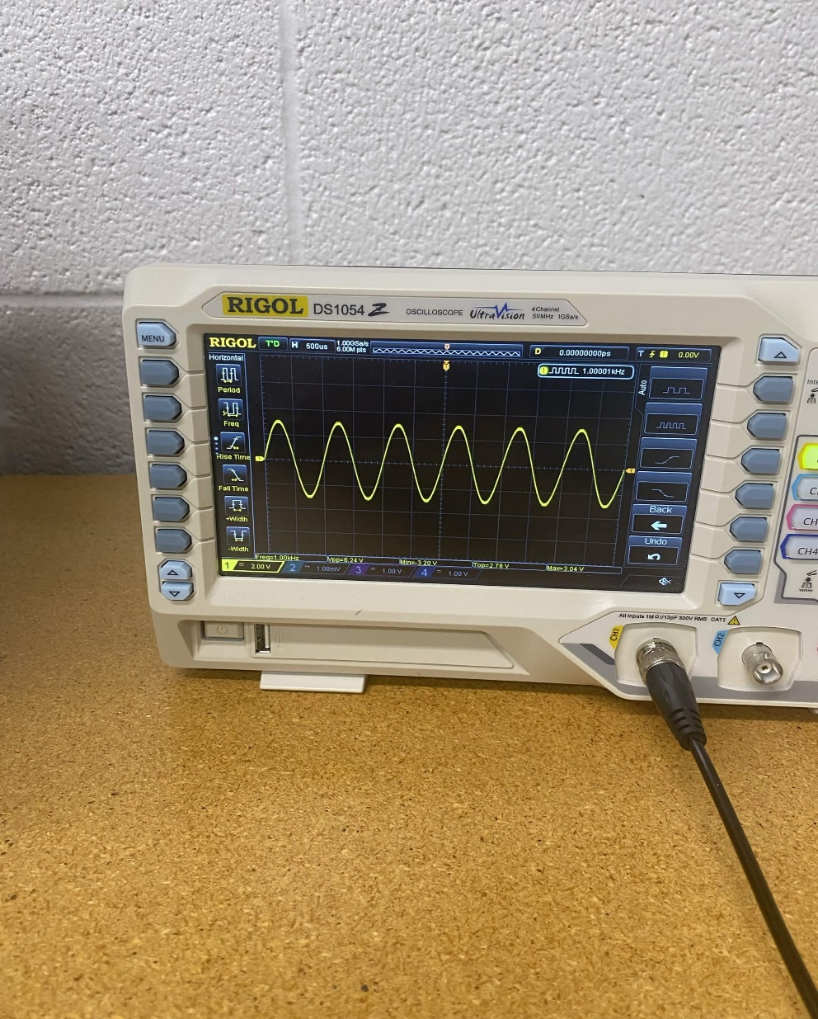
62.4 gain
- Repeat this step for input frequencies of 4 kHz, 10 kHz, and 100 kHz. What is occurring and why is it happening. Compare your results to Equation 4. (1 Point)
4k: 61.6
10k: 57.6
100k: 15.2
Gain rolloff from high-frequency operation of an op-amp with limitations of op-amp bandwidth.

Now configure an inverting op amp configuration with R₁ = 1 kHz and R₂ = 1 kHz. Use network analyzer to plot closed-loop frequency responses from 100Hz to 5MHz on a logarithmic scale. (1 Point)
To ensure V_{out} does not saturate:
- Set the input amplitude at a low value, try less than 50 mV_{pp}
- View the output on the scope to ensure it isn’t saturating.

- Change R₂ to 4 kΩ, 10 kΩ, 100 kΩ. Save the four plots. Note the DC gain and the -3 dB bandwidth f_{CL} in each case. (1 Point)

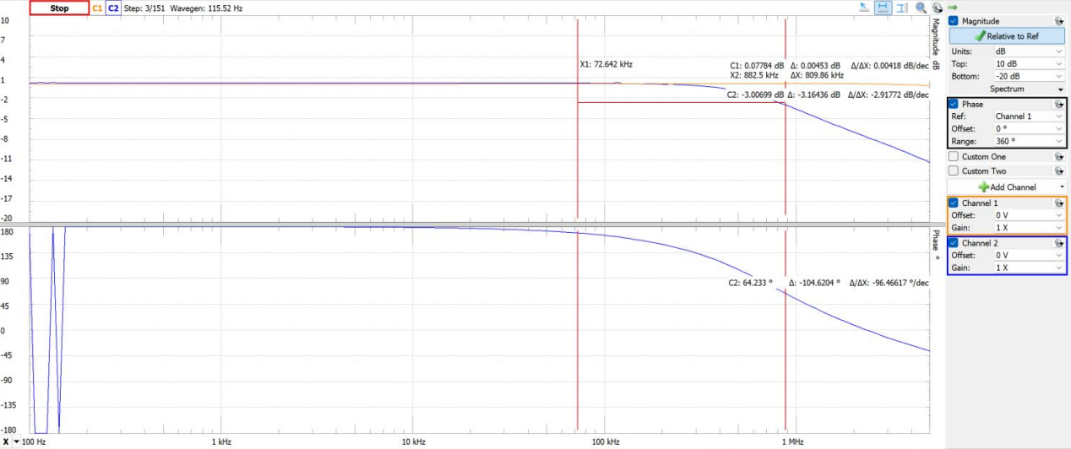
-3dB at 809kHz
DC Gain = 0.183dB
- Compensation:
Feedback circuits are prone to oscillation, producing uncontrolled high frequency signals that can interfere with circuit operation. Such oscillations can be avoided by adding small-value capacitors to the circuit, a process called compensation.
Substitute a CA3130EZ op amp for the 741. The pinouts are the same but the 3130 requires a compensation capacitor C_{C} to be added between pins 1 and 8. The 741 is internally compensated, meaning C_{C} is inside the IC. Use C_{C} = ~56 pF or something close to 56 pF (100 pF would work).
- Connect a CA3130 op amp as an inverting amp with a closed loop gain of A_{CL} = -100 (R₁ = 1 kΩ, R₂ = 100 kΩ). Does the amplifier work? (2 Points)
Yes it gives us a gain
- Now temporarily remove C_{C} and observe V_{out}. What if anything happens? (1 Point)
It breaks as the capacitor now longer regulates the mosfets and it is causing it to randomly flip.
- Connect the CA3130 op amp as a voltage follower (short R_{F} with a jumper wire and remove R₁). Does the circuit work? (1 Point)
Yes.
- Now temporarily remove C_{C} and observe V_{out}. What if anything happens? (1 Point)

Loses stability and oscillates super fast.

Part 2: Difference Amplifier (5 Points)
The difference amplifier amplifies the difference between two input voltages. To obtain a better understanding of how the circuit works, you will simulate the circuit in LTSpice.
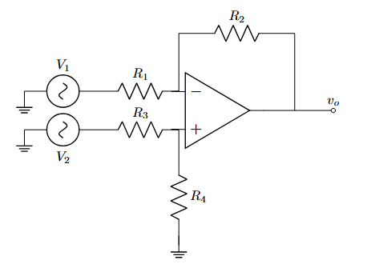
Figure 1 – Difference Amplifier
The differential mode voltage (v_{dm}) and the common mode voltage (v_{cm}) are defined as:
v_{dm} = v₂ – v₁
v_{cm} = (v₂ + v₁)/2
These new voltages relate to the output voltages linearly. The new relationship is as follows:
v_{o} = A_{cm} v_{cm} + A_{dm} v_{dm}
For A_{cm} and A_{dm}, we can determine them analytically and find that with respect to the circuit in figure 5, we have that:
$$A_{cm}=\frac{R_{1}R_{4}-R_{2}R_{3}}{R_{1}\left(R_{3}+R_{4}\right)}$$
$$A_{dm}=\frac{R_{4}\left(R_{1}+R_{2}\right)+R_{2}(R_{3}+R_{4})}{{2R}_{1}(R_{3}+R_{4})}$$
When the two input voltages are the same, they drive the differential mode term to zero. This means that the common mode voltage only shows up in the equation when the two inputs are the same voltage with the same polarity. If there is no common mode or differential mode gain, then that term will be disregarded in calculating v_{o}. This however, only holds true for ideal difference amplifiers.
The common mode gain and the differential mode gain can be used to determine the common mode rejection ratio (CMRR). The CMRR is a measure of how close the circuit is to being ideal and is stated mathematically as:
CMRR = |A_{dm}/A_{cm}|
A high CMRR is the overall goal because a large CMRR means that the common mode voltage will have almost no impact on the output voltage. This is necessary because of the nature of the common mode voltage. When the two input voltages have the same value this is typically a result of electrical “noise.” A high CMRR means that this interference will have very effect on the operation of the circuit.

- Assuming that the op amp is ideal, use superposition to find V_{out}: (1 Point)
V+ * (1 + R2/R1) = V2(R4/(R3 + R4))((R1+R2)/R1)
- Assume R₃ = R₁ and R₄ = R₂, find V_{out}. (0.5 Points)
R2/R1 * (V2-V1)

- Simulate the difference amplifier circuit in LTSpice using the Universal2 Op Amp along with the values in Figure 5 for the resistances. Insert a screenshot of the schematic.
Use the following values: R₁ = 1 kΩ; R₂ = 23 kΩ; R₃ = 1 kΩ; R₄ = 22 kΩ. (0.5 Points)

Set V_{in1} and V_{in2} to 1 V and -1 V respectively. Run a transient simulation and plot and save the inputs and the output. (0.5 Points)
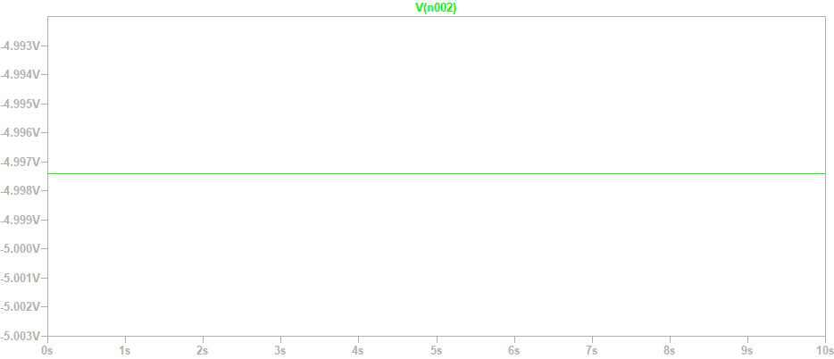
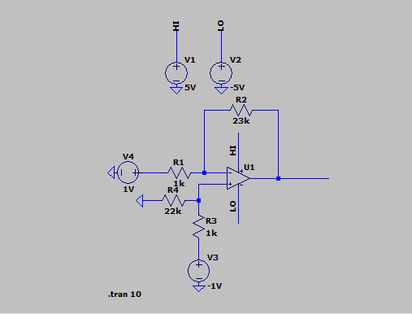
- What is the differential gain: A_{dm} = (V_{out}/(V_{in1}-V_{in2})). How does this compare to using the equation provided above for A_{dm.} (0.5 Points)
R4(R1+R2)+R2(R3+R4) / (2R1(R3+R4)) = 22.978
- Now change the inputs so that they are both 1 V (V_{in1} =V_{in2}). Plot and save the output. (0.5 Points)
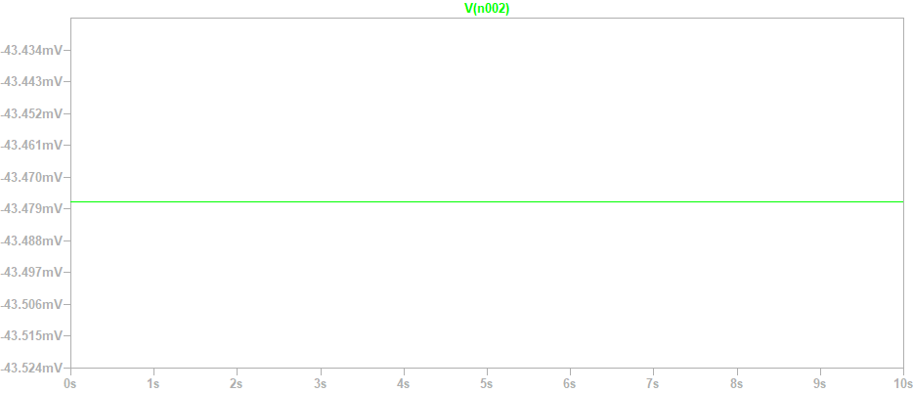
- What is the common mode_{(CM)} gain: A_{cm} = V_{out}/ V_{in1} = V_{out}/ Vin2. How does this compare to using the equation above. (0.5 Points)
0
- Calculate the CMRR using the equation provided. (1 Point)
(R1R4 – R2R3) / (R1(R3+R4)) = -0.0435
- Repeat this procedure on your breadboard in order to find the experimental CMRR. Take note of A_{dm}, A_{cm}, and CMRR and any measurements used to calculate these values. Set the input voltages as needed to prevent saturation and to obtain proper V_{outs.} (1 Point)

Part 3: Summing Amplifier (5 Points)
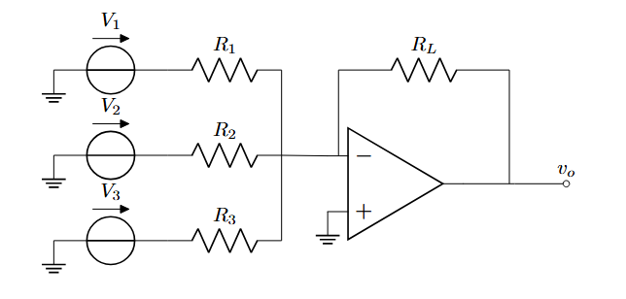
Figure 2 - Summing Amplifier
- Solve the following circuit for V_{out} by hand with respect to the variables in figure 2. (2.5 Points)
Vout = -RL (V1/R1 + V2/R2 + V3/R3)
- With the following values, create the circuit in figure _ in LT Spice and confirm your findings using both the formula you obtained as well as spice.
V₁ = 10 V; V₂ = 2 V; V₃ = 5 V; R₁ = 1 kΩ; R₂ = 50 Ω; R₃ = 20 Ω; R_{L} = 560 Ω; (2.5 Points)

Theoretical: -168V
Real: -10V (output limit / rail probably)
