Objectives
- The objective of this lab is to apply the concepts learned in class about diodes to create a voltage reference.
Equipment
- 1N4148 switching diodes
- Breadboard and various wires
- Various resistors
- Digilent Analog Discovery (DAD) Board
- LTspice and Waveforms
Introduction
Per sources, a voltage reference is an electronic device that ideally produces a fixed voltage irrespective of the load on the device, power supply variations, temperature changes, etc. We can see how good a simple voltage reference is by characterizing it using the following methods.
- The line regulation of a voltage reference is a characteristic which measures how much the output voltage will change given a change in the supply voltage.
- Output resistance is an important characteristic of a voltage reference. Sometimes the output resistance is captured in a parameter called load regulation. Load regulation captures the change in output voltage due to a change output current over the range of expected currents.
- Voltage reference’s ability to suppress unwanted noise at the V_{in}.

In-Lab
Part 1: Characterization of a Voltage Reference (5 Points)
- Measure V_{D} (V_{out}) and I_{D} from the circuit you built in the prelab. You can measure the voltage across R_{X} (300Ω) and calculate the current with that value. Record your measurements. (1 Point)
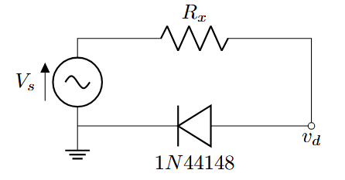
Figure 1 – Diode Example III

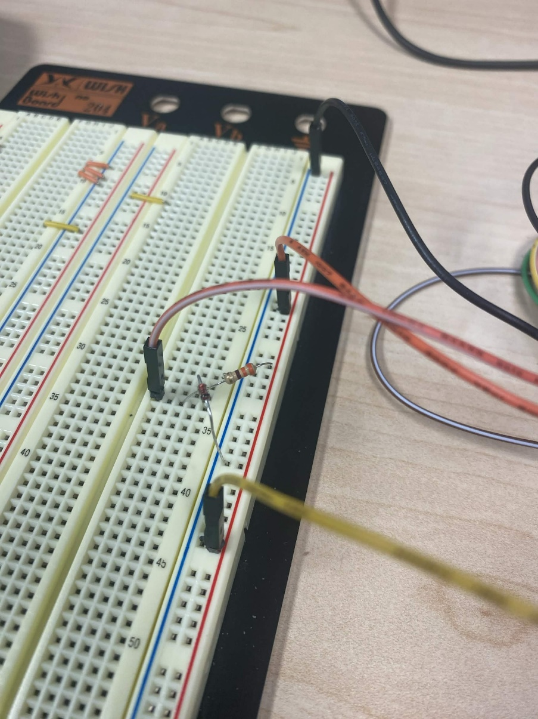

- Measure the line regulation. Set V_{in} to 4 V and measure the output voltage. Then set V_{in} to 5 V and measure the output voltage. Use the formula below to calculate the line regulation of your reference voltage. (1.5 Points)

$$Line Regulation=\frac{∆V_{out}}{∆V_{supply}}×100\%=\frac{.8-.75}{5-4}×100\%=5\%$$

- Measure the load regulation. Measure V_{D} with a V_{in} of 4 V and no load attached. Then attach a 1 kΩ resistor to draw roughly 700 uA from the voltage reference and measure V_{D}. Use the formula below to calculate the load regulation. Use a typical V_{out} of 0.697 V . (1.5 Points)
$$Load Regulation=\frac{.732-.728}{.695}×100\%=.5755\%$$

- Lastly, the voltage reference’s ability to suppress unwanted noise at the supply. (1 Point)
- Replace the diode with a resistor R_{D} with a value of 4.25 Ω calculated using the DC operation point.
- Apply a 100mV 60 Hz sine wave with a DC offset of 4 V to V_{in}.
- Measure the average amplitude at V_{D} and calculate the gain/ attenuation from V_{in} to V_{D}.
~50mV Vd
Gain = .5/4 = 0.0125
Part 2: Full Bridge Rectifier (5 Points)
To rectify both half-cycles of a sine wave, the bridge rectifier uses four diodes, connected together in a “bridge” configuration. The secondary winding of the transformer is connected on one side of the diode bridge network and the load on the other side.
During positive half cycle of the source, diodes D1 and D2 conduct while D3 and D4 are reverse biased. This produces a positive load voltage across the load resistor (note the plus-minus polarity across the load resistor).
During the next half-cycle, the source voltage polarity reverses. Now, D3 and D4 are forward biased while D1 and D2 are reverse biased. This also produces a positive load voltage across the load resistor as before.
Note that regardless of the polarity of the input, the load voltage has the same polarity and the load current is in the same direction. In this way the circuit converts the AC input voltage to the pulsating DC output voltage

- Simulate the circuit in Figure 2 in LT Spice. Pick an ample R_{L} to achieve a proper output for the full bridge rectifier. Apply a 5-V peak, 60-Hz sine wave and, using an oscilloscope, observe the voltage across R_{L}. Examine the waveform, including amplitude and time values. Take a screenshot of this waveform. (2 Points)
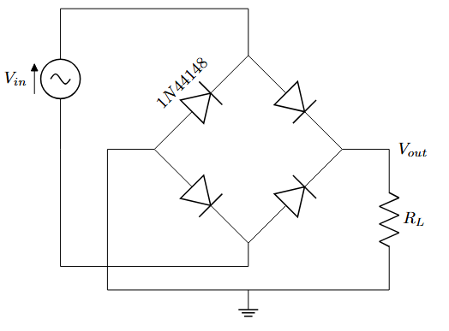
Figure 2 – Full Wave Rectifier
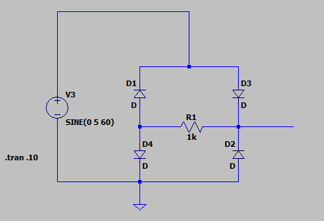
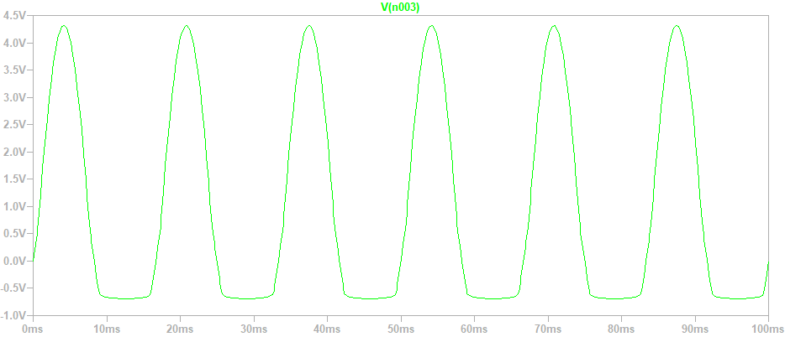

- Now create this circuit on your breadboard. Capture screenshots to verify the output of the circuit. (2 Points)

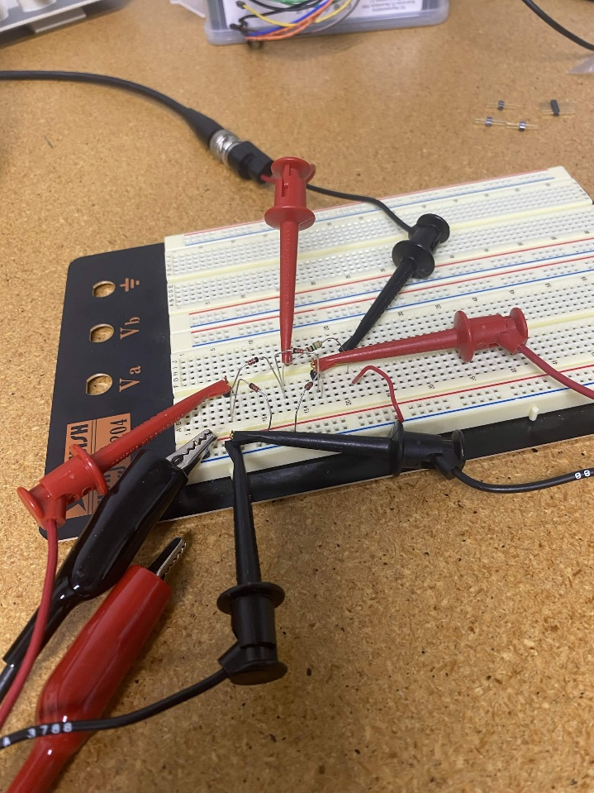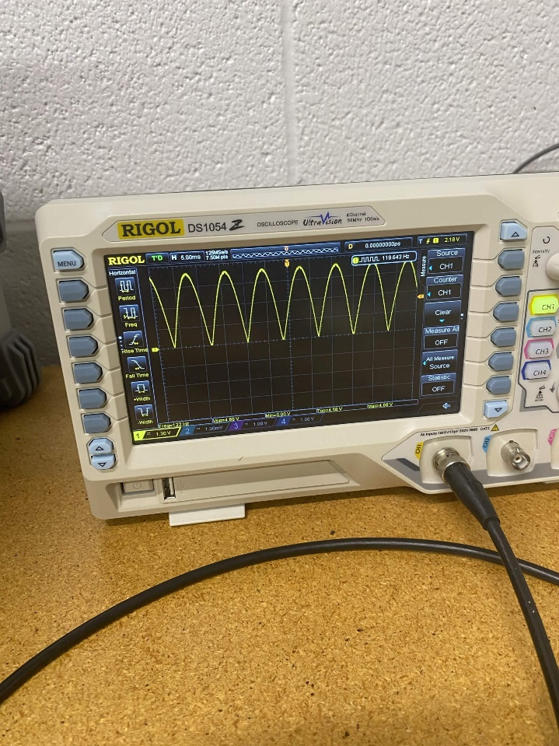
- Now add a capacitor in parallel with R_{L}, observe its effects. What kind of circuit have we created? (1 Points)

A smoothed rectified circuit, where if there is ever a loss of power the capacitor will donate charge; it also combats high frequency noise and shorts it to ground, decoupling it.
Part 3: Cockcroft-Walton Voltage Multiplier (10 Points)
By cascading voltage doublers in a certain way, we can continue to increase the output voltage; this is illustrated in Figure 8. These circuits are called Cockroft-Walton voltage multipliers. Using a large input voltage and many stages of multiplication, DC voltages up to 2 MV (2 million volts) have been demonstrated using such devices.
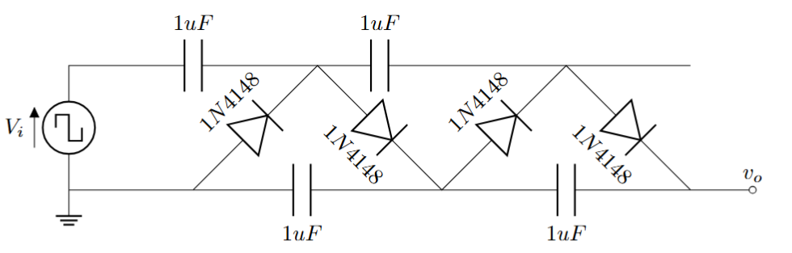
Figure 3 - CW circuit

- Create the following circuit in LTspice with a 5 V amplitude, 1 kHz square wave. Run a simulation and display the output with comparison to the input in separate panes. Also obtain the current output at all 4 of the capacitors. (4 Points)
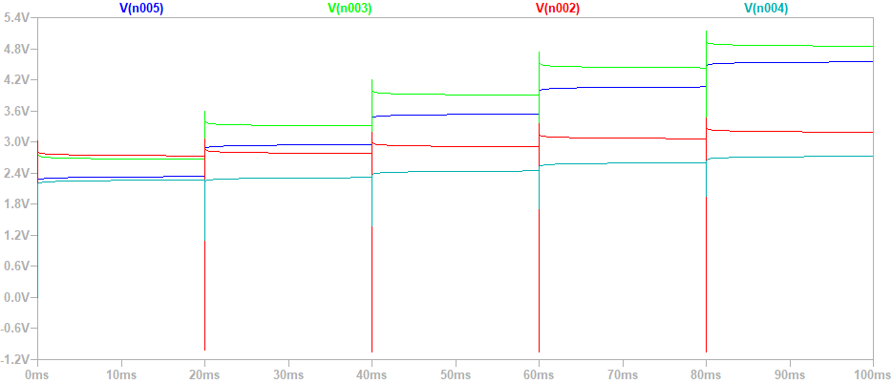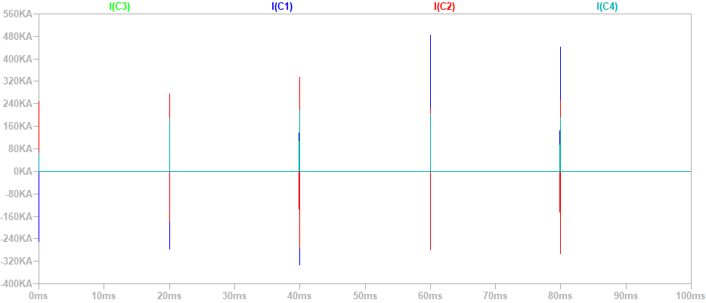
- Now build the same circuit on your breadboard and compare the output to the simulation with respect to V_{o}. (4 Points)
Lost images, we did it in lab

- Pick out one or more features of the circuit to experiment with, this includes the capacitances, input frequency/amplitude, etc. and describe if there is any relationship between such features of the circuit; you could even increase the number of cycles in the circuit. Experiment with this either on the breadboard, LTspice or both. Show some of data to prove your findings. (1 Point)
If we increase the frequency enough the capacitors become shorts.

Proof:
