REQUIREMENTS NOT MET
None
PROBLEMS ENCOUNTERED
None Encountered
FUTURE WORK/APPLICATIONS
In this lab, we learn how to do interrupts from an input! This allows us to have simultaneous actions within our loop with our interrupt firing as necessary; leading to much more efficient and modular programming! This further allows us to make more advanced machines and programs for the microprocessor, maybe a controller for a TV or a key fob!

PRE-LAB EXERCISES
- Assuming that no interrupt has been previously configured, devise and describe a generalized series of steps for configuring any interrupt within the ATxmega128A1U, i.e., not just an interrupt within the TC system. Explain what happens in hardware (in other words, without the programmer’s intervention) when the processor detects and then services (and returns from) an interrupt. Be as specific as possible, referencing certain registers when appropriate. You can assume that the reti instruction does not count as programmer intervention. You may provide a flowchart as a response, if desired.

To configure any interrupt on the ATxmega128A1U, the programmer must first initialize the Stack Pointer (SP) so the hardware can save the return address on the data stack. Every interrupt requires a defined hardware trigger and an assigned priority level.

For timer triggers, this involves setting the period register (TCXn_PER), selecting a clock (TC_CLKSEL_DIVn_gc), and enabling the overflow level in TCXn_INTCTRLA, which causes the hardware to set the overflow interrupt flag (OVFIF) in TCXn_INTFLAGS upon hitting the period value.

For external inputs, we must initialize the relevant GPIO, along with the Input/Sense Configuration bits (ISC[2:0]) in PORTX_PINnCTRL which are configured to detect edge transitions, which automatically sets an interrupt flag (INT0IF or INT1IF) in PORTX.INTFLAGS when triggered.

Once the chosen level is enabled in PMIC.CTRL and interrupts are globally active with the sei instruction, a valid trigger causes the CPU to pause execution, push the Program Counter onto the stack, and vector to the interrupt address (e.g., TCC0_OVF_vect). Upon an interrupt occurring the SREG enables the global interrupt flag.

Because each vector is only four bytes wide, it simply contains an RJMP instruction to the main interrupt program. While the hardware automatically clears OVFIF when vectoring to a timers interrupt, the programmer must explicitly clear the port flags by writing 1 to PORTX.INTFLAGS inside a ports interrupt to prevent immediate re-triggering upon exit. Once the interrupt is fully exited using reti, the SREG disables the global interrupt flag.
PSEUDOCODE/FLOWCHARTS
LAB3_1:
.include “ATxmega128A1Udef.inc”
.org 0
.rjmp MAIN

.org interruptVector
rjmp INTERRUPT

.org 0x0100
MAIN:
setup Stack Pointer
rcall IO initialization
rcall TC initialization
rcall PMIC initialization
sei

LOOP:
rjmp LOOP

DONE:
rjmp DONE

; SUBROUTINES & INTERRUPT SERVICE:
IO:
push registers
load 1 to registers
store register to PORTC Direction
pop registers
return

TC:
push registers
load TCC0_PER with calculated period for 47ms
load TCC0_CTRLA with the correct prescaler & TC_OVFINTLVL (LO/MED/HI)
pop registers
return

PMIC:
push registers
enable relevant level interrupts in PMIC_CTRL (PMIC_(LO/MED/HI)LVLEN_bm)
pop Registers
return

INTERRUPT:
push registers
load SREG
push SREG
load 1 to PORTC_OUTTGL
pop SREG
store SREG
pop registers
return
LAB3_2a:
.include “ATxmega128A1Udef.inc”
.org 0
.rjmp MAIN

.org interruptVector
rjmp INTERRUPT

.org 0x0100
MAIN:
setup Stack Pointer
rcall IO initialization
rcall PMIC initialization
sei

LOOP:
rjmp LOOP
DONE:
rjmp DONE

; SUBROUTINES & INTERRUPT SERVICE:
IO:
push registers
load 0b00000100
store to PORTF_DIRCLR ; Set S1 on the SLB to input (PF2)
load 0xFF
store to PORTC_DIRSET ; Set all of PORTC to output
invert all outputs to PORTC
load 0x02 to ISC (lower three bits of PORTF_PIN2CTRL) ; To trigger on falling edge (active-low switch)
load (1<<2) to PORTF_INT0MASK ; to use INT0 flag as our interrupt
load 1 to PORTF_INTCTRL ; (INT0 = [1:0], 0 = OFF, 1 = LO, 2 = MED, 3 = HI)
pop registers
return

PMIC:
push registers
load PMIC_LOLVLEN_bm to PMIC_CTRL
pop Registers
return

INTERRUPT:
push registers
load & Push SREG
use a dedicated register for counting (R20)
inc r20
cpi r20, 255
brne NO_RESET
load 0 to r20 ; reset r20
NO_RESET:
sts r20, PORTC_OUT
clear interrupt flag
pop & store SREG
pop registers
reti

LAB3_2b:
.include "ATxmega128A1Udef.inc"

.org 0
rjmp MAIN

.org PORTF_INT0_vect ; Vector for S1 switch (Debounce start)
rjmp DEBOUNCE_INTERRUPT

.org TCF0_OVF_vect ; Vector for Debounce Timer (Increment)
rjmp INC_INTERRUPT

.org 0x0100
MAIN:
setup Stack Pointer
rcall IO_INIT
rcall POLL_TC_INIT ; Initialize 47ms polling timer
rcall DEBOUNCE_TC_INIT ; Initialize stopped 40ms debounce timer
rcall PMIC_INIT
sei

LOOP:
read TCD0_INTFLAGS
if OVF flag is NOT set, rjmp LOOP
toggle PD6 (Blue LED)
clear OVF flag
rjmp LOOP

DONE:
rjmp DONE
; SUBROUTINES:
IO_INIT:
push registers
set PF2 to input
set PORTC to output
set PD6 to output
invert pins 0-7 of PORTC
set PF2 pin control for falling-edge detection
set PORTF_INT0MASK to include PF2
set PORTF_INTCTRL to enable Low-Level interrupts
pop registers
return
POLL_TC_INIT:
push registers
load 47ms period into TCD0
set TCD0_CTRLA to enable timer (div8)
pop registers
return
DEBOUNCE_TC_INIT:
push registers
load Period for 40ms into TCF0_PER
set TCF0_INTCTRLA to enable Low-Level interrupts
set TCF0_CTRLA to OFF
pop registers
return
PMIC_INIT:
push registers
load PMIC_LOLVLEN_bm into PMIC_CTRL
pop registers
return
; INTERRUPT SERVICES
DEBOUNCE_INTERRUPT:
push registers, Push SREG
disable PORTF interrupts (to lock out switch)
start TCF0 timer
pop SREG, Pop registers
reti

INC_INTERRUPT:
push registers, Push SREG
stop TCF0 timer
reset TCF0 count
clear TCF0_INTFLAGS
if PF2 is high,
rjmp SKIP_INC (active-low, noise)

inc r20
cpi r20, 256
brne NO_RESET
load 0 to r20
NO_RESET:
store r20 to PORTC_OUT
SKIP_INC:
clear PORTF_INTFLAGS
enable PORTF interrupts
pop SREG, Pop registers
reti

PROGRAM CODE
Lab3_1:
/*
Lab3.asm
Created: 6/4/2026 9:46:41 AM
Author : Evan Baesler

ABSTRACT: We are utilizing timers to cause an overflow flag every 47ms
which will trigger an interrupt, strobing an LED (toggling GPIO.)

OBJECTIVES: (1) Initialize Stack Pointer at SRAM end.
(2) Determine IO direction (singular pin)
(2) Start timer with a 47ms loop
(3) Check for OVFIF flag, and rjmp to an interrupt when checked
(4) Clear flag
*/

.include "ATxmega128A1Udef.inc"

.org 0
rjmp MAIN

.org TCC0_OVF_vect
rjmp INTERRUPT

.org 0x0100
MAIN:

ldi r16, low(RAMEND)
sts CPU_SPL, r16
ldi r16, high(RAMEND)
sts CPU_SPH, r16
; Stack Pointer initialized, we can use subroutines for
; IO/TC initialization!

rcall IO_INIT
rcall TC_INIT
rcall PMIC_INIT
sei

LOOP:

rjmp LOOP

DONE:
rjmp DONE

; -----------
; SUBROUTINES
; -----------

IO_INIT:
push r16

ldi r16, 0x01
sts PORTC_DIRSET, r16 ; PORTC_DIR -> 0x01 -> Output on PC0

pop r16
ret

TC_INIT:
push r16

; SCF = 2MHz, PRE = 8, D = 47*10^-3, PER = 11750 Ticks
ldi r16, low(12050)
sts TCC0_PER, r16
ldi r16, high(12050)
sts TCC0_PER+1, r16 ; Set period of 47ms

ldi r16, TC_CLKSEL_DIV8_gc
sts TCC0_CTRLA, r16 ; Start counting with div8 prescaler

ldi r16, TC_OVFINTLVL_LO_gc
sts TCC0_INTCTRLA, r16 ; Set the TC to low priority interrupt

pop r16
ret

PMIC_INIT:
push r16

; Enable Low-Level Interrupts in the PMIC
ldi r16, PMIC_LOLVLEN_bm
sts PMIC_CTRL, r16

pop r16
ret
; ---------
; INTERRUPT
; ---------

INTERRUPT:
push r16
lds r17, CPU_SREG
push r17

ldi r16, 0x01
sts PORTC_OUTTGL, r16

pop r17
sts CPU_SREG, r17
pop r16
reti

Lab3_2a:
/*
Lab3.asm
Created: 6/7/2026 3:02:45 PM
Author : Evan Baesler

ABSTRACT: We are utilizing S1 on the OOTB SLB with interrupts to do a binary
counter from 0 - 255, and then resetting back down to 0.

OBJECTIVES: (1) Initialize Stack Pointer at SRAM end.
(2) Utilize subroutines to initialize IO & PMIC
(3) Clear counter register (r20)
(4) IO: Set PF2 in, PORTC out, invert PORTC, connect PF2 to LOLVL INT0
(5) PMIC: Enable LOLVL interrupts
(6) sei to do global interrupt enable
(7) INTERRUPT: Push registers, push CPU_SREG to save flags, check if
r20 = 255, reset to 0 if true, increment r20 if false. Send value
to PORTC LEDs; clear interrupt flags, restore CPU_SREG to initial
value
*/

.include "ATxmega128A1Udef.inc"

.org 0
rjmp MAIN

.org PORTF_INT0_vect
rjmp INTERRUPT

.org 0x0100
MAIN:

ldi r16, low(RAMEND)
sts CPU_SPL, r16
ldi r16, high(RAMEND)
sts CPU_SPH, r16

clr r20 ; clear counter
rcall IO_INIT
rcall PMIC_INIT
sei

LOOP:
rjmp LOOP

DONE:
rjmp DONE

; SUBROUTINES

IO_INIT:
push r16
ldi r16, (1<<2) ; bit 2 for PORTF (PF2)
sts PORTF_DIRCLR, r16
ldi r16, 0xFF
sts PORTC_DIRSET, r16

ldi r16, PORT_INVEN_bm
sts PORTC_PIN0CTRL, r16
sts PORTC_PIN1CTRL, r16
sts PORTC_PIN2CTRL, r16
sts PORTC_PIN3CTRL, r16
sts PORTC_PIN4CTRL, r16
sts PORTC_PIN5CTRL, r16
sts PORTC_PIN6CTRL, r16
sts PORTC_PIN7CTRL, r16

lds r16, PORTF_PIN2CTRL ; we do not want to overwrite any defaults for the register
andi r16, 0b11111000 ; setting 010 to ISC[2:0], to create falling-edge ctrl
ori r16, 0b00000010
sts PORTF_PIN2CTRL, r16

ldi r16, 0x01
sts PORTF_INTCTRL, r16 ; create low-level interrupt

ldi r16, (1<<2)
sts PORTF_INT0MASK, r16 ; sets pin 2 to interrupt 0 on PORTF

pop r16
ret

PMIC_INIT:
push r16
ldi r16, PMIC_LOLVLEN_bm
sts PMIC_CTRL, r16
pop r16
ret

; INTERRUPT
INTERRUPT:
push r16
lds r16, CPU_SREG
push r16

inc r20 ; dedicated counting register
cpi r20, 255
brne NO_RESET
clr r20 ; reset
NO_RESET:
sts PORTC_OUT, r20
ldi r16, 1
sts PORTF_INTFLAGS, r16 ; clear INT0IF
pop r16
sts CPU_SREG, r16
pop r16
reti

Lab3_2b:
/*
Lab3.asm
Created: 6/7/2026 3:56:44 PM
Author : Evan Baesler

ABSTRACT: We are utilizing S1 on the OOTB SLB with interrupts to do a binary
counter from 0 - 255, and then resetting back down to 0; simultaneously
we will strobe our blue LED on and off every 47ms. This differs from
lab3_2a by adding a timer-based debounce to the switch S1.

OBJECTIVES: (1) Initialize Stack Pointer at SRAM end.
(2) Utilize subroutines to initialize IO & PMIC
(3) Clear counter register (r20)
(4) IO: Set PF2 in, PORTC out, invert PORTC, connect PF2 to LOLVL INT0
(5) PMIC: Enable LOLVL interrupts
(6) sei to do global interrupt enable
(7) INTERRUPT: Push registers, push CPU_SREG to save flags, check if
r20 = 255, reset to 0 if true, increment r20 if false. Send value
to PORTC LEDs; clear interrupt flags, restore CPU_SREG to initial
value. Utilize a debounce to ensure no double-firing.
*/

.include "ATxmega128A1Udef.inc"

.org 0
rjmp MAIN

.org PORTF_INT0_vect ; When PF2 is pressed, we start a debounce timer.
rjmp DEBOUNCE_INTERRUPT

.org TCF0_OVF_vect ; When the above timer reaches OVF, we increment.
rjmp INC_INTERRUPT

.org 0x0100
MAIN:

ldi r16, low(RAMEND) ; Stack Pointer Initialization
sts CPU_SPL, r16
ldi r16, high(RAMEND)
sts CPU_SPH, r16

clr r20 ; Clear Binary Counter

; Initialization Subroutines
rcall IO_INIT ; Enable PF2 as input, PD6 & PC out.
rcall POLL_TC_INIT ; Initialize 47ms TC for Blue LED PWM
rcall DEBOUNCE_TC_INIT ; Initialize a stopped 40ms debounce TC
rcall PMIC_INIT ; Enable low-level interrupts in PMIC
sei

LOOP:

lds r16, TCD0_INTFLAGS ; Read the polling timer interrupt flags
sbrs r16, 0 ; Skip the toggle if the OVF (bit 0) is NOT set
rjmp LOOP ; If flag is 0, keep looping

ldi r16, (1<<6) ; Bit 6 for PD6 (Blue LED)
sts PORTD_OUTTGL, r16 ; Toggle the blue LED

ldi r16, 1 ; clear OVFIF by writing 1 to it
sts TCD0_INTFLAGS, r16

rjmp LOOP ; Back to polling

DONE:
rjmp DONE ; Never-ending loop

; SUBROUTINES

IO_INIT:
push r16
ldi r16, (1<<2) ; PF2 -> Input
sts PORTF_DIRCLR, r16
ldi r16, 0xFF ; PC -> Output
sts PORTC_DIRSET, r16
ldi r16, (1<<6) ; PD6 -> Output
sts PORTD_DIRSET, r16

ldi r16, PORT_INVEN_bm ; Invert active-low LED outputs
sts PORTC_PIN0CTRL, r16
sts PORTC_PIN1CTRL, r16
sts PORTC_PIN2CTRL, r16
sts PORTC_PIN3CTRL, r16
sts PORTC_PIN4CTRL, r16
sts PORTC_PIN5CTRL, r16
sts PORTC_PIN6CTRL, r16
sts PORTC_PIN7CTRL, r16

lds r16, PORTF_PIN2CTRL ; We do not want to overwrite any defaults for the register
andi r16, 0b11111000 ; Setting 010 to ISC[2:0], to create falling-edge trigger
ori r16, 0b00000010
sts PORTF_PIN2CTRL, r16

ldi r16, 0x01
sts PORTF_INTCTRL, r16 ; Set PF to a low-level interrupt

ldi r16, (1<<2)
sts PORTF_INT0MASK, r16 ; Allows PF2 to trigger INT0 flag

pop r16
ret

POLL_TC_INIT:
push r16
; Set the Timer Period to 11,750 cycles for a prescaler of 8, for 47ms period
ldi r16, low(11750)
sts TCD0_PER, r16
ldi r16, high(11750)
sts TCD0_PER+1, r16
ldi r16, TC_CLKSEL_DIV8_gc
sts TCD0_CTRLA, r16
pop r16
ret

DEBOUNCE_TC_INIT:
push r16
; Set the Timer Period to 10,000 cycles with a prescaler of 8, for a 40ms period
ldi r16, low(10000)
sts TCF0_PER, r16
ldi r16, high(10000)
sts TCF0_PER+1, r16

; Enable low-level interrupts for TCF0
ldi r16, TC_OVFINTLVL_LO_gc
sts TCF0_INTCTRLA, r16

ldi r16, TC_CLKSEL_OFF_gc ; Start in OFF position
sts TCF0_CTRLA, r16
pop r16
ret

PMIC_INIT:
push r16
ldi r16, PMIC_LOLVLEN_bm ; Enable low-level interrupts
sts PMIC_CTRL, r16
pop r16
ret

; INTERRUPT SERVICES
; Triggered upon PF2 press
DEBOUNCE_INTERRUPT:
push r16
lds r16, CPU_SREG ; Store SREG flags to push later
push r16

ldi r16, 0
sts PORTF_INTCTRL, r16 ; Disable any interrupts while in debounce loop

ldi r16, TC_CLKSEL_DIV8_gc
sts TCF0_CTRLA, r16 ; Start counting 40ms debounce

pop r16
sts CPU_SREG, r16
pop r16
reti

; Triggered upon debounce timer ending
INC_INTERRUPT:
push r16
lds r16, CPU_SREG
push r16

ldi r16, TC_CLKSEL_OFF_gc
sts TCF0_CTRLA, r16 ; Stop the timer clock

clr r16
sts TCF0_CNT, r16
sts TCF0_CNT+1, r16 ; Reset count registers

ldi r16, 1
sts TCF0_INTFLAGS, r16 ; Clear timer overflow flag (OVFIF)

; Check if switch is still low (valid press)
lds r16, PORTF_IN
sbrc r16, 2
rjmp SKIP_INC ; If pin is high, it's a false bounce.

cpi r20, 255 ;
inc r20 ; increment after compare to have true 0-255 on LEDs

brne NO_RESET
clr r20

NO_RESET:
sts PORTC_OUT, r20 ; Store value to PORTC LEDs

SKIP_INC:
; Clear interrupt flag
ldi r16, 1
sts PORTF_INTFLAGS, r16

; Allow for interrupts again on PF
ldi r16, 1
sts PORTF_INTCTRL, r16

pop r16
sts CPU_SREG, r16
pop r16
reti
APPENDIX
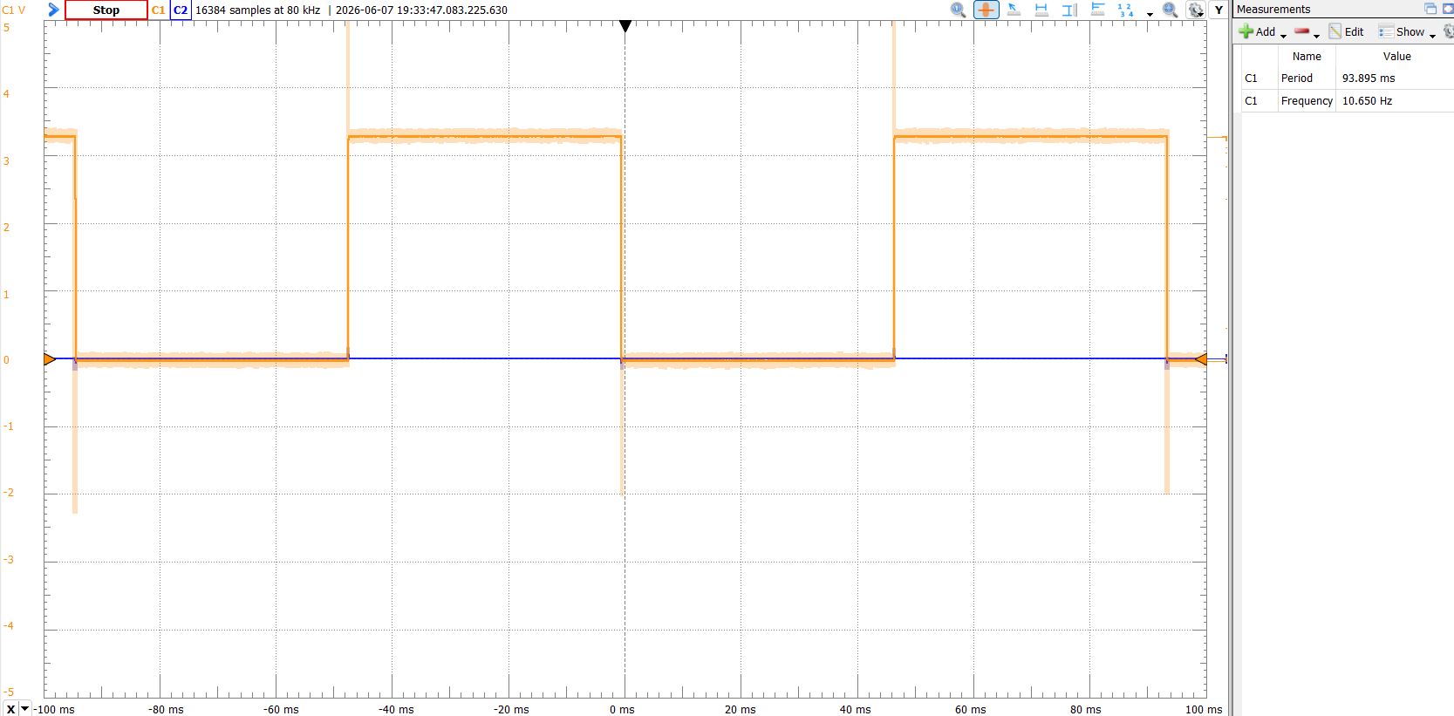
Figure 1: Lab3_1 - 47ms period (Adjusted to 12050 ticks)
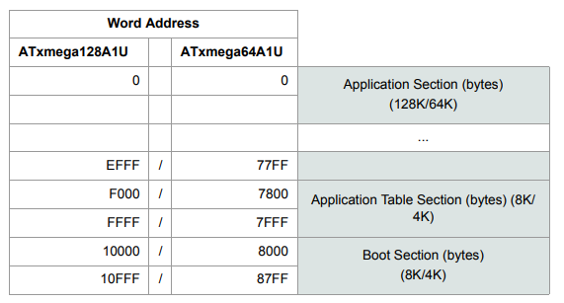
Figure 2: Program Memory Addressing

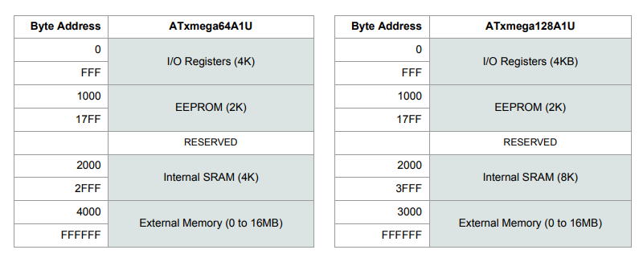
Figure 3: Data Memory Addressing

