REQUIREMENTS NOT MET
None
PROBLEMS ENCOUNTERED
None Encountered
FUTURE WORK/APPLICATIONS
External Bus Interfaces are used to use memory devices and expand our memory capacity for the microprocessor we are utilizing. This is paramount for modular storage devices like an SSD or hard drive, to further the storage capacity of our devices. This also lets us utilize a larger range for I/O rather than restricting us to the pre-routed ones available. Pretty cool!
PRE-LAB EXERCISES
- For each SRAM configuration within the EBI system of the ATxmega128A1U microcontroller, to which address lines do you have external, physical access?

Without ALE1/2: Utilizes A[21:0] with constant direct external access to all pins.

ALE1: Utilizes A[19:0] with constant direct external access to A[19:16], A[15:8]/A[7:0] are multiplexed.

ALE2: Utilizes A[23:0] with constant direct external access to A[15:8], A[23:16]/A[7:0] are multiplexed.

ALE12: Utilizes A[23:0], where all inputs are multiplexed, no external access.

LPC ALE1: Utilizes A[19:0], where A[7:0] shares a bus with D[7:0], so we have constant direct external access to A[19:8].

LPC ALE12: Utilizes A[19:0], where A[7:0], A[15:8], D[7:0] share a bus, so we have constant direct external access to A[19:16].

NOALE 4PORT: Access to all bits A[23:0].

- For the SRAM LPC 3-PORT ALE1 configuration, is it possible to have external, physical access to any address lines above A15? Why or why not?

Yes, because they are not multiplexed, we can reliably read them, as lines A[19:16] are dedicated.

- Describe what performing full address decoding and partial address decoding signifies. Provide examples of both types for [1] an SRAM chip and [2] either an input port or output port.

We know that our modules, whether they be some sort of IO or storage device will occupy set ranges. We know that our CS0-3 are programmable to denote a subset of ranges within our overall memory of 0x3000 – 0xFFFFFF. These can be between 256B and 16MB, where the base address of our chip-selects must be on the edge of a 4KB increment if it is less than or equal to a 4kB size, OR on the edge of an increment equal to the size of the chip select if greater than 4KB.

Say we want our SRAM to start at the beginning of our external memory (0x3000), with a size of 256B, this would mean that we are occupying the range of 0x3000 – 0x30FF, OR:
0011 0000 0000 0000 – 0011 0000 1111 1111.

Since we are occupying the FULL range, we just have to say that our SRAM’s CS connects to CS0, and have the write enable go to PH0, and output enable go to PH1.

However, if the module occupies a subset of a range, say 47 addresses within a 256B module, we have to ensure that this is known by the chip select of our IO’s tri-state buffer/d-flipflops!

Say we denote CS1 = 0x3100 – 0x31FF = 0011 0001 0000 0000 – 0011 0001 1111 1111.
We only want to use 0x3100-0x312E = 0011 0001 0000 0000 – 0011 0001 0010 1110

Only acknowledging the parts separate from our chip-select: (A7:A0)
0000 0000 – 0010 1110, we can derive a logic equation of: /A7*/A6*/(A5*A4)*/(A3*A2*A1*A0) = E1 (for simplicity below)

So our chip selects would be /PH6 * E1 * /PH0 (for write) or /PH6 * E1 * /PH1 (for read)

- In theory, how many 8-bit I/O ports could be mapped to the external data memory space of an ATxmega128A1U microcontroller, assuming that at most one port utilizes any particular address range? Explain your answer, utilizing your response from Exercise iii.

Assuming one address range means one chip-select, we are able to natively support four I/O ports, as we have CS0 – CS3, IF we did address decoding we could technically find the amount of bytes from $3000 - $FFFFFF, which is effectively a range of $FFD000, or 16,764,928 bytes.

- Assume that an SRAM component with the same size as the one on the OOTB Memory Base has to be added to a different computing system containing an ATxmega128A1U but no OOTB Memory Base (i.e., this is not the OOTB µPAD computing system), with the first address of the SRAM starting at address 0x1C8000, instead of the address specified in the “Lab 4 – EBI Pre-Lab Quiz.” Design, on paper, a hardware expansion for this new system, utilizing the same structure of steps laid out in this quiz. Use the same “overall” memory-mapping constraints presented within the quiz.

Appendix Figure 3, We find that 0x1C8000 rests on a 32k edge, so we do not need to do decoding. Simply, we use CS0 for our 32k ram, and provide A[15:0] through a latch and the data bus.

- Assume that some external 256 KB SRAM must be fully mapped, i.e., fully address decoded to the data memory space of the ATxmega128A1U, with the first memory location of the SRAM corresponding to data memory address 0x6B0000. Design, on paper, a hardware expansion for this new system, utilizing the same structure of steps laid out in the relevant pre-lab quiz. Use the same “overall” memory-mapping constraints presented within this quiz. Hint: Consider how many address signals are needed to make the SRAM fully addressable and then consider how you will gain access to all these signals.

Appendix Figure 4, We needed to make sure this was on a chip select edge, which it is not (256k), so we must use a smaller size; after analysis we find it is on a 64kb edge, in retrospect we find CS0 will be used for A16; so we use CS1 = 64k, CS2 = 128k (as we are on the available edge), and CS3 = 64k. We use a latch to access the bits A[15:8].

- Assume that some 8-bit input port should be accessible via the 128 consecutive addresses starting at 0x93C200 within the ATxmega128A1U data memory space. Design, on paper, a hardware expansion for this port, utilizing the same structure of steps laid out in the relevant pre-lab quiz. Use the same “overall” memory-mapping constraints presented within this quiz.

Appendix Figure 5, Not on a 4kb edge (128 <= 4k), so we must start at 0x93C000, to reach the end of our desired range (0x93C2FF) we must use a 512 CS size, which means we are covering the range of 0x93C000 to 0x93C3FF. Decoding derives the decreased range we desire.

- Assume that some external 1 MB SRAM must be fully mapped to the data memory space of the ATxmega128A1U, with the first memory location of the SRAM corresponding to data memory address 0x600000. Design, on paper, a hardware expansion for this new system, utilizing the same structure of steps laid out in the relevant pre-lab quiz. Use the same “overall” memory-mapping constraints presented within this quiz, except that which is concerning the usage of the SRAM 3-PORT ALE1 EBI configuration. Hint: you might consider the use of some other EBI configuration.

Appendix Figure 6, Utilized ALE12, 0x600000 leaves us on a 1MB edge so we do not have to do any decoding. Use two latches for A[15:8], A[23:16] per Figure 27-6 in AU manual.

- How would one go about utilizing the SRAM 4PORT NOALE mode? (Note: Looking at the Alternate Pin Functions only ports H, J, and K by default can be used with the EBI system. How can the other port be activated)?
You first would Enable 4-PORT mode in the EBI_CTRL register, by setting IFMODE[1:0] to 10 for four-port mode, then change SRMODE[1:0] to 11 for NOALE. We then have to activate the fourth port, being either E or F using EBIADROUT[1:0], we can either choose Port F using 00 or Port E using 01 for a full 8-bit usage. We could also move the CS controls to Port PH/PL/PF/PE if desired using EBICSOUT[1:0] (pins 4-7).
PORTH, PORTJ, and PORTK are used for control signals/data bus/address bus respectively, and we add PORTE or PORTF for our upper bits based on our desired configuration described above.
PSEUDOCODE/FLOWCHARTS
Lab4_2:
.equ SRAM_START_ADDR = 0xC58000
.equ IO_START_ADDR = 0xCE72C0
.include “ATxmega128A1Udef.inc”

Create stack pointer
Org & Jump to main
Call EBI_IO_INIT
Call EBI_INIT
Make a pointer to IO_START_ADDR (three bytes)

LOOP:
Load r16 with X
Store X to r16
Jump to LOOP

DONE:
Jump to DONE

;SUBROUTINES
EBI_IO_INIT:
Push register
Set RE, WE, CS0, CS2 as false (active low)
Set ALE1 as false (active high)
Set relevant PORTH controls as outputs
Set PORTK to outputs
Pop register
return

EBI_INIT:
Push register
Set to 8-bit data bus
Set mode and CS size for CS0
Set base address for CS0
Set mode and CS size for CS2
Set base address for CS2
Pop register
return

Lab4_3a:
.equ SRAM_START_ADDR = 0xC58000
.equ IO_START_ADDR = 0xCE72C0
.include "ATxmega128A1Udef.inc"
.include "sram_data.asm"
In sram_data.asm create directives for the start and end address, create a data_size to reference
In data memory create a .byte allocation with data_size
In program memory create stack pointer
Org and jump to main
Create a program pointer and a data pointer (Z & Y for increment/decrement)
Use a pointer to keep track of data size (X)
WRITE:
Load the next byte of Z and post-increment
Store to Y and post increment
Subtract one from X
brne WRITE

READ:
Reset pointers to initial values for read loop
Load the next byte of Y and post-increment
Store to PORTK output
Delay_300MS
Subtract 1 from X
brne READ

DONE:
Rjmp DONE

; SUBROUTINES:
EBI_IO_INIT:
Push register
Set outputs as false
Enable outputs & controls
Pop register
Return

EBI_INIT:
Push register
Set 8-bit data bus
Set CS size and mode for CS0
Set CS size and mode for CS2
Pop register
Return

TC_INIT:
Push register
Store period to TCC0_PER(+1)
Store clock prescaler
Pop register
Return

DELAY_300MS:
Push register
Clear OVFIF flag
OVF_CHECK:
Check flag
Skip line if OVFIF is set:
Rjmp OVFIF_CHECK
Pop Register
Return

Lab4_3b:
.equ SRAM_START_ADDR = 0xC58000
.equ IO_START_ADDR = 0xCE72C0
.equ DATA_VAL = 0x04
.equ DATA_VAL = 0x07

.incude “ATxmega128A1Udef.inc”

Create Stack Pointer
Org and jump to main
MAIN:
Rcall EBI_IO_INIT
Rcall EBI_INIT

Load Y with SRAM_START_ADDR

LOOP:
Load Y with DATA_VAL
Load Y+1 with DATA_VAL2 (use displacement)
Load a register with the data value
Load another register with the second data value

Rjmp LOOP

DONE:
Rjmp DONE

; SUBROUTINES:
EBI_IO_INIT:
Push register
Set outputs as false
Enable outputs & controls
Pop register
Return

EBI_INIT:
Push register
Set 8-bit data bus
Set CS size and mode for CS0
Set CS size and mode for CS2
Pop register
Return

PROGRAM CODE
Lab4_2:
;
; Lab4.asm
;
; Created: 6/16/2026 4:39:45 PM
; Author : Evan Baesler
;

.equ SRAM_START_ADDR = 0xC58000
.equ IO_START_ADDR = 0xCE72C0

.include "ATxmega128A1Udef.inc"

ldi r16, low(RAMEND) ; Stack Pointer initialization
sts CPU_SPL, r16
ldi r16, high(RAMEND)
sts CPU_SPH, r16

.cseg
.org 0x0100
rjmp MAIN

MAIN:
rcall EBI_IO_INIT
rcall EBI_INIT

ldi XL, low(IO_START_ADDR) ; Point to IO Start
ldi XH, high(IO_START_ADDR)
ldi r16, byte3(IO_START_ADDR)
out CPU_RAMPX, r16

LOOP:
ld r16, X ; Load X (/RE enabled)
st X, r16 ; Store X (/WE enabled)

rjmp LOOP

DONE:
rjmp DONE

; SUBROUTINES:
EBI_IO_INIT:
push r16 ; Preserve Register

ldi r16, 0b01010011
sts PORTH_OUTSET, r16 ; Sets RE, WE, CS0, CS2 as false.

ldi r16, (1<<2)
sts PORTH_OUTCLR, r16 ; Sets ALE1 as an false to be output from the XMega.

ldi r16, 0b01010111 ; Initializes outputs for WE,RE,ALE1,CS0,CS2
sts PORTH_DIRSET, r16

ldi r16, 0xFF
sts PORTK_DIRSET, r16 ; Sets addresses to be output from the microcontroller.

pop r16
ret

EBI_INIT:
push r16

ldi r16, 1 ; 8-bit data bus
sts EBI_CTRL, r16 ; EBI CTRL IFMODE[1:0], AU 27.12 (VERY USEFUL)

; CS0 SETUP
ldi r16, 0b00011101 ; MODE[1:0], ASIZE[4:0], 27.11 AU
; SRAM, 32Kb
sts EBI_CS0_CTRLA, r16
ldi r16, byte2(SRAM_START_ADDR) ; Load the upper bytes base address.
sts EBI_CS0_BASEADDR, r16
ldi r16, byte3(SRAM_START_ADDR)
sts EBI_CS0_BASEADDR+1, r16

; CS2 SETUP
ldi r16, 0b00001001 ; MODE[1:0], ASIZE[4:0], 27.11 AU
; SRAM, 1Kb
sts EBI_CS2_CTRLA, r16
ldi r16, byte2(IO_START_ADDR) ; Load the upper bytes base address.
sts EBI_CS2_BASEADDR, r16
ldi r16, byte3(IO_START_ADDR)
sts EBI_CS2_BASEADDR+1, r16

pop r16
ret

Lab4_3a:
/*
* lab4_3a.asm
*
* Created: 6/16/2026 6:26:23 PM
* Author: Evan Baesler
*/

/*
* lab4_3.asm
*
* Created: 6/16/2026 7:28:55 PM
* Author: Evan Baesler
*/
;

.equ SRAM_START_ADDR = 0xC58000
.equ IO_START_ADDR = 0xCE72C0

.include "ATxmega128A1Udef.inc"
.include "sram_data.asm"

.dseg
.byte DATA_SIZE

.cseg
ldi r16, low(RAMEND) ; Set up Stack Pointer (SP)
sts CPU_SPL, r16
ldi r16, high(RAMEND)
sts CPU_SPH, r16

.cseg
.org 0x01000
rjmp MAIN

MAIN:
rcall EBI_IO_INIT
rcall EBI_INIT
rcall TC_INIT

; Setup Flash Pointer (Z) and SRAM Pointer (Y)
ldi ZL, low(DATA << 1) ;
ldi ZH, high(DATA << 1)

ldi YL, low(SRAM_START_ADDR)
ldi YH, high(SRAM_START_ADDR)
ldi r16, byte3(SRAM_START_ADDR)
out CPU_RAMPY, r16 ; Needed for > 64KB addressing, 2^16

ldi XL, low(DATA_SIZE)
ldi XH, high(DATA_SIZE) ; Count size of data

WRITE_LOOP:

lpm r16, Z+ ; Load byte from Program Memory
st Y+, r16 ; Store byte to External SRAM
sbiw X, 1 ; Decrement Counter
brne WRITE_LOOP

; Reset pointers for Read Loop
ldi YL, low(SRAM_START_ADDR)
ldi YH, high(SRAM_START_ADDR)
ldi r16, byte3(SRAM_START_ADDR)
out CPU_RAMPY, r16

ldi XL, low(DATA_SIZE)
ldi XH, high(DATA_SIZE)

; Read SRAM data and output to Port K (LEDs)
READ_LOOP:
ld r17, Y+ ; Read from External SRAM
sts PORTK_OUT, r17 ; Send to IO port
rcall DELAY_300MS ; Wait 300ms
sbiw X, 1 ; Subtract 1 from Counter
brne READ_LOOP

DONE:
rjmp DONE

; --- SUBROUTINES ---

EBI_IO_INIT:
push r16

ldi r16, 0b01010011 ; Sets active-low outputs as false (RE, WE, CS0/2)
sts PORTH_OUTSET, r16
ldi r16, (1<<2)
sts PORTH_OUTCLR, r16 ; Sets active-high outputs as false (ALE1)
ldi r16, 0b01010111
sts PORTH_DIRSET, r16 ; Enables control outputs
ldi r16, 0xFF
sts PORTK_DIRSET, r16 ; Enables outputs

pop r16
ret

EBI_INIT:
push r16

ldi r16, 1 ; 8-bit data bus
sts EBI_CTRL, r16 ; AU 27.12, IFMODE[1:0]

; CS0 SETUP
ldi r16, 0b00011101 ; MODE[1:0], ASIZE[4:0], 27.11 AU
; SRAM, 32Kb
sts EBI_CS0_CTRLA, r16
ldi r16, byte2(SRAM_START_ADDR) ; Load base address to upper bytes.
sts EBI_CS0_BASEADDR, r16
ldi r16, byte3(SRAM_START_ADDR)
sts EBI_CS0_BASEADDR+1, r16

; CS2 SETUP
ldi r16, 0b00001001 ; MODE[1:0], ASIZE[4:0], 27.11 AU
; SRAM, 32Kb
sts EBI_CS2_CTRLA, r16
ldi r16, byte2(IO_START_ADDR) ; Load base address to upper bytes.
sts EBI_CS2_BASEADDR, r16
ldi r16, byte3(IO_START_ADDR)
sts EBI_CS2_BASEADDR+1, r16

pop r16
ret

TC_INIT:
push r16

; SCF = 2MHz, PRE = 64, D = 300*10^-3, PER = 9375 Ticks
ldi r16, low(9375)
sts TCC0_PER, r16
ldi r16, high(9375)
sts TCC0_PER+1, r16 ; Set period of 47ms

ldi r16, TC_CLKSEL_DIV64_gc
sts TCC0_CTRLA, r16 ; Start counting with DIV64 prescaler, AU 14.12

pop r16
ret

DELAY_300MS:
push r16

ldi r16, TC0_OVFIF_bm
sts TCC0_INTFLAGS, r16 ; Resets flag (stores 1 to flag)

OVF_CHECK:
lds r16, TCC0_INTFLAGS ; Loads flags
sbrs r16, TC0_OVFIF_bp ; Checks bit designated for OVFIF flag
rjmp OVF_CHECK

pop r16
ret

Lab4_3b:
/*
* lab4_3.asm
*
* Created: 6/16/2026 7:28:55 PM
* Author: Evan Baesler
*/
;

.equ SRAM_START_ADDR = 0xC58000
.equ IO_START_ADDR = 0xCE72C0
.equ DATA_VAL = 0x04
.equ DATA_VAL2 = 0x07 ; :)

.include "ATxmega128A1Udef.inc"

ldi r16, low(RAMEND)
sts CPU_SPL, r16
ldi r16, high(RAMEND)
sts CPU_SPH, r16

.cseg
.org 0x0100
rjmp MAIN

MAIN:
rcall EBI_IO_INIT
rcall EBI_INIT
rcall TC_INIT

ldi YL, low(SRAM_START_ADDR)
ldi YH, high(SRAM_START_ADDR)
ldi r16, byte3(SRAM_START_ADDR)
out CPU_RAMPY, r16

LOOP:
ldi r16, DATA_VAL
st Y, r16 ; Stores base address

ldi r16, DATA_VAL2
std Y+1, r16 ; Stores by displacement, looping thru same addresses

ld r17, Y ; Loads base address
ldd r18, Y+1 ; Loads by displacement, looping thru same addresses

rjmp LOOP

DONE:
rjmp DONE

; SUBROUTINES:
EBI_IO_INIT:
push r16

ldi r16, 0b01010011 ; Sets active-low outputs as false (RE, WE, CS0/2)
sts PORTH_OUTSET, r16
ldi r16, (1<<2)
sts PORTH_OUTCLR, r16 ; Sets active-high outputs as false (ALE1)
ldi r16, 0b01010111
sts PORTH_DIRSET, r16 ; Enables control outputs
ldi r16, 0xFF
sts PORTK_DIRSET, r16 ; Enables outputs

pop r16
ret

EBI_INIT:
push r16

ldi r16, 1 ; 8-bit data bus
sts EBI_CTRL, r16 ; IFMODE[1:0], AU 27.12

; CS0 SETUP
ldi r16, 0b00011101 ; MODE[1:0], ASIZE[4:0], 27.11 AU
; SRAM, 32Kb
sts EBI_CS0_CTRLA, r16
ldi r16, byte2(SRAM_START_ADDR)
sts EBI_CS0_BASEADDR, r16
ldi r16, byte3(SRAM_START_ADDR)
sts EBI_CS0_BASEADDR+1, r16

; CS2 SETUP
ldi r16, 0b00001001 ; MODE[1:0], ASIZE[4:0], 27.11 AU
; SRAM, 32Kb
sts EBI_CS2_CTRLA, r16
ldi r16, byte2(IO_START_ADDR)
sts EBI_CS2_BASEADDR, r16
ldi r16, byte3(IO_START_ADDR)
sts EBI_CS2_BASEADDR+1, r16

pop r16
ret

TC_INIT:
push r16

; SCF = 2MHz, PRE = 64, D = 47*10^-3, PER = 11750 Ticks
ldi r16, low(9375)
sts TCC0_PER, r16
ldi r16, high(9375)
sts TCC0_PER+1, r16 ; Set period of 47ms

ldi r16, TC_CLKSEL_DIV64_gc ; AU 14.12
sts TCC0_CTRLA, r16 ; Start counting with DIV64 prescaler

pop r16
ret

DELAY_300MS:
push r16

ldi r16, TC0_OVFIF_bm
sts TCC0_INTFLAGS, r16 ; Resets flag (stores 1 to flag)

OVF_CHECK:
lds r16, TCC0_INTFLAGS ; Loads flag
sbrs r16, TC0_OVFIF_bp ; Checks bit designated for OVFIF flag
rjmp OVF_CHECK

pop r16
ret

APPENDIX
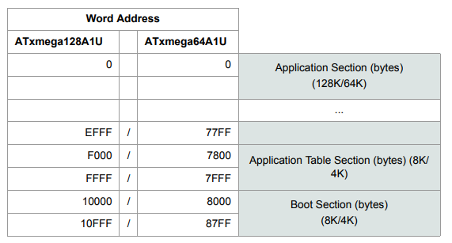
Figure 1: Program Memory Addressing

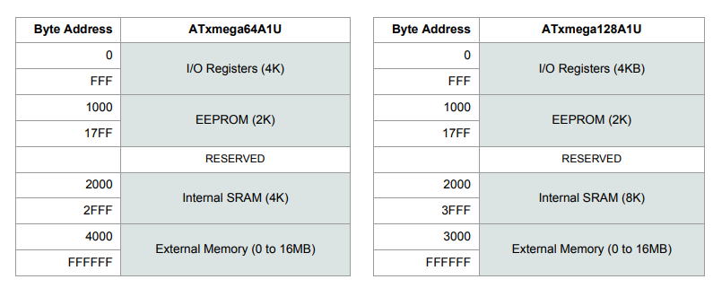
Figure 2: Data Memory Addressing
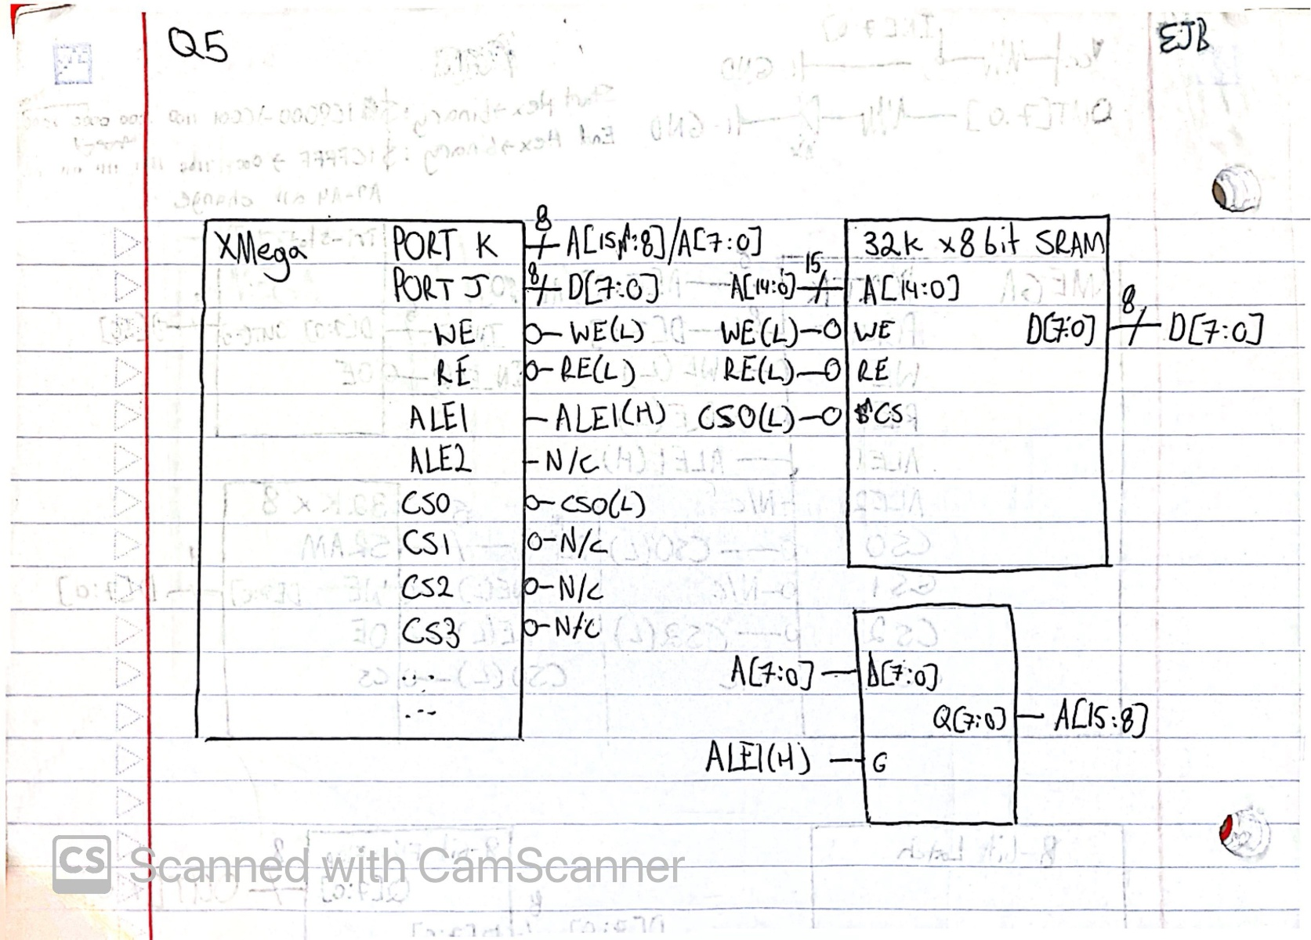
Figure 3: Work for Lab Question 5 (32kb RAM at starting at 0x1C8000)
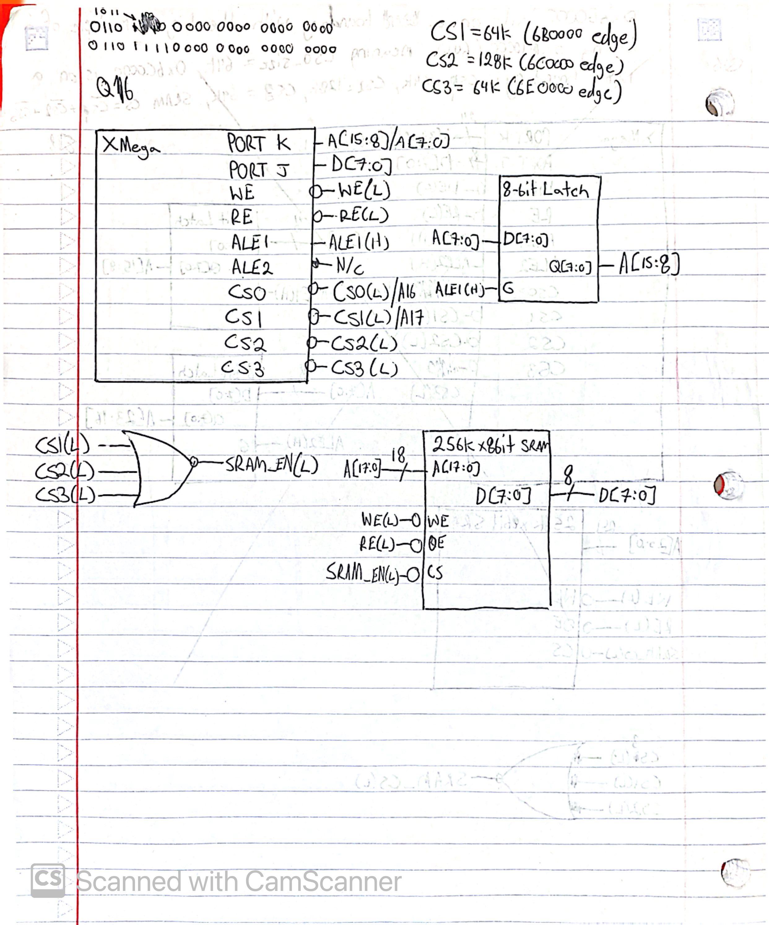
Figure 4: Work for Lab Question 6.

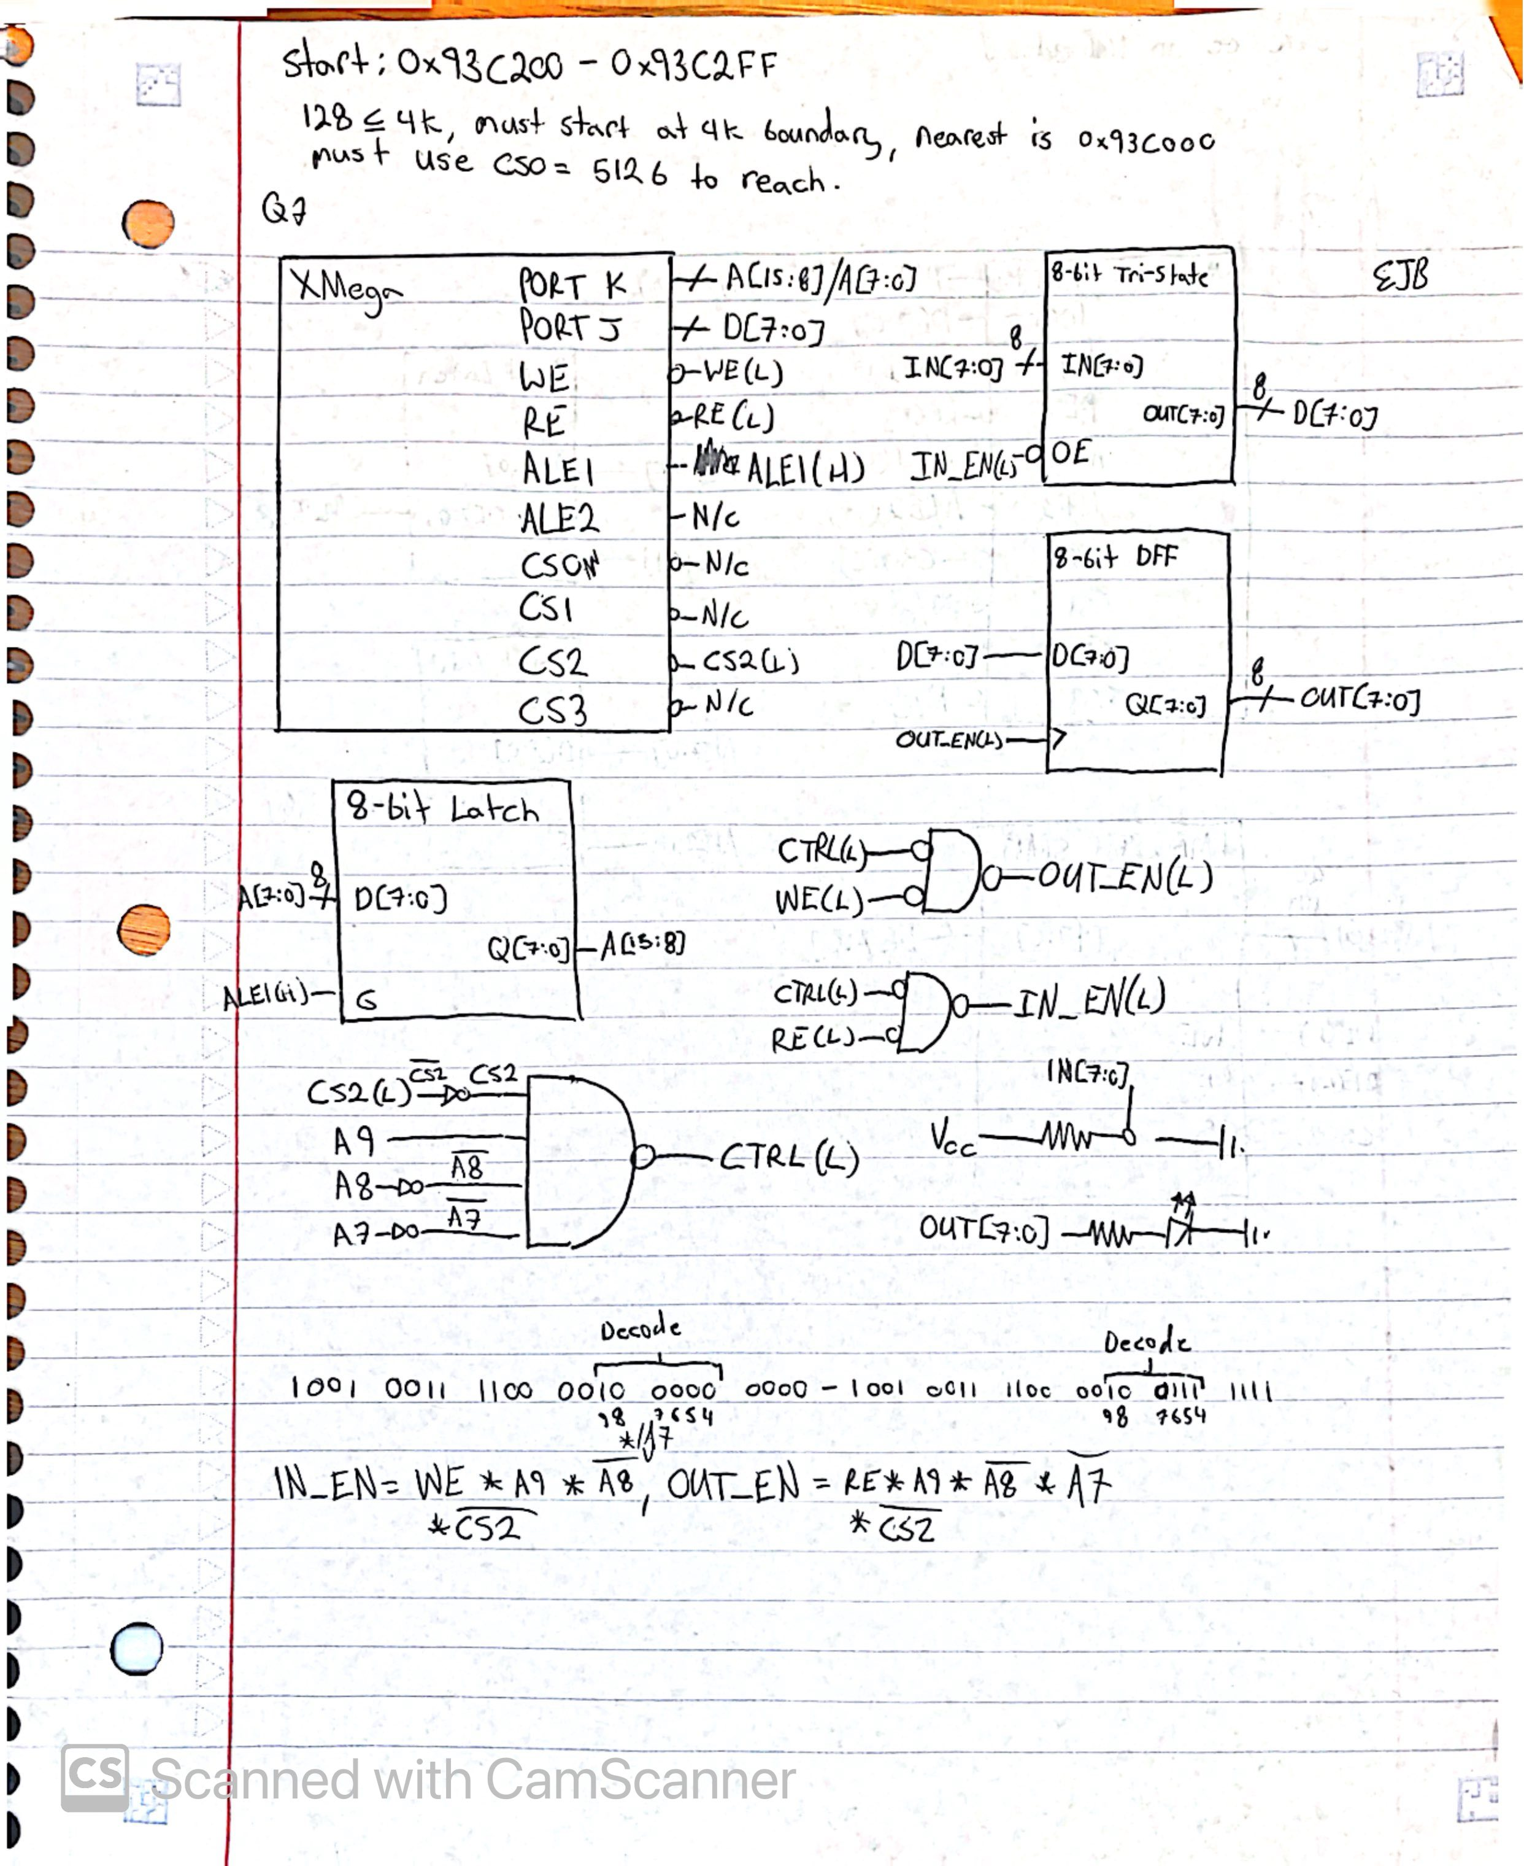
Figure 5: Work for Lab Question 7.

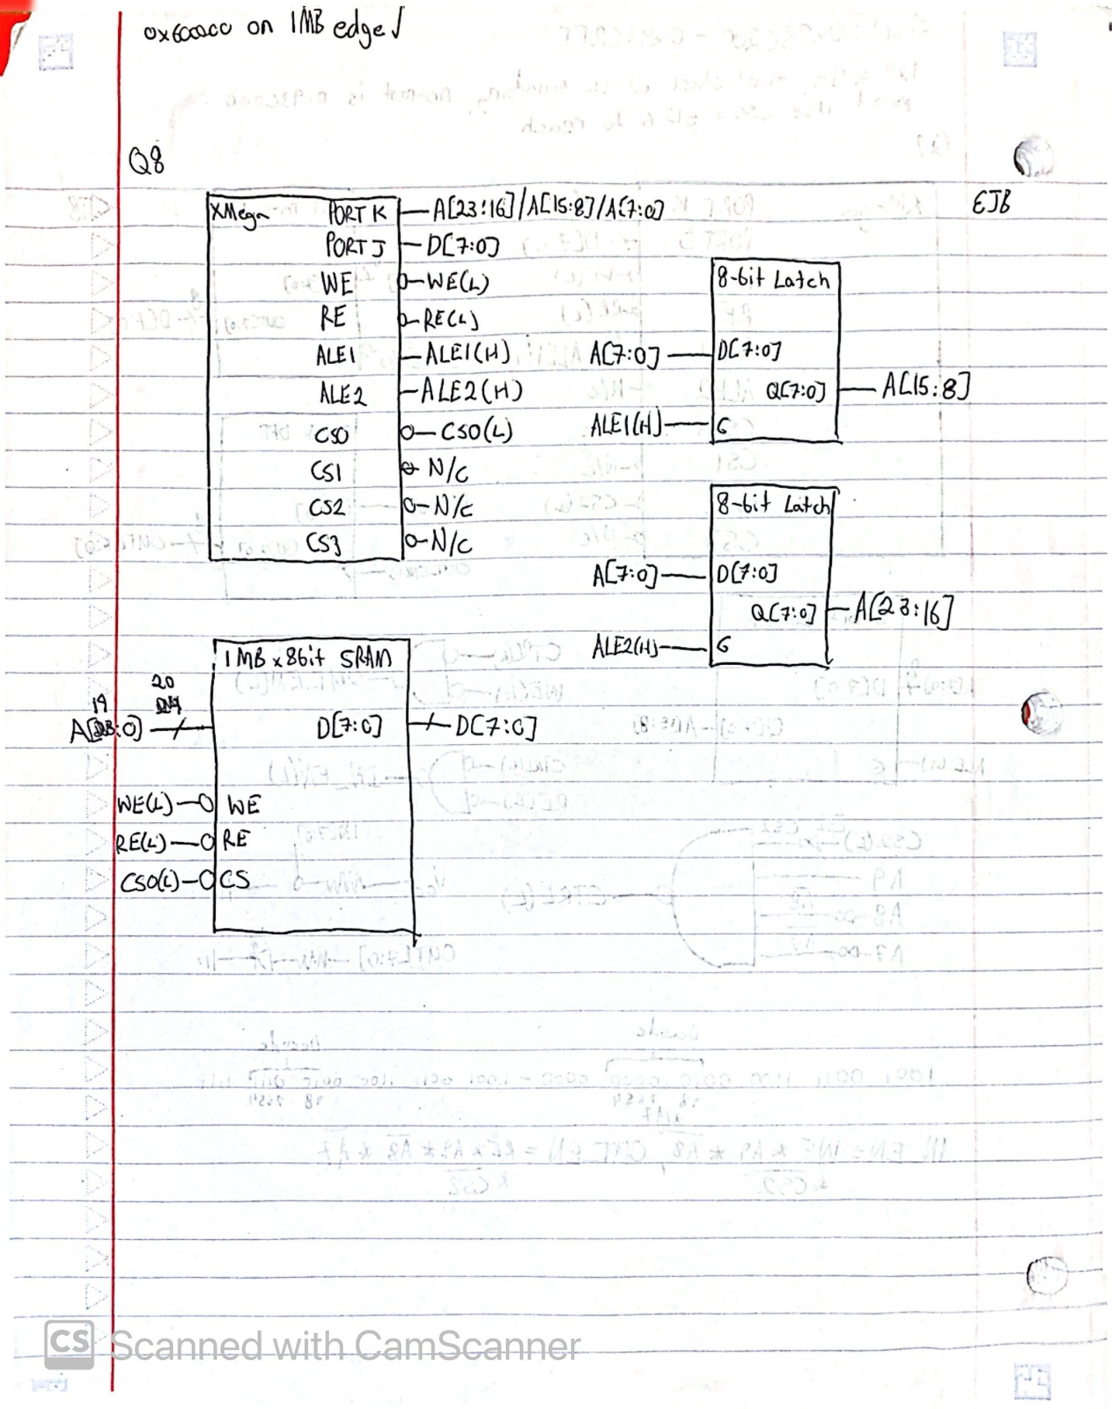
Figure 6: Work for Lab Question 8.

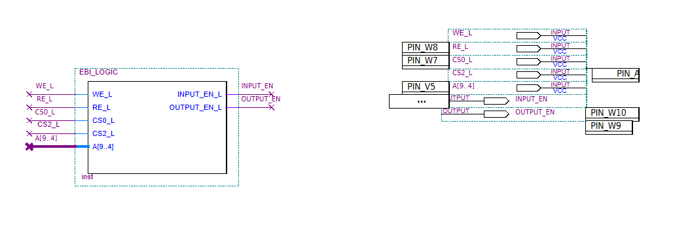
Figure 7: Quartus BDF
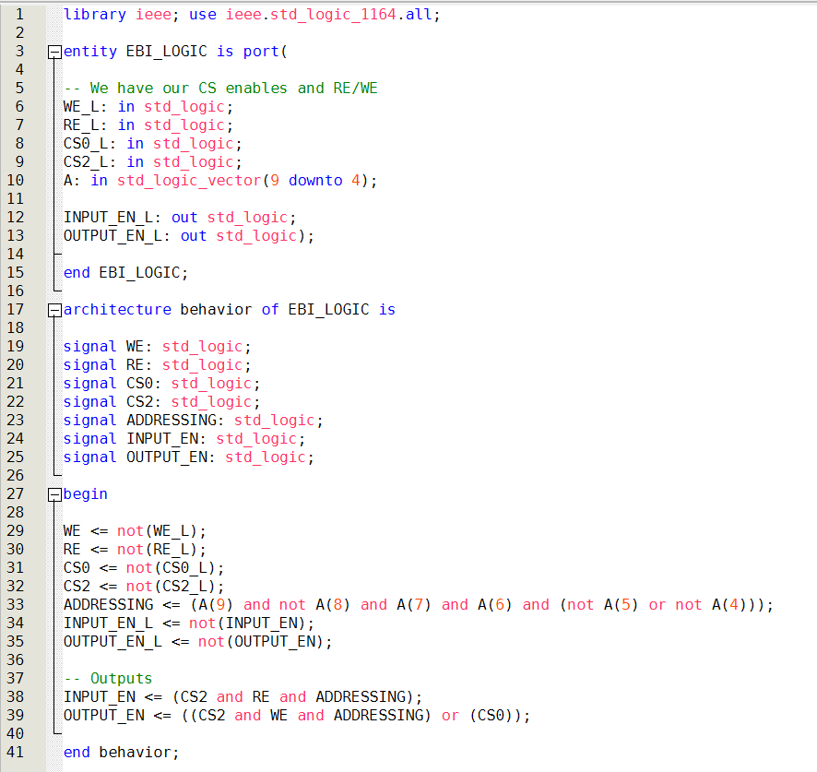
Figure 8: Quartus VHDL
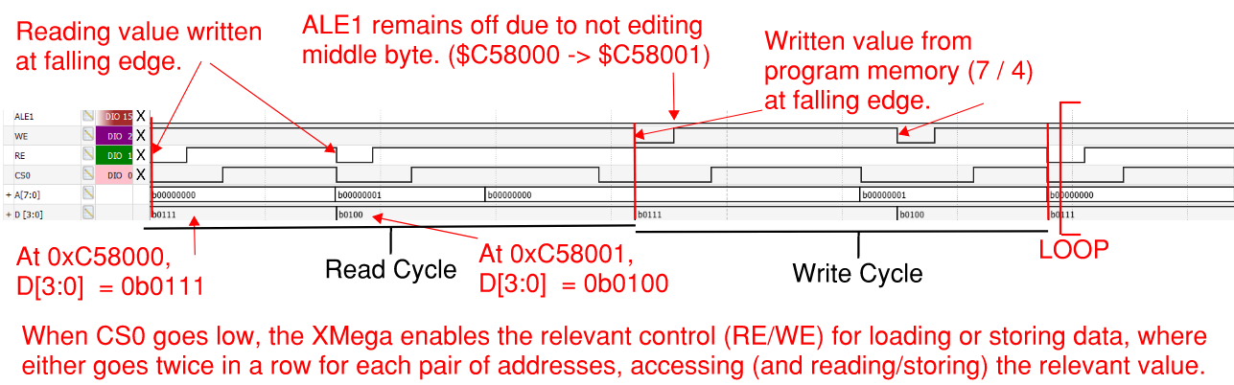
Figure 9: Waveforms DIO Capture of Lab4_3b

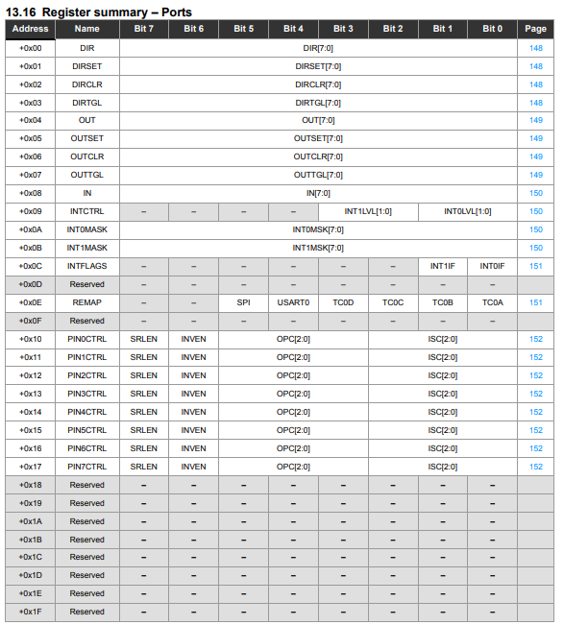
Figure 10: Ports Register Summary
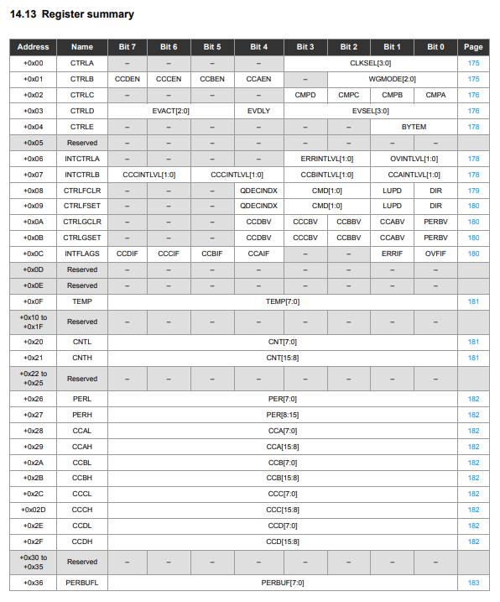
Figure 11: Timer/Counter Register Summary
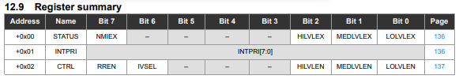
Figure 12: Interrupts Register Summary

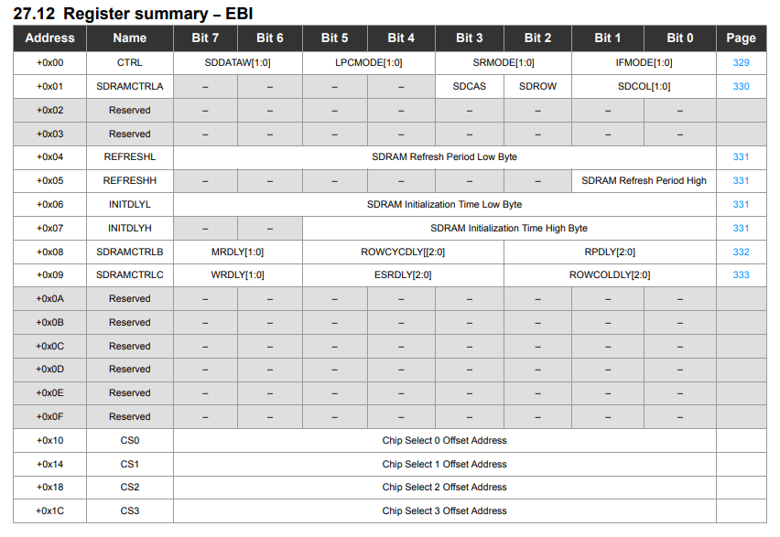
Figure 13: EBI Register Summary
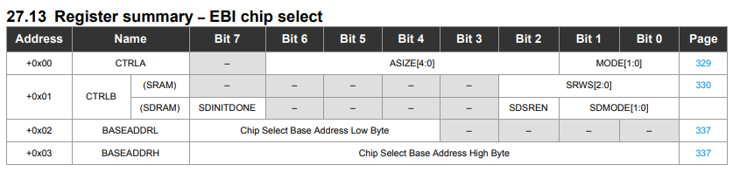
Figure 14: EBI Chip Select Register Summary
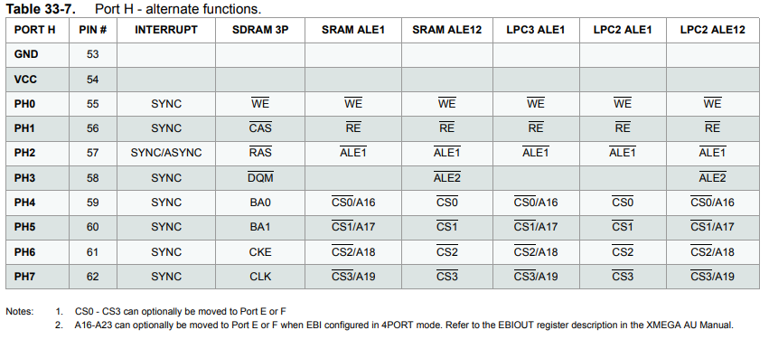
Figure 15: PORTH Alternate Functions
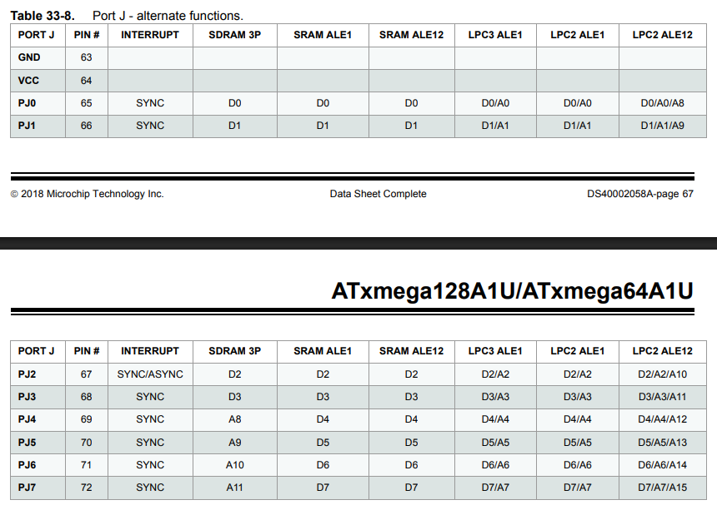
Figure 16: PORTJ Alternate Functions

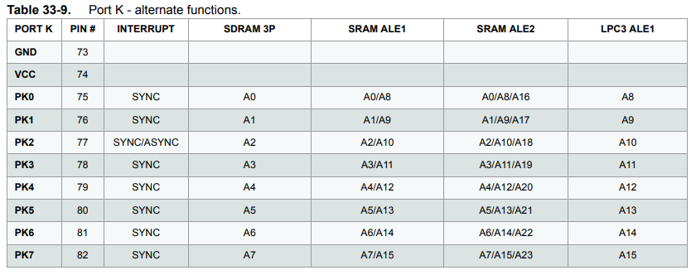
Figure 17: PORTK Alternate Functions

