REQUIREMENTS NOT MET
None
PROBLEMS ENCOUNTERED
None Encountered
FUTURE WORK/APPLICATIONS
This lab taught us how to do communications between microprocessors and other devices! Pretty important to know how to send data to and from an MCU to a peripheral and vice versa, as a microprocessor with no data is not useful at all. Could be used to read data from sensors, send controls to peripheral devices, and more, maybe a lighting controller .

PRE-LAB EXERCISES
- The sampling rate of a UART receiver is usually faster than the baud rate of the overall system. Why is this so?

Because the processor oversamples to detect when the start bit occurs, and to obtain proper sampling of the incoming bits. UART is Asynchronous which means there is not a shared clock; so oversampling helps to sample each bit at the most-accurate time.

- What is the maximum possible baud rate for asynchronous communication within the USART system of the ATxmega128A1U, assuming that the microcontroller has a system clock frequency of 2 MHz and that the USART “double-speed mode” is disabled (i.e., the relevant bit CLK2X is set to 0)? In addition to the maximum rate, provide the values of the relevant registers used to configure that rate. Whenever appropriate, support your answer with calculations.

We would use Table 23-1, which shows for a BSCALE >= 0 we need to use:
$$f_{BAUD}=\frac{f_{PER}}{2^{BSCALE}*16\left(BSEL+1\right)}$$
BSCALE CAN be -7 to 7 (but a constraint of the equation above is BSCALE >= 0) and BSEL can be any value from 0 to 4095; the smaller we make the denominator the higher the baud frequency; so we make BSCALE = 0, and we make BSEL = 0, leaving:
$$f_{BAUD}=\frac{2000000}{16}=125000 bits per second$$

- In the context of the USART system within the ATxmega128A1U, how many buffers (i.e., memory locations that store temporary data) are used by a transmitter? How many are used by a receiver? Additionally, for both transmitters and receivers, explain how the use of buffers provides greater flexibility to an application involving these components.

The transmitter uses a single write buffer (DATA), which lets it have continuous data transmission without any delay by cycling out the current data for the next; the receiver uses a ‘two-level’ receive buffer (DATA) to ensure that the CPU has time to read the data. This ensures that the CPU has more time to read the data and prevent missing any communications.

- If an asynchronous serial communication protocol of 7 data bits, one start bit, one stop bits, odd parity, and baud rate of 37.44 kHz was chosen, calculate how many seconds it would take to transmit the ASCII character string “Dr. Schwartz saw seven slick slimy snakes slowly sliding southward.” (This string has 67 characters.) Note that ASCII is a 7-bit (not an 8-bit) code. Show all work.

37.44kHz = 37440 bits per second; if it takes 7 bits of data, 1 bit for start, 1 bit for stop, and one bit for parity for one full character read, we simply do:

(10 bits*67 characters)/37740 bits per second = 17.753ms
PSEUDOCODE/FLOWCHARTS
Lab5_2:
MAIN:
Initialize SP
Rcall USART_INIT

LOOP:
Load R17 with ‘U’
Rcall OUT_CHAR
rjmp LOOP

; SUBROUTINES
USART_INIT:
Push r16
; Use PortD
Set the TxD pin high (PORTx_OUT)
Set the TxD pin as output
Select BSCALE and BSEL in BAUDCTRLA/B for 37,440 bps
; for an awkward baud rate like this, we should use negative BSCALE, and go to the smallest increment possible, which is 2^-7, If we do the math we find that:
$$\frac{2000000}{37440}=16\left(\left(2^{B_{SCALE}}*B_{SEL}\right)+1\right)$$
$$\frac{53.4188}{16}=2^{B_{SCALE}}*B_{SEL}+1$$
$$2.338675=2^{B_{SCALE}}*B_{SEL}$$
$$\frac{2.338675}{2^{-7}}=299=B_{SEL}, which matches the Excel Calculator$$

Set the frame format / mode in CTRLC
Enable the transmit/receive in CTRLB
Set up Interrupts in CTRLA

Pop r16
ret
OUT_CHAR:
Push r16

; We will first check if there is a transmission in progress, by checking the TXCIF flag in the STATUS register. (bit 6)
WAIT:
Load TXCIF flag in STATUS register, check bit 6 is 1, else branch to WAIT
Load USARTD0_DATA with R17
Pop r16
Ret

Lab5_3:
Same as Lab5_2 but using PORTC instead of PORTD
Lab5_4:
Include prior OUT_CHAR, USART_INIT subroutines from Lab5_2

.org 0
Rjmp MAIN

.org 0x2000
STRING_ADDR:
; input table data here for string

MAIN:
Initialize Stack Pointer
Rcall USART_INIT

Set Z to point to STRING_ADDR

LOOP:

Rjmp LOOP

; --SUBROUTINES-- ;
OUT_STRING:
Push r16
Lpm r17, Z+
Test r17 for zero flag
Branch if not equal to SKIP
If it IS zero we will reset pointers

SKIP: ; No zero flag so we continue writing the string
Rcall OUT_CHAR
Pop r16
Ret

Lab5_5:
; Include the subroutines: OUT_CHAR, USART_INIT (for PORTD) and the associated code.

MAIN:
Set up SP
Call USART_INIT

LOOP:
Call IN_CHAR
Rjmp LOOP

; SUBROUTINES:
; Use subroutines mentioned above from Lab5_4
IN_CHAR:
Push r16

WAIT_IN:
Load status flags
Check if the receive flag is set
Rjmp to WAIT_IN if not

Load r17 with USARTD0_DATA
Rcall OUT_CHAR

Pop r16
Ret

Lab5_6:
; Move over subroutines from Lab5_5, with modified IN_CHAR shown below and new IN_STRING
.equ STR_SIZE = 64

.org 0
Rjmp MAIN

.dseg
.org 0x1000
STR_STORAGE: .byte STR_SIZE

.org 0x100
MAIN:
Initialize SP
Call USART_INIT
Initialize Pointer Y to dseg 0x1000

LOOP:
Call IN_STRING
Rjmp LOOP

; SUBROUTINES
IN_STRING:
Push r16
LOOP_INSTR:
Rcall IN_CHAR
Check for Carriage Return, if true branch to DONE_STRING
Check for Backspace, if true branch to BACK_SPACE
Check for Delete, if true branch to BACK_SPACE

Store r17 to y, post-increment
Rcall OUT_CHAR
Rjmp LOOP_INSTR ; continue loop, ignore conditional statements below

BACK_SPACE:
Sbiw Y, 1
Rjmp LOOP_INSTR

DONE_STRING:
Ldi r17, 0x00
St Y, r17
Pop r16
ret

OUT_STRING:
Push r16
LOOP_OUT:
; Set Y to beginning of string memory
Ld r17, Y+
Tst r17
Branch to DONE_OUT if null

Rcall OUT_CHAR
Rjmp LOOP_OUT

DONE_OUT:
Pop r16
ret

Lab5_7:
; Use USART initialization from previous sections, add interrupt initialization in CTRLA; add a TC
.org 0
Rjmp MAIN
.org USART_INT_VECTOR
Rjmp INTERRUPT

MAIN:
Set PD6 (BLUE_PWM) as an output
Initialize SP
rcall USART_INIT
rcall USART_INTERRUPT_INIT
sei
LOOP:
Toggle PD6 Output
Rjmp LOOP

; SUBROUTINES & INTERRUPTS
PMIC_INIT:
Push r16
Enable the PMIC for low level interrupts
Pop r16
Ret

INTERRUPT:
Push r16
Lds r16, CPU_SREG
Push r16
Rcall IN_CHAR
Rcall OUT_CHAR
Pop r16
Sts CPU_SREG, r16
Pop r16
reti
PROGRAM CODE
Lab5_2:
;
; Lab5.asm
;
; Created: 7/4/2026 3:48:55 PM
; Author : Evan Baesler
;

.include "ATXmega128A1Udef.inc"

.equ B_SEL = 299
.equ B_SCALE = -7

.org 0
rjmp MAIN

.org 0x100
MAIN:

ldi r16, low(RAMEND)
sts CPU_SPL, r16
ldi r16, high(RAMEND)
sts CPU_SPH, r16

rcall USART_INIT

LOOP:
ldi r17, 'U'
rcall OUT_CHAR
rjmp LOOP

; --SUBROUTINES-- ;
USART_INIT:
push r16

; Set the TxD pin high (PORTx_OUT) (PORTC3)
ldi r16, (1<<3)
sts PORTD_OUT, r16

; Set the TxD pin as output
sts PORTD_DIRSET, r16

; Select BSCALE and BSEL in BAUDCTRLA/B for 37,440 bps
; Math Shown on PDF in Pseudocode, derived for BSCALE = -7, BSEL = 299
; BAUDCTRLA = BSEL[7:0]
; BAUDCTRLB = BSCALE[3:0] : BSEL[11:8]
; BSCALE = 1001 = -7 in 2's Comp
; BSEL = 256 + 32 + 8 + 2 + 1 = 2^8 + 2^5 + 2^3 + 2^1 + 2^0
; BAUDCTRLA = 00101011
; BAUDCTRLB = 10010001
ldi r16, low(B_SEL)
sts USARTD0_BAUDCTRLA, r16
ldi r16, ((B_SCALE << 4) | high(B_SEL))
sts USARTD0_BAUDCTRLB, r16

; Set the frame format / mode in CTRLC
; In NON-SPI:
; CTRLC = CMODE[1:0] : PMODE[1:0] : SBMODE : CHSIZE[2:0]
; CMODE = 00 for Asynchronous
; PMODE = 10 for Even Parity
; SBMODE = 0 for 1 Stop Bit
; CHSIZE = 011 for 8-bit data
ldi r16, (USART_CMODE_ASYNCHRONOUS_gc | USART_PMODE_EVEN_gc | USART_CHSIZE_8BIT_gc)
sts USARTD0_CTRLC, r16

; Enable the transmit/receive in CTRLB (CTRLB[4:3]) 4 = RXEN, 3 = TXEN
lds r16, USARTD0_CTRLB
ori r16, 0b00001000 ; Enable Rx/Tx without changing previous defaults
sts USARTD0_CTRLB, r16

; Set up Interrupts in CTRLA (NOT UTILIZED HERE)

pop r16
ret

OUT_CHAR:
push r16

WAIT:
; We check the STATUS register for DREIF, which tells us the current
; transmission is done when the flag goes high. (bit 5)
lds r16, USARTD0_STATUS
sbrs r16, USART_DREIF_bp
rjmp WAIT

sts USARTD0_DATA, r17 ; Data input from main loop

pop r16
ret

Lab5_3:

/*
* Testing.asm
*
* Created: 7/4/2026 6:47:03 PM
* Author: Evan Baesler
*/

.include "ATXmega128A1Udef.inc"

.equ B_SEL = 299
.equ B_SCALE = -7

.org 0
rjmp MAIN

.org 0x100
MAIN:

ldi r16, low(RAMEND)
sts CPU_SPL, r16
ldi r16, high(RAMEND)
sts CPU_SPH, r16

rcall USART_INIT

LOOP:
ldi r17, 'U'
rcall OUT_CHAR
rjmp LOOP

; --SUBROUTINES-- ;
USART_INIT:
push r16

; Set the TxC pin high (PORTx_OUT) (PORTC3)
ldi r16, (1<<3)
sts PORTC_OUT, r16

; Set the TxD pin as output
sts PORTC_DIRSET, r16

; Select BSCALE and BSEL in BAUDCTRLA/B for 37,440 bps
; Math Shown on PDF in Pseudocode, derived for BSCALE = -7, BSEL = 299
; BAUDCTRLA = BSEL[7:0]
; BAUDCTRLB = BSCALE[3:0] : BSEL[11:8]
; BSCALE = 1001 = -7 in 2's Comp
; BSEL = 256 + 32 + 8 + 2 + 1 = 2^8 + 2^5 + 2^3 + 2^1 + 2^0
; BAUDCTRLA = 00101011
; BAUDCTRLB = 10010001
ldi r16, low(B_SEL)
sts USARTC0_BAUDCTRLA, r16
ldi r16, ((B_SCALE << 4) | high(B_SEL))
sts USARTC0_BAUDCTRLB, r16

; Set the frame format / mode in CTRLC
; In NON-SPI:
; CTRLC = CMODE[1:0] : PMODE[1:0] : SBMODE : CHSIZE[2:0]
; CMODE = 00 for Asynchronous
; PMODE = 10 for Even Parity
; SBMODE = 0 for 1 Stop Bit
; CHSIZE = 011 for 8-bit data
ldi r16, (USART_CMODE_ASYNCHRONOUS_gc | USART_PMODE_EVEN_gc | USART_CHSIZE_8BIT_gc)
sts USARTC0_CTRLC, r16

; Enable the transmit/receive in CTRLB (CTRLB[4:3]) 4 = RXEN, 3 = TXEN
lds r16, USARTC0_CTRLB
ori r16, 0b00001000 ; Enable Rx/Tx without changing previous defaults
sts USARTC0_CTRLB, r16

; Set up Interrupts in CTRLA (NOT UTILIZED HERE)

pop r16
ret

OUT_CHAR:
push r16

WAIT:
; We check the STATUS register for DREIF, which tells us the current
; transmission is done when the flag goes high. (bit 5)
lds r16, USARTC0_STATUS
sbrs r16, USART_DREIF_bp
rjmp WAIT

sts USARTC0_DATA, r17 ; Data input from main loop

pop r16
ret

Lab5_4:
/*
* Lab5_4.asm
*
* Created: 7/4/2026 9:00:37 PM
* Author: Evan Baesler
*/

.equ B_SCALE = -7
.equ B_SEL = 299

.org 0
rjmp MAIN

.org 0x2000
STRING_ADDR: ; String Data
.db 'H', 'i', ' ', 'H', 'o', 'w', ' ', 'A', 'r', 'e', ' ', 'Y', 'o', 'u', '?', ' ', ' ', 0

.org 0x100
MAIN:
ldi r16, low(RAMEND)
sts CPU_SPL, r16
ldi r16, high(RAMEND)
sts CPU_SPH, r16

rcall USART_INIT

ldi ZL, low(STRING_ADDR << 1)
ldi ZH, high(STRING_ADDR << 1)

LOOP:

rcall OUT_STRING

rjmp LOOP

; --SUBROUTINES-- ;
OUT_STRING:
push r16
lpm r17, Z+
; branch if null operator
tst r17
brne SKIP

ldi ZL, low(STRING_ADDR << 1)
ldi ZH, high(STRING_ADDR << 1)

SKIP:
rcall OUT_CHAR
pop r16
ret

OUT_CHAR:
push r16

WAIT:
; We check the STATUS register for DREIF, which tells us the current
; transmission is done when the flag goes high. (bit 5)
lds r16, USARTD0_STATUS
sbrs r16, USART_DREIF_bp
rjmp WAIT

sts USARTD0_DATA, r17 ; Data input from main loop

pop r16
ret

USART_INIT:
push r16

; Set the TxD pin high (PORTx_OUT) (PORTD3)
ldi r16, (1<<3)
sts PORTD_OUT, r16

; Set the TxD pin as output
sts PORTD_DIRSET, r16

; Select BSCALE and BSEL in BAUDCTRLA/B for 37,440 bps
; Math Shown on PDF in Pseudocode, derived for BSCALE = -7, BSEL = 299
; BAUDCTRLA = BSEL[7:0]
; BAUDCTRLB = BSCALE[3:0] : BSEL[11:8]
; BSCALE = 1001 = -7 in 2's Comp
; BSEL = 256 + 32 + 8 + 2 + 1 = 2^8 + 2^5 + 2^3 + 2^1 + 2^0
; BAUDCTRLA = 00101011
; BAUDCTRLB = 10010001
ldi r16, low(B_SEL)
sts USARTD0_BAUDCTRLA, r16
ldi r16, ((B_SCALE << 4) | high(B_SEL))
sts USARTD0_BAUDCTRLB, r16

; Set the frame format / mode in CTRLC
; In NON-SPI:
; CTRLC = CMODE[1:0] : PMODE[1:0] : SBMODE : CHSIZE[2:0]
; CMODE = 00 for Asynchronous
; PMODE = 10 for Even Parity
; SBMODE = 0 for 1 Stop Bit
; CHSIZE = 011 for 8-bit data
ldi r16, (USART_CMODE_ASYNCHRONOUS_gc | USART_PMODE_EVEN_gc | USART_CHSIZE_8BIT_gc)
sts USARTD0_CTRLC, r16

; Enable the transmit/receive in CTRLB (CTRLB[4:3]) 4 = RXEN, 3 = TXEN
lds r16, USARTD0_CTRLB
ori r16, 0b00001000 ; Enable Rx/Tx without changing previous defaults
sts USARTD0_CTRLB, r16

; Set up Interrupts in CTRLA (NOT UTILIZED HERE)

pop r16
ret

Lab5_5:
/*
* Lab5_5.asm
*
* Created: 7/4/2026 9:32:48 PM
* Author: Evan Baesler
*/

; Echo program

.equ B_SCALE = -7
.equ B_SEL = 299

.org 0
rjmp MAIN

.org 0x100
MAIN:
ldi r16, low(RAMEND)
sts CPU_SPL, r16
ldi r16, high(RAMEND)
sts CPU_SPH, r16

rcall USART_INIT

LOOP:

rcall IN_CHAR

rjmp LOOP

; --SUBROUTINES-- ;
IN_CHAR:
push r16
WAIT_IN:
; We check the STATUS register for RXCIF, which tells us the current
; transmission is done when the flag goes high. (bit 5)
lds r16, USARTD0_STATUS
sbrs r16, USART_RXCIF_bp
rjmp WAIT_IN

lds r17, USARTD0_DATA
rcall OUT_CHAR
pop r16
ret

OUT_CHAR:
push r16

WAIT_OUT:
; We check the STATUS register for DREIF, which tells us the current
; transmission is done when the flag goes high. (bit 5)
lds r16, USARTD0_STATUS
sbrs r16, USART_DREIF_bp
rjmp WAIT_OUT

sts USARTD0_DATA, r17 ; Data input from main loop

pop r16
ret

USART_INIT:
push r16

; Set the TxD/RxD pin high (PORTx_OUT) (PORTD[4:3])
ldi r16, 0b00011000
sts PORTD_OUT, r16

; Set the TxD pin as output
ldi r16, (1<<3)
sts PORTD_DIRSET, r16
ldi r16, (1<<4)
sts PORTD_DIRCLR, r16

; Select BSCALE and BSEL in BAUDCTRLA/B for 37,440 bps
; Math Shown on PDF in Pseudocode, derived for BSCALE = -7, BSEL = 299
; BAUDCTRLA = BSEL[7:0]
; BAUDCTRLB = BSCALE[3:0] : BSEL[11:8]
; BSCALE = 1001 = -7 in 2's Comp
; BSEL = 256 + 32 + 8 + 2 + 1 = 2^8 + 2^5 + 2^3 + 2^1 + 2^0
; BAUDCTRLA = 00101011
; BAUDCTRLB = 10010001
ldi r16, low(B_SEL)
sts USARTD0_BAUDCTRLA, r16
ldi r16, ((B_SCALE << 4) | high(B_SEL))
sts USARTD0_BAUDCTRLB, r16

; Set the frame format / mode in CTRLC
; In NON-SPI:
; CTRLC = CMODE[1:0] : PMODE[1:0] : SBMODE : CHSIZE[2:0]
; CMODE = 00 for Asynchronous
; PMODE = 10 for Even Parity
; SBMODE = 0 for 1 Stop Bit
; CHSIZE = 011 for 8-bit data
ldi r16, (USART_CMODE_ASYNCHRONOUS_gc | USART_PMODE_EVEN_gc | USART_CHSIZE_8BIT_gc)
sts USARTD0_CTRLC, r16

; Enable the transmit/receive in CTRLB (CTRLB[4:3]) 4 = RXEN, 3 = TXEN
lds r16, USARTD0_CTRLB
ori r16, 0b00011000 ; Enable Rx/Tx without changing previous defaults
sts USARTD0_CTRLB, r16

; Set up Interrupts in CTRLA (NOT UTILIZED HERE)

pop r16
ret

Lab5_6:
/*
* Lab5_6.asm
*
* Created: 7/5/2026 4:00:29 PM
* Author: Evan Baesler
*/

; Move over subroutines from Lab5_5, with modified IN_CHAR shown below and new IN_STRING
.equ STR_SIZE = 0x100
.equ B_SEL = 299
.equ B_SCALE = -7

.org 0
Rjmp MAIN

.dseg
.org 0x2000
STR_STORAGE: .byte STR_SIZE

.cseg
.org 0x100
MAIN:

ldi r16, low(RAMEND)
sts CPU_SPL, r16
ldi r16, high(RAMEND)
sts CPU_SPH, r16

rcall USART_INIT

LOOP:

; Reset Y to start of buffer before input
ldi YL, low(STR_STORAGE)
ldi YH, high(STR_STORAGE)
rcall IN_STRING

; Now echo the string
ldi YL, low(STR_STORAGE)
ldi YH, high(STR_STORAGE)
rcall OUT_STRING

; SUBROUTINES
IN_STRING:
push r16
push YL
push YH

LOOP_INSTR:
rcall IN_CHAR ; loads r17 with input character

; Check for Carriage Return, if true branch to DONE_STRING
cpi r17, 0x0D
breq DONE_STRING

; Check for Backspace, if true branch to BACK_SPACE
cpi r17, 0x08
breq BACK_SPACE
cpi r17, 0x7F
breq BACK_SPACE

; Store r17 to y, post-increment
st Y+, r17
rcall OUT_CHAR
rjmp LOOP_INSTR ; continue loop, ignore conditional statements below

BACK_SPACE:
cpi YL, low(STR_STORAGE)
brne BACK_SPACE_OK
cpi YH, high(STR_STORAGE)
breq LOOP_INSTR

BACK_SPACE_OK:
sbiw Y, 1 ; Push pointer back & replace with ' '
ldi r17, 0x08
rcall OUT_CHAR
ldi r17, ' '
rcall OUT_CHAR
ldi r17, 0x08
rcall OUT_CHAR

rjmp LOOP_INSTR

DONE_STRING:
ldi r17, 0x00
st Y, r17

pop YH
pop YL
pop r16
ret

; --------------------------------------------

OUT_STRING:
push r16

ldi r17, 0x0D
rcall OUT_CHAR

ldi YL, low(STR_STORAGE)
ldi YH, high(STR_STORAGE)

LOOP_OUT:
ld r17, Y+
tst r17
breq DONE_OUT

rcall OUT_CHAR
rjmp LOOP_OUT

DONE_OUT:
ldi r17, 0x0D
rcall OUT_CHAR
pop r16
ret

; --------------------------------------------

IN_CHAR:
push r16
WAIT_IN:
; We check the STATUS register for RXCIF, which tells us the current
; transmission is done when the flag goes high. (bit 5)
lds r16, USARTD0_STATUS
sbrs r16, USART_RXCIF_bp
rjmp WAIT_IN

lds r17, USARTD0_DATA
pop r16
ret

; --------------------------------------------

OUT_CHAR:
push r16

WAIT_OUT:
; We check the STATUS register for DREIF, which tells us the current
; transmission is done when the flag goes high. (bit 5)
lds r16, USARTD0_STATUS
sbrs r16, USART_DREIF_bp
rjmp WAIT_OUT

sts USARTD0_DATA, r17 ; Data input from main loop
pop r16
ret

; --------------------------------------------

USART_INIT:
push r16

; Set the TxD/RxD pin high (PORTx_OUT) (PORTD[4:3])
ldi r16, 0b00011000
sts PORTD_OUT, r16

; Set the TxD pin as output
ldi r16, (1<<3)
sts PORTD_DIRSET, r16
ldi r16, (1<<4)
sts PORTD_DIRCLR, r16

; Select BSCALE and BSEL in BAUDCTRLA/B for 37,440 bps
; Math Shown on PDF in Pseudocode, derived for BSCALE = -7, BSEL = 299
; BAUDCTRLA = BSEL[7:0]
; BAUDCTRLB = BSCALE[3:0] : BSEL[11:8]
; BSCALE = 1001 = -7 in 2's Comp
; BSEL = 256 + 32 + 8 + 2 + 1 = 2^8 + 2^5 + 2^3 + 2^1 + 2^0
; BAUDCTRLA = 00101011
; BAUDCTRLB = 10010001
ldi r16, low(B_SEL)
sts USARTD0_BAUDCTRLA, r16
ldi r16, ((B_SCALE << 4) | high(B_SEL))
sts USARTD0_BAUDCTRLB, r16

; Set the frame format / mode in CTRLC
; In NON-SPI:
; CTRLC = CMODE[1:0] : PMODE[1:0] : SBMODE : CHSIZE[2:0]
; CMODE = 00 for Asynchronous
; PMODE = 10 for Even Parity
; SBMODE = 0 for 1 Stop Bit
; CHSIZE = 011 for 8-bit data
ldi r16, (USART_CMODE_ASYNCHRONOUS_gc | USART_PMODE_EVEN_gc | USART_CHSIZE_8BIT_gc)
sts USARTD0_CTRLC, r16

; Enable the transmit/receive in CTRLB (CTRLB[4:3]) 4 = RXEN, 3 = TXEN
lds r16, USARTD0_CTRLB
ori r16, 0b00011000 ; Enable Rx/Tx without changing previous defaults
sts USARTD0_CTRLB, r16

; Set up Interrupts in CTRLA (NOT UTILIZED HERE)

pop r16
ret

Lab5_7:

/*
* Lab5_7.asm
*
* Created: 7/5/2026 7:44:43 PM
* Author: Evan Baesler
*/

.equ B_SEL = 299
.equ B_SCALE = -7

; Use USART initialization from previous sections
.org 0
rjmp MAIN

.org USARTD0_RXC_vect
rjmp INTERRUPT

MAIN:
ldi r16, (1<<6) ; PD6 (BLUE_PWM) as an output
sts PORTD_DIRSET, r16

ldi r16, low(RAMEND)
sts CPU_SPL, r16
ldi r16, high(RAMEND)
sts CPU_SPH, r16

rcall USART_INIT
rcall TC_INIT
rcall PMIC_INIT

sei
LOOP:

lds r16, TCC0_INTFLAGS ; Read the polling timer interrupt flags
sbrs r16, 0 ; Skip the toggle if the OVF (bit 0) is NOT set
rjmp LOOP ; If flag is 0, keep looping

ldi r16, (1<<6)
sts PORTD_OUTTGL, r16

ldi r16, 1 ; clear OVFIF by writing 1 to it
sts TCC0_INTFLAGS, r16
rjmp LOOP

; SUBROUTINES & INTERRUPTS
PMIC_INIT:
push r16
ldi r16, PMIC_LOLVLEN_bm
sts PMIC_CTRL, r16
Pop r16
Ret

USART_INIT:
push r16

; Set the TxD/RxD pin high (PORTx_OUT) (PORTD[4:3])
ldi r16, 0b00011000
sts PORTD_OUT, r16

; Set the TxD pin as output
ldi r16, (1<<3)
sts PORTD_DIRSET, r16
ldi r16, (1<<4)
sts PORTD_DIRCLR, r16

; Select BSCALE and BSEL in BAUDCTRLA/B for 37,440 bps
; Math Shown on PDF in Pseudocode, derived for BSCALE = -7, BSEL = 299
; BAUDCTRLA = BSEL[7:0]
; BAUDCTRLB = BSCALE[3:0] : BSEL[11:8]
; BSCALE = 1001 = -7 in 2's Comp
; BSEL = 256 + 32 + 8 + 2 + 1 = 2^8 + 2^5 + 2^3 + 2^1 + 2^0
; BAUDCTRLA = 00101011
; BAUDCTRLB = 10010001
ldi r16, low(B_SEL)
sts USARTD0_BAUDCTRLA, r16
ldi r16, ((B_SCALE << 4) | high(B_SEL))
sts USARTD0_BAUDCTRLB, r16

; Set the frame format / mode in CTRLC
; In NON-SPI:
; CTRLC = CMODE[1:0] : PMODE[1:0] : SBMODE : CHSIZE[2:0]
; CMODE = 00 for Asynchronous
; PMODE = 10 for Even Parity
; SBMODE = 0 for 1 Stop Bit
; CHSIZE = 011 for 8-bit data
ldi r16, (USART_CMODE_ASYNCHRONOUS_gc | USART_PMODE_EVEN_gc | USART_CHSIZE_8BIT_gc)
sts USARTD0_CTRLC, r16

; Enable the transmit/receive in CTRLB (CTRLB[4:3]) 4 = RXEN, 3 = TXEN
lds r16, USARTD0_CTRLB
ori r16, 0b00011000 ; Enable Rx/Tx without changing previous defaults
sts USARTD0_CTRLB, r16

; Set up Interrupts in CTRLA (NOT UTILIZED HERE)
ldi r16, USART_RXCINTLVL_LO_gc
sts USARTD0_CTRLA, r16

pop r16
ret

OUT_CHAR:
push r16

WAIT_OUT:
; We check the STATUS register for DREIF, which tells us the current
; transmission is done when the flag goes high. (bit 5)
lds r16, USARTD0_STATUS
sbrs r16, USART_DREIF_bp
rjmp WAIT_OUT

sts USARTD0_DATA, r17 ; Data input from main loop
pop r16
ret

TC_INIT:
push r16
; Set the Timer Period to 31,250 cycles for a prescaler of 64, for 1s period
ldi r16, low(31250)
sts TCC0_PER, r16
ldi r16, high(31250)
sts TCC0_PER+1, r16
ldi r16, TC_CLKSEL_DIV64_gc
sts TCC0_CTRLA, r16
pop r16
ret

INTERRUPT:
push r16
lds r16, CPU_SREG
push r16

lds r17, USARTD0_DATA ; read directly rather than waiting
; to prevent holding up loop

rcall OUT_CHAR

pop r16
sts CPU_SREG, r16
pop r16
reti

APPENDIX
`
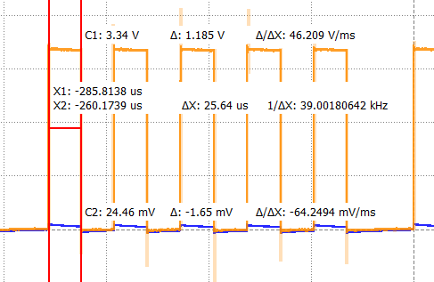
Figure 1: Bit Transmission Measurement (Lab5_3)
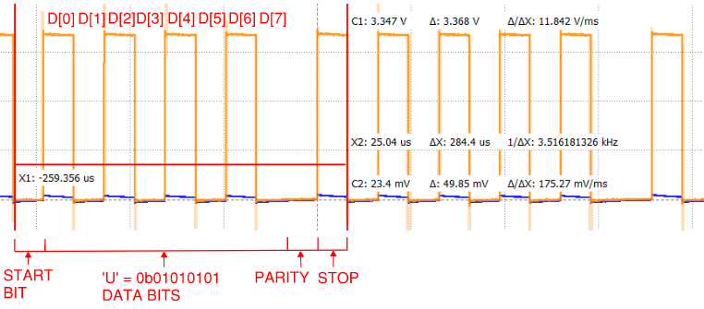
Figure 2: Character Transmission Measurement (Lab5_3)
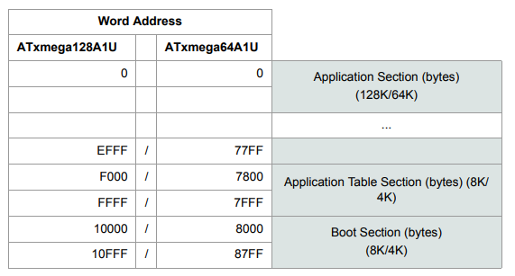
Figure 3: Program Memory Addressing

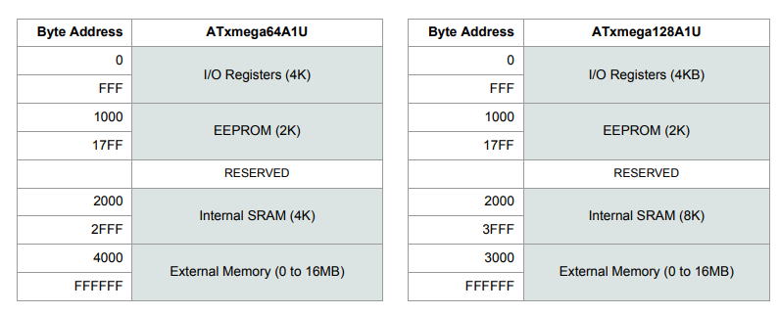
Figure 4: Data Memory Addressing

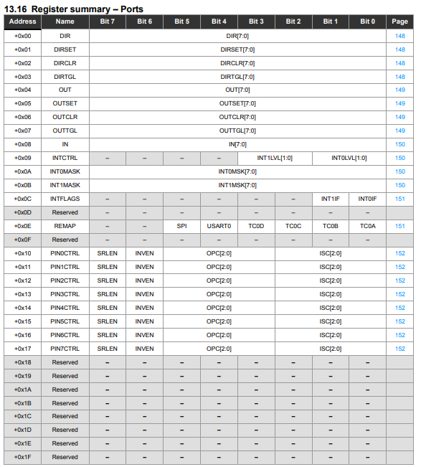
Figure 5: Ports Register Summary
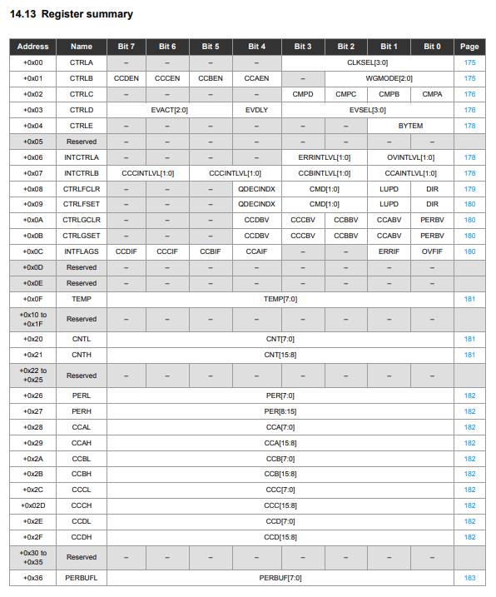
Figure 6: Timer/Counter Register Summary
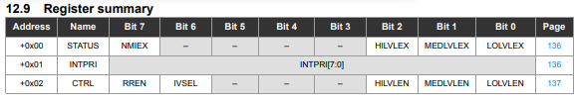
Figure 7: Interrupts Register Summary

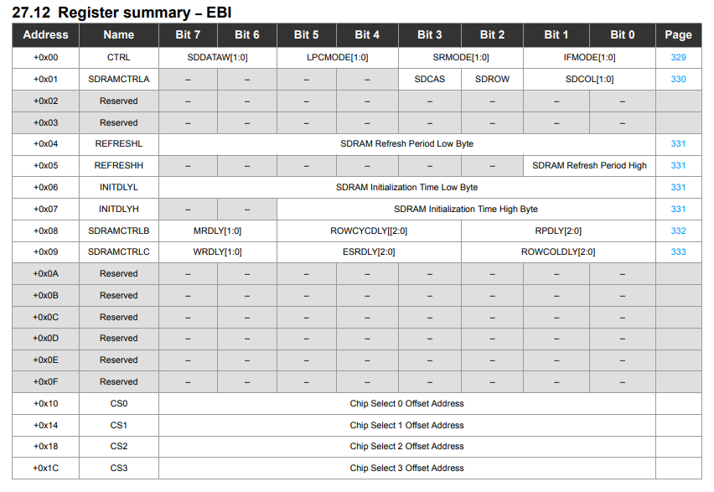
Figure 8: EBI Register Summary
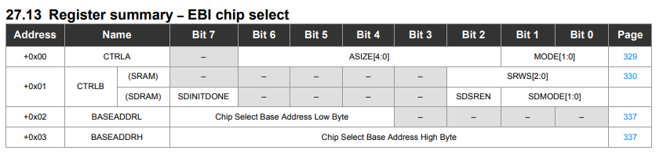
Figure 9: EBI Chip Select Register Summary
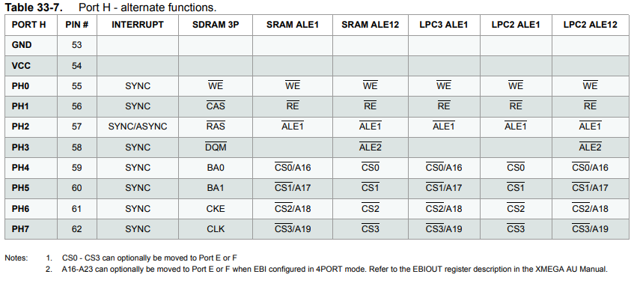
Figure 10: PORTH Alternate Functions
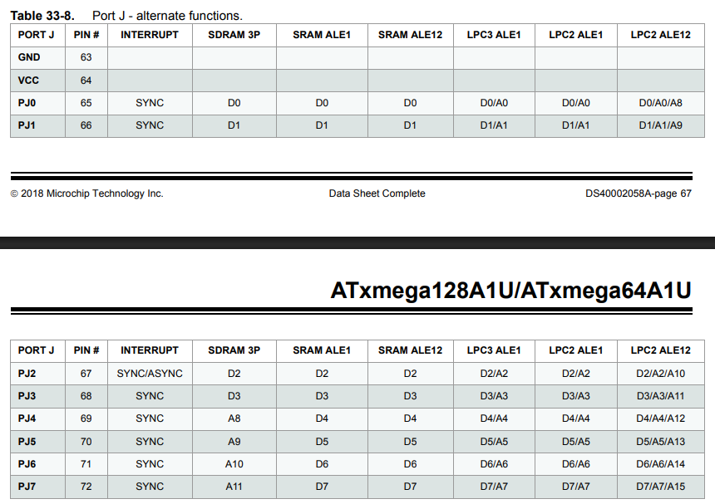
Figure 11: PORTJ Alternate Functions

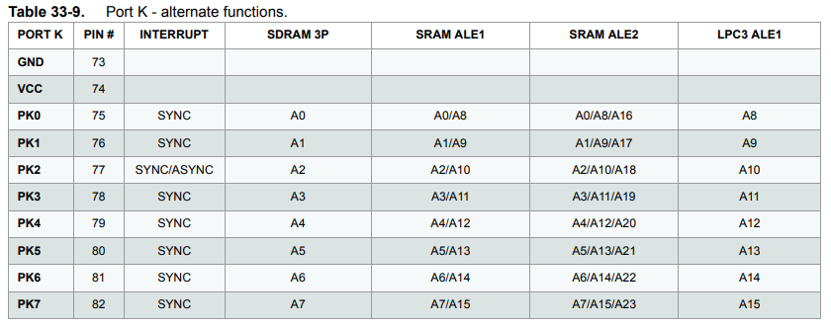
Figure 12: PORTK Alternate Functions
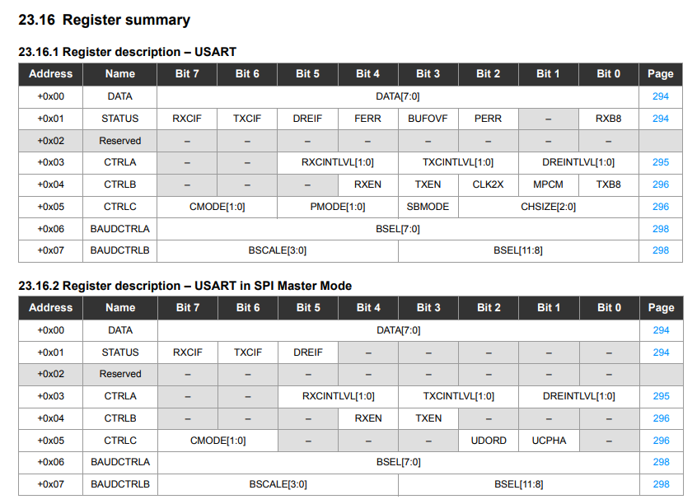
Figure 13: USART Register Summaries
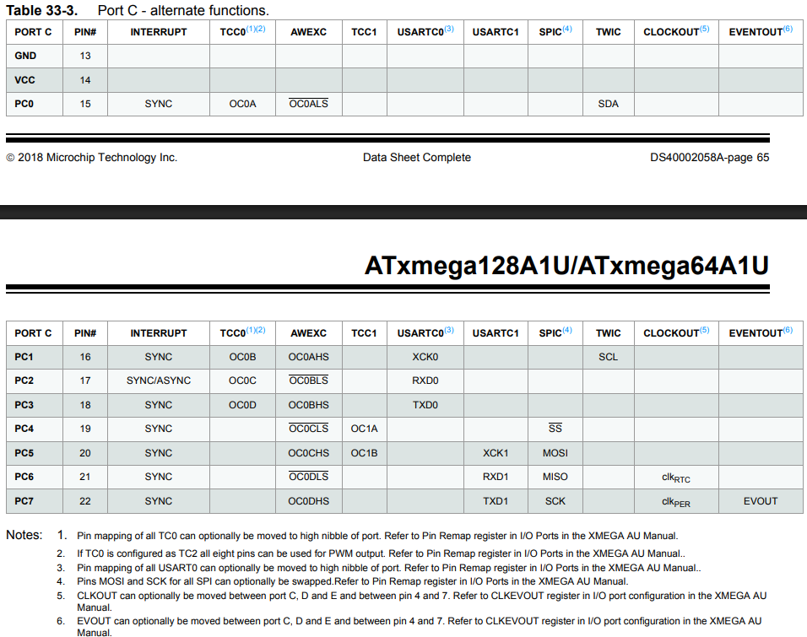
Figure 14: PORTC Alternate Functions

