- DC Operating Points NMOS (tt)
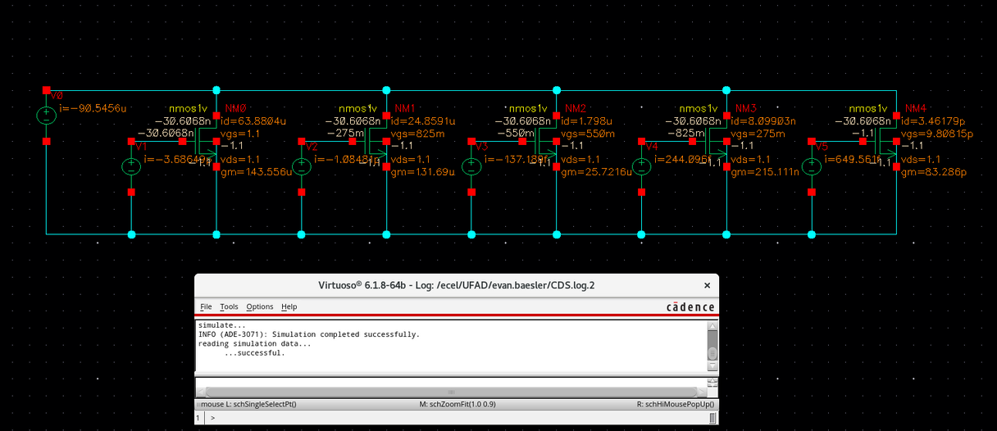

- NMOS IV Curves (ss, tt, ff)
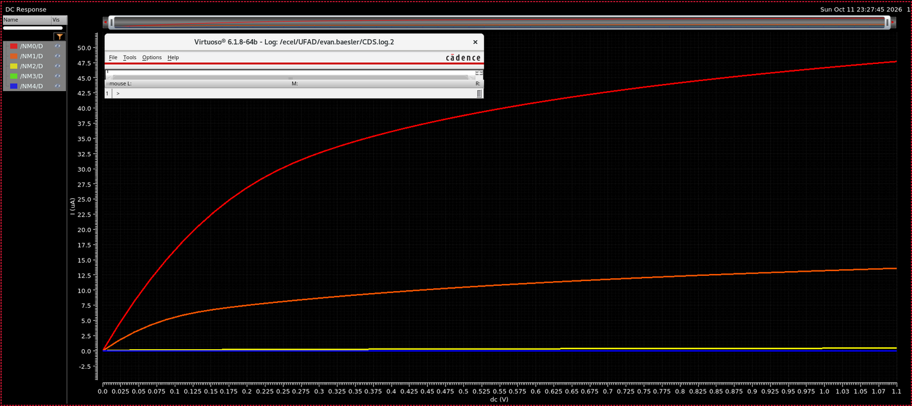
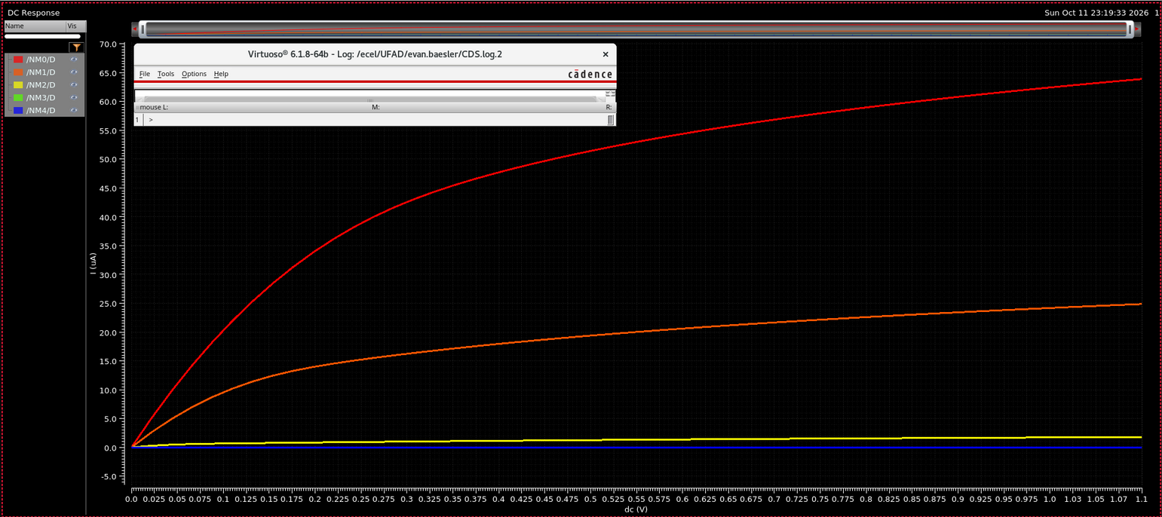
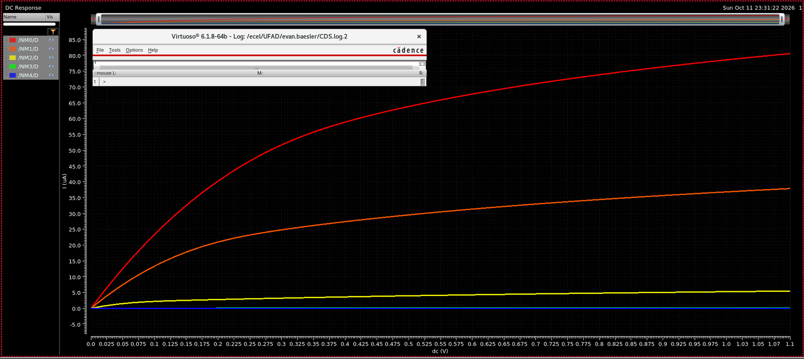
- Parameters
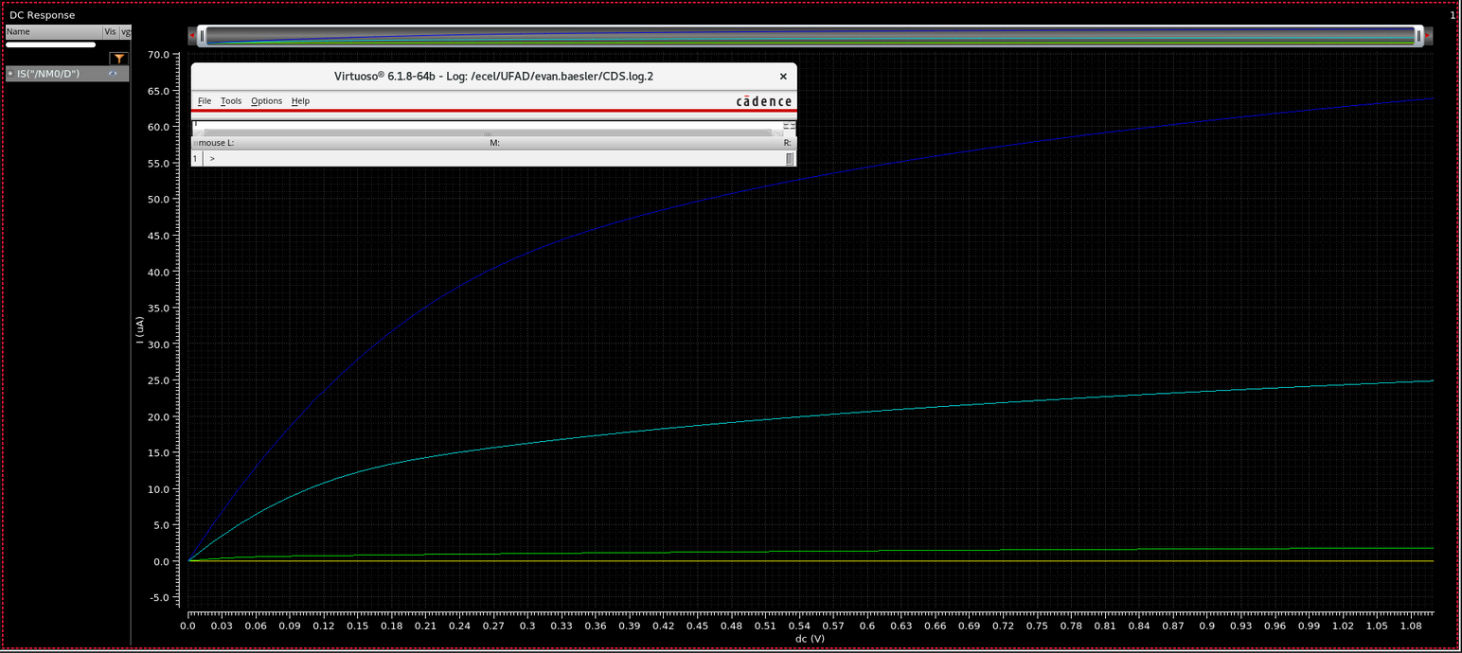
- NMOS Types
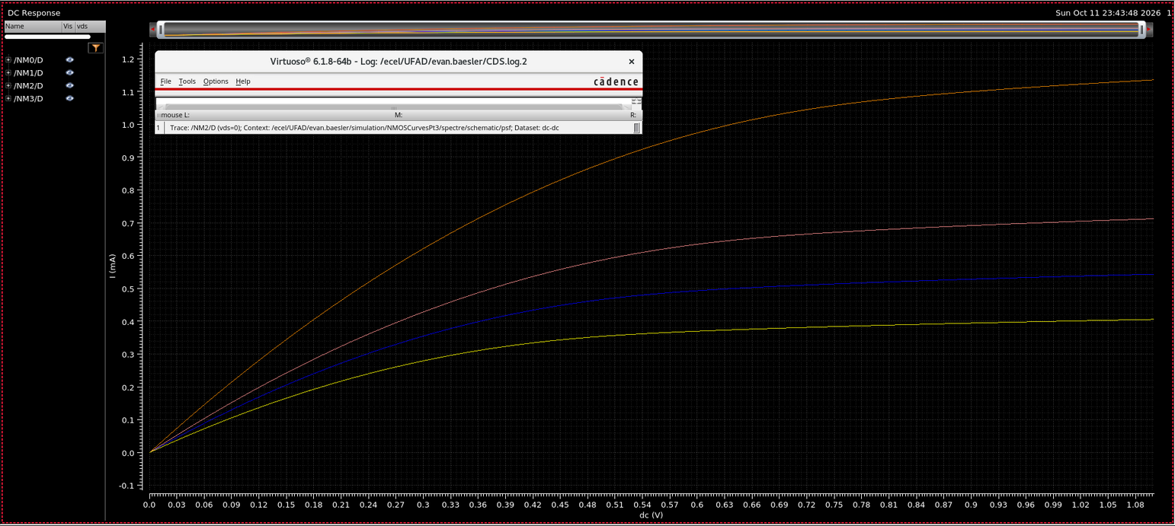

- Parametric 180nm (used NN as there was no TT, assumed n = normal = typical = t)
1.8V VGS MAX
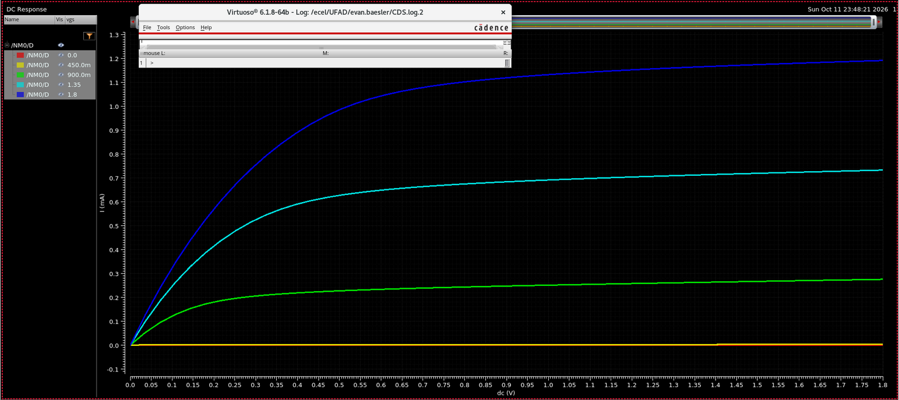
1.1V VGS MAX (I believe this one is correct, provided both incase!)
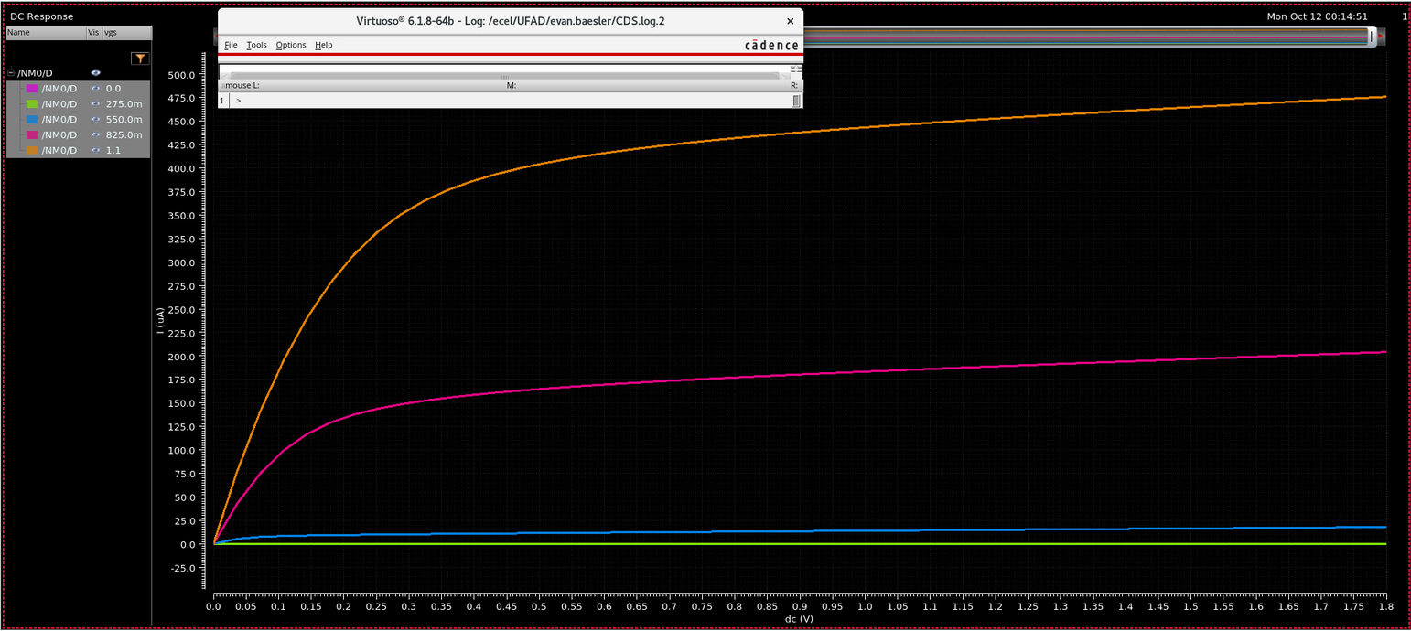
- Based on part 3, we can see that gate currents increase proportionally with the speed of the device, as in SS we can see the lowest peaks and in FF we see the highest. This is meant to model the actual performance of a transistor versus baseline, where faster means higher drive current, faster charging, and faster switching.

- The 45nm technology node utilized a drain current of ~65uA, whilst the 180nm utilized ~475mV for 1.1V VGS_{max} or ~1.2mA for 1.8V VGS_{max}; I was unsure whether we were meant to match the gate voltage to 1.8V (as was given on the drain), or to leave it at 1.1V.

- The slope of the 45nm current continues going upwards, but it’s growth tapers off as we go to higher voltages as the transistor reaches saturation.

- 45nm NMOS (tt): tox_n = 2.41E-9
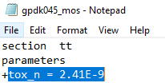
180nm NMOS (nn): toxn=4.0e-9
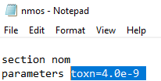

Which is equivalent to 2.41 nm and 4.0 nm.

Dennard’s scaling states that the scaling factor should be the new size over the old size, or $\frac{45nm}{180nm}=4$, however, the oxide did not shrink by a factor of 4, instead it shrunk to about 60% of the original. This is likely because of the limitations of scaling the oxide layer down such as gate leakage current, causing the design to stray away from Dennard’s scaling.

