- 3-INPUT NAND TRANSIENT (45nm)
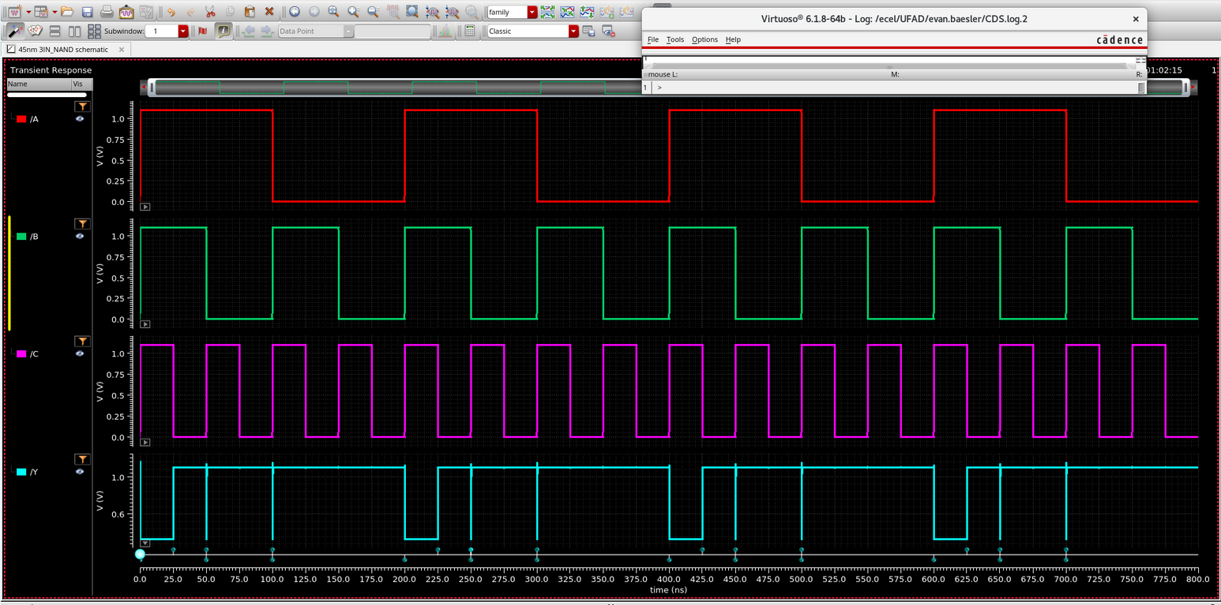

- 3-INPUT NAND (45nm)
(exceptions on bounces, consistent otherwise.)
Transient Rise & Fall (Output) for WP = WN = 1
Rise: 9.685ps
Fall: 14.42ps

Transient Rise & Fall (Output) for WP = 1.25, WN = 1
Rise: 9.699ps
Fall: 14.99ps

Transient Rise & Fall (Output) for WP = 1.5, WN = 1
Rise: 9.547ps
Fall: 15.23ps

Transient Rise & Fall (Output) for WP = 1, WN = 1.25
Rise: 9.875ps
Fall: 13.66ps

Transient Rise & Fall (Output) for WP = 1, WN = 1.5
Rise: 10.12ps
Fall: 13.12ps

Same around: WP = 1, WN = 1.55
Rise: 17.49ps
Fall: 16.59ps
17.49 – 16.59 = .9, just over 5%
So, we get 186nm NMOS, 120nm PMOS

- 3-INPUT NAND TRANSIENT (180nm)
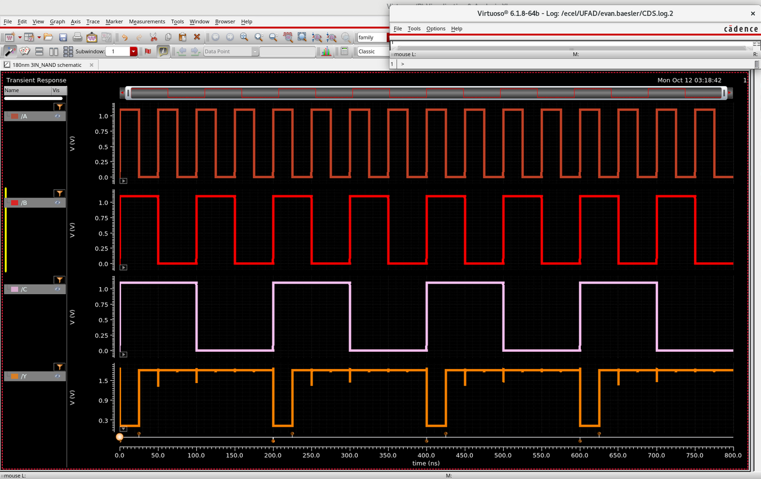

- 3-INPUT NAND (180nm)
Transient Rise & Fall (Output) for WP = WN = 1
Rise: 24.16ps
Fall: 45.17ps

Transient Rise & Fall (Output) for WP = 1, WN = 1.25
Rise: 35.67ps
Fall: 22.12ps

Transient Rise & Fall (Output) for WP = 1, WN = 1.5
Rise: 20.4ps
Fall: 29.86ps

Transient Rise & Fall (Output) for WP = 1.25, WN = 1
Rise: 24.16ps
Fall: 45.17ps

Transient Rise & Fall (Output) for WP = 1.5, WN = 1
Rise: 26.7ps
Fall: 83.08ps

Closest found: PW = 1, WN = 1.875:
Rise: 38.56ps
Fall: 40.09ps
Diff: 40.09-38.56 = 1.53, within 5% of eachother.
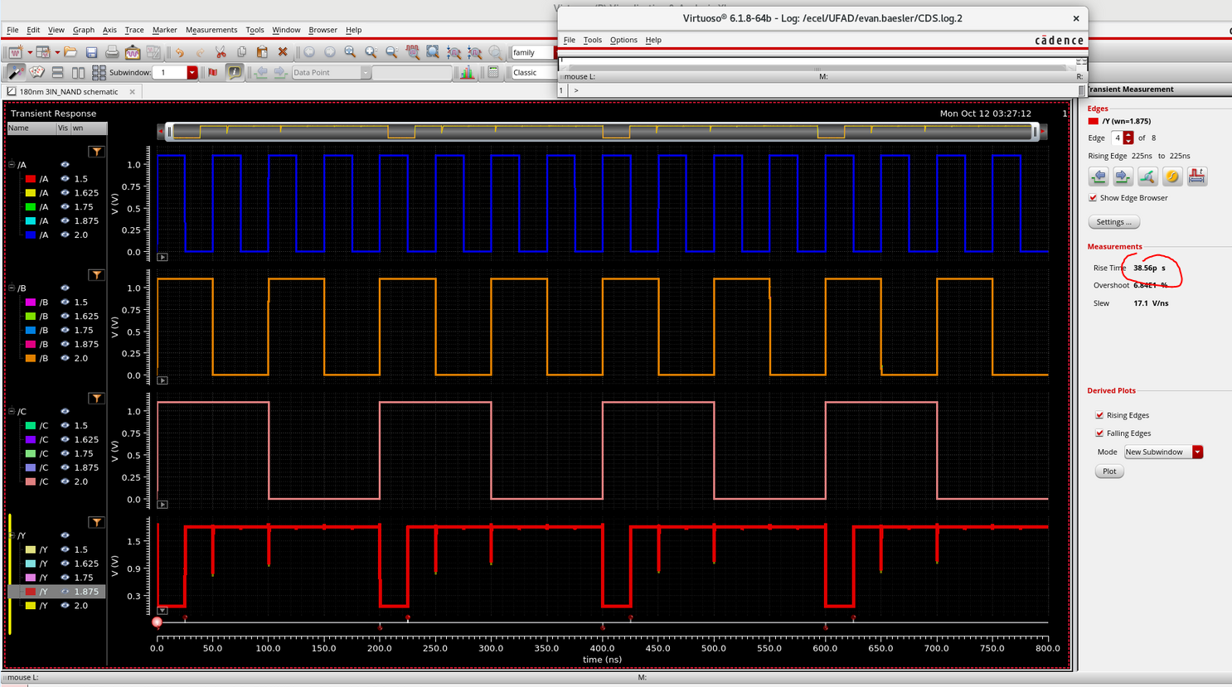

- Naturally, the 45nm technology node is significantly faster and has quicker rise and fall times, which were about 17ps avg rise/fall versus 39.5ps avg rise/fall, which means the smaller technology node is denser and over twice as fast as the previous nodes. This is likely due to the fact that smaller dimensions means smaller parasitic capacitance, which allows for faster charging and discharging.

To size these two transistors effectively, I tried to keep their differences within 5% of each other, which brought the sizes up considerably. Both transistors found a need for increasing the WN value, to bring the fall time down. I think that the sizing was different between the two transistors due to differing materials and nuance behind the parasitics.

- Used 120nm transistor size standard:
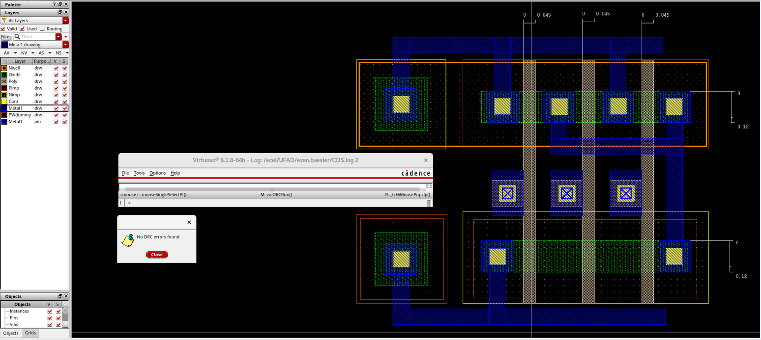

- The 180nm NAND is expected to be larger than the 45nm NAND because its transistors will generally be larger in terms of width and length. Ideally, the ratio of area would be that the 180nm would be: $\frac{180nm^{2}}{45nm^{2}}=16$ times larger than the 45nm NAND. Although, with the different NMOS sizing this might fluctuate slightly.

- DRC:

- LVS
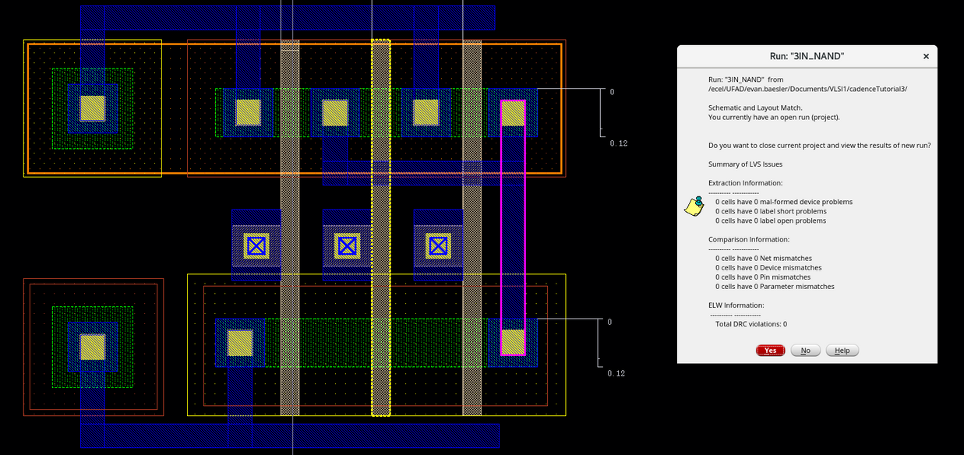

- LVS Output:
