Objectives
- Understand several building blocks used in transistor circuit design and learn about their limitations.
- Reinforce concepts learned in the design of common-source, common-gate, and common-drain amplifiers.
Equipment
- 2 CD4007UBE transistor array ICs
- Breadboard and various wires
- Various resistors
- Digilent Analog Discovery (DAD) Board
Introduction
In this lab we will be using the CD4007UBE transistor array. Each 4007 array has three NMOS and three PMOS transistors. They are arranged in NMOS/PMOS pairs as shown below. Each NMOS/PMOS pair is internally connected slightly differently, which constrains how the transistors can be used in external circuits. Use the following layout in figure 1 below to build your circuits in this lab.
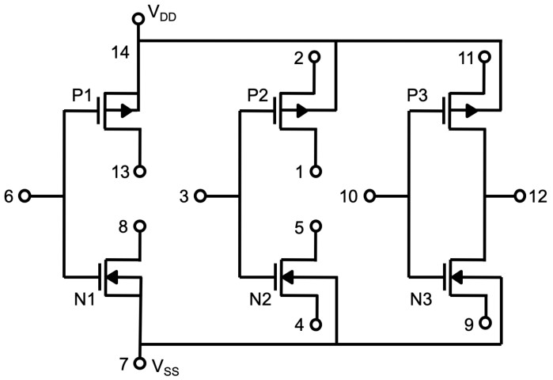
Figure 1 – CD4007UBE Layout
Only a few transistors on each chip will be used. The other FETs we will leave “floating” (disconnected). However, on each chip pins 14 and 7 must always be connected to the positive and negative supply voltages V_{DD} and V_{SS}, respectively. These pins are internally connected to the sources of transistors N₁ and P₁ but also to the substrates of the other MOSFETs in the chip. The biasing is required so that all of the transistors are isolated by reverse-biased PN junctions.
In this lab we will first be introduced to building current mirrors in Part 1. Then we will build an PMOS circuit in part 1 using one chip and we will then build an NMOS circuit in Part 2. *We will eventually connect the circuits together so be sure to keep them on your breadboard before coming to lab.

Pre-Lab
Part 1: Intro to Current Mirrors (10 Points)
A current mirror is used to copy or multiply the input current. It is often used as a bias circuit that provides a known current to an analog circuit like a common-source amplifier with an active load. A current mirror in CMOS relies on the property that ideal transistors of the same size (W/L) with the same V_{GS} have the same drain current (I_{D}) regardless of V_{DS} as long as both are in saturation. A simple NMOS current mirror is shown in Figure 2. With real transistors, however, I_{D} changes slightly with V_{DS} because of the channel-length modulation. In small signal, this effect appears as a finite output impedance (as opposed to the infinite output impedance of an ideal current mirror).

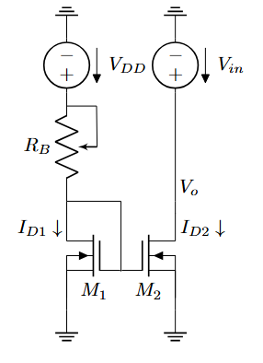
Figure 2 – NMOS current mirror.

- +Create the following current mirror in Figure 2 on your breadboard and complete the following items. (5 Points)
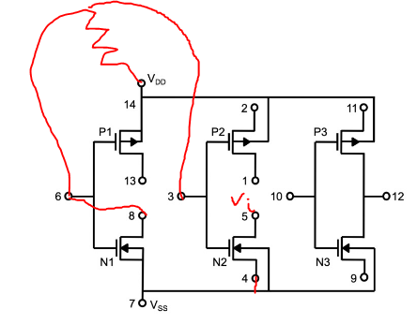
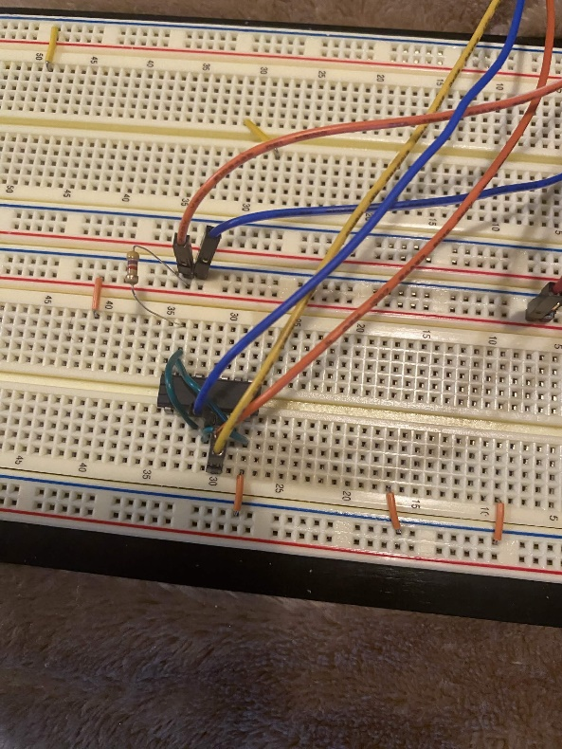
- Choose R_{B} such that I_{D1} = 1 mA; (you can use a normal resistor).
- Set V_{DD} = 5 V.
- Use your CD4007UBE array IC and get familiar with its pin-layout.
- Set V_{in} to a 2 V, 1 kHz sine wave and plot I_{D2} versus V_{o} using XY mode in waveforms.

- Show the output swing and output impedance of the current mirror in waveforms as well. (5 Points)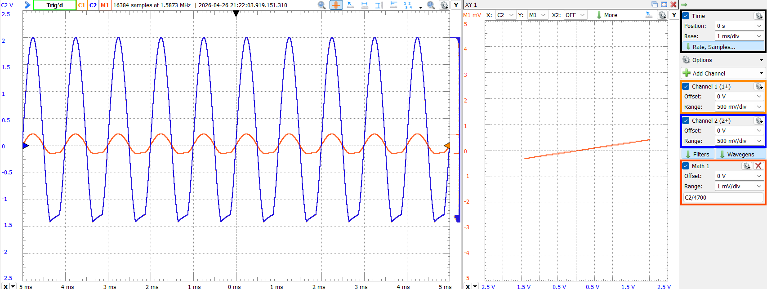
Used a math function to divide voltage by resistance for current

Part 2: Current Mirror Building Block (30 Points)
Current mirrors are fundamental biasing elements used in many analog integrated circuits. By using matched transistors operating in saturation, a current mirror can replicate a reference current in another branch of a circuit. In this section, a PMOS current mirror is constructed using the CD4007 transistor array to investigate how accurately current can be mirrored and how non-ideal transistor effects influence the output current and output resistance.
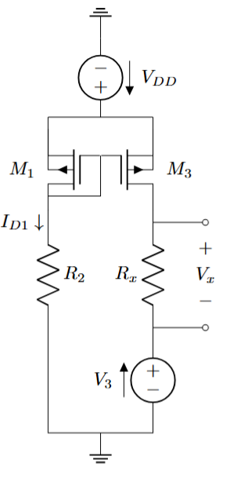
Figure 3 – PMOS Current Mirror
- Build a PMOS current mirror using the following specifications:
- Use your first 4007 array chip.
- Use the “P₂” and “P₃” MOSFETs.
- Set V₃ to 0 V (DC).
- Choose a value for R₂ to set I₃ to roughly 0.05 mA (50 uA).
* To calculate I₃, use R_{X} = ~1 kΩ as an ammeter to find the current of P₃: I₃ = V_{X} / R_{X}.
Record your chosen value of R₂ (10 Points)
1k for 5v/1k = 5mA
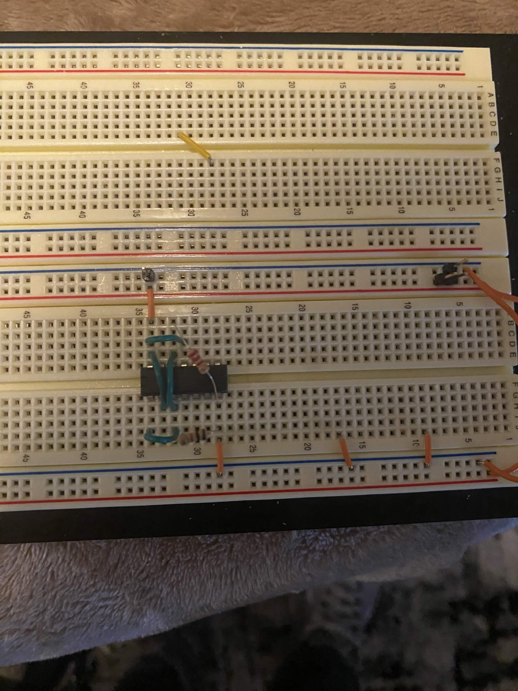

- Measure and record all node voltages and verify that both FETs are active. Are the drain currents of P₂ and P₃ approximately equal? (10 Points)
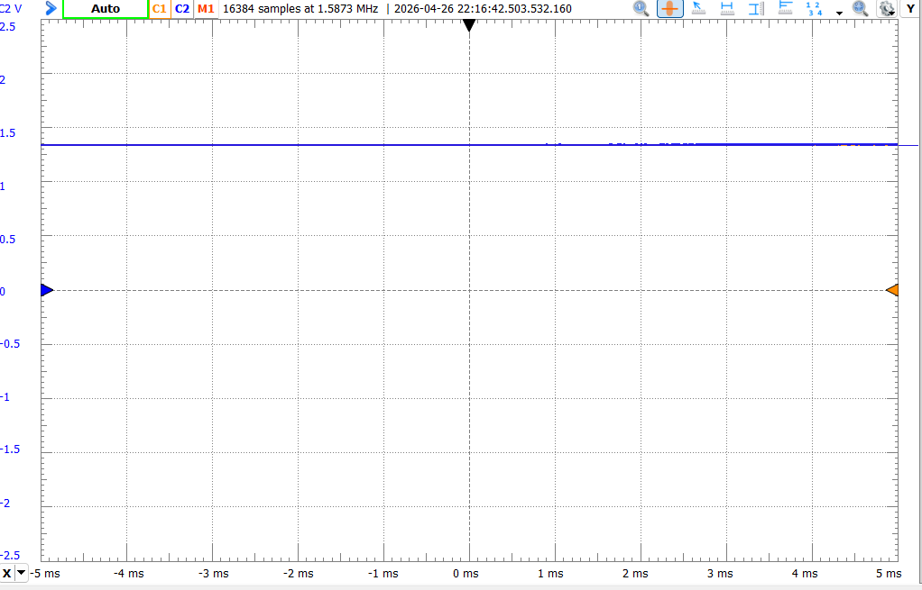
yes

- Add a 400 mV 1 kHz sine wave to V₃. Measure the resulting AC component of I₃. Estimate the output resistance of the current mirror as the ratio of the change in V_{D3} to the change in I₃. (10 Points)
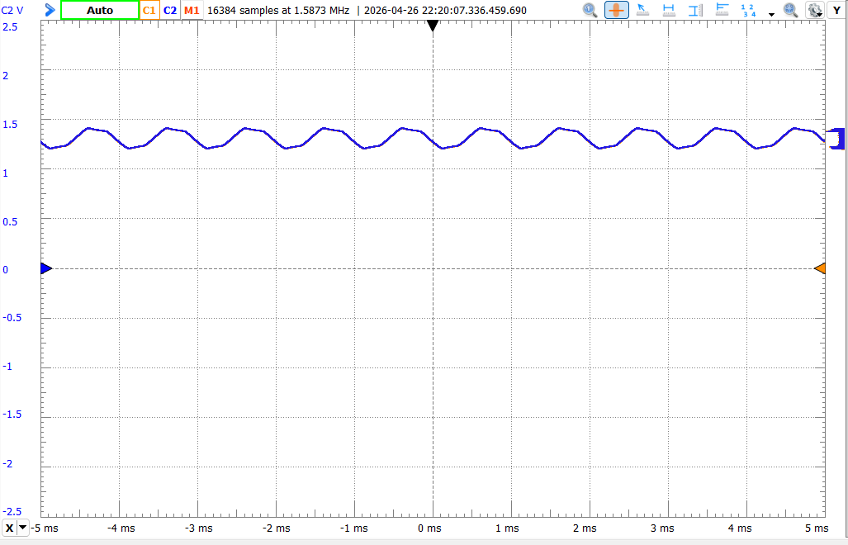

Part 3: NMOS Differential Pair Building Block (40 Points)
Differential amplifiers are one of the most important building blocks in analog circuit design and form the input stage of many operational amplifiers. A differential pair amplifies the difference between two input signals while rejecting signals that are common to both inputs. In this section, an NMOS differential pair will be implemented using the CD4007 array. The circuit will be used to examine offset voltage, differential gain, common-mode gain, and the common-mode rejection ratio (CMRR).
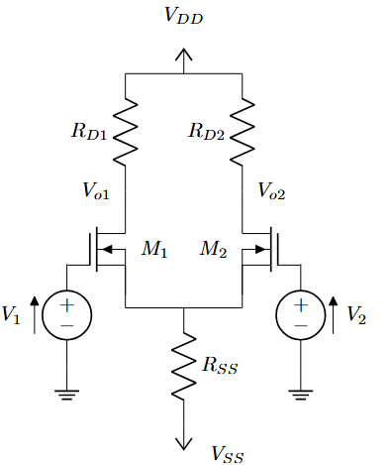
Figure 4 – NMOS Differential Pair Amplifier
- Build the differential pair amplifier in LTspice with the following:
- Use your second CD4007UBE array IC
- Use the “N₂” and “N₃” FETs from your NMOS array.
- R_{SS} = 33 kΩ
- R_{D1} = R_{D2} = 68 kΩ.
- V_{SS} = – 5 V.
- V_{DD} = 5 V
- Use Waveform Generators 1 and 2 for input voltages V₁ and V₂. (4 Points)

- Find a combination of DC values for V₁ and V₂ so that their sum is approximately 0 V (will be in the mV range), and the output voltages V_{o1} and V_{o2} are the same and in the range of 3 V. Record V_{O1}, V_{O2}, and the node voltage at the source of the MOSFETs. Calculate the current using the following values: V_{DD}, V_{O1/2}, and R_{D1/2}. (6 Points)

- Because the FETs N₂ and N₃ are matched, the difference between V₁ and V₂ when the output voltages are equal should be small (mV range). This difference is the offset voltage V_{OS}. Record your V_{OS}. (4 Points)

- With the DC values of V₁ and V₂ fixed, add a 50 mV 1 kHz sine wave to V₁. Measure the amplitudes of V_{o1} and V_{o2}, and observe their phases/signs. Record the amplitude of the source terminals of N₂ and N₃. (8 Points)

- Turn off the AC part of V₁ and add a 50 mV 1 kHz sine wave to V₂. Record the same values from IV. (4 Points)

- Compute the differential mode gain A_{DM}, differential output voltage (V_{odm}), and differential input voltage (V_{idm}). A_{DM} can be defined as the ratio of the differential output signal V_{odm} = V_{o1} - V_{o2} to the differential input signal V_{idm} = V_{i1} – V_{i2}, A_{DM} = V_{odm}/V_{idm}. (6 Points)

- Add 10 mV 1 kHz sine waves with equal phase to both V₁ and V₂ with their DC values still unchanged.
Repeat IV. Measure the differential output voltage. Compute the common-mode gain A_{CM}. Where A_{CM} is the ratio of the differential output signal V_{odm} = V_{o1} - V_{o2} to the common-mode input signal V_{icm} = V_{i1} = V_{i2} A_{DM} = V_{odm} / V_{icm}. (6 Points)

- Compute the common-mode rejection ratio such that CMRR = 20 log10(|A_{DM}|/|A_{CM}|). (4 Points)

