REQUIREMENTS NOT MET
None.
PROBLEMS ENCOUNTERED
None Encountered.

PSEUDOCODE/FLOWCHARTS
SECTION 1
#define TABSIZE 16
#define OUT_TAB_START 0x3700
#include <avr/io.h>
int main(void){
// create an array of 8-bit value with a size of 16; replace ?? with the values in Table 1, separated by commas
uint8_t IN_TAB [TABSIZE] = { data };
uint8_t *IN_TAB_P = &IN_TAB; // create a pointer to this table
// Note that using the // create a pointer to this table & above is not necessary since by default, 8-bit arrays are
// pointers which point to the first element of the array.
// Thus, using both *IN_TAB_P = &IN_TAB; or *IN_TAB_P = IN_TAB; will produce the same
// functionality since IN_TAB is an address; however, to remain consistent we will use the ampersand.

// Initialize a pointer to point to the output table at location 0x3700. Call it OUT_TAB_P
uint8_t OUT_TAB_P (pointer type)value OUT_TAB_START

SECTION 2
//To start the processing, we can use the following template:
while(1){
// Loop till null, i.e., loop while the values at that address are non-zero
// (null)
while(*IN_TAB_P){
// Check for the conditions
// Recall when using an *, we are analyzing the value at that
// pointer
// Dereference IN_TAB_P and check if bit 5 is set (See the Example
// 2).
// if bit 5 was set, then multiply by 2
if( value of IN_TAB_P & (1<<5) not 0 ){
value of IN_TAB_P = value of IN_TAB_P * 2
// check if the value at IN_TAB_P times two is greater than
// or equal to 70
if( value of IN_TAB_P >= 70 ) {
/*Store the result to address pointed by OUT_TAB_P */
// remember to alter the data at an address using a
// pointer, then you must use an (*). (See Example 1)
value of OUT_TAB_P = value of in IN_TAB_P

/*Increment OUT_TAB_P to move to next available space
*/

OUT_TAB_P += 1

}
}
else{
// if the input value (dereference IN_TAB_P) +3 is less than
//78
store the value to OUT_TAB_P
if( value of IN_TAB_P < 75 ){ // Same as IN_TAB_P+3 < 78
/*Store the result to address pointed by OUT_TAB_P */
value of OUT_TAB_P = (value of IN_TAB_P + 3)

/*Increment OUT_TAB_P to move to available space */
OUT_TAB_P += 1
}
}
IN_TAB_P+=1; // increment IN_TAB_P, the next address in IN_TAB
}
}
return 0;
}

PROGRAM CODE
SECTION 1
/*
* HW3.c
*
* Created: 7/11/2026 3:25:39 PM
* Author : Evan Baesler
*/

#define TABSIZE 16
#define OUT_TAB_START 0x3700
#include <avr/io.h>
int main(void){
// create an array of 8-bit value with a size of 16; replace ?? with the values in Table 1, separated by commas
uint8_t IN_TAB [TABSIZE] = { 201, 0x22, 051, 91, 0x91, 0x2A, 'U', 0130, '#', 0b01010101, 'J', 0x21, 0x55, 32, 0b00011110, 0 };
uint8_t *IN_TAB_P = &IN_TAB; // create a pointer to this table
// Note that using the // create a pointer to this table & above is not necessary since by default, 8-bit arrays are
// pointers which point to the first element of the array.
// Thus, using both *IN_TAB_P = &IN_TAB; or *IN_TAB_P = IN_TAB; will produce the same
// functionality since IN_TAB is an address; however, to remain consistent we will use the ampersand.

// Initialize a pointer to point to the output table at location 0x3700. Call it OUT_TAB_P
uint8_t *OUT_TAB_P = (uint8_t *)OUT_TAB_START; // Treats the pointer as a hex number

SECTION 2
//To start the processing, we can use the following template:
while(1){
// Loop till null, i.e., loop while the values at that address are non-zero (not null)
while(*IN_TAB_P){
// Check for the conditions
// Recall when using an *, we are analyzing the value at that pointer
// Dereference IN_TAB_P and check if bit 5 is set (See the Example 2).
//if bit 5 was set, then multiply the value by two!
if( *IN_TAB_P & (1<<5) ){
*IN_TAB_P = *IN_TAB_P * 2;
// check if the value at IN_TAB_P times two is greater than or equal to 70
if( *IN_TAB_P >= 70 ) {
/*Store the result to address pointed by OUT_TAB_P */
// remember to alter the data at an address using a pointer, then you must use an (*). (See Example 1)
*OUT_TAB_P = *IN_TAB_P;

/*Increment OUT_TAB_P to move to next available space */
OUT_TAB_P += 1;
}
}
else{
// if the input value (dereference IN_TAB_P) +3 is less than 78, store the result in the output table.
if( (*IN_TAB_P) < 75 ){
/*Store the result to address pointed by OUT_TAB_P */
*OUT_TAB_P = (*IN_TAB_P + 3);
/*Increment OUT_TAB_P to move to available space */
OUT_TAB_P += 1;
}
}
IN_TAB_P+=1; // increment IN_TAB_P, the next address in IN_TAB
// should this instruction be somewhere else?
// Yes, we moved it up two rows INTO the loop.
}
}
return 0;
}

APPENDIX
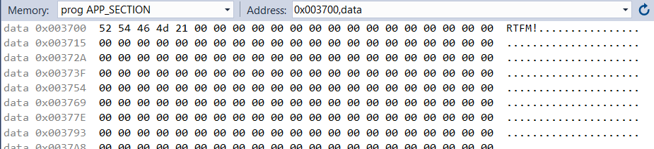
Figure 1: Output Table Filtered Values

