REQUIREMENTS NOT MET
None
PROBLEMS ENCOUNTERED
None Encountered
FUTURE WORK/APPLICATIONS
ADC is what allows almost any peripheral to work in a quantitative measure. With ADC, we can read the values from photoresistors, waveform inputs, and any other sort of sensor connected to an ADC input pin. Fundamental to creating useful PCBs and products .

PRE-LAB EXERCISES
- Why must we use the ADCA module as opposed to the ADCB module?

PortA is connected to the photoresistors pins on PortA, where ADCB is connected to PortB.

- Would it be possible to use any other ADC configurations such as single-ended, differential, differential with gain, etc. with the current pinout and connections of the OOTB Analog Backpack? Why or why not?

Single-ended mode would not be ideal as we want the differential voltage across CDS- and CDS+.

So, Differential is the ideal setting since we want our ADC output to be based on the difference between the CDS- and CDS+ signals. Since the voltage difference is large enough to do without amplification, we do not need gain, so we COULD use gain so long as the gain is small enough to not go higher or lower than the maximum rail limits.

- What would the main benefit be for using a 12-bit ADC system rather than an 8-bit ADC system? Would there be any reason to use 8-bit resolution instead of 12-bit resolution?

A higher bit count means higher resolution, allowing you to be more accurate (i.e, 5.75% battery left instead of 6%)

8-bit would give 256 values, 12-bit would give 4096 values.

Less bits means faster processing and less memory.

- What is the decimal voltage value that is equivalent to a 12-bit signed result of 0x304, given a voltage range of -5V to +5?

12-bit = 4096 values, with a voltage range between -5V and 5V, we have a 10V range, so our quantization increment will be 10/4096 = 0.002441V per count; 0x304 = 772, so 772 * 10/4096 ~= 1.8848V

- Given an 8-bit signed ADC system with a voltage reference range of -3V to +6V, express the expected digital value in terms of the analog input voltage, using the form VD = f(VA).

We want -128 at VA <= Vmin, and +127 when VA => Vmax, so to get this we would need our denominator to be Vmax – Vmin = 9, and our numerator to be Va – Vmin (to get 0/9).

This would give us ((Va + 3)/9) * 255 – 128, at Va = -3, 0/9 * 255 – 128 = -128, at Va = 6, 1*255-128 = 127.

PSEUDOCODE/FLOWCHARTS
Lab7_1.c
Int main(void){
Create adc_output variable
Adc_init
While(1){
Start ADC
Wait for finish
Store value and reset
}
}
Void adc_init(void){
Set 2.5V ref
Put into a differential with gain mode for pin access (1x gain)
Set resolution to 12bit, right adjusted
Set prescaler
Select positivity/negativity of pins
Enable ADC
}

Lab7_2.c
Int main(){
Create adc_output variable
Set blue/green PWM to outputs
Set blue, clear green
Tcc0_init
Adc_init
Sei
While(1){
// empty loop
}
}

Void tcc0_init(void){
Set period and prescaler for .1 second length
Enable PMIC
Set event system to run off of TCC0 OVF
}

Void adc_init(void){
Set 2.5V ref
Put into a differential with gain mode for pin access (1x gain)
Set resolution to 12bit, right adjusted
Set prescaler
Select positivity/negativity of pins
Set event system control to channel 0, convert on channel 0
Enable ADC
}

ISR(ADCA_CHANNEL0){
Update adc_output
Toggle LEDs
}
Lab7_3.c
Int main{
Tcc0_init
Adc_init
Usartd0_init
Sei
While(1){
Turn off flag
Save adc output to secondary variable so data does not change during loop
Determine sign and save to variable
Calculate decimals from formula on lab doc
Use outchar and outstring to output decimal and format
Use a table with hexchars and index via nibble to output hex values
Carriage return/newline
}}

Void usartd0_init(void){
Set TxD to high, output
Set RxD to input
Set Baud rate via BSEL/BSCALE
Set as asynchronous, odd parity, 8bit channel
Enable Tx/Rx
}

Void outchar(char){
Wait for transfer
Send char to data bus
}

Void outstring(string){
For loop outchar
}

Reuse adc_init, tcc0_init
Update ADC_CH0 ISR to save the output to a variable and set a variable flag.

Lab7_4.c
Main{
Tcc0_init
Adc_init
Usartd0_init
Sei
While (1){

If adc_flag{
Reset flag
Store adc output to secondary variable
Output low byte and high byte using outchar
}}}

Reuse usartd0_init, tcc0_init (with 155Hz), adc_init, outchar/outstring, and ISR.

Lab7_5.c
Main{
Tcc0_init
Adc_init
Usartd0_init
Sei
While (1){

If adc_flag{
Reset flag
Store adc output to secondary variable
Output low byte and high byte using outchar
}}}

ISR(usartd0_rxif){
If usartd0.data = ‘P’{
Connect photocell pins
}
elseif usartd0.data = ‘W’{
Connect AIN pins
}
}

Reuse usartd0_init with receive interrupts, tcc0_init (with 155Hz), adc_init, outchar/outstring, and ISR

PROGRAM CODE
Lab7_1.c
/*
* lab7_1.c
*
* Created: 7/19/2026 11:07:50 PM
* Author : Evan Baesler
*/

#include <avr/io.h>

void adc_init(void);

int main(void){

int16_t adc_output;

adc_init();

while(1) {
// Start conversion on CH0
ADCA.CH0.CTRL |= ADC_CH_START_bm;

// Wait for conversion to finish (check interrupt flag)
while(!(ADCA.CH0.INTFLAGS & ADC_CH_CHIF_bm));

// Store result and clear flag
adc_output = ADCA.CH0.RES;
ADCA.CH0.INTFLAGS = ADC_CH_CHIF_bm;
}

}

void adc_init(void) {
// Set 2.5V voltage reference on PB
ADCA.REFCTRL = ADC_REFSEL_AREFB_gc;

// 12-bit signed ADC, right-adjusted with signed mode conversion
ADCA.CTRLB = ADC_CONMODE_bm | ADC_RESOLUTION_12BIT_gc;

// Set clock prescaler
ADCA.PRESCALER = ADC_PRESCALER_DIV512_gc;

// Select positive and negative inputs (Use DIFF w/ 1x Gain for pin support)
// Pin1 = CDS+, Pin6 = CDS-
ADCA.CH0.MUXCTRL = ADC_CH_MUXPOS_PIN1_gc | ADC_CH_MUXNEG_PIN6_gc;

// Set gain & enable the channel / module
ADCA.CH0.CTRL = ADC_CH_GAIN_1X_gc;
ADCA.CH0.CTRL |= ADC_CH_INPUTMODE_DIFFWGAIN_gc;
ADCA.CTRLA = ADC_ENABLE_bm;
}

Lab7_2.c
/*
* lab7_2.c
*
* Created: 7/20/2026 6:38:19 PM
* Author: Evan Baesler
*/

#include <avr/io.h>
#include <avr/interrupt.h>

int16_t adc_output = 0;

void tcc0_init(void);
void adc_init(void);

int main(void){

PORTD.DIRSET = PIN5_bm | PIN6_bm;

PORTD.OUTSET = PIN5_bm;
PORTD.OUTCLR = PIN6_bm;

tcc0_init();
adc_init();

sei();

while(1){

}
}

void tcc0_init(void){

// Do NOT put a overflow interrupt, event system handles it
TCC0.PER = 3125; // .1(2000000/64) = 3125
TCC0.CTRLA = TC_CLKSEL_DIV64_gc; // .1(2000000/64) = 3125

PMIC.CTRL = PMIC_LOLVLEN_bm; // Enable low-level interrupts

EVSYS.CH0MUX = EVSYS_CHMUX_TCC0_OVF_gc; // Send TCC0 OVF to event system
}

// From lab7_1, expanded

void adc_init(void) {
// Set 2.5V voltage reference on PB
ADCA.REFCTRL = ADC_REFSEL_AREFB_gc;

// 12-bit signed ADC, right-adjusted with signed mode conversion
ADCA.CTRLB = ADC_CONMODE_bm | ADC_RESOLUTION_12BIT_gc;

// Set clock prescaler
ADCA.PRESCALER = ADC_PRESCALER_DIV512_gc;

// Select positive and negative inputs (Use DIFF w/ 1x Gain for pin support)
// Pin1 = CDS+, Pin6 = CDS-
ADCA.CH0.MUXCTRL = ADC_CH_MUXPOS_PIN1_gc | ADC_CH_MUXNEG_PIN6_gc;

// Set gain & enable the channel / module
ADCA.CH0.CTRL = ADC_CH_GAIN_1X_gc;
ADCA.CH0.CTRL |= ADC_CH_INPUTMODE_DIFFWGAIN_gc;

// Enable ADC low-level interrupt
ADCA.CH0.INTCTRL = ADC_CH_INTLVL_LO_gc;

// Allow event system control to use channels 0-3, do conversion on CH0
ADCA.EVCTRL = ADC_EVSEL_0123_gc | ADC_EVACT_CH0_gc;

// Enable ADC :)
ADCA.CTRLA = ADC_ENABLE_bm;

}

ISR(ADCA_CH0_vect){

// Update ADC Output
adc_output = ADCA.CH0.RES;

// Toggle LEDs
PORTD.OUTTGL = PIN5_bm | PIN6_bm;

}
Lab7_3.c
/*
* lab7_3.c
*
* Created: 7/20/2026 9:45:32 PM
* Author: Evan Baesler
*/

#include <avr/io.h>
#include <avr/interrupt.h>

int8_t BSEL = 17;
int8_t BSCALE = -7; // 110400 bps
int16_t adc_output = 0;
volatile uint8_t adc_flag = 0;

void tcc0_init(void);
void adc_init(void);
void usartd0_init(void);
void outchar(char c);
void outstring(const char *str);

int main(void){

tcc0_init();
adc_init();
usartd0_init();

sei();

while(1){
if(adc_flag){
adc_flag = 0;

int16_t data = adc_output;
char sign = '+';

if (data < 0){
sign = '-';
data = -data; // Remove two's comp so we can make it easier to read.
}

float voltage = ((float)data / 2048.0f) * 2.5f;
int int1 = voltage;
float voltage2 = 10.0f * (voltage - int1);
int int2 = voltage2;
float voltage3 = 10.0f * (voltage2 - int2);
int int3 = voltage3;

outstring("Transmitted Result: ");
outchar(sign);
outchar('0' + int1); // ASCII 0 + int lets us output a number
outchar('.');
outchar('0' + int2);
outchar('0' + int3);
outstring(" V (0x");

// Output 3-digit Hex value
char hex_chars[] = "0123456789ABCDEF"; // Treats as an array of hex_chars[i]

outchar(hex_chars[(data >> 8) & 0x0F]); // Shifts hex to the right, and uses the byte value as
outchar(hex_chars[(data >> 4) & 0x0F]); // a way to access hex_chars[i].
outchar(hex_chars[data & 0x0F]);

outstring(")\r\n");
}
}
}

void tcc0_init(void){

// Do NOT put a overflow interrupt, event system handles it
TCC0.PER = 3125; // .1(2000000/64) = 3125
TCC0.CTRLA = TC_CLKSEL_DIV64_gc; // .1(2000000/64) = 3125

PMIC.CTRL = PMIC_LOLVLEN_bm; // Enable low-level interrupts

EVSYS.CH0MUX = EVSYS_CHMUX_TCC0_OVF_gc; // Send TCC0 OVF to event system
}

// From lab7_1

void adc_init(void) {
// Set 2.5V voltage reference on PB
ADCA.REFCTRL = ADC_REFSEL_AREFB_gc;

// 12-bit signed ADC, right-adjusted with signed mode conversion
ADCA.CTRLB = ADC_CONMODE_bm | ADC_RESOLUTION_12BIT_gc;

// Set clock prescaler
ADCA.PRESCALER = ADC_PRESCALER_DIV512_gc;

// Select positive and negative inputs (Use DIFF w/ 1x Gain for pin support)
// Pin1 = CDS+, Pin6 = CDS-
ADCA.CH0.MUXCTRL = ADC_CH_MUXPOS_PIN1_gc | ADC_CH_MUXNEG_PIN6_gc;

// Set gain & enable the channel / module
ADCA.CH0.CTRL = ADC_CH_GAIN_1X_gc;
ADCA.CH0.CTRL |= ADC_CH_INPUTMODE_DIFFWGAIN_gc;

// Enable ADC low-level interrupt
ADCA.CH0.INTCTRL = ADC_CH_INTLVL_LO_gc;

// Allow event system control to use channels 0-3, do conversion on CH0
ADCA.EVCTRL = ADC_EVSEL_0123_gc | ADC_EVACT_CH0_gc;

// Enable ADC :)
ADCA.CTRLA = ADC_ENABLE_bm;

}

void usartd0_init(void){
PORTD.OUTSET = PIN3_bm; // TxD set high
PORTD.DIRSET = PIN3_bm; // TxD output
PORTD.DIRCLR = PIN4_bm; // RxD input

USARTD0.BAUDCTRLA = BSEL;
USARTD0.BAUDCTRLB = (BSCALE << 4);

// Asynchronous, 8 data bits, ODD parity, 1 stop bit
USARTD0.CTRLC = USART_CMODE_ASYNCHRONOUS_gc | USART_PMODE_ODD_gc | USART_CHSIZE_8BIT_gc;

USARTD0.CTRLB = USART_TXEN_bm | USART_RXEN_bm;
}

void outchar(char c){
while(!(USARTD0.STATUS & USART_DREIF_bm));
USARTD0.DATA = c;
}

void outstring(const char *str){
for(uint8_t i = 0; str[i] != 0; i++){
outchar(str[i]);
}
}

ISR(ADCA_CH0_vect){

// Update ADC Output
adc_output = ADCA.CH0.RES;
adc_flag = 1;

}
Lab7_4.c
/*
* lab7_4.c
*
* Created: 7/21/2026 9:47:41 AM
* Author: Evan Baesler
*/

#include <avr/io.h>
#include <avr/interrupt.h>

int8_t BSEL = 17;
int8_t BSCALE = -7; // 110400 bps
int16_t adc_output = 0;
volatile uint8_t adc_flag = 0;

void tcc0_init(void);
void adc_init(void);
void usartd0_init(void);
void outchar(char c);
void outstring(const char *str);

int main(void){

tcc0_init();
adc_init();
usartd0_init();

sei();

while(1){
if(adc_flag){
adc_flag = 0;

int16_t data = adc_output;

// Send low byte, then high byte (or vice-versa depending on endianness)
outchar(data & 0xFF); // Low byte
outchar((data >> 8) & 0xFF); // High byte
}
}
}

void tcc0_init(void){

// Do NOT put a overflow interrupt, event system handles it
TCC0.PER = 1612; // (1/155)(2000000/8) ~= 1612
TCC0.CTRLA = TC_CLKSEL_DIV8_gc; // (1/155)(2000000/8) ~= 1612

PMIC.CTRL = PMIC_LOLVLEN_bm; // Enable low-level interrupts

EVSYS.CH0MUX = EVSYS_CHMUX_TCC0_OVF_gc; // Send TCC0 OVF to event system
}

// From lab7_1
void adc_init(void) {
// Set 2.5V voltage reference on PB
ADCA.REFCTRL = ADC_REFSEL_AREFB_gc;

// 12-bit signed ADC, right-adjusted with signed mode conversion
ADCA.CTRLB = ADC_CONMODE_bm | ADC_RESOLUTION_12BIT_gc;

// Set clock prescaler
ADCA.PRESCALER = ADC_PRESCALER_DIV512_gc;

// Select positive and negative inputs (Use DIFF w/ 1x Gain for pin support)
// Pin1 = CDS+, Pin6 = CDS-
ADCA.CH0.MUXCTRL = ADC_CH_MUXPOS_PIN1_gc | ADC_CH_MUXNEG_PIN6_gc;

// Set gain & enable the channel / module
ADCA.CH0.CTRL = ADC_CH_GAIN_1X_gc;
ADCA.CH0.CTRL |= ADC_CH_INPUTMODE_DIFFWGAIN_gc;

// Enable ADC low-level interrupt
ADCA.CH0.INTCTRL = ADC_CH_INTLVL_LO_gc;

// Allow event system control to use channels 0-3, do conversion on CH0
ADCA.EVCTRL = ADC_EVSEL_0123_gc | ADC_EVACT_CH0_gc;

// Enable ADC :)
ADCA.CTRLA = ADC_ENABLE_bm;

}

void usartd0_init(void){
PORTD.OUTSET = PIN3_bm; // TxD set high
PORTD.DIRSET = PIN3_bm; // TxD output
PORTD.DIRCLR = PIN4_bm; // RxD input

USARTD0.BAUDCTRLA = BSEL;
USARTD0.BAUDCTRLB = (BSCALE << 4);

// Asynchronous, 8 data bits, ODD parity, 1 stop bit
USARTD0.CTRLC = USART_CMODE_ASYNCHRONOUS_gc | USART_PMODE_ODD_gc | USART_CHSIZE_8BIT_gc;

USARTD0.CTRLB = USART_TXEN_bm | USART_RXEN_bm;
}

void outchar(char c){
while(!(USARTD0.STATUS & USART_DREIF_bm));
USARTD0.DATA = c;
}

void outstring(const char *str){
for(uint8_t i = 0; str[i] != 0; i++){
outchar(str[i]);
}
}

ISR(ADCA_CH0_vect){

// Update ADC Output
adc_output = ADCA.CH0.RES;
adc_flag = 1;
}
Lab7_5.c
/*
* lab7_5.c
*
* Created: 7/21/2026 6:21:19 PM
* Author: Evan Baesler
*/

#include <avr/io.h>
#include <avr/interrupt.h>

int8_t BSEL = 17;
int8_t BSCALE = -7; // 110400 bps
int16_t adc_output = 0;
volatile uint8_t adc_flag = 0;
char usart_input = 0;

void tcc0_init(void);
void adc_init(void);
void usartd0_init(void);
void outchar(char c);
void outstring(const char *str);

int main(void){

tcc0_init();
adc_init();
usartd0_init();

sei();

while(1){
if(adc_flag){
adc_flag = 0;

int16_t data = adc_output;

// Send low byte, then high byte (or vice-versa depending on endianness)
outchar(data & 0xFF); // Low byte
outchar((data >> 8) & 0xFF); // High byte
}
}
}

void tcc0_init(void){

// Do NOT put a overflow interrupt, event system handles it
TCC0.PER = 1612; // (1/155)(2000000/8) ~= 1612
TCC0.CTRLA = TC_CLKSEL_DIV8_gc; // (1/155)(2000000/8) ~= 1612

PMIC.CTRL = PMIC_LOLVLEN_bm; // Enable low-level interrupts

EVSYS.CH0MUX = EVSYS_CHMUX_TCC0_OVF_gc; // Send TCC0 OVF to event system
}

// From lab7_1

void adc_init(void) {
// Set 2.5V voltage reference on PB
ADCA.REFCTRL = ADC_REFSEL_AREFB_gc;

// 12-bit signed ADC, right-adjusted with signed mode conversion
ADCA.CTRLB = ADC_CONMODE_bm | ADC_RESOLUTION_12BIT_gc;

// Set clock prescaler
ADCA.PRESCALER = ADC_PRESCALER_DIV512_gc;

// Select positive and negative inputs (Use DIFF w/ 1x Gain for pin support)
// Pin1 = CDS+, Pin6 = CDS-
ADCA.CH0.MUXCTRL = ADC_CH_MUXPOS_PIN1_gc | ADC_CH_MUXNEG_PIN6_gc;

// Set gain & enable the channel / module
ADCA.CH0.CTRL = ADC_CH_GAIN_1X_gc;
ADCA.CH0.CTRL |= ADC_CH_INPUTMODE_DIFFWGAIN_gc;

// Enable ADC low-level interrupt
ADCA.CH0.INTCTRL = ADC_CH_INTLVL_LO_gc;

// Allow event system control to use channels 0-3, do conversion on CH0
ADCA.EVCTRL = ADC_EVSEL_0123_gc | ADC_EVACT_CH0_gc;

// Enable ADC :)
ADCA.CTRLA = ADC_ENABLE_bm;

}

void usartd0_init(void){
PORTD.OUTSET = PIN3_bm; // TxD set high
PORTD.DIRSET = PIN3_bm; // TxD output
PORTD.DIRCLR = PIN4_bm; // RxD input

USARTD0.BAUDCTRLA = BSEL;
USARTD0.BAUDCTRLB = (BSCALE << 4);

// Asynchronous, 8 data bits, ODD parity, 1 stop bit
USARTD0.CTRLC = USART_CMODE_ASYNCHRONOUS_gc | USART_PMODE_ODD_gc | USART_CHSIZE_8BIT_gc;

USARTD0.CTRLB = USART_TXEN_bm | USART_RXEN_bm;
USARTD0.CTRLA = USART_RXCINTLVL_LO_gc;
}

void outchar(char c){
while(!(USARTD0.STATUS & USART_DREIF_bm));
USARTD0.DATA = c;
}

void outstring(const char *str){
for(uint8_t i = 0; str[i] != 0; i++){
outchar(str[i]);
}
}

ISR(ADCA_CH0_vect){

// Update ADC Output
adc_output = ADCA.CH0.RES;
adc_flag = 1;

}

ISR(USARTD0_RXC_vect){

usart_input = USARTD0.DATA;

if (usart_input == ('P' | 'p')){

ADCA.CH0.MUXCTRL = ADC_CH_MUXPOS_PIN1_gc | ADC_CH_MUXNEG_PIN6_gc;

}

else if (usart_input == ('W' | 'w')){

ADCA.CH0.MUXCTRL = ADC_CH_MUXPOS_PIN5_gc | ADC_CH_MUXNEG_PIN4_gc;

}

}

APPENDIX
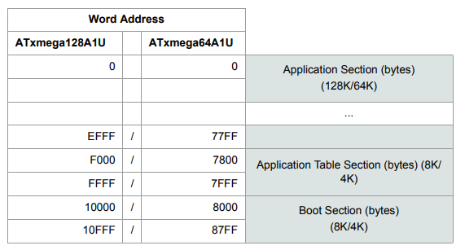
Figure 1: Program Memory Addressing

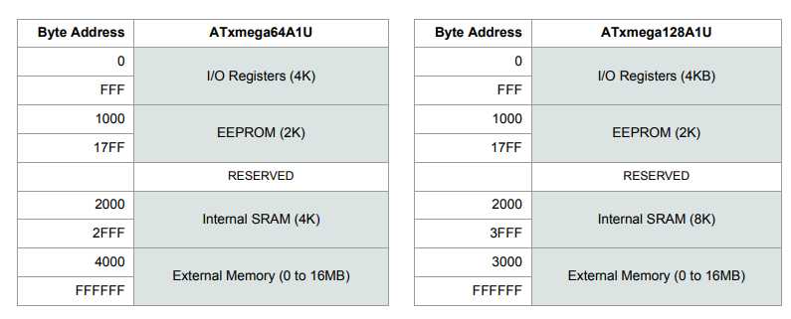
Figure 2: Data Memory Addressing

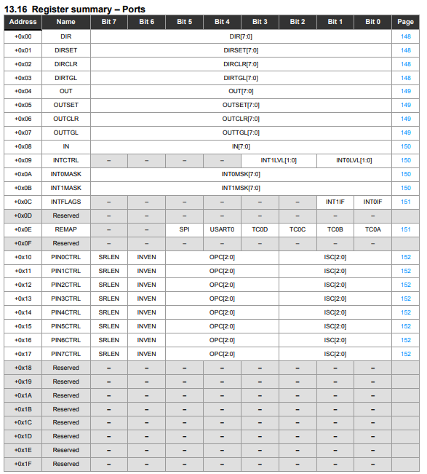
Figure 3: Ports Register Summary
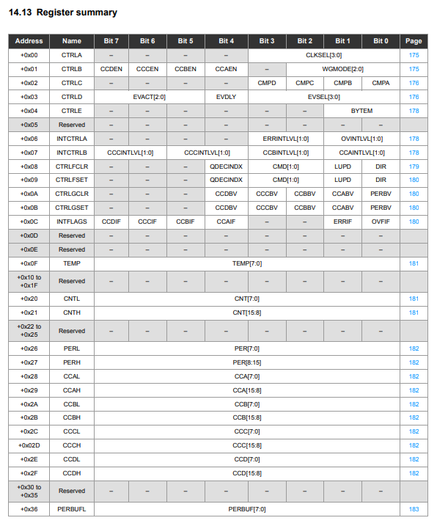
Figure 4: Timer/Counter Register Summary
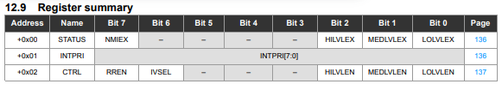
Figure 5: Interrupts Register Summary

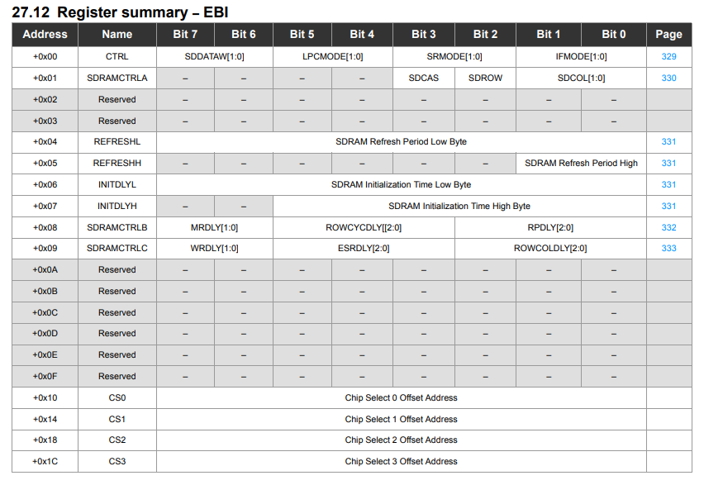
Figure 6: EBI Register Summary
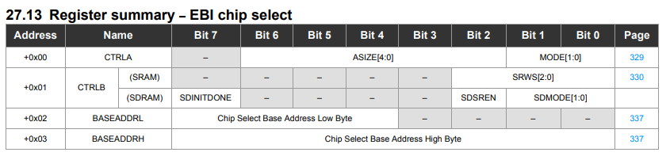
Figure 7: EBI Chip Select Register Summary
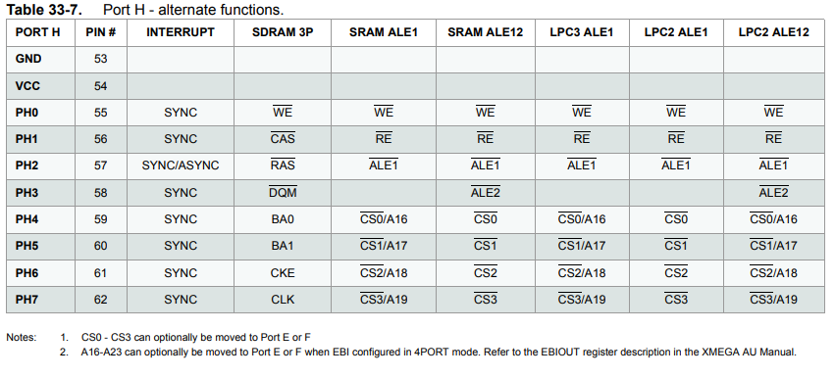
Figure 8: PORTH Alternate Functions
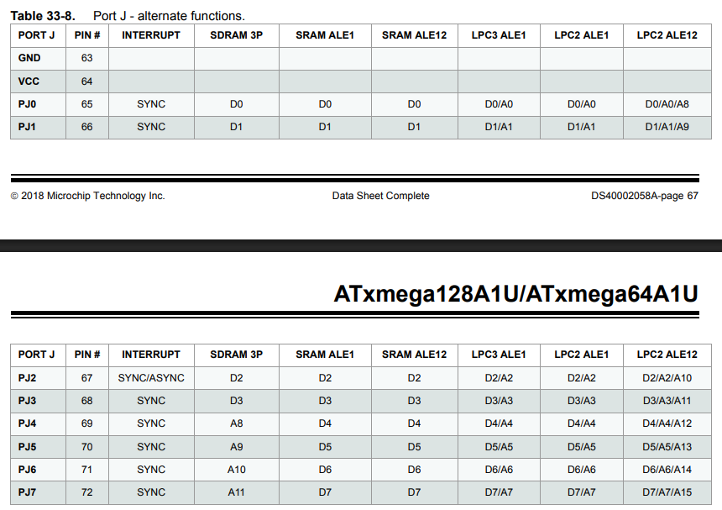
Figure 9: PORTJ Alternate Functions

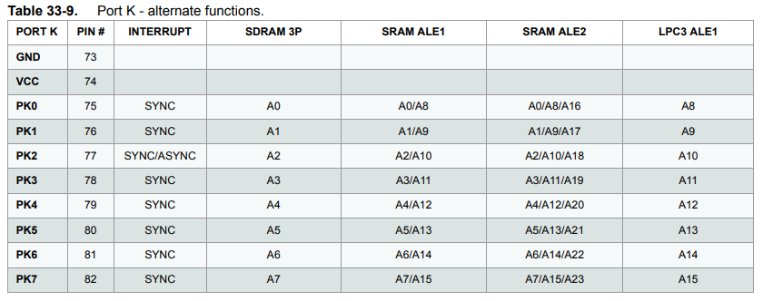
Figure 10: PORTK Alternate Functions
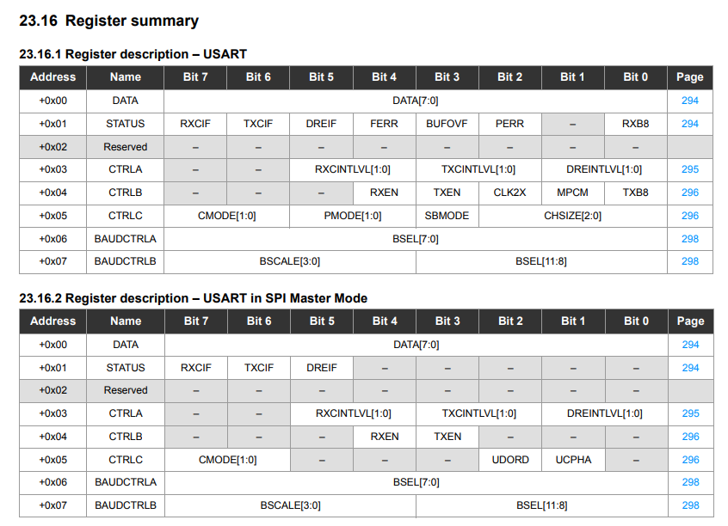
Figure 11: USART Register Summaries
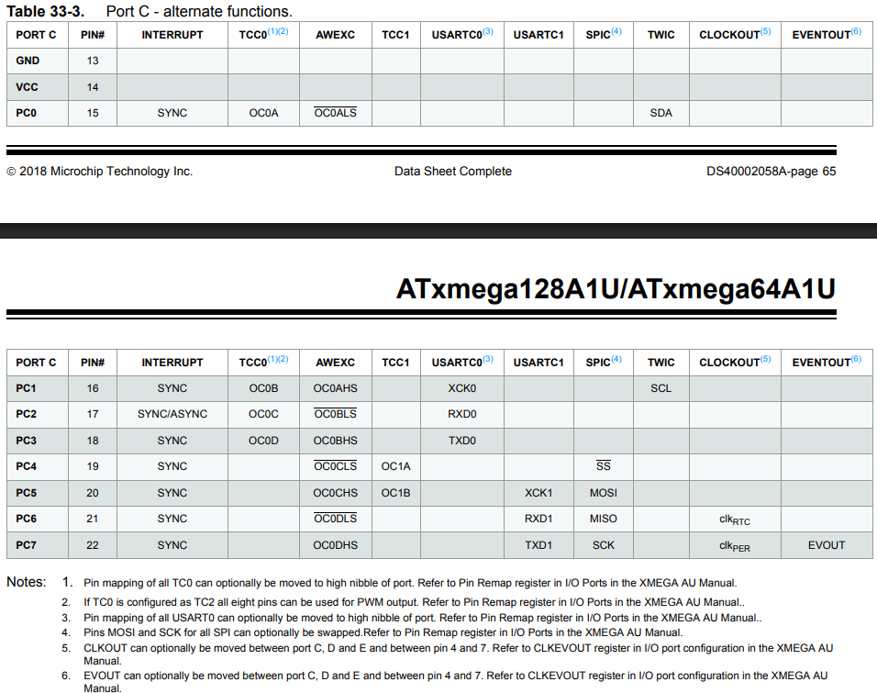
Figure 12: PORTC Alternate Functions
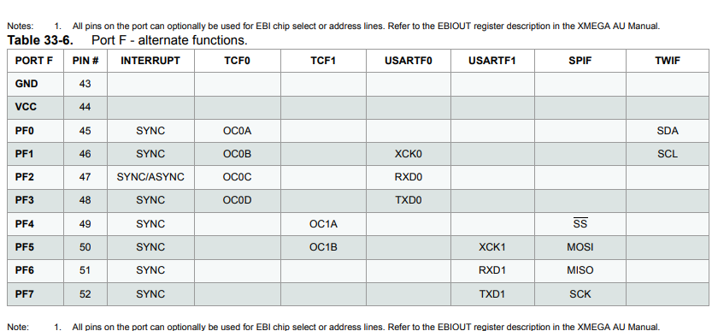
Figure 13: PORTF Alternate Functions
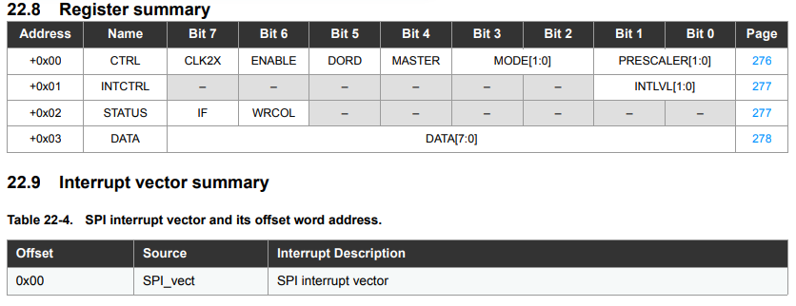
Figure 14: SPI Register Summary
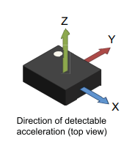
Figure 15: Axis Directions for IMU

