REQUIREMENTS NOT MET
None
PROBLEMS ENCOUNTERED
None Encountered
FUTURE WORK/APPLICATIONS
Finally, we wrap up this awesome semester with utilizing the DAC and DMA. Through the utilization of these two peripherals, we are able to rapidly transmit data, allowing us to modify the delivered frequency to simulate musical notes. The utilization of these peripherals could allow us to create varying frequency waveforms, potentially for wireless communications and audio creation.
Thanks for the awesome semester .

PRE-LAB EXERCISES
- Why might you be unable to generate a desired frequency with this method of using an interrupt? Refer to the disassembly of the interrupt service routine. Additionally, temporarily change the optimization level of your compiler to -O1. Are the results any different? Why or why not?

If the timer is running too quickly, the ISR may not be available within time to actually trigger as it is still executing commands behind the scenes, which would cause it to only update when the ISR is available, seemingly at a rate around 1 kHz.

Changing the optimization level to -O1 DOES fix the error; allowing for sine waves over 1kHz (around 1500 Hz maximum), probably by removing the ISR and instead polling, allowing for much faster updates.

- Would a method of synchronous polling (i.e., a method with no interrupts) result in the same issue identified in the previous exercise? In other words, would the desired frequency not initially met now be achieved? Alter your program to check your answer, and then take a screenshot of the waveform generated, again denoting a precise frequency measurement of this waveform within the screenshot.

It likely would improve the maximum frequency considerably, causing the update rate to be limited by the processor speed rather than the ISR availability.

- What is the correlation between the amount of data points used to recreate the waveform and the overall quality of the waveform?

A higher data point count means higher resolution, where we are able to visualize more individual steps along the sine wave. However, with higher quality resolution, we also have more data to process and this directly lowers our processing speed, and effectively our maximum frequencies.
PSEUDOCODE / FLOWCHARTS
Lab8_1.c

Initialize Clock @ 32MHz & DACA

Sine_table[256] = sine_table data

While 1{
Wait for DAC:
Update DAC
}

Daca_init:
Select AREFB
Select Single CH0
Enable DAC & CH0

Lab8_2a.c
Initialize Clock @ 32MHz & DACA & TCC0
Enable SEI

Infinite while loop{}

Daca_init from lab8_1.c

Tcc0_init:
Set period to 659.26 Hz
Set Prescaler
Enable lo-level interrupts
Enable PMIC for lo-level interrupts

ISR(TCC0_OVF):
If (count < 255):
Count += 1
Else:
Count = 0

DACA.DATA = sine_table[count]

Lab8_2b.c
Initialize Clock @ 32MHz & DACA & TCC0
Enable SEI

Infinite while loop:
If TCC0 OVF:
DACA.DATA = sine_table[count];
If count < 255:
Count += 1
Else:
Count = 0

Daca_init:
Select AREFB (2.5V)
Select CH0
Enable DAC & CH0

Tcc0_init:
Select period
Select prescaler

Lab8_3.c
Initialize Clock @ 32MHz & DACA & TCC0 & DMAC

Infinite while loop:

Daca_init:
Select AREFB (2.5V)
Select CH0
Enable DAC & CH0

Tcc0_init:
Select period
Select prescaler

Dmac_init:
Select infinite repeats
Address source & destination
TRFCNT = 512 (256 * 2)

Select REPEAT, SINGLE, 2BYTE for CTRLA
Select BLOCK SRC LD, INC SRCDIR, BURST DESTRELOAD, INC DESTDIR for ADDRCTLR

EVSYS fires on TCC0 OVF, DMAC triggered by EVSYS CH0

Enable DMA / CH0

Lab8_4.c
Initialize Clock @ 32MHz & DACA & TCC0 & DMAC
Enable Audio Amp

Infinite while loop:

Daca_init:
Select AREFB (2.5V)
Select CH1
Enable DAC & CH0

Tcc0_init:
Reset CNT
Reset flags
Select period
Select prescaler

Dmac_init:
Select infinite repeats
Address source & destination
TRFCNT = 512 (256 * 2)

Select REPEAT, SINGLE, 2BYTE for CTRLA
Select BLOCK SRC LD, INC SRCDIR, BURST DESTRELOAD, INC DESTDIR for ADDRCTLR

EVSYS fires on TCC0 OVF, DMAC triggered by EVSYS CH0

Enable DMA / CH0
Lab8_5.c
Initialize Clock @ 32MHz & DACA & TCC0 & TCC1 & DMAC & USARTD0
Create baud rate, period, mode variables

// TCC0 is Playback, TCC1 is Delay

Create Sine & Tri tables
Create a Pointer, set to Sine table

Enable Audio Amp

Infinite while loop:

Wait for USART:
Take input character
Compare character, set to respective note or change mode

Wait for TCC1 OVF
Reset flag
Turn off playback timer

Daca_init:
Select AREFB (2.5V)
Select CH1
Enable DAC & CH0

Tcc0_init:
Reset CNT
Reset flags
Select period
Select prescaler

Tcc1_init:
Reset CNT
Set period
Reset flag
Turn off

Dmac_init:
Select infinite repeats
Address source & destination
TRFCNT = 512 (256 * 2)

Select REPEAT, SINGLE, 2BYTE for CTRLA
Select BLOCK SRC LD, INC SRCDIR, BURST DESTRELOAD, INC DESTDIR for ADDRCTLR

EVSYS fires on TCC0 OVF, DMAC triggered by EVSYS CH0

Enable DMA / CH0

Usartd0_init:
Set TX/RX pins
Set baud rate
Set PuTTy configs & enable

Usartd0_in:
Wait for USART:
Return char

Set_wave(mode):
Disable DMA
Check mode:
Select mode via pointer
Update addressing
Reset TRFCNT
Enable DMA

Set_note(freq):
Update Tcc0.PER with freq
Reset Tcc0.CNT
Enable prescaler
Reset Tcc1.CNT
Reset Tcc1 flags
Enable Tcc1 prescaler

Note_timer:
Reset Tcc1.CT
Reset Tcc1 flags
Enable timer

PROGRAM CODE
Lab8_1.c

/*
* lab8_1.c
*
* Created: 7/21/2026 9:25:58 PM
* Author : Evan Baesler
*/

#include <avr/io.h>

extern void clock_init(void);

void daca_init(void);
uint16_t value = 2621;

int main(void)
{

clock_init(); // Sets Clock to 32MHz
daca_init();

while (1)
{
// Poll until DAC channel 0 data register is empty
if (DACA.STATUS & DAC_CH0DRE_bm)
{
DACA.CH0DATA = value;
}
}
}

void daca_init(void){
DACA.CTRLC = DAC_REFSEL_AREFB_gc; // REFSEL[1:0] on bits 4:3, AREFB = 2.5V
DACA.CTRLB = DAC_CHSEL_SINGLE_gc;
DACA.CTRLA = DAC_ENABLE_bm | DAC_CH0EN_bm;
}

Lab8_2a.c
/*
* lab8_2.c
*
* Created: 7/26/2026 10:15:16 PM
* Author: Evan Baesler
*/

#include <avr/io.h>
#include <avr/interrupt.h>

extern void clock_init(void);

void daca_init(void);
void tcc0_init(void);
uint16_t count = 0;

// 256 Value Sine Wave Approximation
uint16_t sine_table[256] =
{0x800, 0x832, 0x864, 0x896, 0x8c8, 0x8fa, 0x92c, 0x95e,
0x98f, 0x9c0, 0x9f1, 0xa22, 0xa52, 0xa82, 0xab1, 0xae0,
0xb0f, 0xb3d, 0xb6b, 0xb98, 0xbc5, 0xbf1, 0xc1c, 0xc47,
0xc71, 0xc9a, 0xcc3, 0xceb, 0xd12, 0xd39, 0xd5f, 0xd83,
0xda7, 0xdca, 0xded, 0xe0e, 0xe2e, 0xe4e, 0xe6c, 0xe8a,
0xea6, 0xec1, 0xedc, 0xef5, 0xf0d, 0xf24, 0xf3a, 0xf4f,
0xf63, 0xf76, 0xf87, 0xf98, 0xfa7, 0xfb5, 0xfc2, 0xfcd,
0xfd8, 0xfe1, 0xfe9, 0xff0, 0xff5, 0xff9, 0xffd, 0xffe,
0xfff, 0xffe, 0xffd, 0xff9, 0xff5, 0xff0, 0xfe9, 0xfe1,
0xfd8, 0xfcd, 0xfc2, 0xfb5, 0xfa7, 0xf98, 0xf87, 0xf76,
0xf63, 0xf4f, 0xf3a, 0xf24, 0xf0d, 0xef5, 0xedc, 0xec1,
0xea6, 0xe8a, 0xe6c, 0xe4e, 0xe2e, 0xe0e, 0xded, 0xdca,
0xda7, 0xd83, 0xd5f, 0xd39, 0xd12, 0xceb, 0xcc3, 0xc9a,
0xc71, 0xc47, 0xc1c, 0xbf1, 0xbc5, 0xb98, 0xb6b, 0xb3d,
0xb0f, 0xae0, 0xab1, 0xa82, 0xa52, 0xa22, 0x9f1, 0x9c0,
0x98f, 0x95e, 0x92c, 0x8fa, 0x8c8, 0x896, 0x864, 0x832,
0x800, 0x7cd, 0x79b, 0x769, 0x737, 0x705, 0x6d3, 0x6a1,
0x670, 0x63f, 0x60e, 0x5dd, 0x5ad, 0x57d, 0x54e, 0x51f,
0x4f0, 0x4c2, 0x494, 0x467, 0x43a, 0x40e, 0x3e3, 0x3b8,
0x38e, 0x365, 0x33c, 0x314, 0x2ed, 0x2c6, 0x2a0, 0x27c,
0x258, 0x235, 0x212, 0x1f1, 0x1d1, 0x1b1, 0x193, 0x175,
0x159, 0x13e, 0x123, 0x10a, 0xf2, 0xdb, 0xc5, 0xb0,
0x9c, 0x89, 0x78, 0x67, 0x58, 0x4a, 0x3d, 0x32,
0x27, 0x1e, 0x16, 0xf, 0xa, 0x6, 0x2, 0x1,
0x0, 0x1, 0x2, 0x6, 0xa, 0xf, 0x16, 0x1e,
0x27, 0x32, 0x3d, 0x4a, 0x58, 0x67, 0x78, 0x89,
0x9c, 0xb0, 0xc5, 0xdb, 0xf2, 0x10a, 0x123, 0x13e,
0x159, 0x175, 0x193, 0x1b1, 0x1d1, 0x1f1, 0x212, 0x235,
0x258, 0x27c, 0x2a0, 0x2c6, 0x2ed, 0x314, 0x33c, 0x365,
0x38e, 0x3b8, 0x3e3, 0x40e, 0x43a, 0x467, 0x494, 0x4c2,
0x4f0, 0x51f, 0x54e, 0x57d, 0x5ad, 0x5dd, 0x60e, 0x63f,
0x670, 0x6a1, 0x6d3, 0x705, 0x737, 0x769, 0x79b, 0x7cd};

int main(void)
{

clock_init(); // Sets Clock to 32MHz
daca_init();
tcc0_init();
sei();

while (1)
{
// Poll until DAC channel 0 data register is empty
}
}

void daca_init(void){
DACA.CTRLC = DAC_REFSEL_AREFB_gc; // REFSEL[1:0] on bits 4:3, AREFB = 2.5V
DACA.CTRLB = DAC_CHSEL_SINGLE_gc;
DACA.CTRLA = DAC_ENABLE_bm | DAC_CH0EN_bm;
}

void tcc0_init(void){
TCC0.PER = 192; // 1/659.26(32MHz/1) = 48539/256 = 190, adjusted to 192 for accuracy based on clock speed variance
TCC0.CTRLA = TC_CLKSEL_DIV1_gc;
TCC0.INTCTRLA = TC_OVFINTLVL_LO_gc;
PMIC.CTRL = PMIC_LOLVLEN_bm;
}

ISR(TCC0_OVF_vect){

if (count < 255){
count += 1;
}
else {
count = 0;
}

DACA.CH0DATA = sine_table[count];
}
Lab8_2b.c
/*
* lab8_2.c
*
* Created: 7/27/2026 10:58:55 PM
* Author: Evan Baesler
*/

#include <avr/io.h>
#include <avr/interrupt.h>

extern void clock_init(void);

void daca_init(void);
void tcc0_init(void);
uint16_t count = 0;

// 256 Value Sine Wave Approximation
uint16_t sine_table[256] =
{0x800, 0x832, 0x864, 0x896, 0x8c8, 0x8fa, 0x92c, 0x95e,
0x98f, 0x9c0, 0x9f1, 0xa22, 0xa52, 0xa82, 0xab1, 0xae0,
0xb0f, 0xb3d, 0xb6b, 0xb98, 0xbc5, 0xbf1, 0xc1c, 0xc47,
0xc71, 0xc9a, 0xcc3, 0xceb, 0xd12, 0xd39, 0xd5f, 0xd83,
0xda7, 0xdca, 0xded, 0xe0e, 0xe2e, 0xe4e, 0xe6c, 0xe8a,
0xea6, 0xec1, 0xedc, 0xef5, 0xf0d, 0xf24, 0xf3a, 0xf4f,
0xf63, 0xf76, 0xf87, 0xf98, 0xfa7, 0xfb5, 0xfc2, 0xfcd,
0xfd8, 0xfe1, 0xfe9, 0xff0, 0xff5, 0xff9, 0xffd, 0xffe,
0xfff, 0xffe, 0xffd, 0xff9, 0xff5, 0xff0, 0xfe9, 0xfe1,
0xfd8, 0xfcd, 0xfc2, 0xfb5, 0xfa7, 0xf98, 0xf87, 0xf76,
0xf63, 0xf4f, 0xf3a, 0xf24, 0xf0d, 0xef5, 0xedc, 0xec1,
0xea6, 0xe8a, 0xe6c, 0xe4e, 0xe2e, 0xe0e, 0xded, 0xdca,
0xda7, 0xd83, 0xd5f, 0xd39, 0xd12, 0xceb, 0xcc3, 0xc9a,
0xc71, 0xc47, 0xc1c, 0xbf1, 0xbc5, 0xb98, 0xb6b, 0xb3d,
0xb0f, 0xae0, 0xab1, 0xa82, 0xa52, 0xa22, 0x9f1, 0x9c0,
0x98f, 0x95e, 0x92c, 0x8fa, 0x8c8, 0x896, 0x864, 0x832,
0x800, 0x7cd, 0x79b, 0x769, 0x737, 0x705, 0x6d3, 0x6a1,
0x670, 0x63f, 0x60e, 0x5dd, 0x5ad, 0x57d, 0x54e, 0x51f,
0x4f0, 0x4c2, 0x494, 0x467, 0x43a, 0x40e, 0x3e3, 0x3b8,
0x38e, 0x365, 0x33c, 0x314, 0x2ed, 0x2c6, 0x2a0, 0x27c,
0x258, 0x235, 0x212, 0x1f1, 0x1d1, 0x1b1, 0x193, 0x175,
0x159, 0x13e, 0x123, 0x10a, 0xf2, 0xdb, 0xc5, 0xb0,
0x9c, 0x89, 0x78, 0x67, 0x58, 0x4a, 0x3d, 0x32,
0x27, 0x1e, 0x16, 0xf, 0xa, 0x6, 0x2, 0x1,
0x0, 0x1, 0x2, 0x6, 0xa, 0xf, 0x16, 0x1e,
0x27, 0x32, 0x3d, 0x4a, 0x58, 0x67, 0x78, 0x89,
0x9c, 0xb0, 0xc5, 0xdb, 0xf2, 0x10a, 0x123, 0x13e,
0x159, 0x175, 0x193, 0x1b1, 0x1d1, 0x1f1, 0x212, 0x235,
0x258, 0x27c, 0x2a0, 0x2c6, 0x2ed, 0x314, 0x33c, 0x365,
0x38e, 0x3b8, 0x3e3, 0x40e, 0x43a, 0x467, 0x494, 0x4c2,
0x4f0, 0x51f, 0x54e, 0x57d, 0x5ad, 0x5dd, 0x60e, 0x63f,
0x670, 0x6a1, 0x6d3, 0x705, 0x737, 0x769, 0x79b, 0x7cd};

int main(void)
{

clock_init(); // Sets Clock to 32MHz
daca_init();
tcc0_init();
sei();

while (1)
{
if (TCC0.INTFLAGS & TC0_OVFIF_bm){
TCC0.INTFLAGS = TC0_OVFIF_bm;
DACA.CH0DATA = sine_table[count];
if (count < 255){
count += 1;
}
else {
count = 0;
}

}
}
}

void daca_init(void){
DACA.CTRLC = DAC_REFSEL_AREFB_gc; // REFSEL[1:0] on bits 4:3, AREFB = 2.5V
DACA.CTRLB = DAC_CHSEL_SINGLE_gc;
DACA.CTRLA = DAC_ENABLE_bm | DAC_CH0EN_bm;
}

void tcc0_init(void){
TCC0.PER = 85; // 1/659.26(32MHz/1) = 84, adjusted to 85 for accuracy based on clock speed variance
TCC0.CTRLA = TC_CLKSEL_DIV1_gc;
}

Lab8_3.c
/*
* lab8_3.c
*
* Created: 7/27/2026 11:31:17 PM
* Author: Evan Baesler
*/
#include <avr/io.h>

extern void clock_init(void);
void daca_init(void);
void tcc0_init(void);
void dmac_init(void);

// 256 Value Sine Wave Approximation
uint16_t sine_table[256] =
{0x800, 0x832, 0x864, 0x896, 0x8c8, 0x8fa, 0x92c, 0x95e,
0x98f, 0x9c0, 0x9f1, 0xa22, 0xa52, 0xa82, 0xab1, 0xae0,
0xb0f, 0xb3d, 0xb6b, 0xb98, 0xbc5, 0xbf1, 0xc1c, 0xc47,
0xc71, 0xc9a, 0xcc3, 0xceb, 0xd12, 0xd39, 0xd5f, 0xd83,
0xda7, 0xdca, 0xded, 0xe0e, 0xe2e, 0xe4e, 0xe6c, 0xe8a,
0xea6, 0xec1, 0xedc, 0xef5, 0xf0d, 0xf24, 0xf3a, 0xf4f,
0xf63, 0xf76, 0xf87, 0xf98, 0xfa7, 0xfb5, 0xfc2, 0xfcd,
0xfd8, 0xfe1, 0xfe9, 0xff0, 0xff5, 0xff9, 0xffd, 0xffe,
0xfff, 0xffe, 0xffd, 0xff9, 0xff5, 0xff0, 0xfe9, 0xfe1,
0xfd8, 0xfcd, 0xfc2, 0xfb5, 0xfa7, 0xf98, 0xf87, 0xf76,
0xf63, 0xf4f, 0xf3a, 0xf24, 0xf0d, 0xef5, 0xedc, 0xec1,
0xea6, 0xe8a, 0xe6c, 0xe4e, 0xe2e, 0xe0e, 0xded, 0xdca,
0xda7, 0xd83, 0xd5f, 0xd39, 0xd12, 0xceb, 0xcc3, 0xc9a,
0xc71, 0xc47, 0xc1c, 0xbf1, 0xbc5, 0xb98, 0xb6b, 0xb3d,
0xb0f, 0xae0, 0xab1, 0xa82, 0xa52, 0xa22, 0x9f1, 0x9c0,
0x98f, 0x95e, 0x92c, 0x8fa, 0x8c8, 0x896, 0x864, 0x832,
0x800, 0x7cd, 0x79b, 0x769, 0x737, 0x705, 0x6d3, 0x6a1,
0x670, 0x63f, 0x60e, 0x5dd, 0x5ad, 0x57d, 0x54e, 0x51f,
0x4f0, 0x4c2, 0x494, 0x467, 0x43a, 0x40e, 0x3e3, 0x3b8,
0x38e, 0x365, 0x33c, 0x314, 0x2ed, 0x2c6, 0x2a0, 0x27c,
0x258, 0x235, 0x212, 0x1f1, 0x1d1, 0x1b1, 0x193, 0x175,
0x159, 0x13e, 0x123, 0x10a, 0xf2, 0xdb, 0xc5, 0xb0,
0x9c, 0x89, 0x78, 0x67, 0x58, 0x4a, 0x3d, 0x32,
0x27, 0x1e, 0x16, 0xf, 0xa, 0x6, 0x2, 0x1,
0x0, 0x1, 0x2, 0x6, 0xa, 0xf, 0x16, 0x1e,
0x27, 0x32, 0x3d, 0x4a, 0x58, 0x67, 0x78, 0x89,
0x9c, 0xb0, 0xc5, 0xdb, 0xf2, 0x10a, 0x123, 0x13e,
0x159, 0x175, 0x193, 0x1b1, 0x1d1, 0x1f1, 0x212, 0x235,
0x258, 0x27c, 0x2a0, 0x2c6, 0x2ed, 0x314, 0x33c, 0x365,
0x38e, 0x3b8, 0x3e3, 0x40e, 0x43a, 0x467, 0x494, 0x4c2,
0x4f0, 0x51f, 0x54e, 0x57d, 0x5ad, 0x5dd, 0x60e, 0x63f,
0x670, 0x6a1, 0x6d3, 0x705, 0x737, 0x769, 0x79b, 0x7cd};

int main(void)
{
clock_init(); // Sets Clock to 32MHz
daca_init();
tcc0_init();
dmac_init();

while (1)
{
// NO OP
}
}

void daca_init(void){
DACA.CTRLC = DAC_REFSEL_AREFB_gc; // REFSEL[1:0] on bits 4:3, AREFB = 2.5V
DACA.CTRLB = DAC_CHSEL_SINGLE_gc;
DACA.CTRLA = DAC_ENABLE_bm | DAC_CH0EN_bm;
}

void tcc0_init(void){
TCC0.PER = 85; // 32MHz/(256*1479.98) ~= 84.5, adjusted for accuracy
TCC0.CTRLA = TC_CLKSEL_DIV1_gc;
}

void dmac_init(void){

DMA.CH0.REPCNT = 0; // Infinite Repeats

// Source Addressing thru pointers
DMA.CH0.SRCADDR0= (uint8_t)((uintptr_t) sine_table);
DMA.CH0.SRCADDR1= (uint8_t)(((uintptr_t) sine_table) >> 8);
DMA.CH0.SRCADDR2= (uint8_t)(((uint32_t)((uintptr_t)sine_table)) >>16);

// Destination Addressing
DMA.CH0.DESTADDR0= (uint8_t)((uintptr_t) &DACA.CH0DATA);
DMA.CH0.DESTADDR1= (uint8_t)(((uintptr_t) &DACA.CH0DATA) >> 8);
DMA.CH0.DESTADDR2= (uint8_t)(((uint32_t)((uintptr_t)&DACA.CH0DATA)) >>16);

DMA.CH0.TRFCNT = 512; // 256 samples * 2 bytes

// Turn on repeat, CH0, and 2BYTE burst
DMA.CH0.CTRLA = DMA_CH_REPEAT_bm | DMA_CH_SINGLE_bm | DMA_CH_BURSTLEN_2BYTE_gc; // one 2-byte sample per trigger

// Reload full block, increment source/output, reload in bursts
DMA.CH0.ADDRCTRL =
DMA_CH_SRCRELOAD_BLOCK_gc |
DMA_CH_SRCDIR_INC_gc |
DMA_CH_DESTRELOAD_BURST_gc |
DMA_CH_DESTDIR_INC_gc;

// Timer overflow -> Event Channel 0 -> DMA Update
EVSYS.CH0MUX = EVSYS_CHMUX_TCC0_OVF_gc;
DMA.CH0.TRIGSRC = DMA_CH_TRIGSRC_EVSYS_CH0_gc;

DMA.CH0.CTRLA |= DMA_CH_ENABLE_bm;
DMA.CTRL = DMA_ENABLE_bm; // Activate DMA
}

Lab8_4.c
/*
* lab8_4.c
*
* Created: 7/28/2026 9:56:28 PM
* Author: Evan Baesler
*/

#include <avr/io.h>

// PROTOTYPES

extern void clock_init(void);
void daca_init(void);
void tcc0_init(void);
void dmac_init(void);

// 256 Value Sine Wave Approximation
uint16_t sine_table[256] =
{0x800, 0x832, 0x864, 0x896, 0x8c8, 0x8fa, 0x92c, 0x95e,
0x98f, 0x9c0, 0x9f1, 0xa22, 0xa52, 0xa82, 0xab1, 0xae0,
0xb0f, 0xb3d, 0xb6b, 0xb98, 0xbc5, 0xbf1, 0xc1c, 0xc47,
0xc71, 0xc9a, 0xcc3, 0xceb, 0xd12, 0xd39, 0xd5f, 0xd83,
0xda7, 0xdca, 0xded, 0xe0e, 0xe2e, 0xe4e, 0xe6c, 0xe8a,
0xea6, 0xec1, 0xedc, 0xef5, 0xf0d, 0xf24, 0xf3a, 0xf4f,
0xf63, 0xf76, 0xf87, 0xf98, 0xfa7, 0xfb5, 0xfc2, 0xfcd,
0xfd8, 0xfe1, 0xfe9, 0xff0, 0xff5, 0xff9, 0xffd, 0xffe,
0xfff, 0xffe, 0xffd, 0xff9, 0xff5, 0xff0, 0xfe9, 0xfe1,
0xfd8, 0xfcd, 0xfc2, 0xfb5, 0xfa7, 0xf98, 0xf87, 0xf76,
0xf63, 0xf4f, 0xf3a, 0xf24, 0xf0d, 0xef5, 0xedc, 0xec1,
0xea6, 0xe8a, 0xe6c, 0xe4e, 0xe2e, 0xe0e, 0xded, 0xdca,
0xda7, 0xd83, 0xd5f, 0xd39, 0xd12, 0xceb, 0xcc3, 0xc9a,
0xc71, 0xc47, 0xc1c, 0xbf1, 0xbc5, 0xb98, 0xb6b, 0xb3d,
0xb0f, 0xae0, 0xab1, 0xa82, 0xa52, 0xa22, 0x9f1, 0x9c0,
0x98f, 0x95e, 0x92c, 0x8fa, 0x8c8, 0x896, 0x864, 0x832,
0x800, 0x7cd, 0x79b, 0x769, 0x737, 0x705, 0x6d3, 0x6a1,
0x670, 0x63f, 0x60e, 0x5dd, 0x5ad, 0x57d, 0x54e, 0x51f,
0x4f0, 0x4c2, 0x494, 0x467, 0x43a, 0x40e, 0x3e3, 0x3b8,
0x38e, 0x365, 0x33c, 0x314, 0x2ed, 0x2c6, 0x2a0, 0x27c,
0x258, 0x235, 0x212, 0x1f1, 0x1d1, 0x1b1, 0x193, 0x175,
0x159, 0x13e, 0x123, 0x10a, 0xf2, 0xdb, 0xc5, 0xb0,
0x9c, 0x89, 0x78, 0x67, 0x58, 0x4a, 0x3d, 0x32,
0x27, 0x1e, 0x16, 0xf, 0xa, 0x6, 0x2, 0x1,
0x0, 0x1, 0x2, 0x6, 0xa, 0xf, 0x16, 0x1e,
0x27, 0x32, 0x3d, 0x4a, 0x58, 0x67, 0x78, 0x89,
0x9c, 0xb0, 0xc5, 0xdb, 0xf2, 0x10a, 0x123, 0x13e,
0x159, 0x175, 0x193, 0x1b1, 0x1d1, 0x1f1, 0x212, 0x235,
0x258, 0x27c, 0x2a0, 0x2c6, 0x2ed, 0x314, 0x33c, 0x365,
0x38e, 0x3b8, 0x3e3, 0x40e, 0x43a, 0x467, 0x494, 0x4c2,
0x4f0, 0x51f, 0x54e, 0x57d, 0x5ad, 0x5dd, 0x60e, 0x63f,
0x670, 0x6a1, 0x6d3, 0x705, 0x737, 0x769, 0x79b, 0x7cd};

int main(void)
{

clock_init(); // Sets Clock to 32MHz

daca_init(); // Digital to Analog Converter
tcc0_init(); // Frequency Timer
dmac_init(); // Initialize Table in Memory

// Enable audio amplifier (disable shutdown)
PORTC.DIRSET = PIN7_bm;
PORTC.OUTSET = PIN7_bm;

while (1)
{
// NO OP
}
}

void daca_init(void)
{
// Enable DAC Channel 1 for Speaker
DACA.CTRLB = DAC_CHSEL_SINGLE1_gc;

// Use AREFB (2.5V) as the DAC reference
DACA.CTRLC = DAC_REFSEL_AREFB_gc;

DACA.CTRLA = DAC_ENABLE_bm | DAC_CH1EN_bm | DAC_CH0EN_bm;
}

void tcc0_init(void)
{
TCC0.CNT = 0;
TCC0.INTFLAGS = TC0_OVFIF_bm;

// 32 MHz / ((83 + 1) * 256) = 1488.1 Hz
// Closest integer timer period to 1479.98 Hz
TCC0.PER = 83;
TCC0.CTRLA = TC_CLKSEL_DIV1_gc;
}

void dmac_init(void)
{
DMA.CTRL|= DMA_RESET_bm; // Reset DMA

DMA.CH0.TRFCNT = 512;
DMA.CH0.REPCNT = 0;

// Reload full block, increment source/output, reload in bursts
DMA.CH0.ADDRCTRL =
DMA_CH_SRCRELOAD_BLOCK_gc |
DMA_CH_SRCDIR_INC_gc |
DMA_CH_DESTRELOAD_BURST_gc |
DMA_CH_DESTDIR_INC_gc;

// Turn on Repeat, CH0, and 2BYTE burst
DMA.CH0.CTRLA =
DMA_CH_REPEAT_bm |
DMA_CH_SINGLE_bm |
DMA_CH_BURSTLEN_2BYTE_gc;

// Timer overflow -> Event Channel 0 -> DMA Update
EVSYS.CH0MUX = EVSYS_CHMUX_TCC0_OVF_gc;
DMA.CH0.TRIGSRC = DMA_CH_TRIGSRC_EVSYS_CH0_gc;

// Source Addressing thru pointers
DMA.CH0.SRCADDR0= (uint8_t)((uintptr_t) sine_table);
DMA.CH0.SRCADDR1= (uint8_t)(((uintptr_t) sine_table) >> 8);
DMA.CH0.SRCADDR2= (uint8_t)(((uint32_t)((uintptr_t)sine_table)) >>16);

// Destination Addressing
DMA.CH0.DESTADDR0= (uint8_t)((uintptr_t) &DACA.CH1DATA);
DMA.CH0.DESTADDR1= (uint8_t)(((uintptr_t) &DACA.CH1DATA) >> 8);
DMA.CH0.DESTADDR2= (uint8_t)(((uint32_t)((uintptr_t)&DACA.CH1DATA)) >>16);

DMA.CH0.CTRLA |= DMA_CH_ENABLE_bm;

DMA.CTRL = DMA_ENABLE_bm;
}

Lab8_5.c
/*
* lab8_5.c
*
* Created: 7/29/2026 8:53:41 AM
* Author: Evan Baesler
*/

#include <avr/io.h>

// PROTOTYPES

extern void clock_init(void);
void usartd0_init(void);
void daca_init(void);
void tcc0_init(void);
void dmac_init(void);

char usartd0_in(void);
void set_note(float freq);
void set_wave(uint8_t mode);

uint16_t per; // Played Note Frequency
uint8_t mode = 0; // 0 = sine, 1 = triangle

// Baud Rate (9600bps from previous labs)
uint8_t BSEL = 207;
uint8_t BSCALE = 0;

// 256 Value Sine Wave Approximation
uint16_t sine_table[256] =
{0x800, 0x832, 0x864, 0x896, 0x8c8, 0x8fa, 0x92c, 0x95e,
0x98f, 0x9c0, 0x9f1, 0xa22, 0xa52, 0xa82, 0xab1, 0xae0,
0xb0f, 0xb3d, 0xb6b, 0xb98, 0xbc5, 0xbf1, 0xc1c, 0xc47,
0xc71, 0xc9a, 0xcc3, 0xceb, 0xd12, 0xd39, 0xd5f, 0xd83,
0xda7, 0xdca, 0xded, 0xe0e, 0xe2e, 0xe4e, 0xe6c, 0xe8a,
0xea6, 0xec1, 0xedc, 0xef5, 0xf0d, 0xf24, 0xf3a, 0xf4f,
0xf63, 0xf76, 0xf87, 0xf98, 0xfa7, 0xfb5, 0xfc2, 0xfcd,
0xfd8, 0xfe1, 0xfe9, 0xff0, 0xff5, 0xff9, 0xffd, 0xffe,
0xfff, 0xffe, 0xffd, 0xff9, 0xff5, 0xff0, 0xfe9, 0xfe1,
0xfd8, 0xfcd, 0xfc2, 0xfb5, 0xfa7, 0xf98, 0xf87, 0xf76,
0xf63, 0xf4f, 0xf3a, 0xf24, 0xf0d, 0xef5, 0xedc, 0xec1,
0xea6, 0xe8a, 0xe6c, 0xe4e, 0xe2e, 0xe0e, 0xded, 0xdca,
0xda7, 0xd83, 0xd5f, 0xd39, 0xd12, 0xceb, 0xcc3, 0xc9a,
0xc71, 0xc47, 0xc1c, 0xbf1, 0xbc5, 0xb98, 0xb6b, 0xb3d,
0xb0f, 0xae0, 0xab1, 0xa82, 0xa52, 0xa22, 0x9f1, 0x9c0,
0x98f, 0x95e, 0x92c, 0x8fa, 0x8c8, 0x896, 0x864, 0x832,
0x800, 0x7cd, 0x79b, 0x769, 0x737, 0x705, 0x6d3, 0x6a1,
0x670, 0x63f, 0x60e, 0x5dd, 0x5ad, 0x57d, 0x54e, 0x51f,
0x4f0, 0x4c2, 0x494, 0x467, 0x43a, 0x40e, 0x3e3, 0x3b8,
0x38e, 0x365, 0x33c, 0x314, 0x2ed, 0x2c6, 0x2a0, 0x27c,
0x258, 0x235, 0x212, 0x1f1, 0x1d1, 0x1b1, 0x193, 0x175,
0x159, 0x13e, 0x123, 0x10a, 0xf2, 0xdb, 0xc5, 0xb0,
0x9c, 0x89, 0x78, 0x67, 0x58, 0x4a, 0x3d, 0x32,
0x27, 0x1e, 0x16, 0xf, 0xa, 0x6, 0x2, 0x1,
0x0, 0x1, 0x2, 0x6, 0xa, 0xf, 0x16, 0x1e,
0x27, 0x32, 0x3d, 0x4a, 0x58, 0x67, 0x78, 0x89,
0x9c, 0xb0, 0xc5, 0xdb, 0xf2, 0x10a, 0x123, 0x13e,
0x159, 0x175, 0x193, 0x1b1, 0x1d1, 0x1f1, 0x212, 0x235,
0x258, 0x27c, 0x2a0, 0x2c6, 0x2ed, 0x314, 0x33c, 0x365,
0x38e, 0x3b8, 0x3e3, 0x40e, 0x43a, 0x467, 0x494, 0x4c2,
0x4f0, 0x51f, 0x54e, 0x57d, 0x5ad, 0x5dd, 0x60e, 0x63f,
0x670, 0x6a1, 0x6d3, 0x705, 0x737, 0x769, 0x79b, 0x7cd};

// 256 Value Triangle Wave Approximation
uint16_t tri_table[256] =
{0x00, 0x20, 0x40, 0x60, 0x80, 0xa0, 0xc0, 0xe0, 0x100,
0x120, 0x140, 0x160, 0x180, 0x1a0, 0x1c0, 0x1e0, 0x200,
0x220, 0x240, 0x260, 0x280, 0x2a0, 0x2c0, 0x2e0, 0x300,
0x320, 0x340, 0x360, 0x380, 0x3a0, 0x3c0, 0x3e0, 0x400,
0x420, 0x440, 0x460, 0x480, 0x4a0, 0x4c0, 0x4e0, 0x500,
0x520, 0x540, 0x560, 0x580, 0x5a0, 0x5c0, 0x5e0, 0x600,
0x620, 0x640, 0x660, 0x680, 0x6a0, 0x6c0, 0x6e0, 0x700,
0x720, 0x740, 0x760, 0x780, 0x7a0, 0x7c0, 0x7e0, 0x800,
0x81f, 0x83f, 0x85f, 0x87f, 0x89f, 0x8bf, 0x8df, 0x8ff,
0x91f, 0x93f, 0x95f, 0x97f, 0x99f, 0x9bf, 0x9df, 0x9ff,
0xa1f, 0xa3f, 0xa5f, 0xa7f, 0xa9f, 0xabf, 0xadf, 0xaff,
0xb1f, 0xb3f, 0xb5f, 0xb7f, 0xb9f, 0xbbf, 0xbdf, 0xbff,
0xc1f, 0xc3f, 0xc5f, 0xc7f, 0xc9f, 0xcbf, 0xcdf, 0xcff,
0xd1f, 0xd3f, 0xd5f, 0xd7f, 0xd9f, 0xdbf, 0xddf, 0xdff,
0xe1f, 0xe3f, 0xe5f, 0xe7f, 0xe9f, 0xebf, 0xedf, 0xeff,
0xf1f, 0xf3f, 0xf5f, 0xf7f, 0xf9f, 0xfbf, 0xfdf, 0xfff,
0xfdf, 0xfbf, 0xf9f, 0xf7f, 0xf5f, 0xf3f, 0xf1f, 0xeff,
0xedf, 0xebf, 0xe9f, 0xe7f, 0xe5f, 0xe3f, 0xe1f, 0xdff,
0xddf, 0xdbf, 0xd9f, 0xd7f, 0xd5f, 0xd3f, 0xd1f, 0xcff,
0xcdf, 0xcbf, 0xc9f, 0xc7f, 0xc5f, 0xc3f, 0xc1f, 0xbff,
0xbdf, 0xbbf, 0xb9f, 0xb7f, 0xb5f, 0xb3f, 0xb1f, 0xaff,
0xadf, 0xabf, 0xa9f, 0xa7f, 0xa5f, 0xa3f, 0xa1f, 0x9ff,
0x9df, 0x9bf, 0x99f, 0x97f, 0x95f, 0x93f, 0x91f, 0x8ff,
0x8df, 0x8bf, 0x89f, 0x87f, 0x85f, 0x83f, 0x81f, 0x800,
0x7e0, 0x7c0, 0x7a0, 0x780, 0x760, 0x740, 0x720, 0x700,
0x6e0, 0x6c0, 0x6a0, 0x680, 0x660, 0x640, 0x620, 0x600,
0x5e0, 0x5c0, 0x5a0, 0x580, 0x560, 0x540, 0x520, 0x500,
0x4e0, 0x4c0, 0x4a0, 0x480, 0x460, 0x440, 0x420, 0x400,
0x3e0, 0x3c0, 0x3a0, 0x380, 0x360, 0x340, 0x320, 0x300,
0x2e0, 0x2c0, 0x2a0, 0x280, 0x260, 0x240, 0x220, 0x200,
0x1e0, 0x1c0, 0x1a0, 0x180, 0x160, 0x140, 0x120, 0x100,
0xe0, 0xc0, 0xa0, 0x80, 0x60, 0x40, 0x20};

// Point to a Table
uint16_t *waveform_ptr = sine_table;

int main(void)
{

clock_init(); // Sets Clock to 32MHz

usartd0_init(); // Initialize USART
daca_init(); // Digital To Analog Converter
tcc0_init(); // Audio Playback Timer
tcc1_init(); // Audio Delay Timer
dmac_init(); // Initialize table in memory

// Enable audio amplifier (disable shutdown)
PORTC.DIRSET = PIN7_bm;
PORTC.OUTSET = PIN7_bm;

while (1)
{
if(USARTD0.STATUS & USART_RXCIF_bm) // Wait for USART to be ready
{
char c = usartd0_in(); // Get input character

if(c=='s' || c=='S') // Do both 's' or 'S' for caps insensitivity
{
mode ^= 1; // Flip between 0/1
set_wave(mode); // Update mode
}
else if(c=='e' || c=='E')
set_note(1046.50); // Play C6
else if(c=='4')
set_note(1108.73); // Play C#6 / Db6
else if(c=='r' || c=='R')
set_note(1174.66); // Play D6
else if(c=='5')
set_note(1244.51); // Play D#6 / Eb6
else if(c=='t' || c=='T')
set_note(1318.51); // Play E6
else if(c=='y' || c=='Y')
set_note(1396.91); // Play F6
else if(c=='7')
set_note(1479.98); // Play F#6 / Gb6
else if(c=='u' || c=='U')
set_note(1567.98); // Play G6
else if(c=='8')
set_note(1661.22); // Play G#6 / Ab6
else if(c=='i' || c=='I')
set_note(1760.00); // Play A6
else if(c=='9')
set_note(1864.66); // Play A#6 / Bb6
else if(c=='o' || c=='O')
set_note(1975.53); // Play B6
else if(c=='p' || c=='P')
set_note(2093.00); // Play C7
}

if(TCC1.INTFLAGS & TC1_OVFIF_bm) // Wait for delay to end
{
TCC1.INTFLAGS = TC1_OVFIF_bm; // Reset flag
TCC0.CTRLA = TC_CLKSEL_OFF_gc; // Turn off audio playback timer
}
}
}

void daca_init(void)
{
// Enable DAC Channel 1 for Speaker
DACA.CTRLB = DAC_CHSEL_SINGLE1_gc; // Select DAC Channel 1 (PA3) (Speaker)

// Use AREFB (2.5V) as the DAC reference
DACA.CTRLC = DAC_REFSEL_AREFB_gc;

DACA.CTRLA = DAC_ENABLE_bm | DAC_CH1EN_bm; // Enable CH1 DAC
}

void tcc0_init(void)
{
// Audio Playback Timer
TCC0.CNT = 0; // Reset TCC0 count
TCC0.INTFLAGS = TC0_OVFIF_bm; // Reset TCC0 flags
TCC0.CTRLA = TC_CLKSEL_OFF_gc; // Turn off playback
}

void tcc1_init(void)
{
// Audio Delay Timer
TCC1.CNT = 0;

// 275ms delay (just enough to prevent skipping when holding key)
TCC1.PER = (275e-3)*(32e6/256); // 256 PRE set in DMA
TCC1.INTFLAGS = TC1_OVFIF_bm; // Reset flags

TCC1.CTRLA = TC_CLKSEL_OFF_gc; // Turn off delay
}

void dmac_init(void)
{
DMA.CTRL|= DMA_RESET_bm; // Reset DMA

DMA.CH0.TRFCNT = 512; // 256 Data Entries * 2
DMA.CH0.REPCNT = 0; // Infinite Repeats

// Reload full block, increment source/output, reload in bursts
DMA.CH0.ADDRCTRL =
DMA_CH_SRCRELOAD_BLOCK_gc |
DMA_CH_SRCDIR_INC_gc |
DMA_CH_DESTDIR_INC_gc |
DMA_CH_DESTRELOAD_BURST_gc;

// Turn on repeat, CH0, and 2BYTE burst
DMA.CH0.CTRLA =
DMA_CH_REPEAT_bm |
DMA_CH_SINGLE_bm |
DMA_CH_BURSTLEN_2BYTE_gc;

// Timer overflow -> Event Channel 0 -> DMA Update
EVSYS.CH0MUX = EVSYS_CHMUX_TCC0_OVF_gc;
DMA.CH0.TRIGSRC = DMA_CH_TRIGSRC_EVSYS_CH0_gc;

// Source addressing thru pointers
DMA.CH0.SRCADDR0= (uint8_t)((uintptr_t) sine_table);
DMA.CH0.SRCADDR1= (uint8_t)(((uintptr_t) sine_table) >> 8);
DMA.CH0.SRCADDR2= (uint8_t)(((uint32_t)((uintptr_t)sine_table)) >>16);

// Destination Addressing
DMA.CH0.DESTADDR0= (uint8_t)((uintptr_t) &DACA.CH1DATA);
DMA.CH0.DESTADDR1= (uint8_t)(((uintptr_t) &DACA.CH1DATA) >> 8);
DMA.CH0.DESTADDR2= (uint8_t)(((uint32_t)((uintptr_t)&DACA.CH1DATA)) >>16);

DMA.CH0.CTRLA |= DMA_CH_ENABLE_bm;

DMA.CTRL = DMA_ENABLE_bm;
}

void usartd0_init(void)
{
// TX (PD3) output
PORTD.OUTSET = PIN3_bm;
PORTD.DIRSET = PIN3_bm;

// RX (PD2) input
PORTD.DIRCLR = PIN2_bm;

// 9600 baud @ 32 MHz
USARTD0.BAUDCTRLA = BSEL;
USARTD0.BAUDCTRLB = BSCALE;

// 8 data bits, no parity, 1 stop bit
USARTD0.CTRLC = USART_CHSIZE_8BIT_gc;

// Enable transmitter / receiver
USARTD0.CTRLB = USART_TXEN_bm | USART_RXEN_bm;
}

char usartd0_in(void)
{
while (!(USARTD0.STATUS & USART_RXCIF_bm)); // Wait for USART

return USARTD0.DATA; // Sends back char from USARTD0 input
}

void set_note(float freq)
{
per = (32000000.0 / (256.0 * freq)) - 1; // PER = SCF/(PRE*FREQ) - 1

TCC0.PER = per; // Update frequency
TCC0.CNT = 0; // Reset count
TCC0.CTRLA = TC_CLKSEL_DIV1_gc; // Start audio playback timer

TCC1.CNT = 0;
TCC1.INTFLAGS = TC1_OVFIF_bm;
TCC1.CTRLA = TC_CLKSEL_DIV256_gc; // Start 275ms delay timer
}

void set_wave(uint8_t mode)
{
// Temporarily disable DMA channel during config
DMA.CH0.CTRLA &= ~DMA_CH_ENABLE_bm;

if(mode == 0) // Mode 0 = Sine
{
waveform_ptr = sine_table;
}
else // Mode 1 = Tri
{
waveform_ptr = tri_table;
}

// Update source address
DMA.CH0.SRCADDR0 = (uint8_t)((uintptr_t)waveform_ptr);
DMA.CH0.SRCADDR1 = (uint8_t)(((uintptr_t)waveform_ptr) >> 8);
DMA.CH0.SRCADDR2 = (uint8_t)(((uint32_t)((uintptr_t)waveform_ptr)) >> 16);

// Reset transfer count
DMA.CH0.TRFCNT = 512;

// Re-enable DMA CH0
DMA.CH0.CTRLA |= DMA_CH_ENABLE_bm;
}

void note_timer(void)
{
TCC1.CNT = 0; // Reset timer

TCC1.INTFLAGS = TC1_OVFIF_bm; // Reset flags

TCC1.CTRLA = TC_CLKSEL_DIV256_gc; // Enable 275ms timer
}
APPENDIX
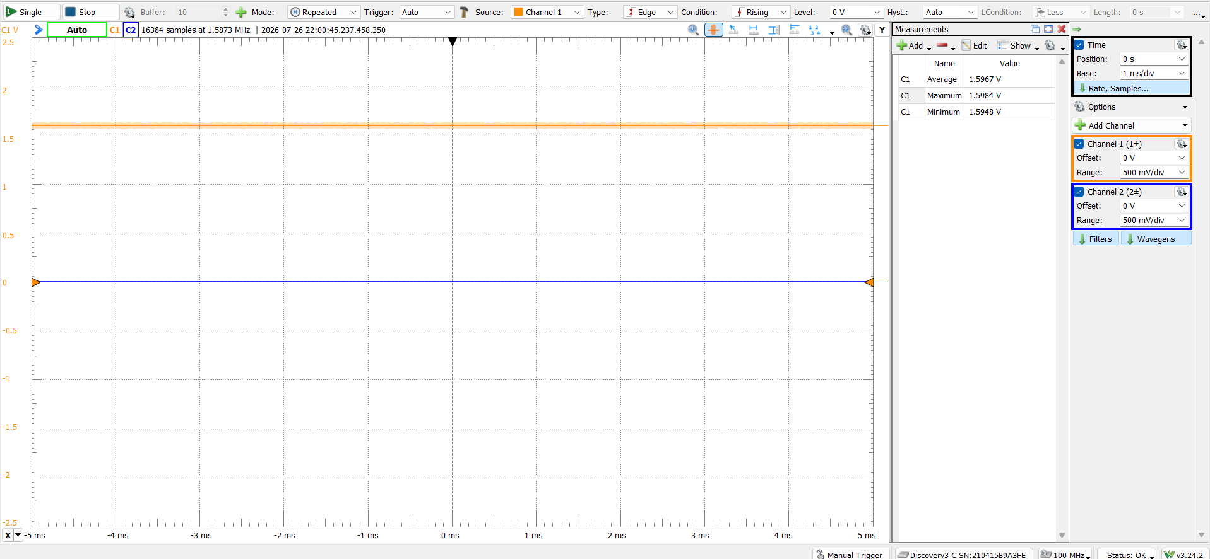
Figure 1: 1.6V Output from DAC in Part 1
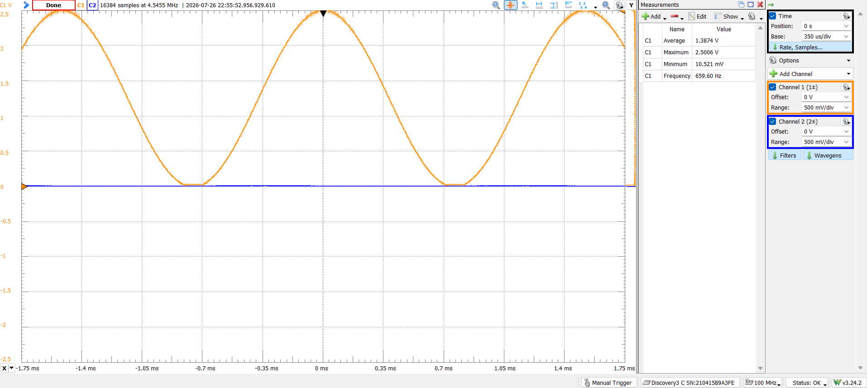
Figure 2: E₅ Waveform
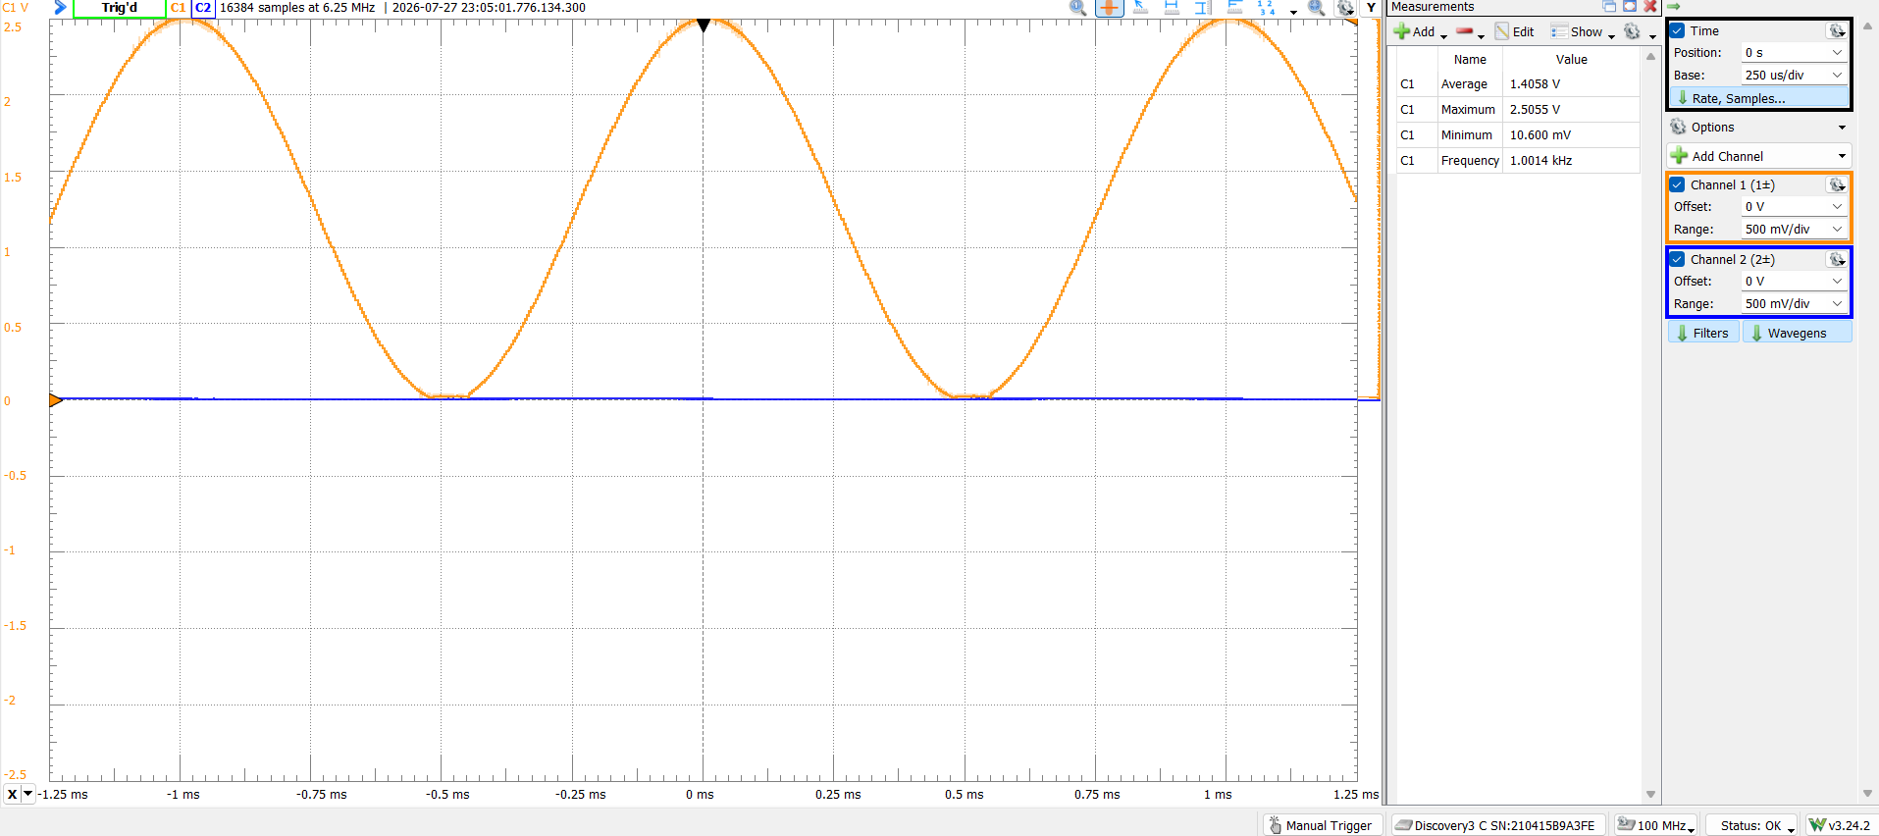
Figure 3: Attempt at 1059.26 Hz (WITH ISR), fails at 1kHz
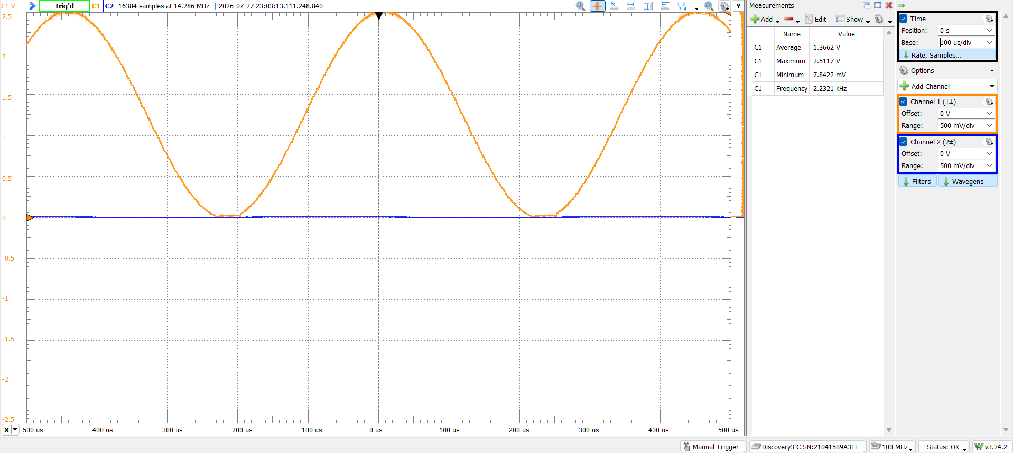
Figure 4: Max Frequency Sine Wave in lab8_2.2a (NO ISR) of 2.23kHz.
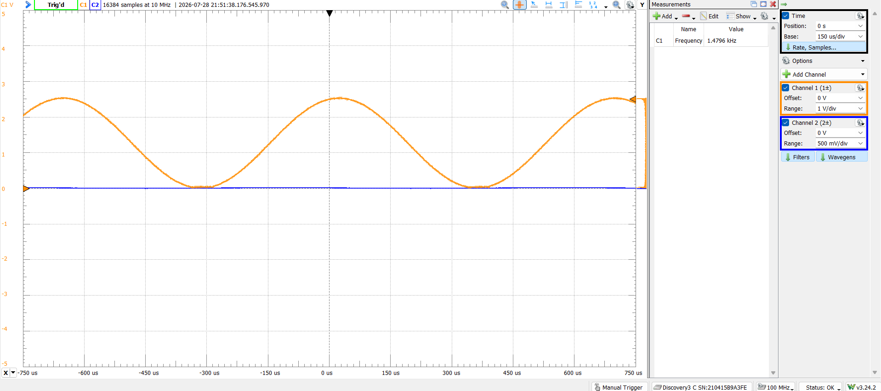
Figure 5: Lab8_2b Waveform of F# (6) or 1479.98 Hz WITHOUT DMA
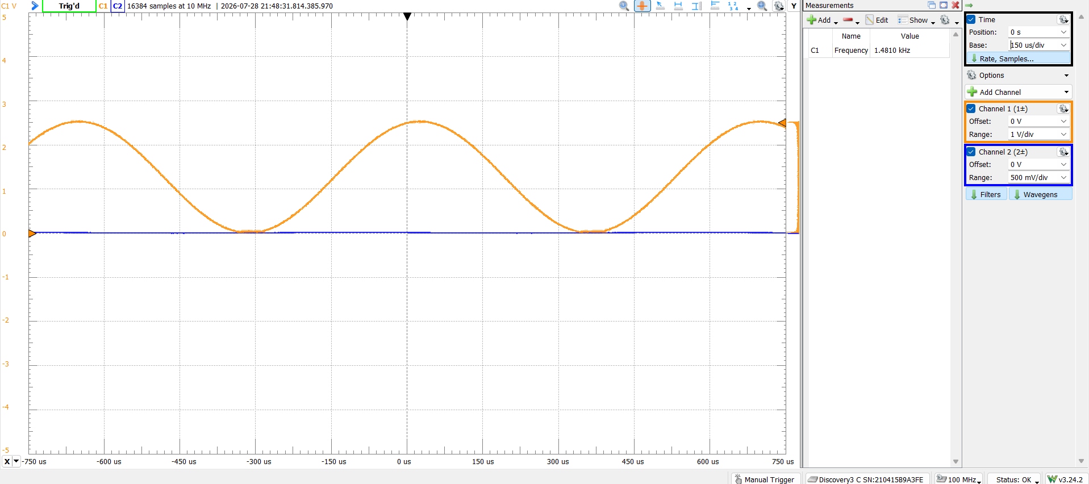
Figure 6: Lab6_3 Waveform of F# (6) or 1479.98 Hz WITH DMA
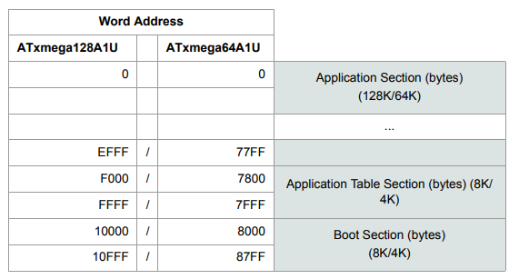
Figure 7: Program Memory Addressing

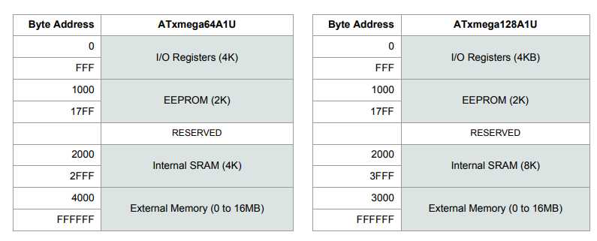
Figure 8: Data Memory Addressing

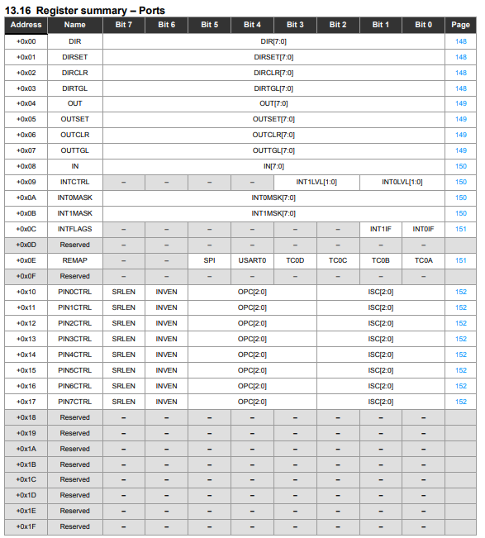
Figure 9: Ports Register Summary
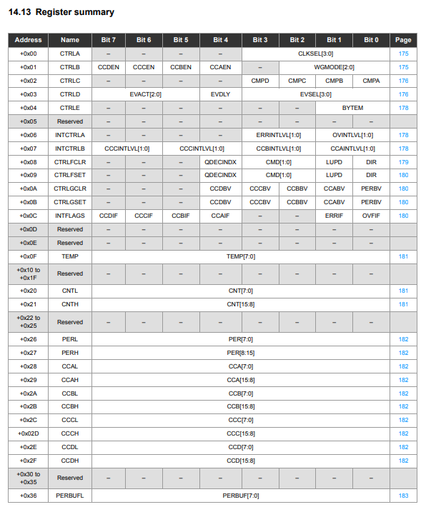
Figure 10: Timer/Counter Register Summary
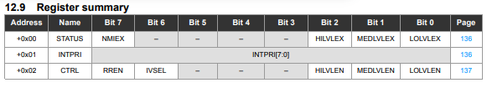
Figure 11: Interrupts Register Summary

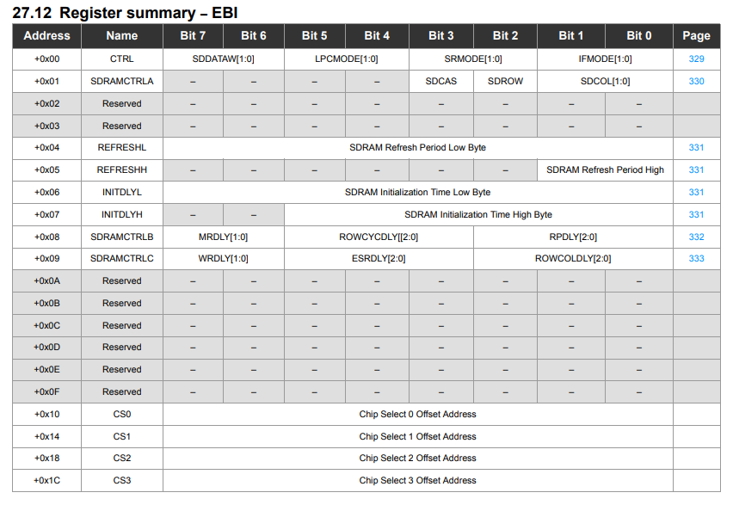
Figure 12: EBI Register Summary
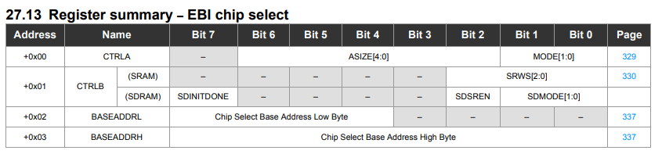
Figure 13: EBI Chip Select Register Summary
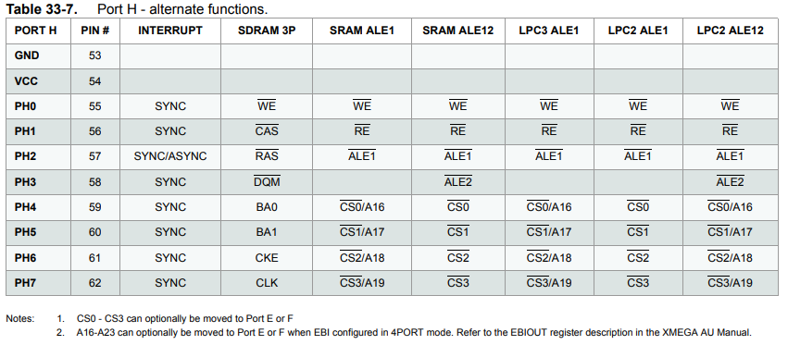
Figure 14: PORTH Alternate Functions
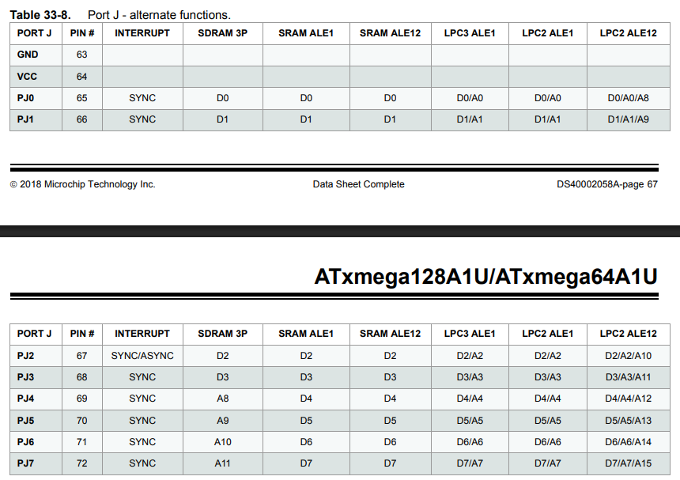
Figure 15: PORTJ Alternate Functions

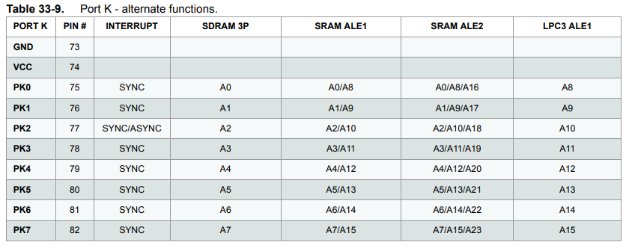
Figure 16: PORTK Alternate Functions
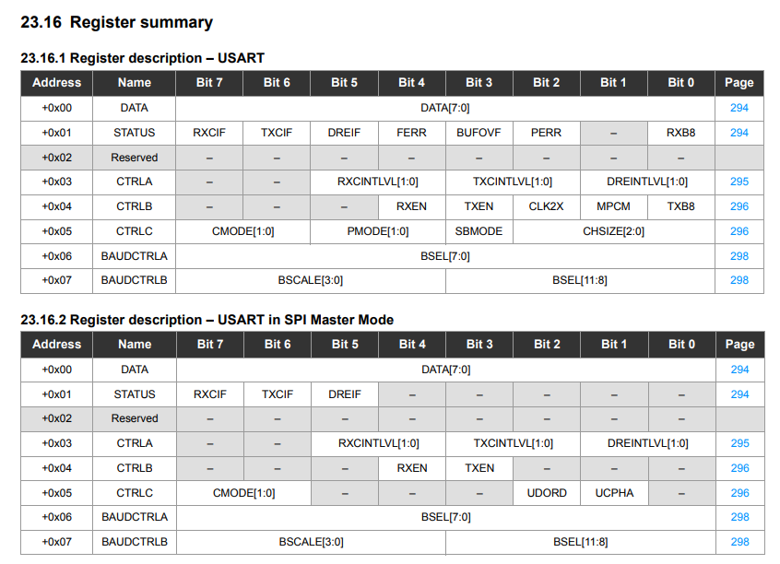
Figure 17: USART Register Summaries
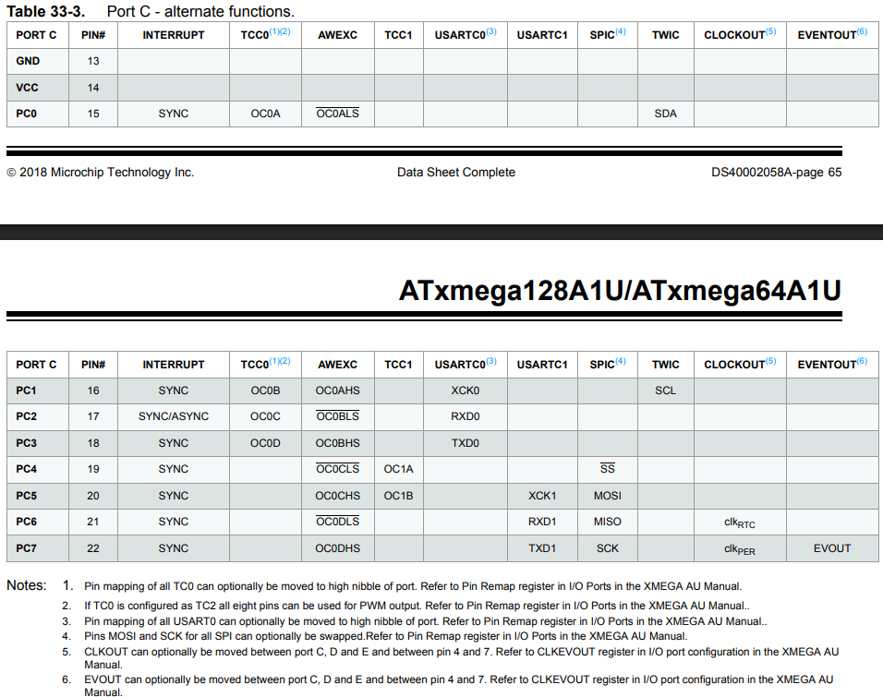
Figure 18: PORTC Alternate Functions
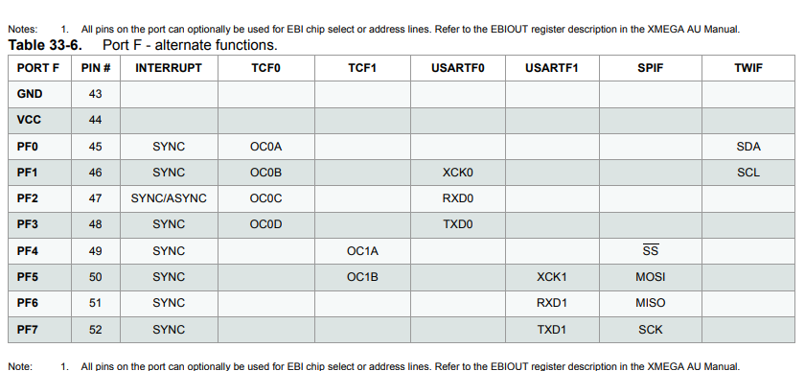
Figure 19: PORTF Alternate Functions
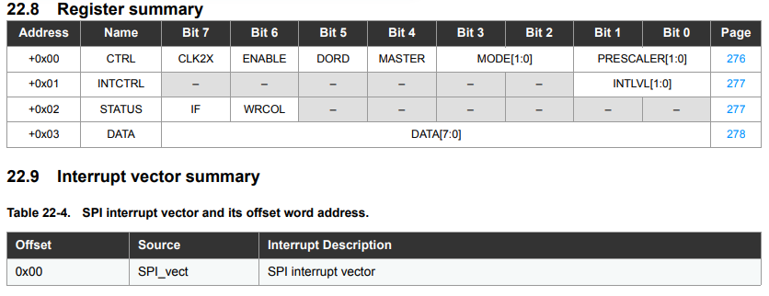
Figure 20: SPI Register Summary
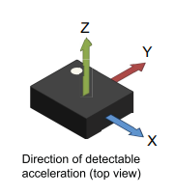
Figure 21: Axis Directions for IMU

