VLSI 1: CADENCE TUTORIAL PT. 1
SCHEMATIC & SYMBOL:

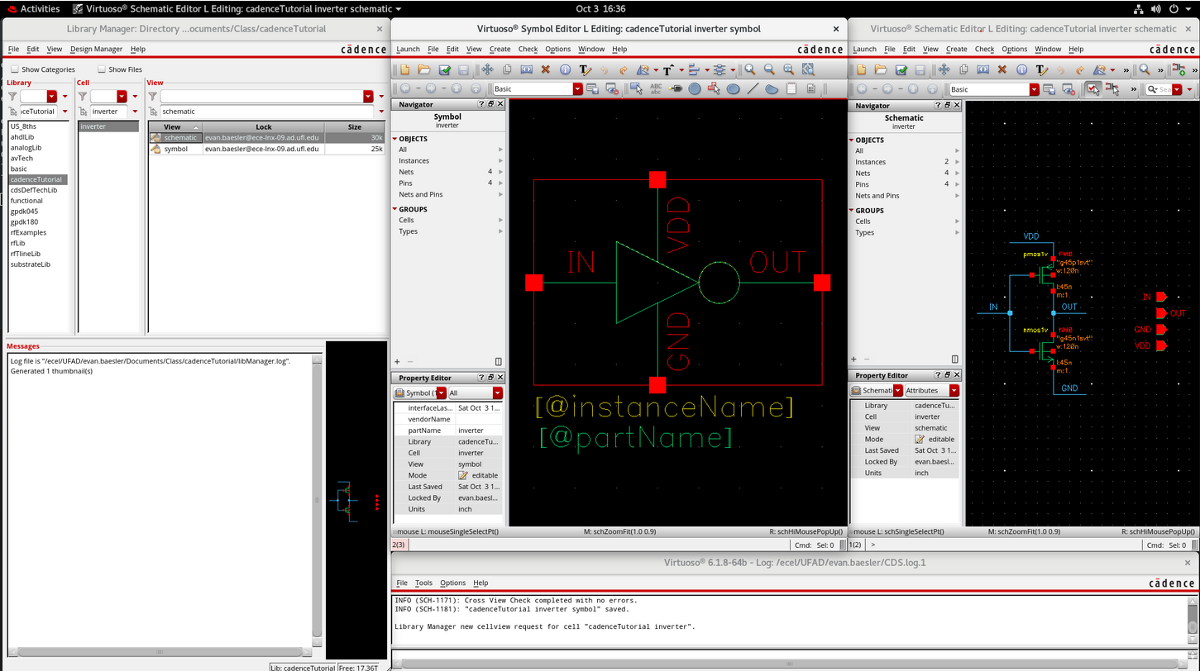
QUESTIONS:
- What is a Process Design Kit (PDK) and how is it used?
- A PDK is a group of design rules, assets and verification tools provided by a manufacturer to create ICs. They are important because they can determine the manufacturability of a circuit created in Cadence, and provide the basic components needed to make anything.

- Discuss technology node feature size and how it is defined.
- A technology node feature size is effectively the minimum size that any feature must be to be fabricated and is used to name a generation of technology. A 45nm technology node refers to features on the order of 45nm, but does not guarantee that 45nm is the actual minimum physical feature size.

- List at least four major foundries (foundries that tape out the chip, not electronic sellers).
- TSMC, Samsung Foundry, GlobalFoundries, and UMC.

