REQUIREMENTS NOT MET
None
PROBLEMS ENCOUNTERED
None Encountered
FUTURE WORK/APPLICATIONS
This lab teaches us the usage of Serial Peripheral Interface (SPI), which is fundamental to high-speed transmissions, by connecting a ‘master’ to a ‘student’ devices, we can have full-duplex communication from one to another, allowing us to have much faster rates than USART by sharing a clock signal (SCK). SPI also allows us to interface multiple devices or ‘students,’ by use of CS/SS. This could be used for high-speed sensors such as sound sensors, brightness sensors, etc. SPI is the ‘king of speed.’

PRE-LAB EXERCISES
- In regard to SPI communication that is to exist between the relevant ATxmega128A1U and IMU chips, answer each of the questions within the previously given bulleted list.

  - Which device(s) should be given the role of master and which device(s) should be given the role of student?
    - The microcontroller should be given the master role to control the clock signal (SCK), chip selects, and the initialization of all read/write transmissions.
    - The IMU chip should be given the student role to be driven by the microcontroller, remaining inactive except for when the master enables it via chip select and drives it with SCK, allowing it to transmit and be read from.

  - How will the student device(s) be enabled? If a student select is utilized, rather than just have the device(s) be permanently enabled, which pin(s) will be used?
    - The IMU will be enabled via an active-low CS/SS signal, which is driven by pin 12 for both chips.

  - What is the order of data transmission? Is the MSb or LSb transmitted first?
    - MSB in/out first down to LSB in/out last per IMU specification.

  - In regard to the relevant clock signal, should data be latched on a rising edge or on a falling edge?
    - It should be latched on the rising edge, per IMU timing diagram (page 25), with new data bits transmitted on the falling edge.

  - What is the maximum serial clock frequency that can be utilized by the relevant devices?
    - The IMU Timing Values chart shows a maximum SPI clock frequency of 10MHz.

- Why is it a better idea to modify global flag variables inside of ISRs instead of doing everything inside of them?

  - To reduce the time spent in the ISR, allowing the program to run the main loop as often as possible, and allowing other interrupts to fire as necessary (otherwise they are blocked.) Utilizing communication protocols within the ISR can also lead to race conditions.

- To output two unsigned 32-bit values 0x42676937 [CH1] and 0xDEADBEEF [CH2] to SerialPlot, list all the bytes in the order you would send them via UART.

  - Little endian, from right to left: 0x37, 0x69, 0x67, 0x42; 0xEF, 0xBE, 0xAD, 0xDE.

- What is the most positive value that can be received from the accelerometer (in decimal)? What about the most negative?

  - If bit 16 (2¹⁵) determines sign, we can say that we are able to say that we can show 2¹⁵ – 1, or 32,767 down to -2⁻¹⁵, or -32,768.

PSEUDOCODE/FLOWCHARTS
spi.c
/*------------------------------------------------------------------------------
spi.c --

Description:
Provides useful definitions for manipulating the relevant SPI
module of the ATxmega128A1U.

Author(s): Dr. Eric M. Schwartz, Christopher Crary, Wesley Piard
Last modified by: Dr. Eric M. Schwartz
Last modified on: 30 May 2026
------------------------------------------------------------------------------*/

/********************************DEPENDENCIES**********************************/

#include <avr/io.h>
#include "spi.h"

/*****************************END OF DEPENDENCIES******************************/

/*****************************FUNCTION DEFINITIONS*****************************/

void spi_init(void)
{

/* Initialize the relevant SPI output signals to be in an "idle" state.
* Refer to the relevant timing diagram within the LSM6DSL datasheet.
* (You may wish to utilize the macros defined in `spi.h`.) */
PORTF.OUTSET = SS | SCK;

/* Configure the pin direction of relevant SPI signals. */
PORTF.DIRSET = MOSI | SS | SCK;
PORTF.DIRCLR = MISO;

/* Set the other relevant SPI configurations. */
SPIF.CTRL = SPI_PRESCALER_DIVX_gc |
SPI_MASTER_bm |
SPI_MODE_3_gc |
SPI_ENABLE_bm;
}

void spi_write(uint8_t data)
{
/* Write to the relevant DATA register. */
SPIF.DATA = data;

/* Wait for relevant transfer to complete. */
while(IF FLAG NOT TRUE);

/* In general, it is probably wise to ensure that the relevant flag is
* cleared at this point, but, for our contexts, this will occur the
* next time we call the `spi_write` (or `spi_read`) routine.
* Really, because of how the flag must be cleared within
* ATxmega128A1U, it would probably make more sense to have some single
* function, say `spi_transceive`, that both writes and reads
* data, rather than have two functions `spi_write` and `spi_read`,
* but we will not concern ourselves with this possibility
* during this semester of the course. */
}

uint8_t spi_read(void)
{
/* Write some arbitrary data to initiate a transfer. */
SPIF.DATA = 0x37;

/* Wait for relevant transfer to be complete. */
while(IF FLAG NOT TRUE);

/* After the transmission, return the data that was received. */
return SPIF.DATA;
}

/***************************END OF FUNCTION DEFINITIONS************************/

Lab6_2.c
/*
* lab6_2.c
*
* Created: 7/12/2026 2:52:31 PM
* Author : Evan Baesler
*/

#include <avr/io.h>
#include "spi.h"

int main(void)
{
// Initialize the SPI module
call spi_init

while(1)
{
PORTF.OUTCLR = SS; // Simulate turning IMU CS on

// Transmit 0x42
spi_write(0x42)

PORTF.OUTSET = SS; // Simulate turning IMU CS off
}
}

/*****************************FUNCTION DEFINITIONS*****************************/

void spi_init(void)
{

/* Initialize the relevant SPI output signals to be in an "idle" state.
* Refer to the relevant timing diagram within the LSM6DSL datasheet.
* (You may wish to utilize the macros defined in `spi.h`.) */
PORTF.OUTSET = SS | SCK;

/* Configure the pin direction of relevant SPI signals. */
PORTF.DIRSET = MOSI | SS | SCK;
PORTF.DIRCLR = MISO;

/* Set the other relevant SPI configurations. */
SPIF.CTRL = SPI_PRESCALER_DIVX_gc |
SPI_MASTER_bm |
SPI_MODE_3_gc |
SPI_ENABLE_bm;
}

void spi_write(uint8_t data)
{
/* Write to the relevant DATA register. */
SPIF.DATA = data;

/* Wait for relevant transfer to complete. */
while(IF FLAG NOT TRUE);

/* In general, it is probably wise to ensure that the relevant flag is
* cleared at this point, but, for our contexts, this will occur the
* next time we call the `spi_write` (or `spi_read`) routine.
* Really, because of how the flag must be cleared within
* ATxmega128A1U, it would probably make more sense to have some single
* function, say `spi_transceive`, that both writes and reads
* data, rather than have two functions `spi_write` and `spi_read`,
* but we will not concern ourselves with this possibility
* during this semester of the course. */
}

uint8_t spi_read(void)
{
/* Write some arbitrary data to initiate a transfer. */
SPIF.DATA = 0x37;

/* Wait for relevant transfer to be complete. */
while(IF FLAG NOT TRUE);

/* After the transmission, return the data that was received. */
return SPIF.DATA;
}

/***************************END OF FUNCTION DEFINITIONS************************/

Lab6_3.c
Include dependencies (spi, lsm6dsl, io)
Write Prototypes

Main
{
spi_init
uint8_t output = 0

while(true)
{
output = LSM_read(WHO_AM_I)
}
}

// SUBROUTINES:
uint8_t LSM_read(reg_addr) // uint8_t to read the value of a register
[
Enable IMU
Read from address (MSB ON)
WAIT FOR TRANSFER
Read a dummy value
WAIT FOR TRANSFER
Disable IMU
Return Data from Address
}

void LSM_write(reg addr, data)
{
Enable IMU
Write to address (MSB OFF)
WAIT FOR TRANSFER
Write value
WAIT FOR TRASNFER
Disable IMU
}

Reuse SPI_init from prior section

Lab6_4
Include dependencies (spi, lsm6dsl, io)
Write Prototypes

Main
{
spi_init
LSM_init
sei

while(1)
{
// INFINITE WAIT LOOP
}
}

// SUBROUTINES
Reuse spi_init, LSM_read/write

void LSM_init(void)
{
Set SW_Reset flag
Delay
Set interrupt to active-low
Enable data-ready interrupt
Disable DEN in output
Set up sampling frequency and sensitivity

Set INT1 to relevant pin
Set low level interrupt sense
Enable low level interrupts
}

Void usartd0_out_repeat(*data, length)
{
For (I = 0; I < length; i++)
{
Usartd0_out_char(data[i])a // PROVIDED
}
}

// INTERRUPT
Interrupt(PORTC_INT0)
{
Output = LSM_READ(OUTX_L_XL)
Reset interrupt flag
}

Lab6_5
Include dependencies (io, interrupt, spi, uart, lsm)
Include prior subroutines (LSM functions, spi, usart, repeat)

Volatile accel_flag
Accel_data[6] = {0,0,0,0,0,0}

Main
{
Spi_init
LSM_init
Usartd0_init
While(1)
{
If accel_flag
{
Accel_data[0-5] gets X-Z data
Usartd0_out_repeat(accel_data, 6)

Reset accel flag
Enable INT0 on PORTC
}
}
}

// INTERRUPT
Interrupt(PORTC_INT0)
{
Accel_flag = 1
Disable interrupt on PORTC
Reset interrupt flag
}

Lab6_6
Include dependencies (io, interrupt, spi, uart, lsm)
Include prior subroutines (LSM read/write functions, spi, usart, repeat)

Volatile accel_flag
gyro_data[6] = {0,0,0,0,0,0}

Main
{
Spi_init
LSM_init
Usartd0_init
While(1)
{
If gyro_flag
{
Accel_data[0-5] gets X-Z data
Usartd0_out_repeat(accel_data, 6)

Reset gyro flag
Enable INT0 on PORTC
}
}
}

// INTERRUPT
Interrupt(PORTC_INT0)
{
Gyro_flag = 1
Disable interrupt on PORTC
Reset interrupt flag
}

void LSM_init(void)
{
Set SW_Reset flag
Delay
Set interrupt to active-low
Enable data-ready interrupt for gyro
Disable DEN in output
Set up sampling frequency and sensitivity for gyro

Set INT1 to relevant pin
Set low level interrupt sense
Enable low level interrupts
}

PROGRAM CODE
spi.h
#ifndef SPI_H_ // Header guard.
#define SPI_H_

/*------------------------------------------------------------------------------
spi.h --

Description:
Provides function prototypes and macro definitions for utilizing the SPI
system of the ATxmega128A1U.

Author(s): Dr. Eric M. Schwartz, Christopher Crary, Wesley Piard
Last modified by: Dr. Eric M. Schwartz
Last modified on: 30 May 2026
Last configured by: Evan Baesler
Last configured on: 12 July 2026
------------------------------------------------------------------------------*/

/********************************DEPENDENCIES**********************************/

#include <avr/io.h>

/*****************************END OF DEPENDENCIES******************************/

/***********************************MACROS*************************************/

#define SS_bm (1<<4)
#define MOSI_bm (1<<5)
#define MISO_bm (1<<6)
#define SCK_bm (1<<7) // Per PORTF Alternate Functions

/********************************END OF MACROS*********************************/

/*****************************FUNCTION PROTOTYPES******************************/

/*------------------------------------------------------------------------------
spi_init --

Description:
Initializes the relevant SPI module to communicate with the LSM6DSL.

Input(s): N/A
Output(s): N/A
------------------------------------------------------------------------------*/
void spi_init(void);

/*------------------------------------------------------------------------------
spi_write --

Description:
Transmits a single byte of data via the relevant SPI module.

Input(s): `data` - 8-bit value to be written via the relevant SPI module.
Output(s): N/A
------------------------------------------------------------------------------*/
void spi_write(uint8_t data);

/*------------------------------------------------------------------------------
spi_read --

Description:
Reads a byte of data via the relevant SPI module.

Input(s): N/A
Output(s): 8-bit value read from the relevant SPI module.
------------------------------------------------------------------------------*/
uint8_t spi_read(void);

/**************************END OF FUNCTION PROTOTYPES**************************/

#endif // End of header guard.

spi.c
/*------------------------------------------------------------------------------
spi.c --

Description:
Provides useful definitions for manipulating the relevant SPI
module of the ATxmega128A1U.

Author(s): Dr. Eric M. Schwartz, Christopher Crary, Wesley Piard
Last modified by: Dr. Eric M. Schwartz
Last modified on: 30 May 2026
Last configured by: Evan Baesler
Last configured on: 12 July 2026
------------------------------------------------------------------------------*/

/********************************DEPENDENCIES**********************************/

#include <avr/io.h>
#include "spi.h"

/*****************************END OF DEPENDENCIES******************************/

/*****************************FUNCTION DEFINITIONS*****************************/

void spi_init(void)
{

/* Initialize the relevant SPI output signals to be in an "idle" state.
* Refer to the relevant timing diagram within the LSM6DSL datasheet.
* (You may wish to utilize the macros defined in `spi.h`.) */
PORTF.OUTSET = SS_bm | SCK_bm;

/* Configure the pin direction of relevant SPI signals. */
PORTF.DIRSET = SS_bm | MOSI_bm | SCK_bm;
PORTF.DIRCLR = MISO_bm;

/* Set the other relevant SPI configurations. */
SPIF.CTRL = SPI_PRESCALER_DIV16_gc |
SPI_MASTER_bm |
SPI_MODE_3_gc |
SPI_ENABLE_bm;
// This leaves CTRL.DORD false, so MSB -> LSB
}

void spi_write(uint8_t data)
{
/* Write to the relevant DATA register. */
SPIF.DATA = data;

/* Wait for relevant transfer to complete. */
while(!(SPIF.STATUS & (SPI_IF_bm)));

/* In general, it is probably wise to ensure that the relevant flag is
* cleared at this point, but, for our contexts, this will occur the
* next time we call the `spi_write` (or `spi_read`) routine.
* Really, because of how the flag must be cleared within
* ATxmega128A1U, it would probably make more sense to have some single
* function, say `spi_transceive`, that both writes and reads
* data, rather than have two functions `spi_write` and `spi_read`,
* but we will not concern ourselves with this possibility
* during this semester of the course. */
}

uint8_t spi_read(void)
{
/* Write some arbitrary data to initiate a transfer. */
SPIF.DATA = 0x37;

/* Wait for relevant transfer to be complete. */
while(!(SPIF.STATUS & (SPI_IF_bm)));

/* After the transmission, return the data that was received. */
return SPIF.DATA;
}

/***************************END OF FUNCTION DEFINITIONS************************/

usart.h
#ifndef USART_H // Header guard.
#define USART_H

/*------------------------------------------------------------------------------
usart.h --

Description:
Provides some useful declarations regarding the USART system of the
ATxmega128A1U.

Author(s): Dr. Eric Schwartz, Christopher Crary, Wesley Piard
Last modified by: Dr. Eric M. Schwartz
Last modified on: 30 May 2026
------------------------------------------------------------------------------*/

/********************************DEPENDENCIES**********************************/

#include <avr/io.h>

/*****************************END OF DEPENDENCIES******************************/

/***********************************MACROS*************************************/
/********************************END OF MACROS*********************************/

/*******************************CUSTOM DATA TYPES******************************/
/***************************END OF CUSTOM DATA TYPES***************************/

/*****************************FUNCTION PROTOTYPES******************************/

/*------------------------------------------------------------------------------
usartd0_in_char --

Description:
Returns a single character via the receiver of the USARTD0 module.

Input(s): N/A
Output(s): Character received from USARTD0 module.
------------------------------------------------------------------------------*/
char usartd0_in_char(void);

/*------------------------------------------------------------------------------
usartd0_in_string --

Description:
Reads in a string with the receiever of the USARTD0 module.

The string is to be stored within a pre-allocated buffer, accessible
via the character pointer `buf`.

Input(s): `buf` - Pointer to character buffer.
Output(s): N/A
------------------------------------------------------------------------------*/
void usartd0_in_string(char * buf);

/*------------------------------------------------------------------------------
usartd0_init --

Description:
Configures the USARTD0 module for a specific asynchronous serial protocol.

Input(s): N/A
Output(s): N/A
------------------------------------------------------------------------------*/
void usartd0_init(void);

/*------------------------------------------------------------------------------
usartd0_out_char --

Description:
Outputs a character via the transmitter of the USARTD0 module.

Input(s): `c` - Read-only character.
Output(s): N/A
------------------------------------------------------------------------------*/
void usartd0_out_char(char c);

/*------------------------------------------------------------------------------
usartd0_out_string --

Description:
Outputs a string via the transmitter of the USARTD0 module.

The string is to be stored within a pre-allocated buffer, accessible
via the character pointer `str`.

Input(s): `str` - Pointer to read-only character string.
Output(s): N/A
------------------------------------------------------------------------------*/
void usartd0_out_string(const char * str);

/**************************END OF FUNCTION PROTOTYPES**************************/

#endif // End of header guard.

usart.c
/*------------------------------------------------------------------------------
usart.c --

Description:
Provides some useful definitions regarding the USART system of the
ATxmega128A1U.

Author(s): Dr. Eric Schwartz, Christopher Crary, Wesley Piard
Last modified by: Dr. Eric M. Schwartz
Last modified on: 30 May 2026
------------------------------------------------------------------------------*/

/********************************DEPENDENCIES**********************************/

#include <avr/io.h>
#include "usart.h"

/*****************************END OF DEPENDENCIES******************************/

/***********************************MACROS*************************************/

/* At 2 MHz SYSclk, 5 BSEL, -6 BSCALE corresponds to 115200 bps */
#define BSEL (5)
#define BSCALE (-6)

/********************************END OF MACROS*********************************/

/*****************************FUNCTION DEFINITIONS*****************************/

char usartd0_in_char(void)
{
/* intentionally left blank */
}

void usartd0_in_string(char * buf)
{
/* intentionally left blank */
}

void usartd0_init(void)
{
/* Configure relevant TxD and RxD pins. */
PORTD.OUTSET = PIN3_bm;
PORTD.DIRSET = PIN3_bm;
PORTD.DIRCLR = PIN2_bm;

/* Configure baud rate. */
USARTD0.BAUDCTRLA = (uint8_t)BSEL;
USARTD0.BAUDCTRLB = (uint8_t)((BSCALE << 4)|(BSEL >> 8));

/* Configure remainder of serial protocol. */
/* (In this example, a protocol with 8 data bits, no parity, and
* one stop bit is chosen.) */
USARTD0.CTRLC = (USART_CMODE_ASYNCHRONOUS_gc |
USART_PMODE_DISABLED_gc |
USART_CHSIZE_8BIT_gc) &
~USART_SBMODE_bm;

/* Enable receiver and/or transmitter systems. */
USARTD0.CTRLB = USART_RXEN_bm | USART_TXEN_bm;

/* Enable interrupt (optional). */
/* USARTD0.CTRLA = USART_RXCINTLVL_MED_gc; */
}

void usartd0_out_char(char c)
{
while(!(USARTD0.STATUS & USART_DREIF_bm));
USARTD0.DATA = c;
}

void usartd0_out_string(const char * str)
{
while(*str) usartd0_out_char(*(str++));
}

/***************************END OF FUNCTION DEFINITIONS************************/

lsm6dsl.h
#ifndef LSM6DSL_H_ // Header guard.
#define LSM6DSL_H_

/*------------------------------------------------------------------------------
lsm6dsl.h --

Description:
Provides custom data types to make it easier to handle any data
read from the LSM6DSL IMU.

The LSM6DSL can output accelerometer and gyroscope data. Data from both
of these sensors is represented in a 16-bit signed format.

Author(s): Wesley Piard & Dr. Eric M. Schwartz
Last modified by: Dr. Eric M. Schwartz
Last modified on: 30 May 2026
------------------------------------------------------------------------------*/

/***********************************MACROS*************************************/

#define LSM6DSL_SPI_READ_STROBE_bm 0x80
#define LSM6DSL_SPI_WRITE_STROBE_bm 0x00

/********************************END OF MACROS*********************************/

/*******************************CUSTOM DATA TYPES******************************/

/* Used to differentiate the accelerometer and gyroscope within the LSM6DSL. */
typedef enum {LSM6DSL_ACCEL, LSM6DSL_GYRO} lsm6dsl_module_t;

/* Can be used to contain the separated bytes of data as they are read from
* the LSM6DSL. */
typedef struct lsm6dsl_data_raw
{
uint8_t accel_x_low, accel_x_high;
uint8_t accel_y_low, accel_y_high;
uint8_t accel_z_low, accel_z_high;

uint8_t gyro_x_low, gyro_x_high;
uint8_t gyro_y_low, gyro_y_high;
uint8_t gyro_z_low, gyro_z_high;
}lsm6dsl_data_raw_t;

/* Contains the full concatenated signed 16-bit words of data. */
typedef struct lsm6dsl_data_full
{
int16_t accel_x, accel_y, accel_z;
int16_t gyro_x, gyro_y, gyro_z;
}lsm6dsl_data_full_t;

/* Provides the ability to choose how to access the LSM6DSL data. */
typedef union lsm6dsl_data
{
lsm6dsl_data_full_t word;
lsm6dsl_data_raw_t byte;
}lsm6dsl_data_t;

/***************************END OF CUSTOM DATA TYPES***************************/

/*****************************FUNCTION PROTOTYPES******************************/

uint8_t LSM_read(uint8_t reg_addr)
{
PORTF.OUTCLR = SS_bm; // Enable IMU

SPIF.DATA = (reg_addr | 0x80); // READ FROM ADDRESS (MSB ON)

while(!(SPIF.STATUS & (SPI_IF_bm))); // WAIT FOR TRANSFER

SPIF.DATA = 0x37; // DUMMY VALUE, OVERWRITTEN IN NEXT CLK

while(!(SPIF.STATUS & (SPI_IF_bm))); // WAIT FOR TRANSFER

PORTF.OUTSET = SS_bm; // Disable IMU

return SPIF.DATA; // RETURN DATA FROM ADDRESS

}

void LSM_write(uint8_t reg_addr, uint8_t data)
{
PORTF.OUTCLR = SS_bm; // Enable IMU

SPIF.DATA = (reg_addr); // WRITE TO ADDRESS (MSB OFF)

while(!(SPIF.STATUS & (SPI_IF_bm))); // WAIT FOR TRANSFER

SPIF.DATA = data; // WRITTEN VALUE

while(!(SPIF.STATUS & (SPI_IF_bm))); // WAIT FOR TRANSFER

PORTF.OUTSET = SS_bm; // Disable IMU
}

/**************************END OF FUNCTION PROTOTYPES**************************/

#endif // End of header guard.

lsm6dsl_registers.h
#ifndef LSM6DSL_REGISTERS_H_ // Header guard.
#define LSM6DSL_REGISTERS_H_

/*------------------------------------------------------------------------------
lsm6dsl_registers.h --

Description:
Provides useful macro definitions and symbols that can be used
when accesing registers of the LSM6DSL IMU.

Created by: OOTB-LT
Created on: 14 September 2019

Last modified by: Dr. Eric M. Schwartz
Last modified on: 30 May 2026
------------------------------------------------------------------------------*/

/***********************************MACROS*************************************/
/********************************END OF MACROS*********************************/

/*******************************CUSTOM DATA TYPES******************************/

typedef enum LSM6DSL_ACCEL_REGISTERS
{

FUNC_CFG_ACCESS = 0x01,
SENSOR_SYNC_TIME_FRAME = 0x04,
SENSOR_SYNC_RES_RATIO = 0x05,

FIFO_CTRL1 = 0x06,
FIFO_CTRL2 = 0x07,
FIFO_CTRL3 = 0x08,
FIFO_CTRL4 = 0x09,
FIFO_CTRL5 = 0x0A,

DRDY_PULSE_CFG_G = 0x0B,

INT1_CTRL = 0x0D,
INT2_CTRL = 0x0E,

WHO_AM_I = 0x0F,

CTRL1_XL = 0x10,

CTRL2_G = 0x11,

CTRL3_C = 0x12,
CTRL4_C = 0x13,
CTRL5_C = 0x14,
CTRL6_C = 0x15,

CTRL7_G = 0x16,

CTRL8_XL = 0x17,
CTRL9_XL = 0x18,
CTRL10_C = 0x19,

MASTER_CONFIG = 0x1A,

WAKE_UP_SRC = 0x1B,

TAP_SRC = 0x1C,
D6D_SRC = 0x1D,
STATUS_REG = 0x1E,

OUT_TEMP_L = 0x20,
OUT_TEMP_H = 0x21,

OUTX_L_G = 0x22,
OUTX_H_G = 0x23,
OUTY_L_G = 0x24,
OUTY_H_G = 0x25,
OUTZ_L_G = 0x26,
OUTZ_H_G = 0x27,

OUTX_L_XL = 0x28,
OUTX_H_XL = 0x29,
OUTY_L_XL = 0x2A,
OUTY_H_XL = 0x2B,
OUTZ_L_XL = 0x2C,
OUTZ_H_XL = 0x2D,

SENSORHUB1_REG = 0x2E,
SENSORHUB2_REG = 0x2F,
SENSORHUB3_REG = 0x30,
SENSORHUB4_REG = 0x31,
SENSORHUB5_REG = 0x32,
SENSORHUB6_REG = 0x33,
SENSORHUB7_REG = 0x34,
SENSORHUB8_REG = 0x35,
SENSORHUB9_REG = 0x36,
SENSORHUB10_REG = 0x37,
SENSORHUB11_REG = 0x38,
SENSORHUB12_REG = 0x39,

FIFO_STATUS1 = 0x3A,
FIFO_STATUS2 = 0x3B,
FIFO_STATUS3 = 0x3C,
FIFO_STATUS4 = 0x3D,

FIFO_DATA_OUT_L = 0x3E,
FIFO_DATA_OUT_H = 0x3F,

TIMESTAMP0_REG = 0x40,
TIMESTAMP1_REG = 0x41,
TIMESTAMP2_REG = 0x42,

STEP_TIMESTAMP_L = 0x49,
STEP_TIMESTAMP_H = 0x4A,

STEP_COUNTER_L = 0x4B,
STEP_COUNTER_H = 0x4C,

SENSORHUB13_REG = 0x4D,
SENSORHUB14_REG = 0x4E,
SENSORHUB15_REG = 0x4F,
SENSORHUB16_REG = 0x50,
SENSORHUB17_REG = 0x51,
SENSORHUB18_REG = 0x52,

FUNC_SRC1 = 0x53,
FUNC_SRC2 = 0x54,

WRIST_TILT_IA = 0x55,

TAP_CFG = 0x58,
TAP_THS_6D = 0x59,

INT_DUR2 = 0x5A,

WAKE_UP_THS = 0x5B,
WAKE_UP_DUR = 0x5C,

FREE_FALL = 0x5D,

MD1_CFG = 0x5E,
MD2_CFG = 0x5F,

MASTER_CMD_CODE = 0x60,

SENS_SYNC_SPI_ERROR_CODE = 0x61,

OUT_MAG_RAW_X_L = 0x66,
OUT_MAG_RAW_X_H = 0x67,
OUT_MAG_RAW_Y_L = 0x68,
OUT_MAG_RAW_Y_H = 0x69,
OUT_MAG_RAW_Z_L = 0x6A,
OUT_MAG_RAW_Z_H = 0x6B,

X_OFS_USR = 0x73,
Y_OFS_USR = 0x74,
Z_OFS_USR = 0x75

}LSM6DSL_REGA_t;

/***************************END OF CUSTOM DATA TYPES***************************/

#endif // End of header guard.
Lab6_2
/*
* lab6_2.c
*
* Created: 7/12/2026 2:52:31 PM
* Author : Evan Baesler
*/

#include <avr/io.h>
#include "spi.h"

int main(void)
{
// Initialize the SPI module
spi_init();

while(1)
{
PORTF.OUTCLR = SS_bm; // Simulate turning IMU CS on

// Transmit 0x42
spi_write(0x42);

PORTF.OUTSET = SS_bm; // Simulate turning IMU CS off
}
}

/*****************************FUNCTION DEFINITIONS*****************************/

void spi_init(void)
{

/* Initialize the relevant SPI output signals to be in an "idle" state.
* Refer to the relevant timing diagram within the LSM6DSL datasheet.
* (You may wish to utilize the macros defined in `spi.h`.) */
PORTF.OUTSET = SS_bm | SCK_bm;

/* Configure the pin direction of relevant SPI signals. */
PORTF.DIRSET = SS_bm | MOSI_bm | SCK_bm;
PORTF.DIRCLR = MISO_bm;

/* Set the other relevant SPI configurations. */
SPIF.CTRL = SPI_PRESCALER_DIV16_gc |
SPI_MASTER_bm |
SPI_MODE_3_gc |
SPI_ENABLE_bm;
// This leaves CTRL.DORD false, so MSB -> LSB
}

void spi_write(uint8_t data)
{
/* Write to the relevant DATA register. */
SPIF.DATA = data;

/* Wait for relevant transfer to complete. */
while(!(SPIF.STATUS & (SPI_IF_bm)));

/* In general, it is probably wise to ensure that the relevant flag is
* cleared at this point, but, for our contexts, this will occur the
* next time we call the `spi_write` (or `spi_read`) routine.
* Really, because of how the flag must be cleared within
* ATxmega128A1U, it would probably make more sense to have some single
* function, say `spi_transceive`, that both writes and reads
* data, rather than have two functions `spi_write` and `spi_read`,
* but we will not concern ourselves with this possibility
* during this semester of the course. */
}

uint8_t spi_read(void)
{
/* Write some arbitrary data to initiate a transfer. */
SPIF.DATA = 0x37;

/* Wait for relevant transfer to be complete. */
while(!(SPIF.STATUS & (SPI_IF_bm)));

/* After the transmission, return the data that was received. */
return SPIF.DATA;
}

/***************************END OF FUNCTION DEFINITIONS************************/

Lab6_3
/*
* lab6_3.c
*
* Created: 7/14/2026 12:52:10 AM
* Author: Evan Baesler
*/

#include <avr/io.h>
#include "spi.h"
#include "lsm6dsl.h"
#include "lsm6dsl_registers.h"

uint8_t LSM_read(uint8_t reg_addr);
void LSM_write(uint8_t reg_addr, uint8_t data); // PROTOTYPES

int main(void)
{
spi_init();
uint8_t output;

while(1)
{

output = LSM_read(WHO_AM_I);

}

}

uint8_t LSM_read(uint8_t reg_addr)
{
PORTF.OUTCLR = SS_bm; // Enable IMU

SPIF.DATA = (reg_addr | 0x80); // READ FROM ADDRESS (MSB ON)

while(!(SPIF.STATUS & (SPI_IF_bm))); // WAIT FOR TRANSFER

SPIF.DATA = 0x37; // DUMMY VALUE, OVERWRITTEN IN NEXT CLK

while(!(SPIF.STATUS & (SPI_IF_bm))); // WAIT FOR TRANSFER

PORTF.OUTSET = SS_bm; // Disable IMU

return SPIF.DATA; // RETURN DATA FROM ADDRESS

}

void LSM_write(uint8_t reg_addr, uint8_t data)
{
PORTF.OUTCLR = SS_bm; // Enable IMU

SPIF.DATA = (reg_addr); // WRITE TO ADDRESS (MSB OFF)

while(!(SPIF.STATUS & (SPI_IF_bm))); // WAIT FOR TRANSFER

SPIF.DATA = data; // WRITTEN VALUE

while(!(SPIF.STATUS & (SPI_IF_bm))); // WAIT FOR TRANSFER

PORTF.OUTSET = SS_bm; // Disable IMU
}

void spi_init(void)
{

/* Initialize the relevant SPI output signals to be in an "idle" state.
* Refer to the relevant timing diagram within the LSM6DSL datasheet.
* (You may wish to utilize the macros defined in `spi.h`.) */
PORTF.OUTSET = SS_bm | SCK_bm;

/* Configure the pin direction of relevant SPI signals. */
PORTF.DIRSET = SS_bm | MOSI_bm | SCK_bm;
PORTF.DIRCLR = MISO_bm;

/* Set the other relevant SPI configurations. */
SPIF.CTRL = SPI_PRESCALER_DIV16_gc |
SPI_MASTER_bm |
SPI_MODE_3_gc |
SPI_ENABLE_bm;
// This leaves CTRL.DORD false, so MSB -> LSB
}

Lab6_4
/*
* lab6_4.c
*
* Created: 7/14/2026 2:10:29 AM
* Author: Evan Baesler
*/

#include <avr/io.h>
#include <avr/interrupt.h>
#include "spi.h"
#include "lsm6dsl.h"
#include "lsm6dsl_registers.h"

void spi_init(void);
void LSM_init(void);
uint8_t LSM_read(uint8_t reg_addr);
void LSM_write(uint8_t reg_addr, uint8_t data); // PROTOTYPES
uint8_t output;

int main(void)
{
spi_init();
LSM_init();

sei();

while(1)
{

// NOOP TIL INTERRUPT IS READY

}

}

// SUBROUTINES

void spi_init(void)
{

/* Initialize the relevant SPI output signals to be in an "idle" state.
* Refer to the relevant timing diagram within the LSM6DSL datasheet.
* (You may wish to utilize the macros defined in `spi.h`.) */
PORTF.OUTSET = SS_bm | SCK_bm;

/* Configure the pin direction of relevant SPI signals. */
PORTF.DIRSET = SS_bm | MOSI_bm | SCK_bm;
PORTF.DIRCLR = MISO_bm;

/* Set the other relevant SPI configurations. */
SPIF.CTRL = SPI_PRESCALER_DIV16_gc |
SPI_MASTER_bm |
SPI_MODE_3_gc |
SPI_ENABLE_bm;
// This leaves CTRL.DORD false, so MSB -> LSB
}

void LSM_init(void)
{
LSM_write(CTRL3_C, 0x01); // SW_RESET FLAG, SELF CLEARS
for(uint16_t i = 0; i < 2000; i++);

LSM_write(CTRL3_C, (1<<5)); // SET INTERRUPT TO ACTIVE-LOW
LSM_write(INT1_CTRL, 0x01); // ENABLE INT1_DRDY_XL

LSM_write(CTRL9_XL, 0); // DISABLE DEN IN DATA OUTPUT FOR HIGHER RES
LSM_write(CTRL1_XL, 0b01010000); // 208Hz, +-2g
// THIS MEANS 208 SAMPLES / SECOND

PORTC.DIRCLR = PIN6_bm; // INT1 PIN
PORTC.PIN6CTRL = PORT_ISC_LEVEL_gc; // LOW LEVEL INTERRUPT SENSE
PORTC.INTCTRL = PORT_INT0LVL_LO_gc; // SET INT0 TO LO LVL INT
PORTC.INT0MASK = PIN6_bm; // CONNECT PIN6 TO PORTC INT0
PMIC.CTRL = PMIC_LOLVLEN_bm; // ENABLE LOLVL INT
}

void usartd0_out_repeat(uint8_t *data, uint8_t length)
{
for (uint8_t i = 0; i < length; i++)
{
usartd0_out_char(data[i]);
}
}

uint8_t LSM_read(uint8_t reg_addr)
{
PORTF.OUTCLR = SS_bm; // Enable IMU

SPIF.DATA = (reg_addr | 0x80); // READ FROM ADDRESS (MSB ON)

while(!(SPIF.STATUS & (SPI_IF_bm))); // WAIT FOR TRANSFER

SPIF.DATA = 0x37; // DUMMY VALUE, OVERWRITTEN IN NEXT CLK

while(!(SPIF.STATUS & (SPI_IF_bm))); // WAIT FOR TRANSFER

PORTF.OUTSET = SS_bm; // Disable IMU

return SPIF.DATA; // RETURN DATA FROM ADDRESS

}

void LSM_write(uint8_t reg_addr, uint8_t data)
{
PORTF.OUTCLR = SS_bm; // Enable IMU

SPIF.DATA = (reg_addr); // WRITE TO ADDRESS (MSB OFF)

while(!(SPIF.STATUS & (SPI_IF_bm))); // WAIT FOR TRANSFER

SPIF.DATA = data; // WRITTEN VALUE

while(!(SPIF.STATUS & (SPI_IF_bm))); // WAIT FOR TRANSFER

PORTF.OUTSET = SS_bm; // Disable IMU
}

// INTERRUPTS

ISR(PORTC_INT0_vect)
{

output = LSM_read(OUTX_L_XL);

PORTC.INTFLAGS = PIN6_bm;
}Lab6_5
/*
* lab6_5.c
*
* Created: 7/14/2026 2:32:51 PM
* Author: Evan Baesler
*/

#include <avr/io.h>
#include <avr/interrupt.h>
#include "spi.h"
#include "usart.h"
#include "lsm6dsl.h"
#include "lsm6dsl_registers.h"

void spi_init(void);
void LSM_init(void);
void usartd0_out_repeat(uint8_t *data, uint8_t length);

volatile uint8_t accel_flag;
uint8_t accel_data[6] = {0, 0, 0, 0, 0, 0};

int main(void)
{
spi_init();
LSM_init();
usartd0_init();

sei();

while(1)
{

if (accel_flag == 1){

// 1. READ DATA
accel_data[0] = LSM_read(OUTX_L_XL);
accel_data[1] = LSM_read(OUTX_H_XL);

accel_data[2] = LSM_read(OUTY_L_XL);
accel_data[3] = LSM_read(OUTY_H_XL);

accel_data[4] = LSM_read(OUTZ_L_XL);
accel_data[5] = LSM_read(OUTZ_H_XL);

// 2. LITTLE ENDIAN USART

usartd0_out_repeat(accel_data, 6);

// 3. RESET AND ENABLE FLAG
accel_flag = 0;
PORTC.INT0MASK |= PIN6_bm;
}

}

}

// SUBROUTINES

void spi_init(void)
{

/* Initialize the relevant SPI output signals to be in an "idle" state.
* Refer to the relevant timing diagram within the LSM6DSL datasheet.
* (You may wish to utilize the macros defined in `spi.h`.) */
PORTF.OUTSET = SS_bm | SCK_bm;

/* Configure the pin direction of relevant SPI signals. */
PORTF.DIRSET = SS_bm | MOSI_bm | SCK_bm;
PORTF.DIRCLR = MISO_bm;

/* Set the other relevant SPI configurations. */
SPIF.CTRL = SPI_PRESCALER_DIV16_gc |
SPI_MASTER_bm |
SPI_MODE_3_gc |
SPI_ENABLE_bm;
// This leaves CTRL.DORD false, so MSB -> LSB
}

void LSM_init(void)
{
LSM_write(CTRL3_C, 0x01); // SW_RESET FLAG, SELF CLEARS
for(uint16_t i = 0; i < 2000; i++);

LSM_write(CTRL3_C, (1<<5)); // SET INTERRUPT TO ACTIVE-LOW
LSM_write(INT1_CTRL, 0x01); // ENABLE INT1_DRDY_XL

LSM_write(CTRL9_XL, 0); // DISABLE DEN IN DATA OUTPUT FOR HIGHER RES
LSM_write(CTRL1_XL, 0b01010000); // 208Hz, +-2g
// THIS MEANS 208 SAMPLES / SECOND

PORTC.DIRCLR = PIN6_bm; // INT1 PIN
PORTC.PIN6CTRL = PORT_ISC_LEVEL_gc; // LOW LEVEL INTERRUPT SENSE
PORTC.INTCTRL = PORT_INT0LVL_LO_gc; // SET INT0 TO LO LVL INT
PORTC.INT0MASK = PIN6_bm; // CONNECT PIN6 TO PORTC INT0
PMIC.CTRL = PMIC_LOLVLEN_bm; // ENABLE LOLVL INT
}

void usartd0_out_repeat(uint8_t *data, uint8_t length)
{
for (uint8_t i = 0; i < length; i++)
{
usartd0_out_char(data[i]);
}
}

// INTERRUPTS

ISR(PORTC_INT0_vect)
{

accel_flag = 1; // TELL USART DATA IS READY FOR TRANSMIT.

PORTC.INT0MASK &= ~PIN6_bm; // DISABLE INTERRUPT

PORTC.INTFLAGS = 0x01; // RESET INTERRUPT FLAG

}

Lab6_6 (EC)
/*
* lab6_EC.c
*
* Created: 7/14/2026 5:48:49 PM
* Author: Evan Baesler
*/

#include <avr/io.h>
#include <avr/interrupt.h>
#include "spi.h"
#include "usart.h"
#include "lsm6dsl.h"
#include "lsm6dsl_registers.h"

void spi_init(void);
void LSM_init(void);
void usartd0_out_repeat(uint8_t *data, uint8_t length);

volatile uint8_t gyro_flag;
int8_t gyro_data[6] = {0, 0, 0, 0, 0, 0};

int main(void)
{
spi_init();
LSM_init();
usartd0_init();

sei();

while(1)
{

if (gyro_flag == 1)
{
// 1. READ DATA
gyro_data[0] = LSM_read(OUTX_L_G);
gyro_data[1] = LSM_read(OUTX_H_G);

gyro_data[2] = LSM_read(OUTY_L_G);
gyro_data[3] = LSM_read(OUTY_H_G);

gyro_data[4] = LSM_read(OUTZ_L_G);
gyro_data[5] = LSM_read(OUTZ_H_G);

// 2. LITTLE ENDIAN USART

usartd0_out_repeat(gyro_data, 6);

// 3. RESET AND ENABLE FLAG
gyro_flag = 0;
PORTC.INT0MASK |= PIN6_bm;
}

}

}

// SUBROUTINES

void spi_init(void)
{

/* Initialize the relevant SPI output signals to be in an "idle" state.
* Refer to the relevant timing diagram within the LSM6DSL datasheet.
* (You may wish to utilize the macros defined in `spi.h`.) */
PORTF.OUTSET = SS_bm | SCK_bm;

/* Configure the pin direction of relevant SPI signals. */
PORTF.DIRSET = SS_bm | MOSI_bm | SCK_bm;
PORTF.DIRCLR = MISO_bm;

/* Set the other relevant SPI configurations. */
SPIF.CTRL = SPI_PRESCALER_DIV16_gc |
SPI_MASTER_bm |
SPI_MODE_3_gc |
SPI_ENABLE_bm;
// This leaves CTRL.DORD false, so MSB -> LSB
}

void LSM_init(void)
{
LSM_write(CTRL3_C, 0x01); // SW_RESET FLAG, SELF CLEARS
for(uint16_t i = 0; i < 2000; i++);

LSM_write(CTRL3_C, (1<<5)); // SET INTERRUPT TO ACTIVE-LOW
LSM_write(INT1_CTRL, (1<<1)); // ENABLE INT1_DRDY_G

LSM_write(CTRL9_XL, 0); // DISABLE DEN IN DATA OUTPUT FOR HIGHER RES
LSM_write(CTRL2_G, 0b01010010); // 208Hz, 125DPS
// THIS MEANS 208 SAMPLES / SECOND

PORTC.DIRCLR = PIN6_bm; // INT1 PIN
PORTC.PIN6CTRL = PORT_ISC_LEVEL_gc; // LOW LEVEL INTERRUPT SENSE
PORTC.INTCTRL = PORT_INT0LVL_LO_gc; // SET INT0 TO LO LVL INT
PORTC.INT0MASK = PIN6_bm; // CONNECT PIN6 TO PORTC INT0
PMIC.CTRL = PMIC_LOLVLEN_bm; // ENABLE LOLVL INT
}

void usartd0_out_repeat(uint8_t *data, uint8_t length)
{
for (uint8_t i = 0; i < length; i++)
{
usartd0_out_char(data[i]);
}
}

// INTERRUPTS

ISR(PORTC_INT0_vect)
{

PORTC.INT0MASK &= ~PIN6_bm; // DISABLE INTERRUPT
PORTC.INTFLAGS = 0x01; // RESET INTERRUPT FLAG

gyro_flag = 1; // TELL USART DATA IS READY FOR TRANSMIT.

}

APPENDIX
Figure 1: SPI Waveforms Capture
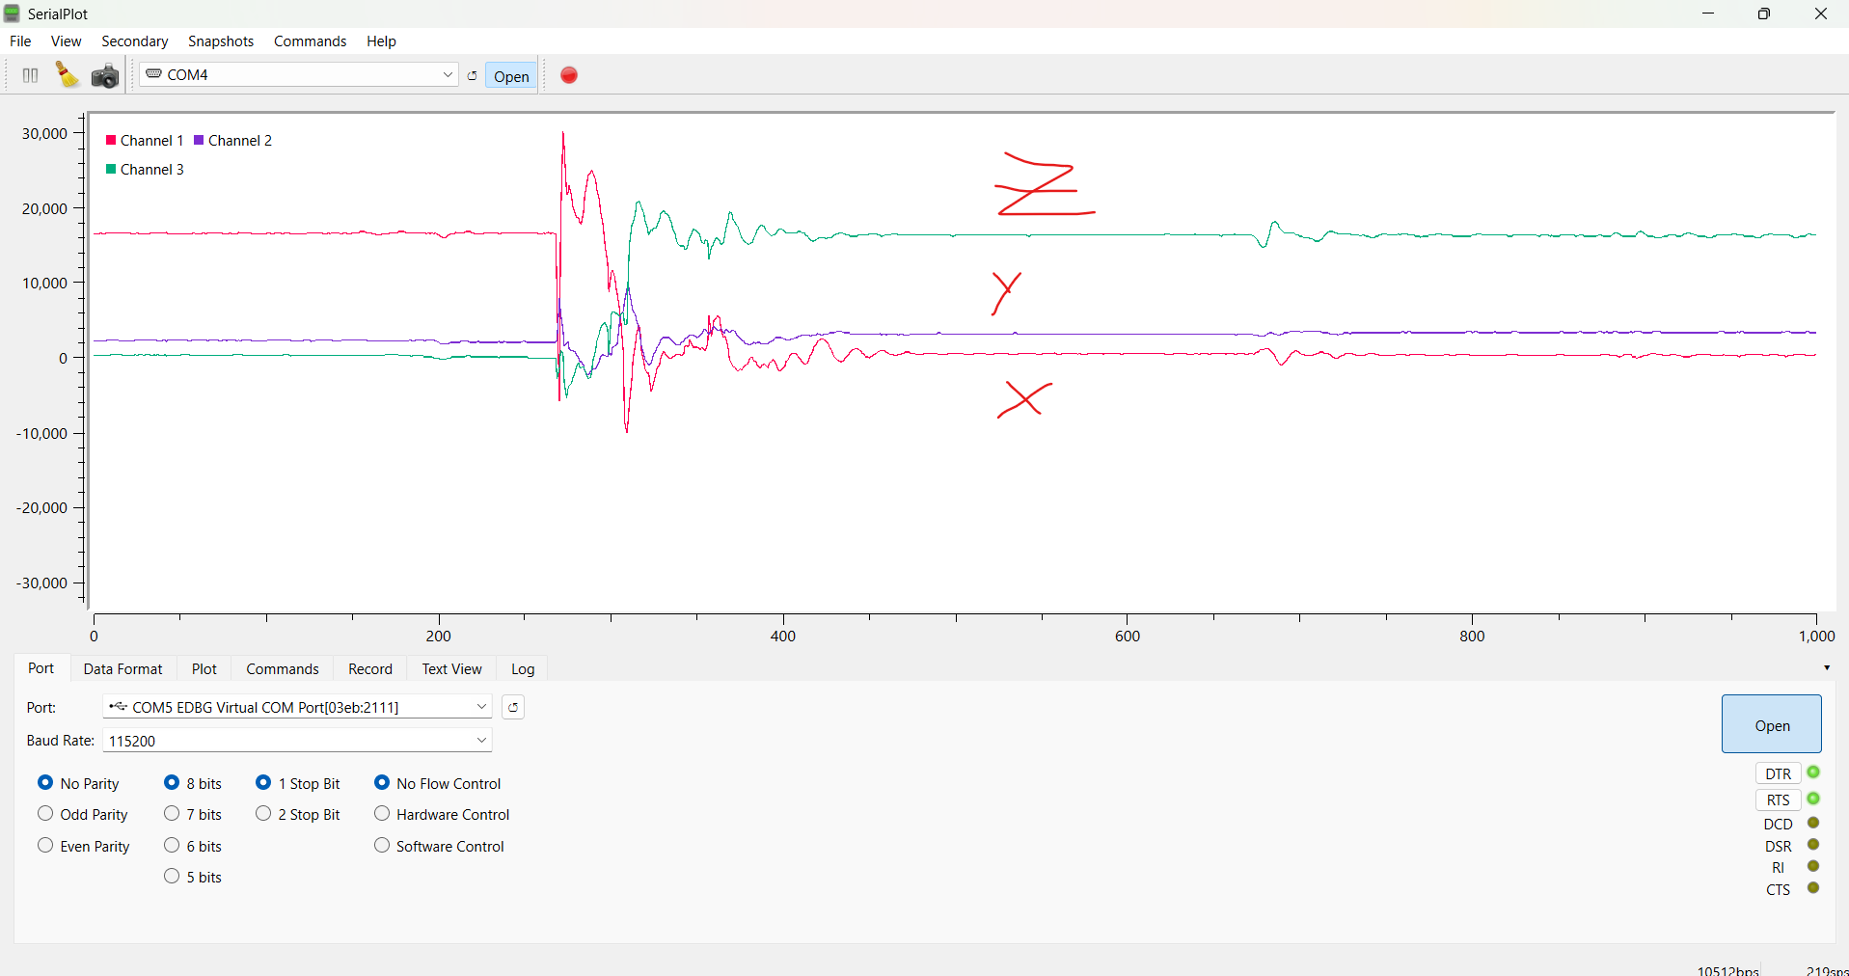
Figure 2: Accelerometer Reading
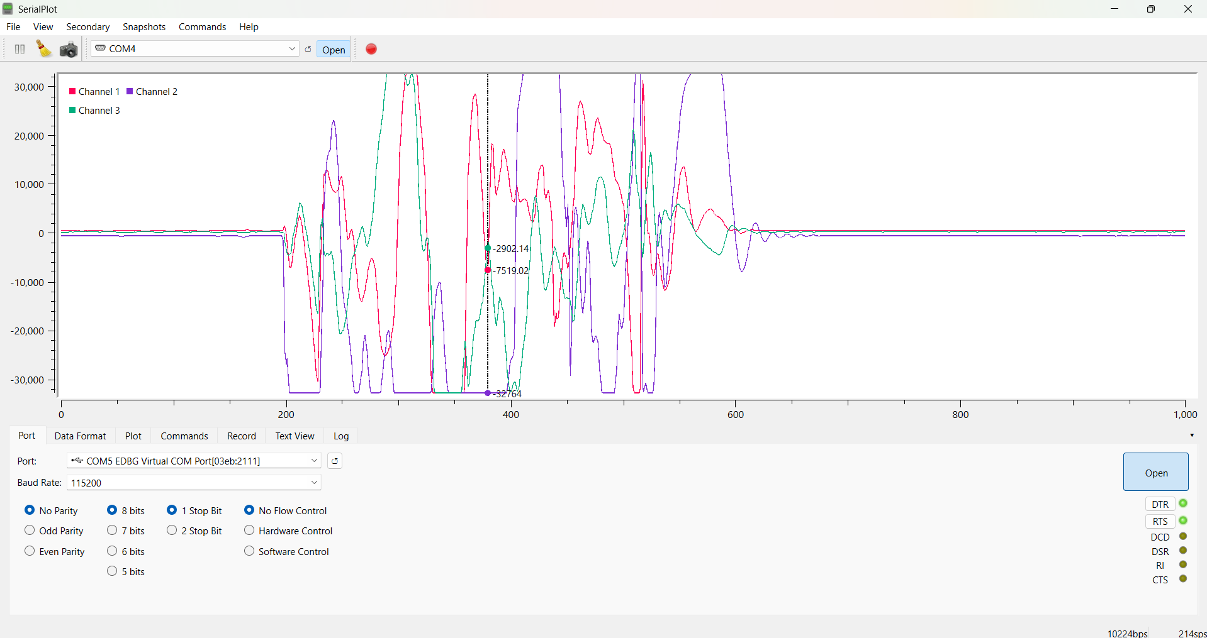
Figure 3: Gyroscope Reading
`
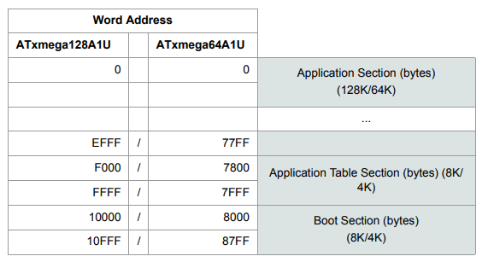
Figure 4: Program Memory Addressing

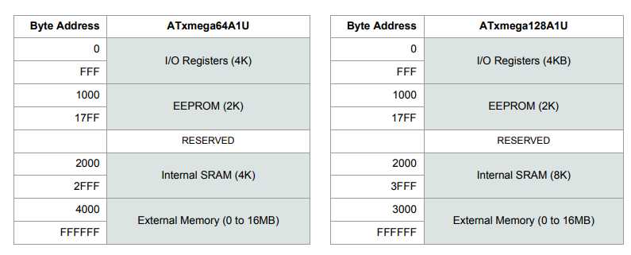
Figure 5: Data Memory Addressing

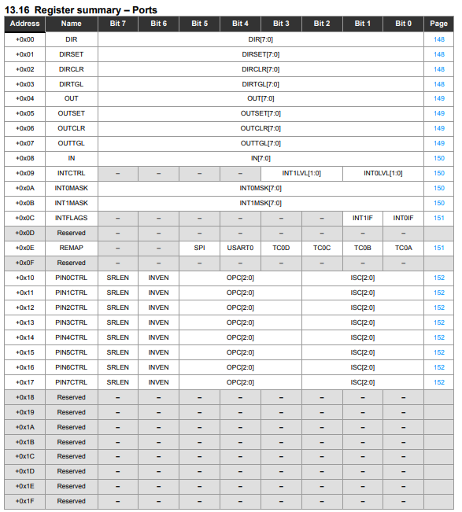
Figure 6: Ports Register Summary
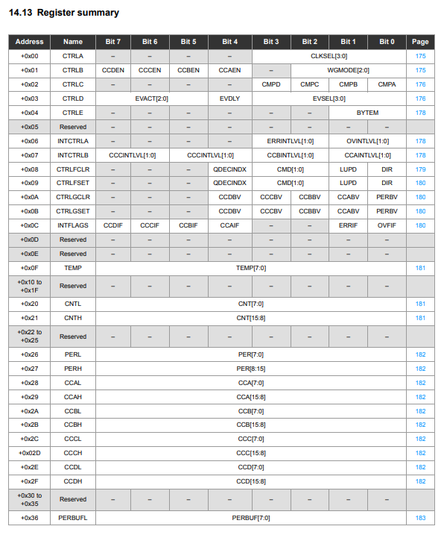
Figure 7: Timer/Counter Register Summary
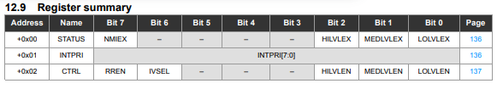
Figure 8: Interrupts Register Summary

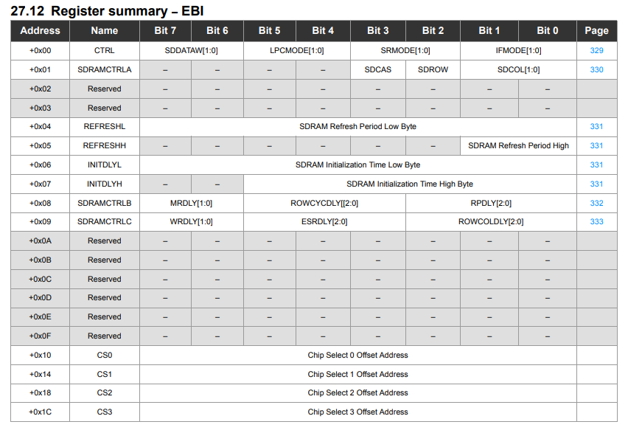
Figure 9: EBI Register Summary
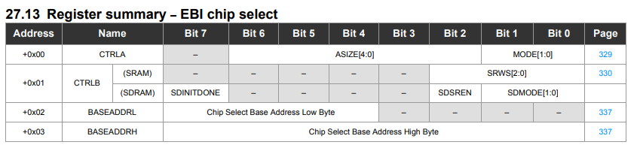
Figure 10: EBI Chip Select Register Summary
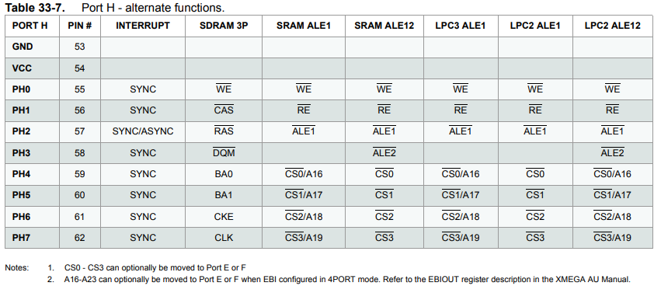
Figure 11: PORTH Alternate Functions
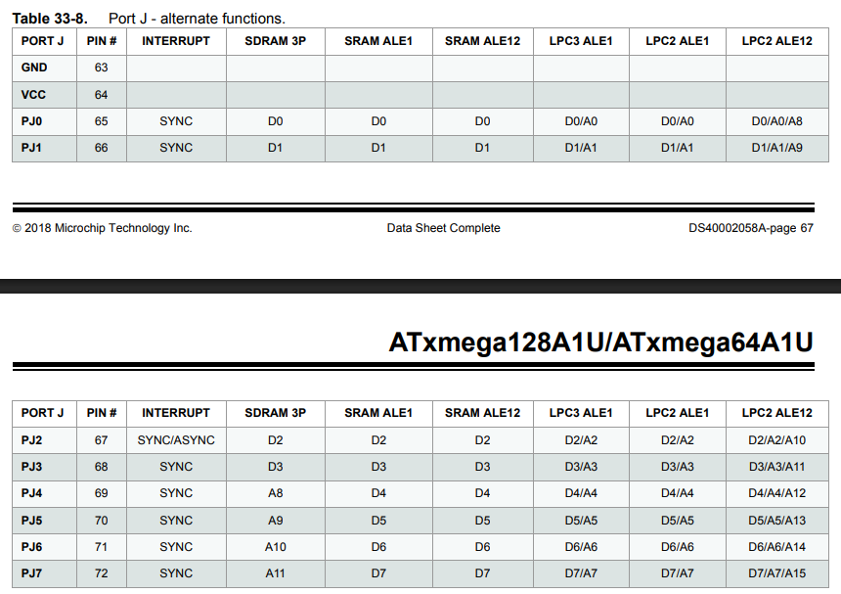
Figure 12: PORTJ Alternate Functions

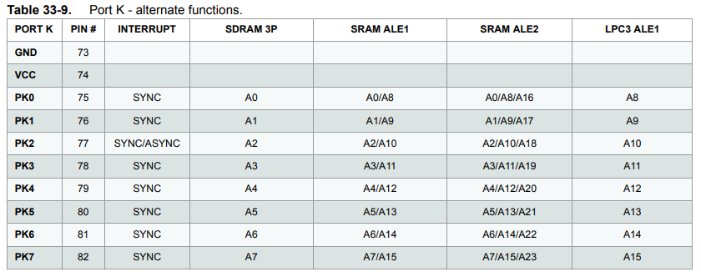
Figure 13: PORTK Alternate Functions
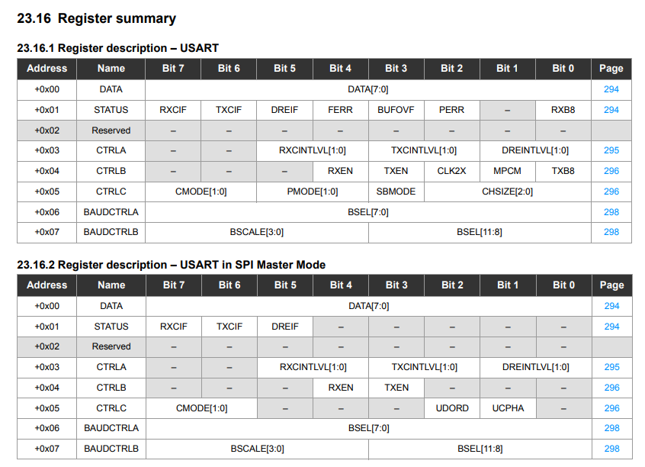
Figure 14: USART Register Summaries
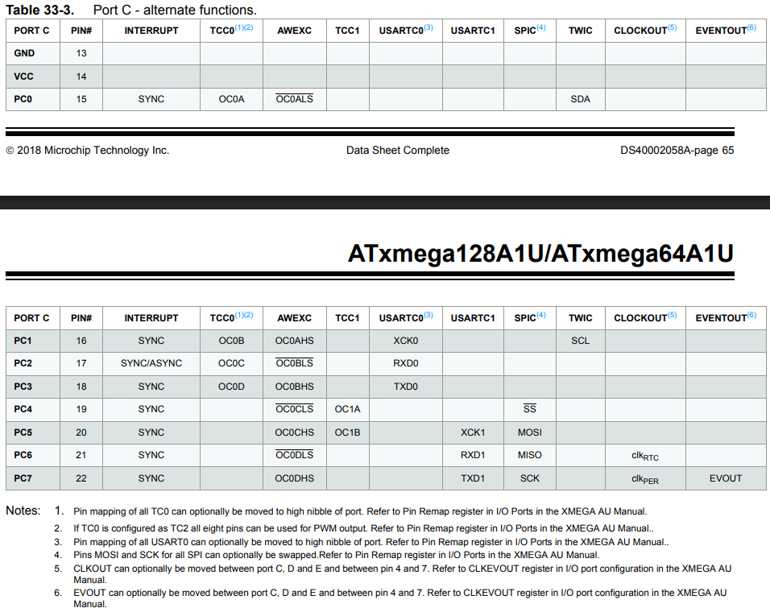
Figure 15: PORTC Alternate Functions
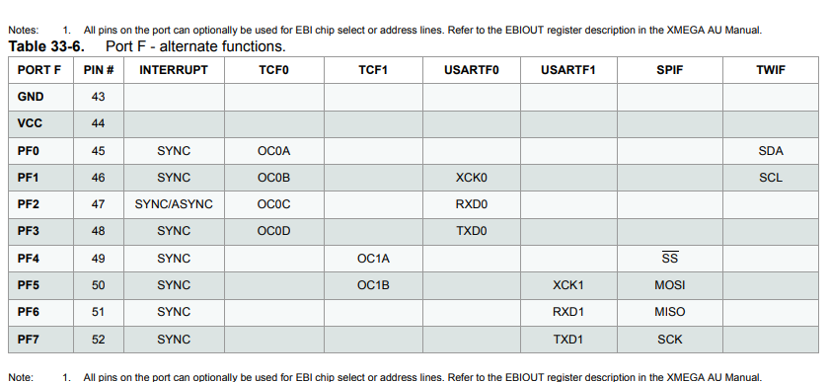
Figure 16: PORTF Alternate Functions
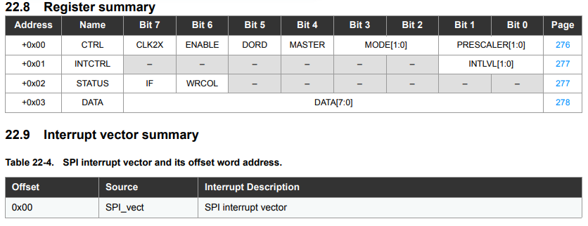
Figure 17: SPI Register Summary
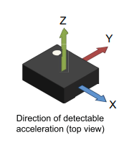
Figure 18: Axis Directions for IMU

