Objectives
- Refresh conceptual knowledge regarding Thevenin/Norton Equivalent Circuits, Current/Voltage Dividers, Input and Output Resistance.
- Demonstrate how to measure such parameters using the DAD board.

Equipment
- Breadboard and various wires
- Various resistors, ranging from 100 to 10k ohms
- Digilent Analog Discovery (DAD) Board
- Digital Multimeter (the DAD works as one if used correctly)
- A copy of LTspice and Waveforms installed on device

Introduction
- Lab Rules and Policies: All rules and policies are subject to change throughout the semester as needed.
  - All lab reports must be submitted as a single PDF file, unless otherwise stated.
  - All figures and tables must include descriptive captions and be properly referenced within the report.
  - Sections that lack required figures, tables, or supporting content will receive no credit for those sections.
  - Report organization must follow the required lab report structure provided in the lab handout.
  - Late submissions will incur a penalty of 10% of the assignment grade for every 24-hour period past the deadline, unless a valid reason for late submission is provided and approved.
  - All submitted files must follow the naming convention below:
LastName_FirstName_Pre/In-Lab##_EEE3308C.pdf
Ex. Dimech_Iain_In-Lab1_EEE3308C.pdf
- Lab Structure/Format: There will be a Pre-Lab and In-Lab portion to every numbered lab for this course.
  - Pre-Lab: The Pre-Lab portion will be done outside of lab as a Homework assignment and be due at your lab start time. (For example, if you have lab starting at 8:10 PM on Wednesday, your Pre-Lab will be due at 8:10 PM that day.)
  - In-Lab: The In-Lab portion will be done in lab using lab equipment, such as the oscilloscope, waveform generator, multimeter, and power supply. Bring all equipment to the lab, such as your breadboard, DAD, wires, and all other electrical devices (resistors, capacitors, lab kit, etc.).

- Impedance vs. Resistance:
  - Resistance is a measure of opposition to the flow of current in an electrical circuit, measured in ohms $(Ω)$
  - Impedance is the frequency-dependent generalization of resistance. These are usually represented by complex numbers. In Circuits 1, we saw these impedances when working with frequency-dependent power sources in conjunction with capacitors and inductors. For example, consider a series RLC circuit with a sine-varying voltage source:
    - For any given angular frequency, $ω$, of the power source, the impedance of the resistor, capacitor, and inductor, denoted as X, is the following:
$$X_{R}=R, { X}_{C}=\frac{1}{ωC}, { X}_{L}=ωL$$
    - At resonance, the impedances for the capacitor and inductor are equivalent and cancel out. This happens when the angular frequency is:
$$ω=\frac{1}{\sqrt{LC}}$$
- Precision and Accuracy: If a measurement can be repeated several times with results that are consistently close to each other, we can say that this measure is precise. If a measurement is close to the “actual” or “accepted” value, then that measurement is accurate.

- Linearity: In electronics, the properties of a circuit typically change as the voltages and currents vary. Assuming the variations are smooth, we can treat those properties as constant if we keep the voltage and current variations small enough. If the circuit element values are independent of voltage and current variations, we can consider the circuit to be linear, so that we can apply circuit theorems such as superposition and Thevenin’s and Norton’s Theorems.

Pre-Lab
Part 1: Thevenin and Norton Equivalents. (20 points)
Thevenin and Norton sources are single-port models that represent the effect of connecting an arbitrary load resistance to a single source. Essentially, a Thevenin equivalent circuit is a voltage source connected in series to a single resistor. This resistor is the equivalent of all resistance (or impedance) in the entire circuit. Norton equivalent sources are current sources connected in parallel to a single resistor. This section will explore the characteristics of a network by its Thevenin and Norton Equivalents.
- Determine the Thevenin and Norton equivalents of the network shown in Figure 1 as viewed at its port. Provide the Thevenin/Norton resistance in terms of R₁, R₂, & R₃. (10 Points)

R_{TH} = 1054.61 ohm

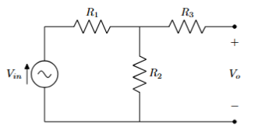
Figure 1 – Source-resistor network.

- Evaluate the Thevenin and Norton equivalents of the network for the following values:
V = 5 V; R₁ = 56 Ω; R₂ = 2.2 kΩ; R₃ = 1 kΩ. Provide the Thevenin voltage (V_{th}) and Norton Current (I_{N}). (5 Points)
V_{TH} = 4.875V I_{N} = 4.623mA

- Build this circuit in LTspice and confirm your results in simulation (i.e. that your Thevenin/Norton circuits function the same for a given load R_{L}). Include images of the circuit and simulation results. (5 Points)
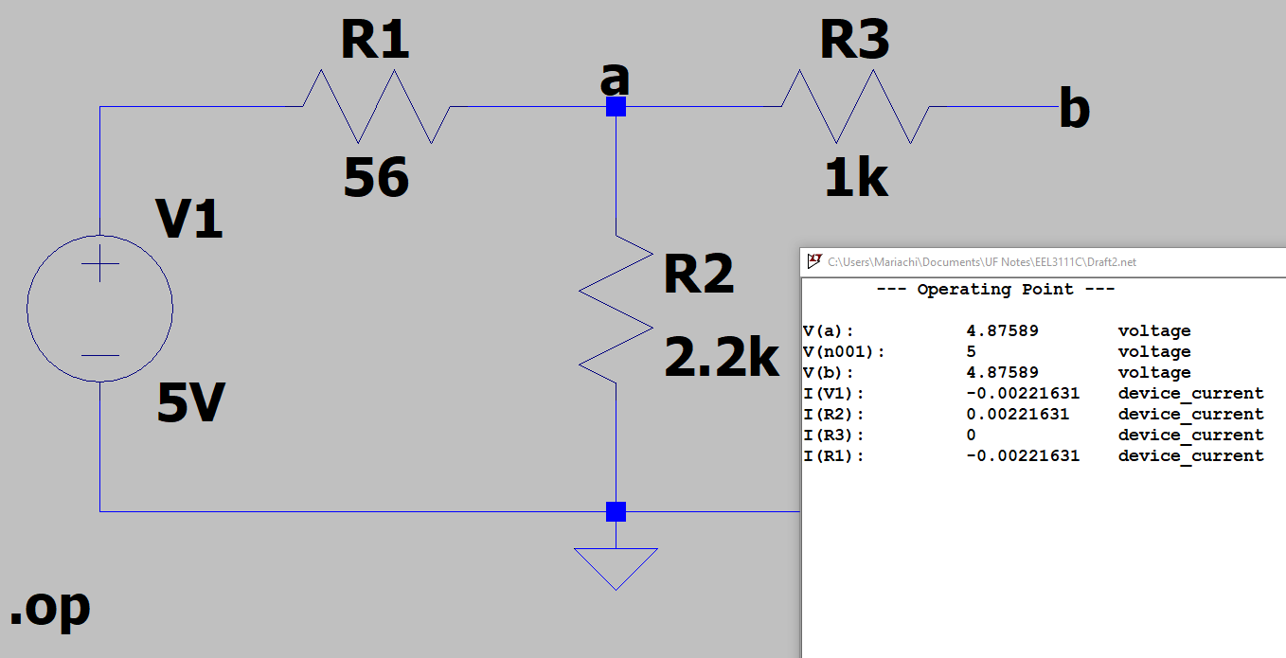

Part 2: Thevenin Equivalent of a Waveform Generator. (20 points)
All circuits have internal resistance, which we call input impedance if they are something which uses power (like a voltmeter) and output impedance if they provide power. The output impedance of the function generator is much less than the input impedance of the scope, so for this section we can assume the internal resistance of the scope is infinite and has no effect on our circuit. In this activity, you will determine the Thevenin equivalent circuit values (V_{th} and R_{th}) for the Waveform Generator on your DAD by performing measurements and some calculations.
- Set the waveform generator to produce a sine wave with a frequency of approximately 400 Hz and an amplitude of approximately 5 volts. There should be no load connected to the waveform generator output for this initial set-up. *Do not ground/short the input pin, you should only have the waveform pin and the scope pin on the same node. Grounding the waveform pin will short the output and may damage the DAD. Accurately measure and record the function generator output voltage: V_{NL}. (5 Points) *Note: Use at least 5 significant digits in your measurements/calculations.
V_{NL} = 4.9923V = V_{Th}
- Connect a 100 Ω resistor across the waveform generator output; accurately measure and record the voltage across the 100 Ω resistor, V_{L}. (5 Points)
V_{L} = 4.7848V
- Using your two recorded voltage values and assuming the load resistor is exactly 100 Ω, calculate the Thevenin equivalent resistance of the waveform generator output. (5 Points)
$$R_{th}=\frac{{(V}_{NL}-V_{L})×R_{L}}{V_{L}}$$
where V_{NL} = V_{O} with no load and V_{L} = V_{O} with a 100 Ω load.

R_{th} = [(4.9923 – 4.7848) * 100]/4.7848 = 4.33665 Ohm

- Using your values for V_{th} and R_{th}, draw the Thevenin and Norton equivalent circuits for the waveform generator output showing values for V_{th}, I_{N}, and R_{th} based on your measurements and calculations. (5 Points) *Note: V_{th} = V_{NL}

Part 3: Maximum Power Transfer. (20 points)
Maximum power is transferred to a load resistor (R_{L}) when the value of the load resistor is selected to match the value of the Thevenin resistance (R_{th}) of the power source. Figure 2 demonstrates this for a value of R_{th} of 10 Ω.
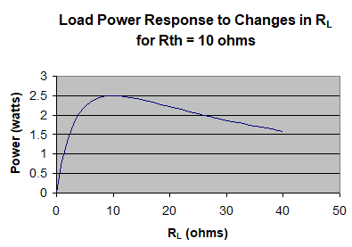
Figure 2 – Load Power Response of a Load Resistor in a Thevenin Circuit.
Suppose you were designing a circuit to deliver power to a 10 Ω load resistor. What would be the value of the Thevenin equivalent resistance, sometimes called the “output” or “source” resistance, that would deliver the most power to the load? Figure 3 indicates that the lower the value of R_{th} the better.
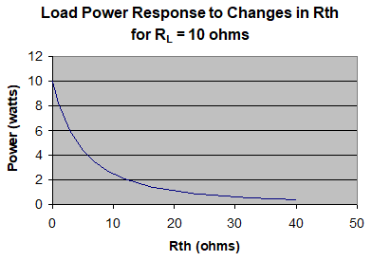
Figure 3 – Load Power Response of R_{th} in a Thevenin Circuit.
A Thevenin resistance of zero would be ideal, and in that case, the power delivered to the load would be highest for every load resistor you could pick. However, only an ideal voltage source has zero Thevenin resistance; all real circuits have a Thevenin resistance greater than zero. But once a circuit has been designed, and the value of R_{th} set, the maximum power for that R_{th}, will be delivered to the circuit’s load when the load resistance equals the R_{th} value.
- With reference to the same function generator set-up used in Part 2, obtain 3 different resistor values that each demonstrate a different aspect of the graph in figure 3. Hint – Reference the curve in figure 2 to understand the properties you are trying to emulate with your resistor values. Note that you already measured V_{th} with a R_{L} = 100 Ω and above; so just enter your previous Output Voltage value from part 2 in the table for all values of V_{th}. Calculate the power delivered to the load for each of the test conditions (R_{L}) and enter them into Table 1. (15 Points)
*Note: $P_{L}=\frac{V_{th}^{2}R_{L}}{{{(R}_{L}+R_{th})}^{2}}$

R_{L} (Ω) | V_{th} (V) | Power_{Load} (W)
42.1875 | 4.9923 | 0.050
50 | 4.9923 | 0.062
100 | 4.9923 | 0.188
Table 1: Power Transfer Measurements
Still waiting on resistors/capacitors kit, could not go lower
- Discuss how your measurement results compare to the concept of Maximum Power Transfer. (5 Points)
Accurately follows that as we put R_{L} as a value much lower than R_{th} that we get closer to 0 W delivered.

Part 4: Circuit Under Test; Input & Output Resistances. (20 points)
In the absence of an input signal, the Thevenin-equivalent voltage source of a circuit has zero magnitude and may therefore be replaced by a short circuit. Similarly, the Norton-equivalent current source has zero magnitude and may be replaced by an open circuit. Under these zero-input conditions, the Thevenin-equivalent model reduces to the Thevenin-equivalent resistance, which represents the resistance seen when looking into the output port. The output resistance, $R_{\text{out}}$, characterizes the dependence of the output voltage on the connected load impedance.
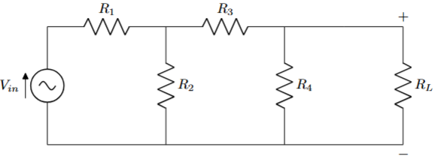
Figure 4 – Part 2 Circuit for Input/Output Resistance Testing
- For the following circuit, find a formula to obtain the input and output resistances (R_{in} and R_{out}) across the voltage source (V_{in}) and load resistor (R_{L}) respectively. (3 Points)
R_{in} = R₁+(R₂||(R₃+R₄))
R_{out} = R₄||(R₃+(R₂||R₁))

- With the following values, construct the circuit on your breadboard:
V_{in} = 1 V; R₁ = 1 kΩ; R₂ = 2.2 kΩ; R₃ = 3.3 kΩ; R₄ = 4.7 kΩ.
*Be sure to include pictures of this circuit built on your breadboard. (3 Points)

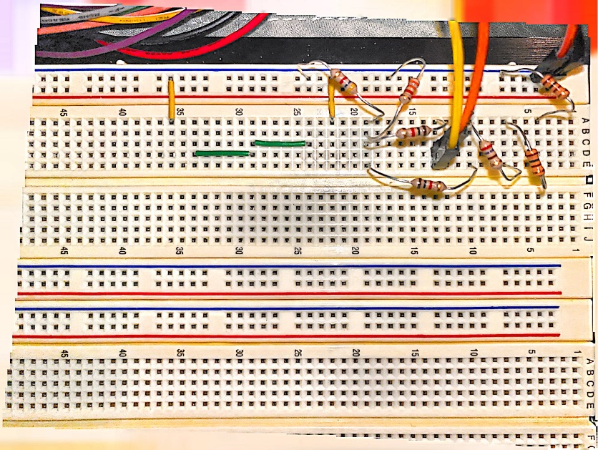
Figure 1: Picture of Breadboard Circuit
Had to use multiple resistors to make 2.2k til I get my resistor kit.

- Given the following values, calculate the expected values of R_{in} and R_{out}. (2 Points)

R_{in} = 2.73k, R_{out} = 2.15k

- Insert a variable resistor R_{s} in series with the source and adjust R_{s} until the voltage at the input node is 0.5 V. Record the value of R_{s}. Measure the open-circuit output voltage (V_{OC}) across R_{L}. (5 Points) R_{s} = 2705 ohm, V_{oc} = 0.4856V

- Insert a resistor at R_{L} and adjust it until the output voltage drops V_{OC}/2. Record the value. (3 Points)
2.2k

- Measure the output voltage across R_{L} for R_{L} = 470 Ω, 1 kΩ, 10 kΩ, $∞$ Ω. Plot V_{O} vs R_{L}. (4 Points)
470ohm -> 61.378mV
1k ohm -> 113.92mV
10k ohm -> 299.63mV
Infinity ohm -> V_{oc} = 0.4856V
