REQUIREMENTS NOT MET
N/A
PROBLEMS ENCOUNTERED
N/A

HOMEWORK EXERCISES
Question 1: Solve the following equations with any real 1 to 3-input logic gate, and any activation level:
- V = A* [/(B*/C) + C*D]
- W = A*B*/C + /(A*B*C)
- U = /(A*B + /C)
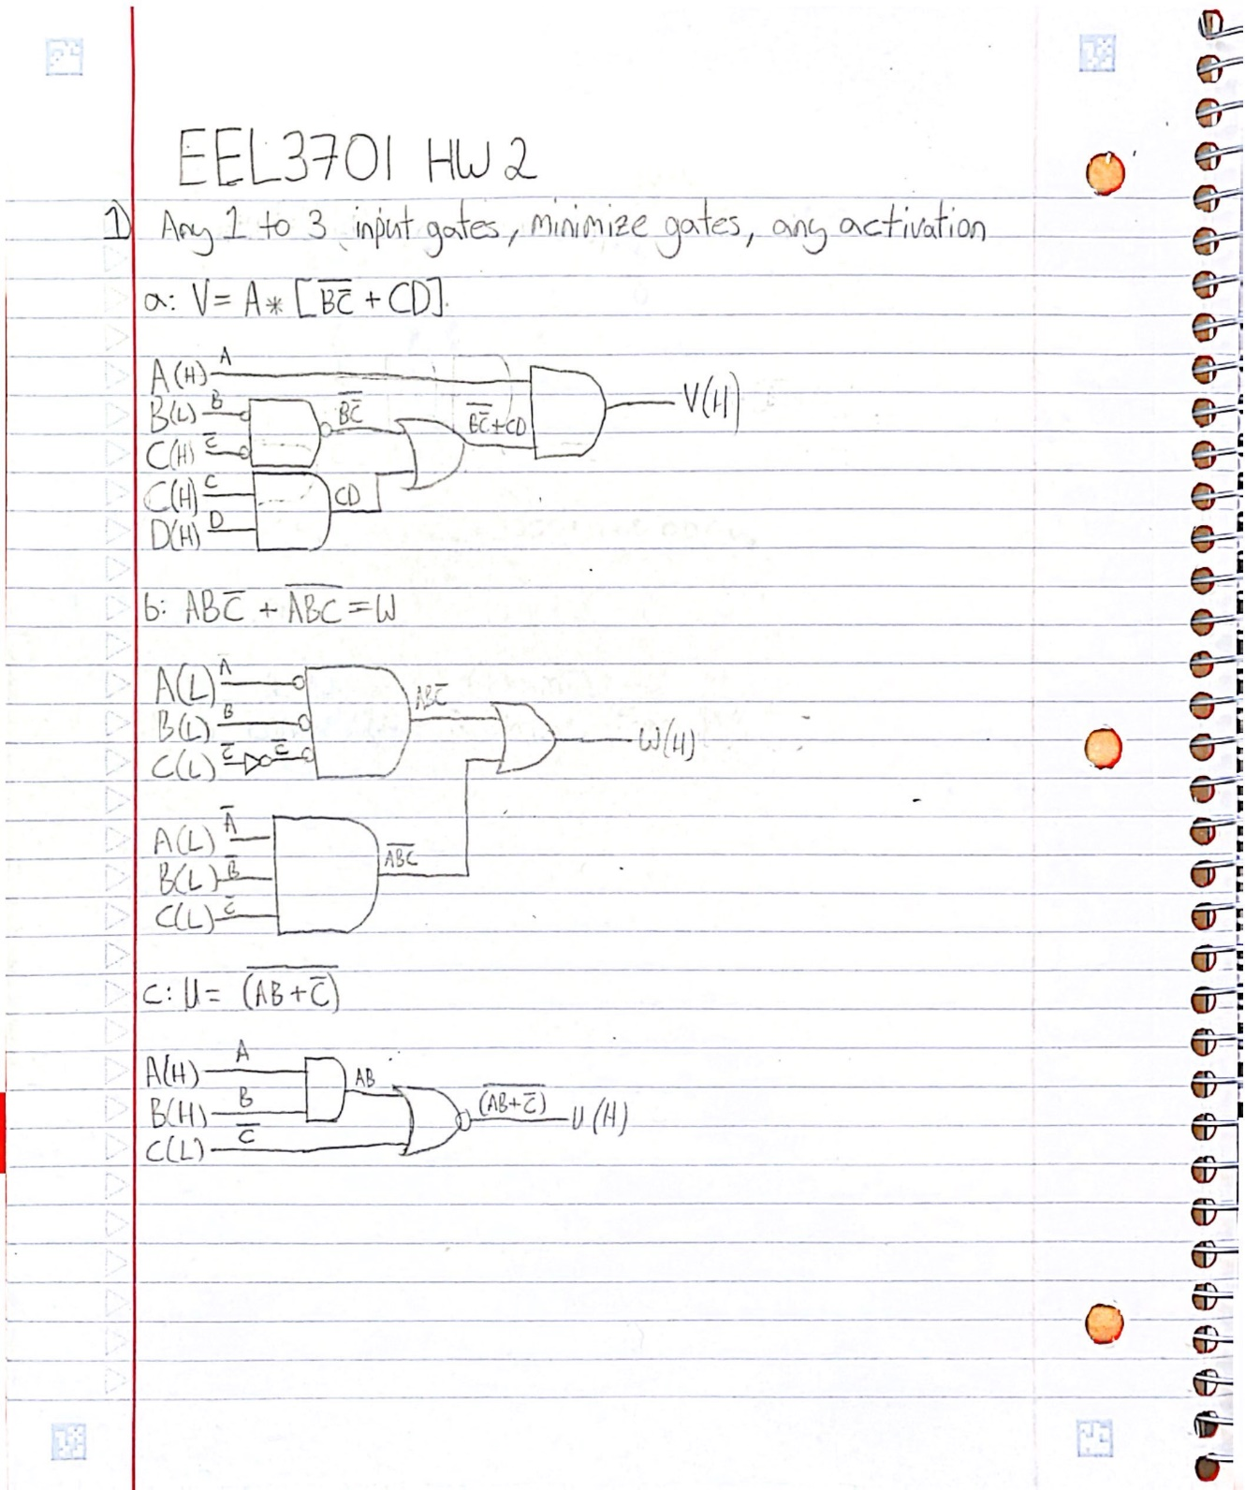
Figure 1: Solutions for 1a through 1c.
Question 2: Solve the following equations with any activation real 1 to 3-input logic gate, with inputs as active high and outputs as active low:
- V = A* [/(B*/C) + C*D]
- W = A*B*/C + /(A*B*C)
- U = /(A*B + /C)
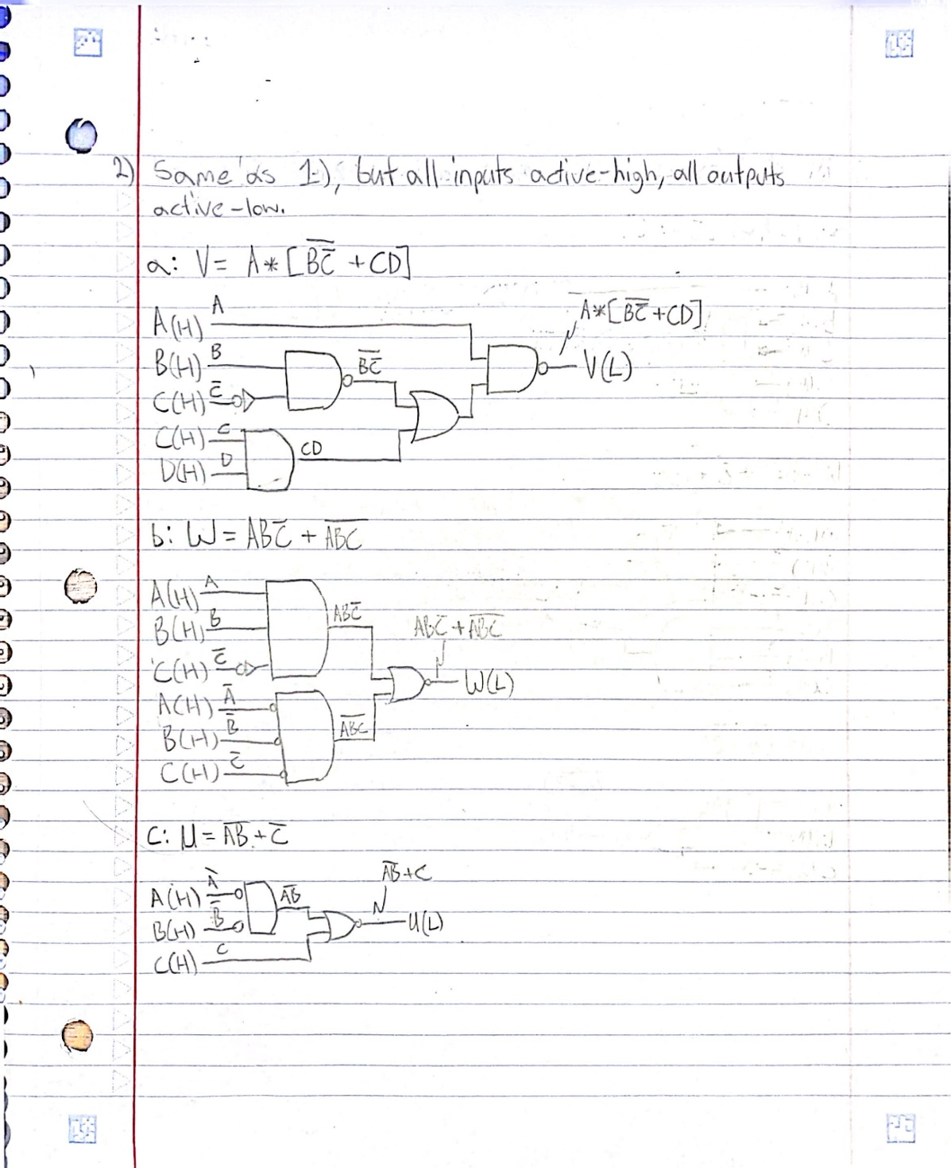
Figure 2: Solutions for 2a through 2c.

Question 3: Solve the following equations with only AND, OR, Level Shifter gates or equivalent, assume all inputs and outputs are active high:
- V = A* [/(B*/C) + C*D]
- W = A*B*/C + /(A*B*C)
- U = /(A*B + /C)
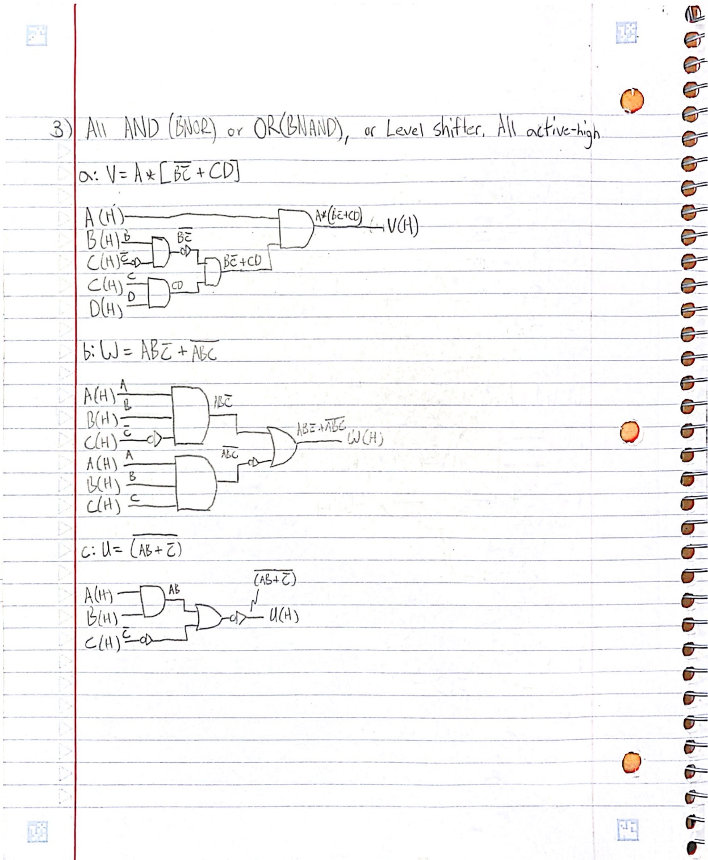
Figure 3: Solutions for 3a through 3c.

Question 4: Design the following logic by direct implementation using only NAND gates or equivalent.
- X = A*/B + A*C for A(H), B(H), C(H), X(H)
- X = A*/B + A*C for A(L), B(L), C(H), X(L)
- X = A*/B + A*C for A(L), B(L), C(L), X(L)
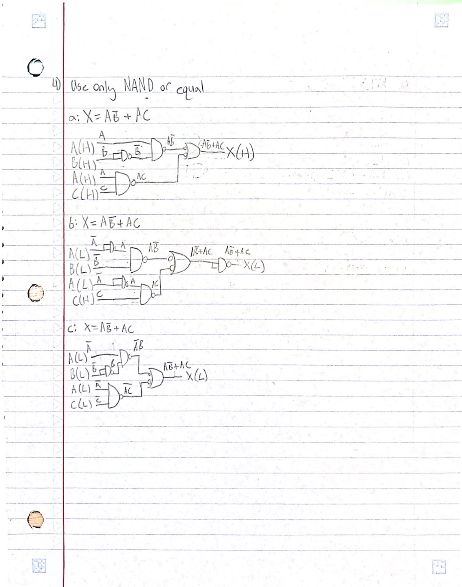
Figure 4: Solutions for 4a through 4c.

Question 5: Create new logic diagrams for problems 1c & 4c, optimizing the number of gates & chips. Label gates and part numbers. Use unused gates on the same chips from one part for the other.
Use activation levels: A(L), B(H), C(H), choose output activation levels.

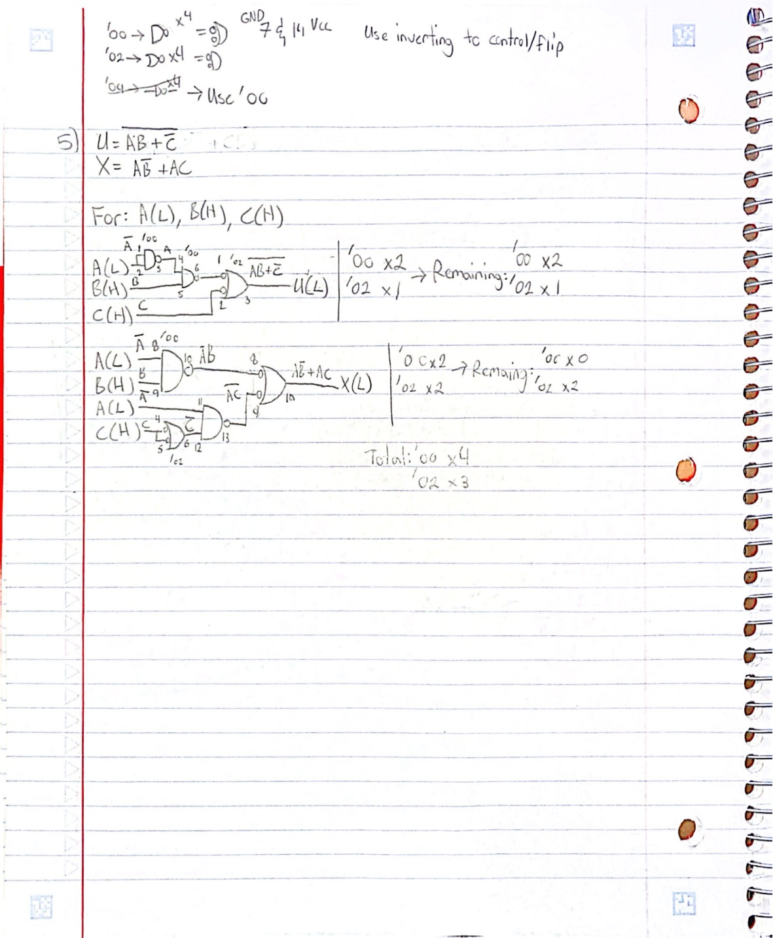
Figure 5: Solution for 5.

