clc; clear; close all;
Butterworth Filter Calculations
% 1) Transfer Function (From Exam 3 Cheat-Sheets)
% H(s) = Kwc^3 // (s+wc)(s^2 + s + wc^2)
% for wc = 2*pi*2000
%
% = 100*wc^3 // (s^3 + 2*wc*s^2 + (2*wc^2)s + wc^3)
% 2) Plots
% Had to ask for help programming the symbolic section & group delay of this part:
% "How do I use an algebraic transfer function's frequency response in
MATLAB?"
% "How do I plot group delay in MATLAB & show it's corner frequency's response?"
s = tf('s'); wc = 2*pi*2000; H = 100*wc^3/(s^3 + 2*wc*s^2 + 2*wc^2*s + wc^3);
f = logspace(1,5,600); w = 2*pi*f;
[mag, phase] = bode(H,w); mag = squeeze(mag); phase = squeeze(phase); % Magnitude
figure(1); subplot(4,1,1) semilogx(f,20*log10(mag)); hold on; plot(2000,37,'ro'); grid on; title('3rd-Order Butterworth Low-pass Filter Magnitude'); xlabel('Frequency (Hz)'); ylabel('Magnitude (dB)');
% Phase
subplot(4,1,2) semilogx(f, phase); hold on; plot(2000, -135, 'ro') grid on;
title('3rd-Order Butterworth Low-pass Filter Phase');

1
xlabel('Frequency (Hz)'); ylabel('Phase (degrees)');
% Group Delay subplot(4,1,3)
gd = -gradient(unwrap(phase*pi/180),w); semilogx(f,gd); hold on; plot(2000,interp1(f,gd,2000),'ro'); grid on; title('3rd-Order Butterworth Low-pass Filter Group Delay'); xlabel('Frequency (Hz)'); ylabel('Group Delay(s)');
subplot(4,1,4); step(H); grid on; title('3rd-Order Butterworth Low-pass Filter Step Response'); xlabel('Time'); ylabel('Amplitude');
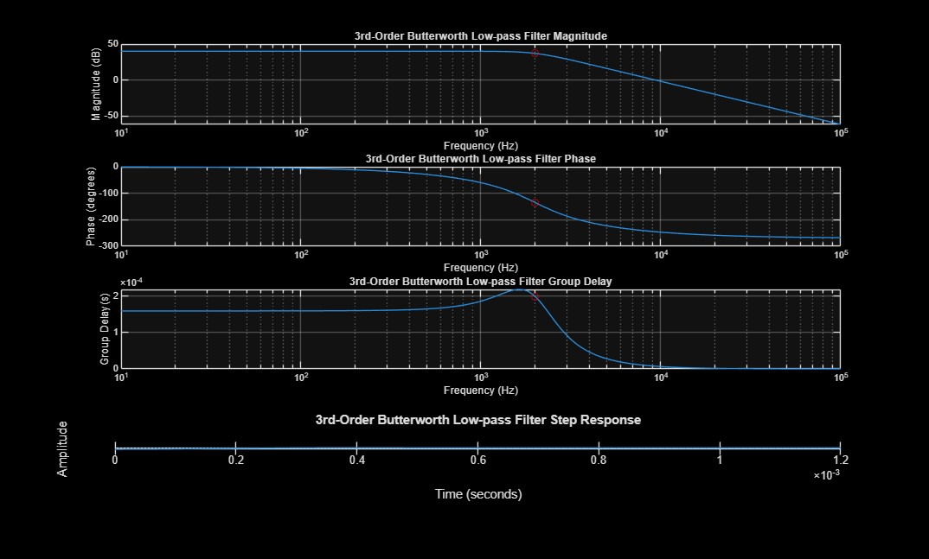
Published with MATLAB® R2025a

2



