REQUIREMENTS NOT MET
- Section III: Simulating – Part E7, as explained below in ‘Problems Encountered’ Part 2.
PROBLEMS ENCOUNTERED
- I encountered issues with the Quartus Waveform simulation license. I had thought to start on HW1 before our first lab and did not see the Quartus Installation Instructions and installed Quartus from the website without knowing about the ModelSim portion. Fixed by following instruction.
- Section III: Simulating – Part E7, I had set the board to be the MAX DE10 Lite and could not do a full compilation. The document says that Professor Schwartz was unable to do this section as well.
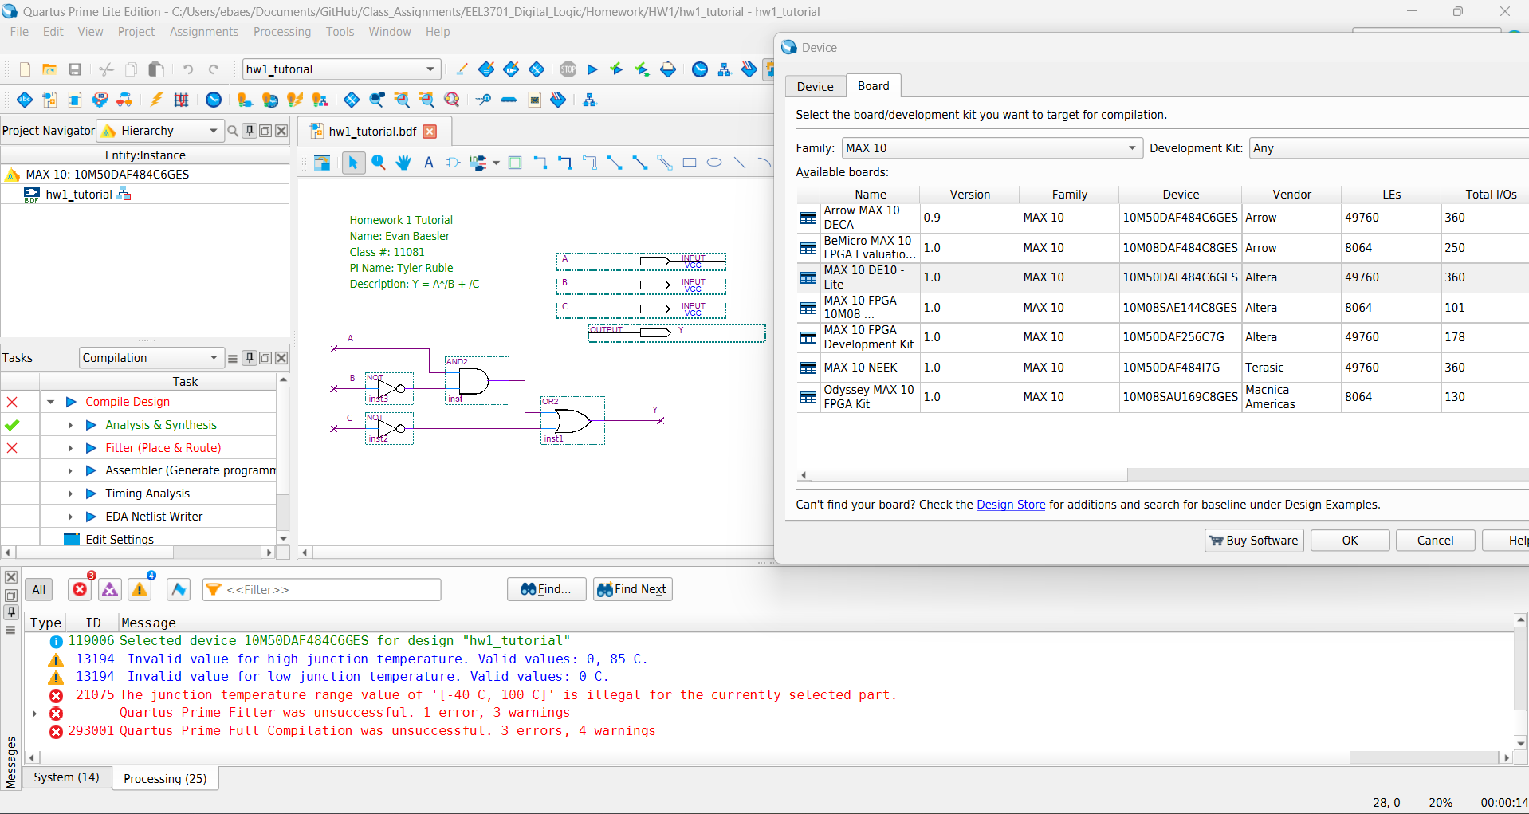
Figure 1: Section III - Simulation Part E7 Error

HOMEWORK EXERCISES

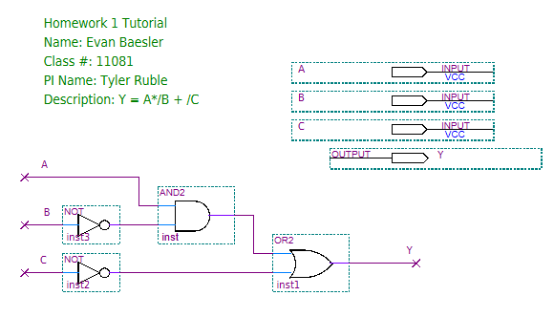
Figure 2: Section II: Design - Part E7: Quartus Circuit Design
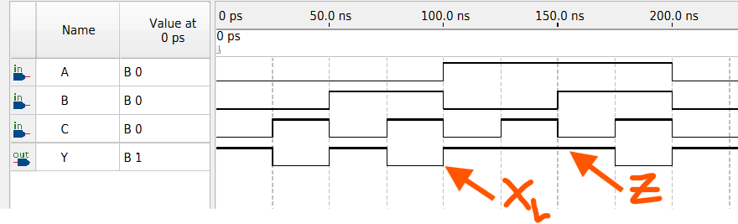
Figure 3: Section III: Simulating - Part E0: Functional Simulation
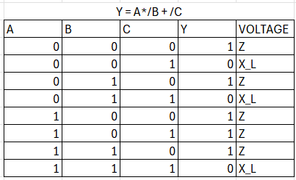
Figure 4: Section III: Simulating – Part E2: Truth/Voltage Table

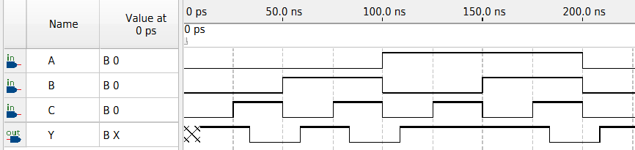
Figure 5: Section III: Simulating Part E3: Timing Simulation
Error with Section III: Simulating Part E7 mentioned in ‘Problems Encountered’.
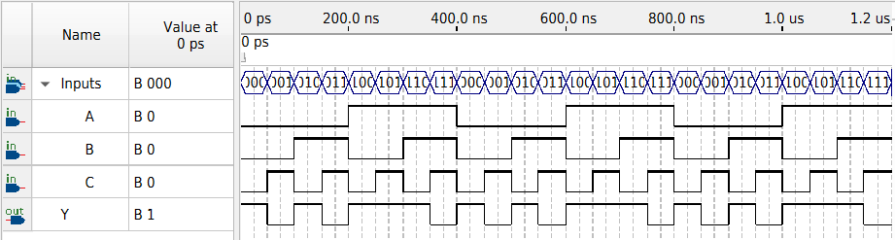
Figure 6: Section III: Simulating Part F6: Grouping Functional Simulation
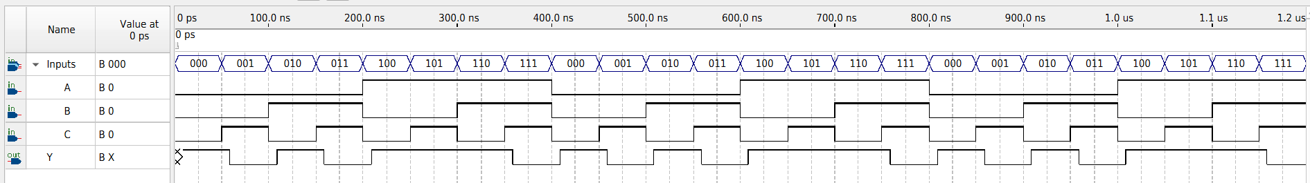
Figure 7: Section III: Simulating Part F6: Grouping Timing Simulation

