Objectives
- Learn how to use lab equipment and its various menu buttons and features
- Demonstrate how to measure various parameters using the equipment in lab

Equipment
- Breadboard and various wires
- Various resistors, ranging from 100 to 10k ohms
- In-Lab Equipment (Oscilloscope, Function Generator, Digital Multimeter, Power Supply)

Introduction
- Lab Structure/Format: There will be a Pre-Lab and In-Lab portion to every numbered lab for this course.
  - Pre-Lab: The Pre-Lab portion will be done outside of lab as a Homework assignment and be due at your lab’s start time. (For example, if you have lab starting at 8:10 PM on Wednesday, your Pre-Lab will be due at 8:10 PM that day.)
  - In-Lab: The In-Lab portion will be done in lab using lab equipment, such as the oscilloscope, waveform generator, multimeter, and power supply. Ideally, we will not be using the DAD board in lab to gain experience with using equipment that is more used in industry, but always bring your DAD regardless. Bring all else to the lab, such as your breadboard, wires, and all other electrical devices (resistors, capacitors, lab kit, etc.). The In-Lab will be due by the start of your next lab. (For example, if you have an in-lab you completed on Wednesday the 7th, you must submit your in-lab document by the start of your next lab the week after, i.e. Wednesday the 14th by the start of the in-lab.)

- Oscilloscope
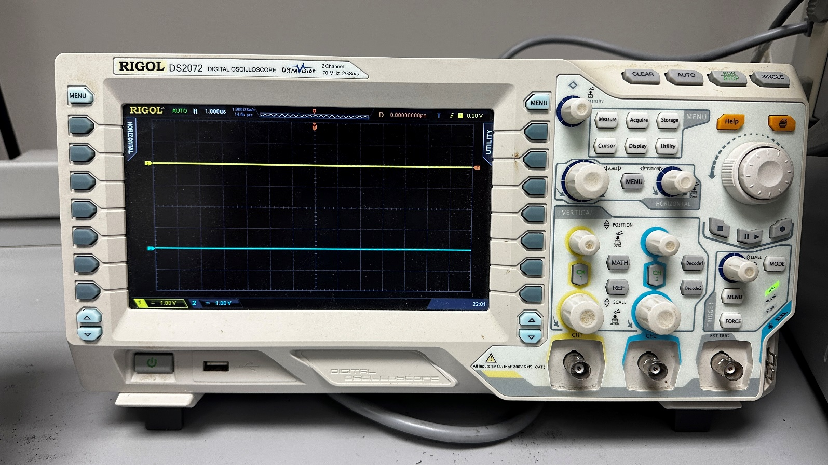

Vertical Controls, Coax Input, and Menu Buttons: The top row of knobs sets the vertical offset of either Channel waveform. Press the “CH1” and “CH2” buttons to select the channels for measurements or to disable the waveform. The larger knobs set the vertical scale of either waveform (i.e. how many volts/division on the graph). The coax inputs can be connected to a BNC cable with grabbers on the other side for input into a protoboard.
Horizontal Controls: The larger knob on the left can be used to set the horizontal scale for waveforms (how many seconds/division on the graph). The menu button can be used to navigate an onscreen time-adjusting menu. The smaller knob on the right sets the horizontal offset for waveforms.
Trigger Controls: The trigger level knob sets the vertical value for a trigger threshold. The menu and mode buttons are used to navigate onscreen menus and change trigger settings (i.e. rising edge, falling edge, etc.).
Wave Property Measurements: Press the menu button to cycle between horizontal and vertical measurement options for your waveforms. Use the buttons below to select which measurements you’d like to display on the bottom of the screen.
Additional Menu Buttons: Can be used to capture additional measurements. Use the cursor button and knob to measure onscreen values between two points.
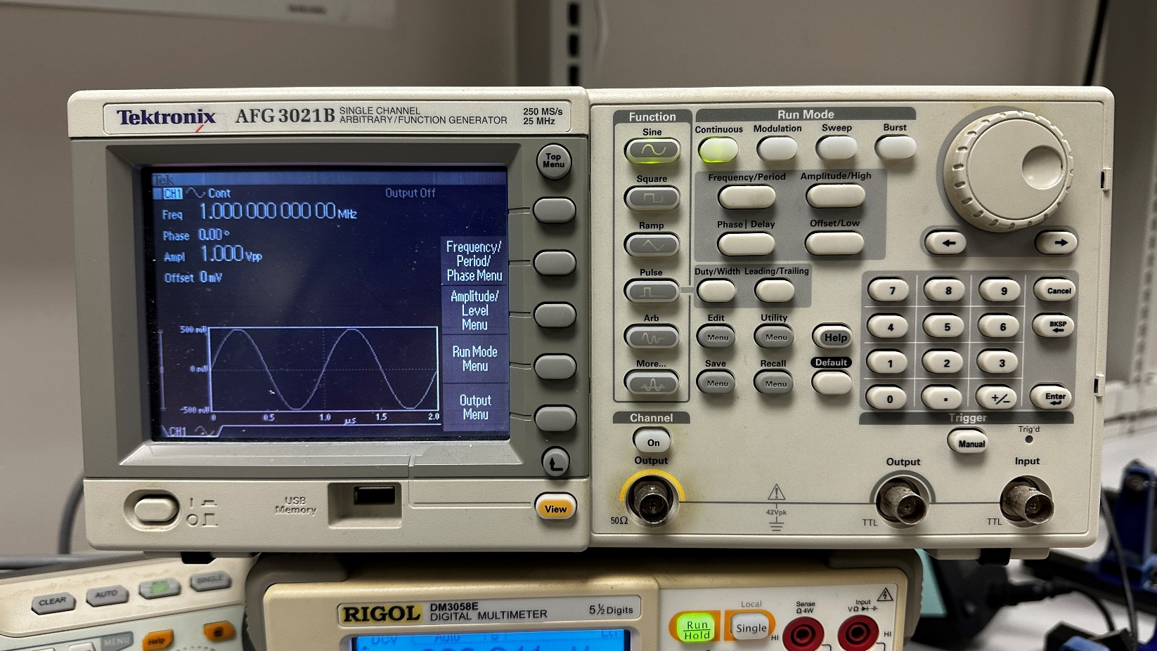
- Function Generator

Note: This function generator might be different than the one in the E-Circuits Lab, but it has the exact same menu buttons.
Wave Selections: Use these buttons to select a wave shape.
Output Into Breadboard: Connect an output coax (BNC) here, use the “On” button to turn on the function generator’s output.
Waveform Properties: Use these buttons to change the amplitude, frequency, phase, and offset of your generated function.
Adjustment Knob: Use this knob to adjust the waveform properties when prompted on the screen. Use the buttons to change which number you’d like to change in a specified property.
Additional Options: To navigate onscreen menus using these buttons.
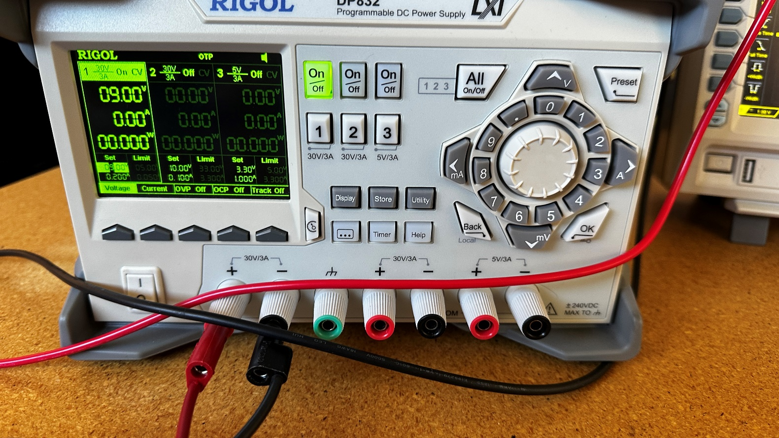
- Power Supply

Output Terminals: Use wires with banana leads to plug into these output ports. There are three red and black pairs, the left two being used to supply 30 V, and the rightmost being used to supply 5V. The red is for power into the breadboard, and the black is for common ground. The green is for true ground (which is almost never needed, especially not in E-Circuits)
Output Controls: Use the On/Off buttons to turn on or off each of the three supplies. Use the numbers to select between which power supply you’d like to adjust.
Voltage and Current Adjustment: Use the knob and numbered buttons to adjust your needed voltage and current level.
Additional Buttons: Use these to switch between current and voltage, as well as the set the needed voltage/current level or setting a limit for the power supply.
Note: Especially dealing with integrated chips and smaller resistors, it is extremely important to make sure that you set an appropriate limit in your power supply to prevent short circuits or heat damage!
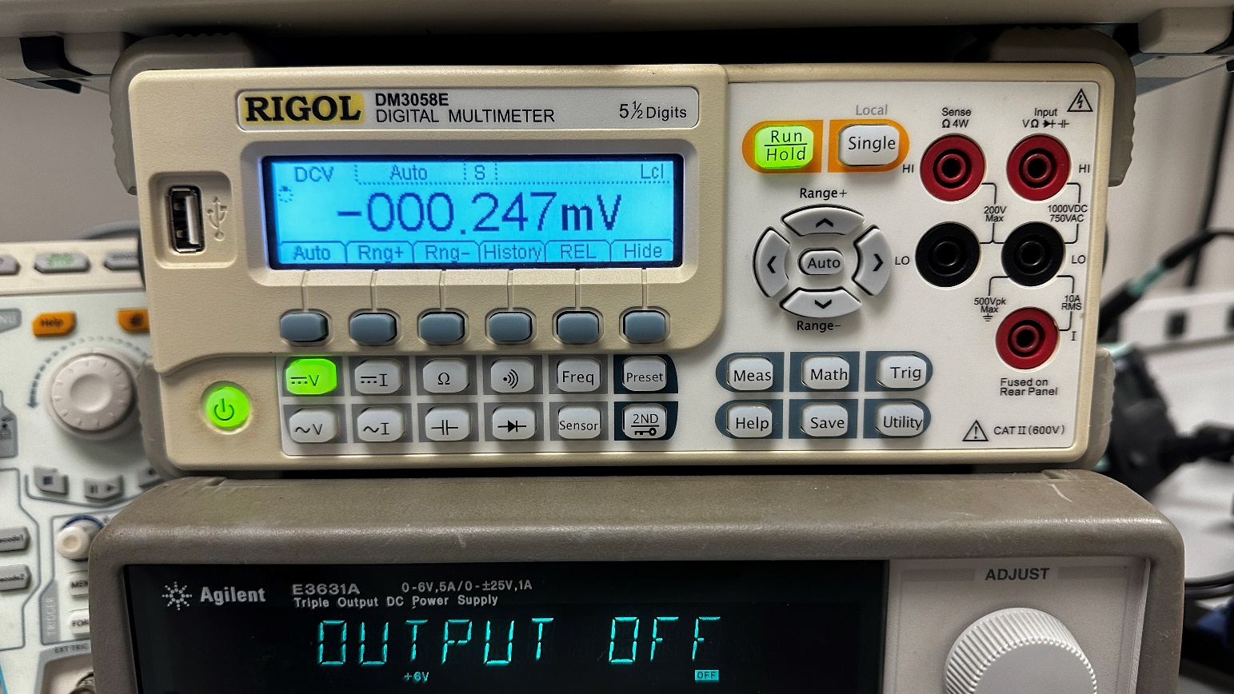
- Digital Multimeter

Function Selection Buttons: Use these buttons to cycle between which mode of measurement (voltage, current, resistance, etc.)
Input Terminals: Use these terminals to connect banana leads into them. The top right red terminal is used for voltage and resistance measurement. The middle two black terminals are used for ground to create a differential. The bottom right red terminal is used to measure current.
General Controls: Select between a constant running measurement or a single snapshot.

In-Lab
Part 1: Working with the Lab Equipment (10 Points)
- Connect the function generator to the oscilloscope. Generate a 150 Hz sine wave such that it sweeps between 0 V and 4 V. (Think about the needed amplitude and offset.) Show at least two periods on the oscilloscope. Include a picture of this in your report and demo this to your TA. (3 Points)
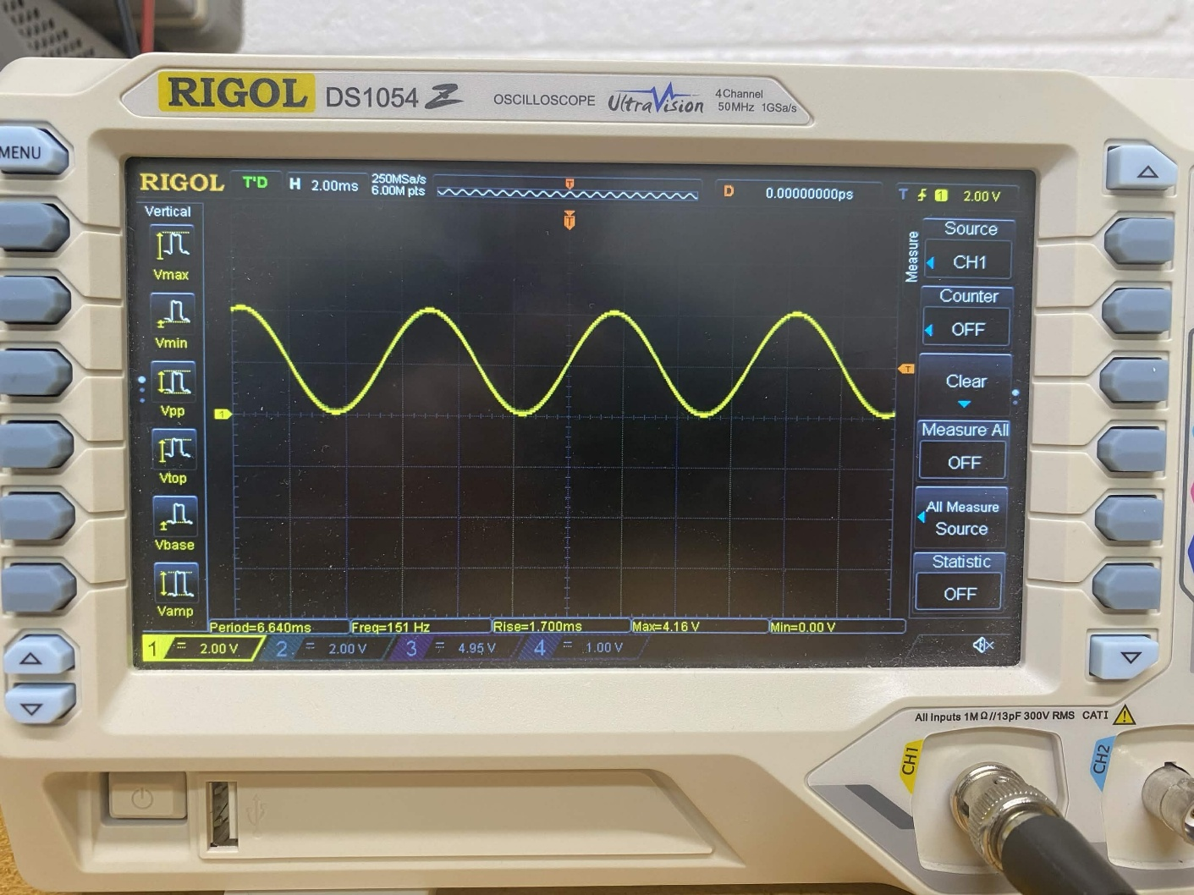
- Generate a 200 kHz square wave with 1 V of amplitude and 0 DC offset and trigger the oscilloscope to capture it at the rising edge. Zoom in on the oscilloscope, enough to see just about one period. What do you notice about the square wave? Include a picture of this in your report and explain any reasoning as to why what you see occurs. (3 Points)
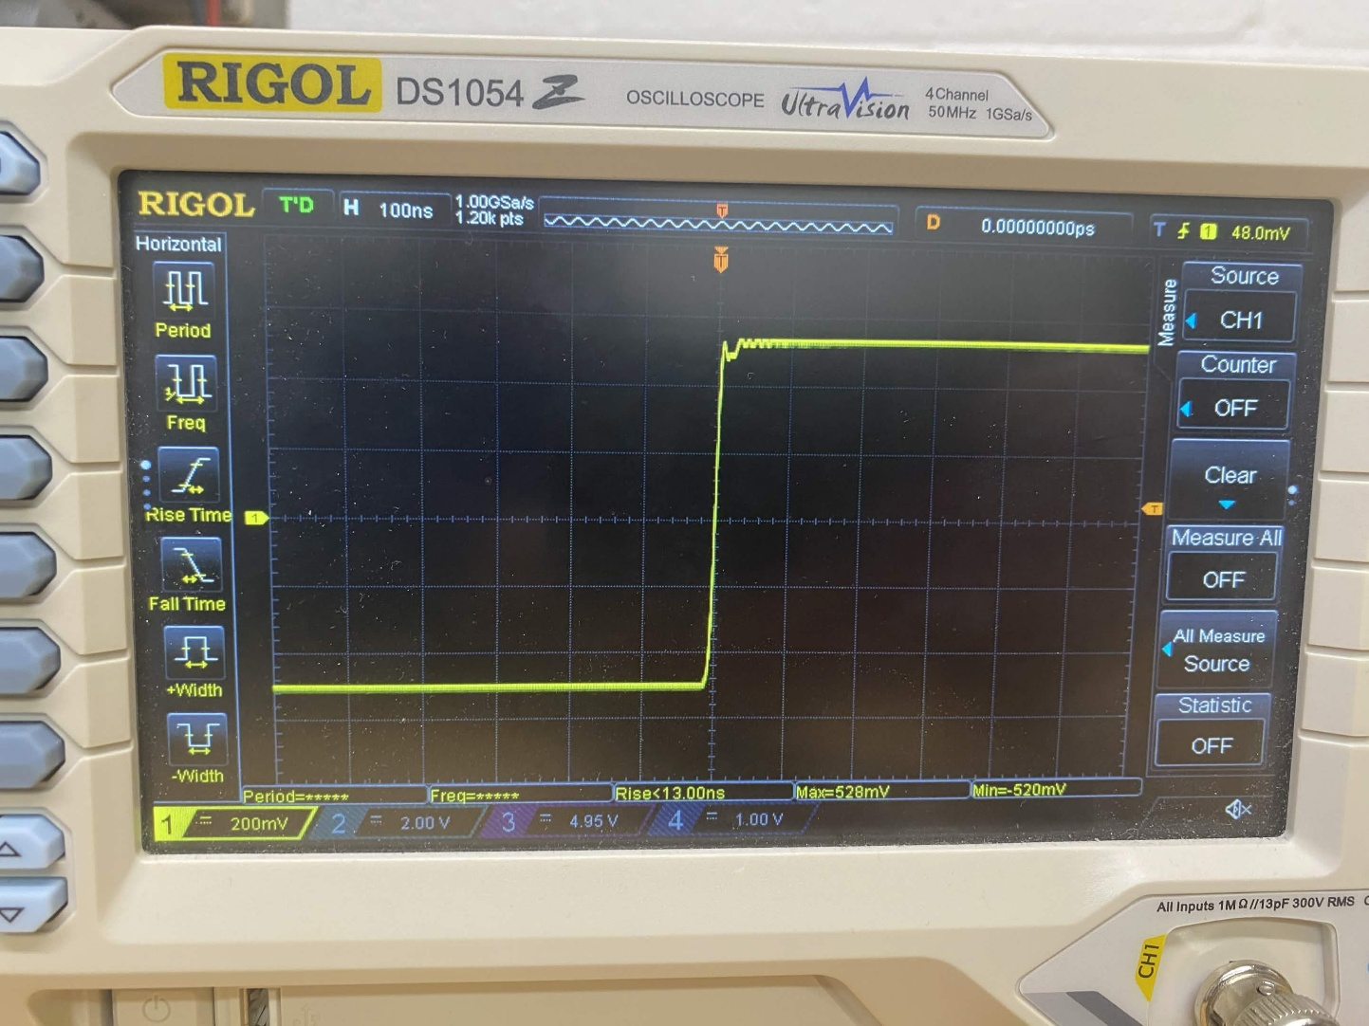
- There is a slight problem when working with the power supply, in that it does not create a negative voltage supply by default. This will prove to be cumbersome when working with op-amps and other IC’s that require both positive and negative voltage supply. Fortunately, there is a way to navigate this issue using the power supply in lab. Generate a -5 V supply using your power supply by following these steps:
  - Set DC supplies 1 and 2 to 5 V. Do not turn them on yet!
  - Connect a red wire with banana and alligator leads to the (+) terminal of DC supply 1.
  - Connect a black wire with banana and alligator leads to the (-) terminal of DC supply 1.
  - “Daisy chain” a black wire with both banana leads from the (-) terminal of DC supply 1 to the (+) terminal of DC supply 2.
  - Connect a red wire with banana and alligator leads to the (-) terminal of DC supply 2.
  - Turn on both DC supplies.
  - You should notice that the red wire connected to the (+) of DC supply 1 reads +5 V, and the red wire connected to the (-) of DC supply 2, when in reference to a common ground (i.e. the alligator lead connected to the (-) of DC supply 1).
Confirm this negative voltage value using the digital multimeter. Include a picture of this in your report and demo this to your TA. (4 Points) 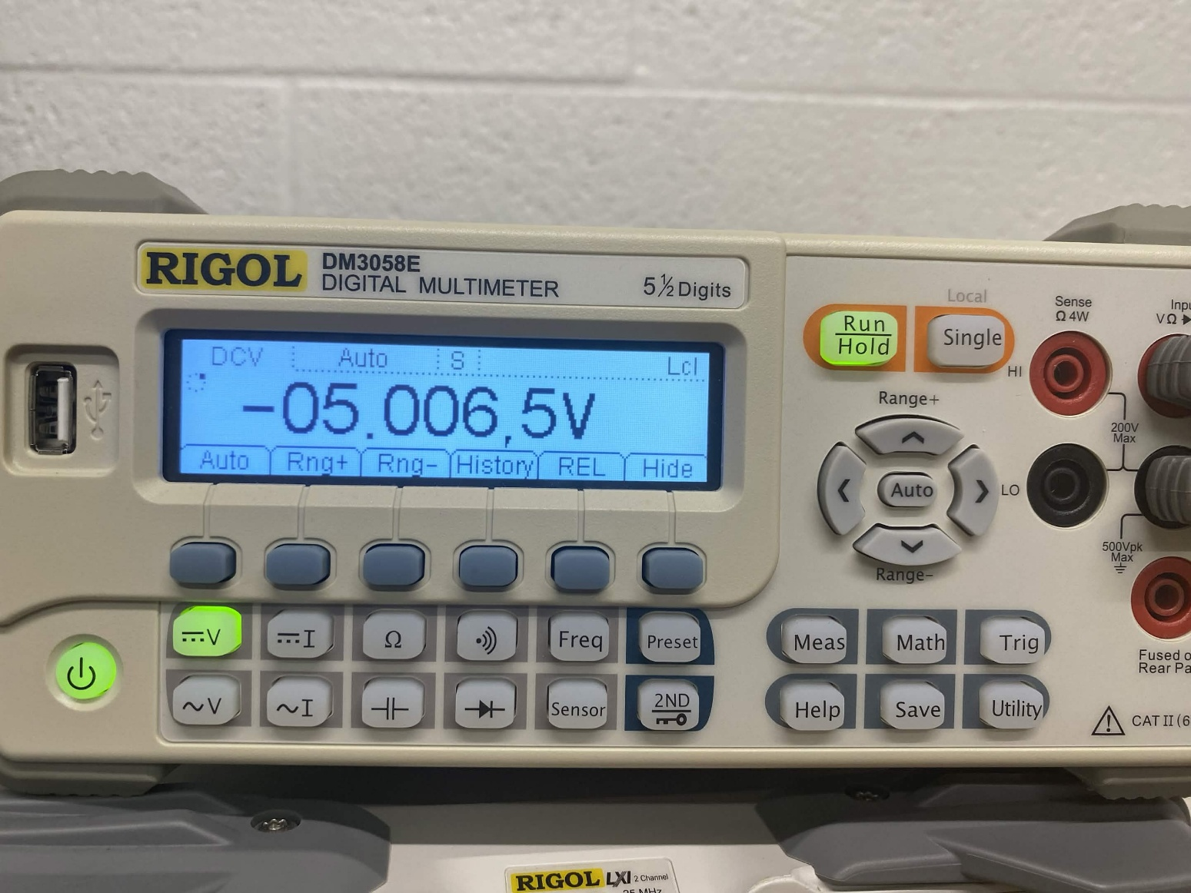

Part 2: Thevenin Equivalent of a Function Generator. (4 points)
We are going to repeat Part 2 from the pre-lab; except this time we are going to be finding the Thevenin equivalent of a function generator in the lab and not the waveforms generator on the DAD.
- Set the function generator to produce a sine wave with a frequency of approximately 400 Hz and an amplitude of approximately 5 V. Accurately measure and record the function generator output voltage: V_{NL} = V_{O} = Output Voltage. (1 Point)
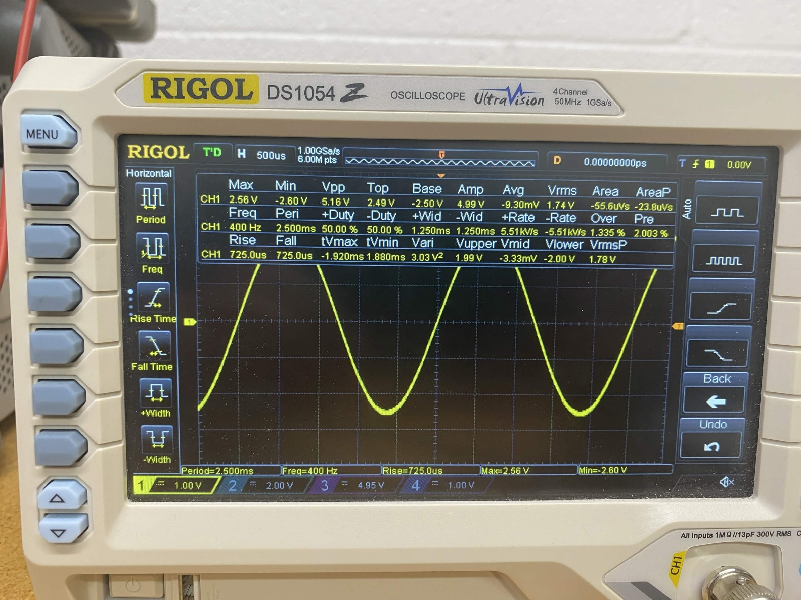
- Connect a 100 Ω resistor across the function generator output; accurately measure and record the voltage across the 100 Ω resistor, V_{L}. (1 Point)
3.45V
- Using your two recorded voltage values and assuming the load resistor is exactly 100 Ω, calculate the Thevenin equivalent resistance of the function generator output. (1 Point)
$$R_{th}=\frac{{(V}_{NL}-V_{L})×R_{L}}{V_{L}}$$
where V_{NL} = V_{O} with no load and V_{L} = V_{O} with a 100 Ω load.
V_{NL} = 5.16V, V_{L} = 3.36

R_{th} = $\left(5.16-3.36\right)*\frac{100}{3.36}=53.57 ohm$

- Using your values for V_{th} and R_{th}, draw the only the Thevenin equivalent circuit for the function generator output showing values for V_{th} and R_{th}. (1 Point)

3.36/53.57 = 0.0627A

Part 3: Thevenin Exercise (6 points)
On the whiteboard in lab, your TA will draw a circuit that you will have to:
- Recreate this on your breadboard. Include a picture. (1 Point)
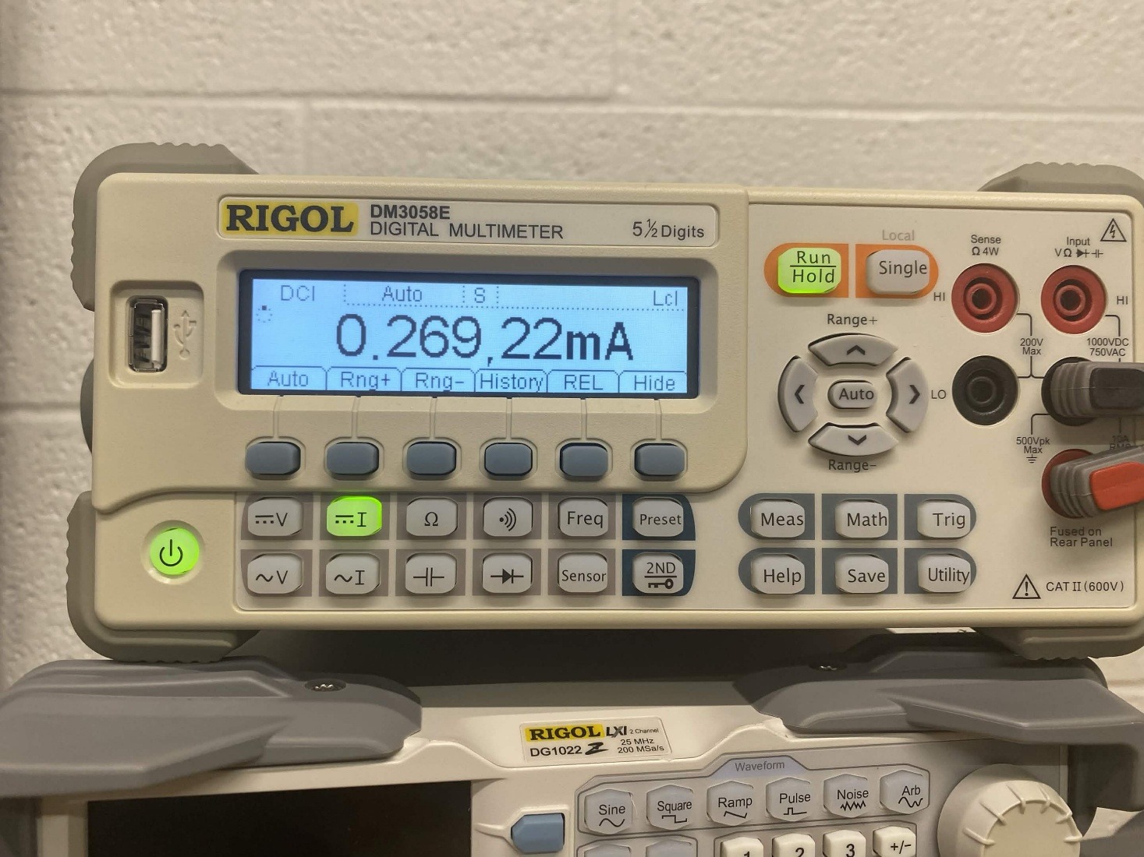
- Measure the output resistance of this circuit. Include a picture in your report. (1 Point)
R_{th} = 4750
- Draw a Thevenin equivalent circuit. Include calculations of equivalence resistance. (1 Point)
V_{th} = 5 * 1000/6000 =
- Measure the current through a branch of the modified circuit that your UPI chooses. It will be noted as either a current between two nodes or as an arrow. (1 Point)
I_{N} = 269.22mA
- Confirm the current of this branch through simulation. Include your screenshots in your report. (1 Point)

- Demo your findings to a UPI for credit before leaving lab. (1 Point)
