HW10
Acknowledgement: For Q1 & Q2 I did search online for MATLAB, particularly plotting
Q1:
A:
Transfers:
H_butter =
1.559e12
-----------------------------------------------------
s^4 + 1642 s^3 + 1.348e06 s^2 + 6.482e08 s + 1.559e11
H_bessel =
1.559e12
----------------------------------------------------
s^4 + 1963 s^3 + 1.734e06 s^2 + 7.94e08 s + 1.559e11
Bode Magnitude:
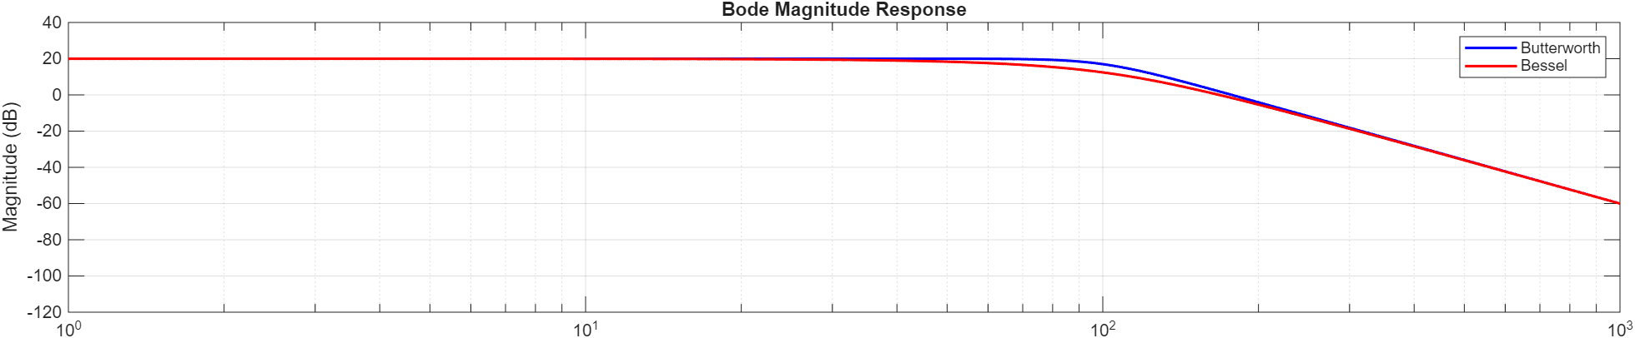
Bode Phase:
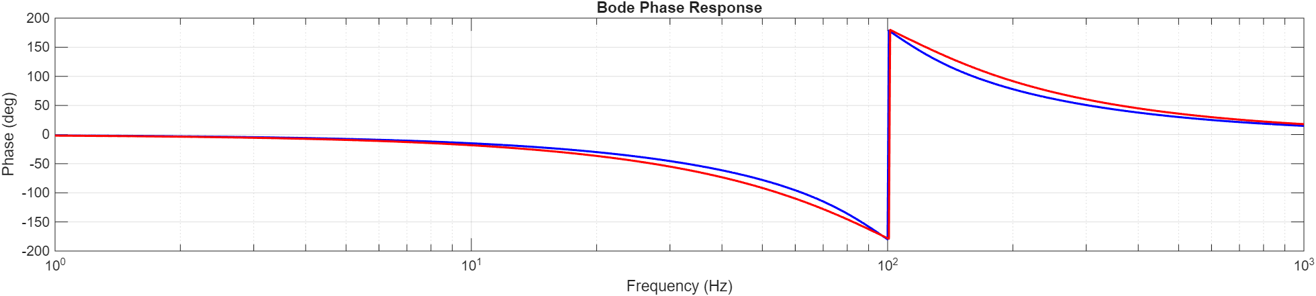
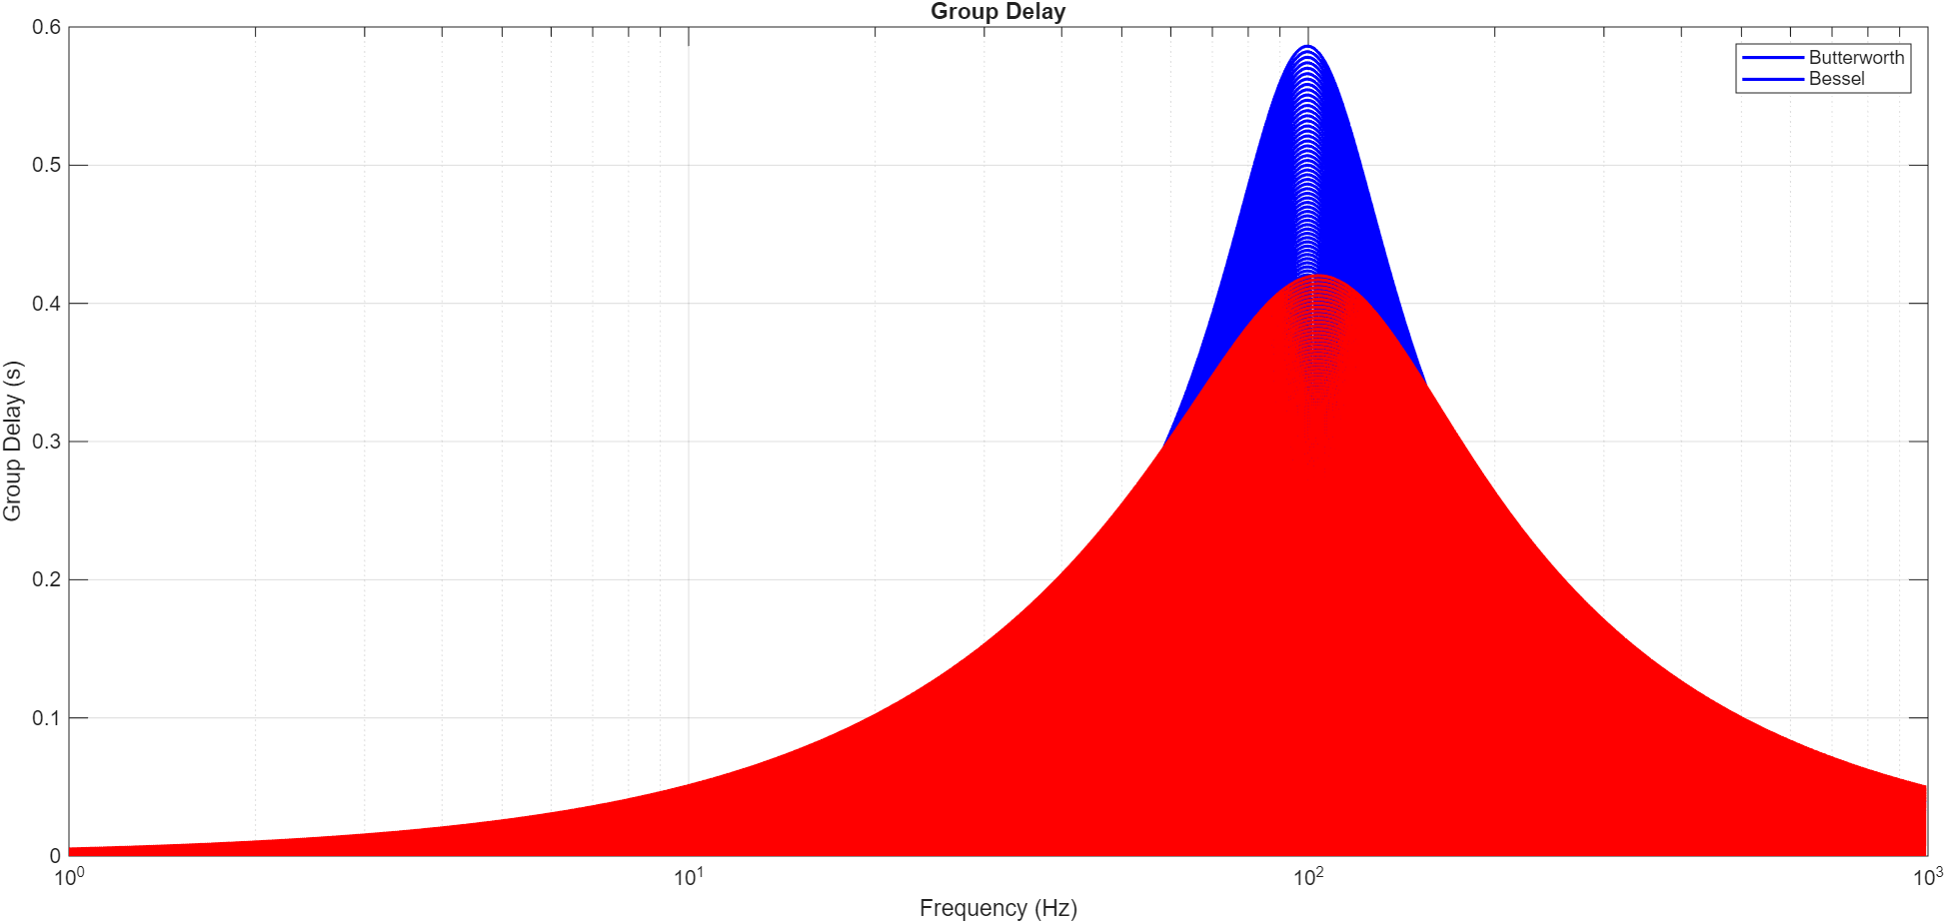
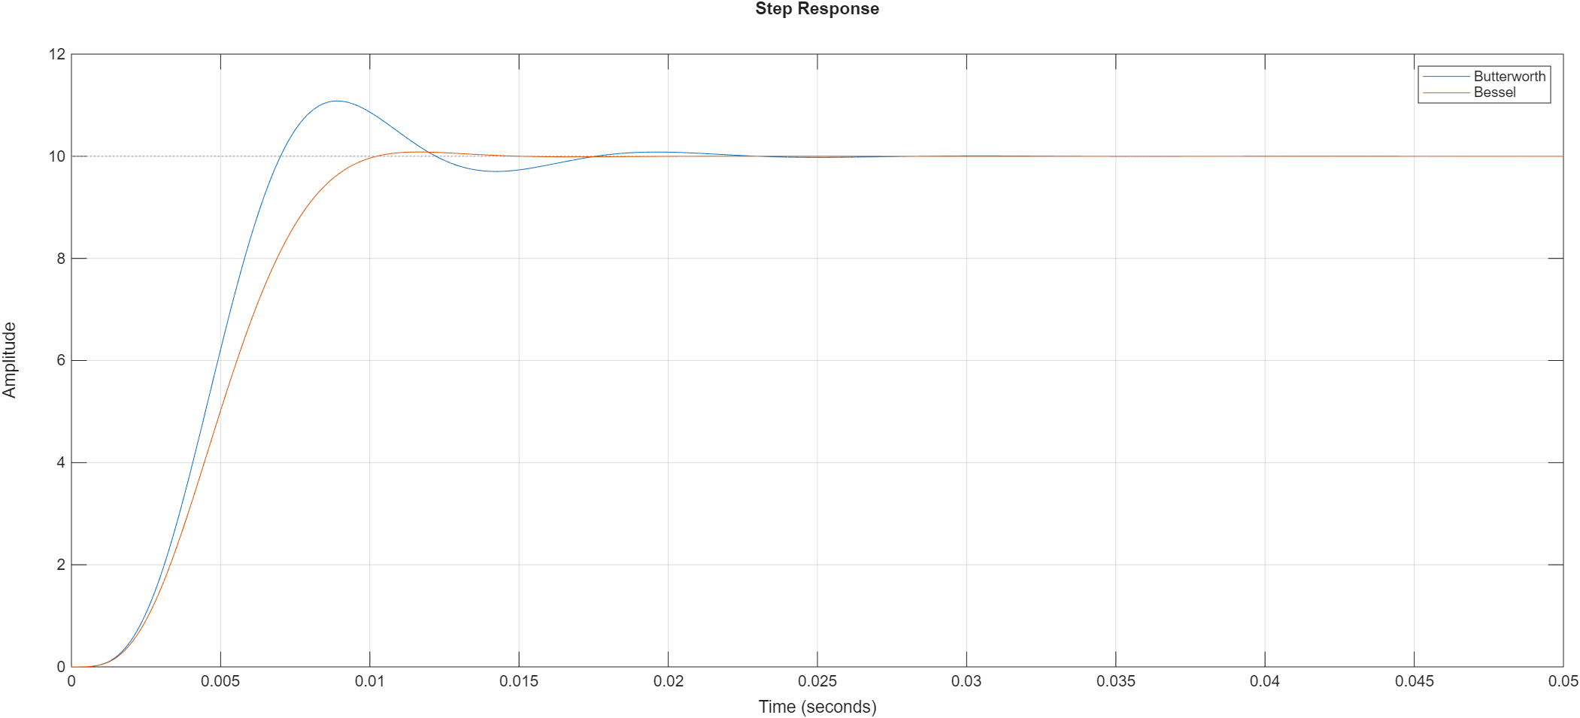
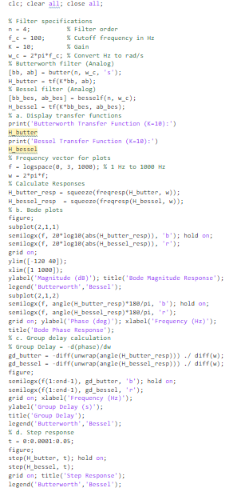

Q2:
Transfer:
H_bpf =
7.436e34 s^5
------------------------------------------------------------------------------------------------------
s^10 + 3.05e07 s^9 + 5.515e14 s^8 + 6.491e21 s^7 + 5.262e28 s^6 + 2.804e35 s^5 + 9.088e41 s^4
+ 1.936e48 s^3 + 2.841e54 s^2 + 2.714e60 s + 1.537e66

Bode Magnitude:
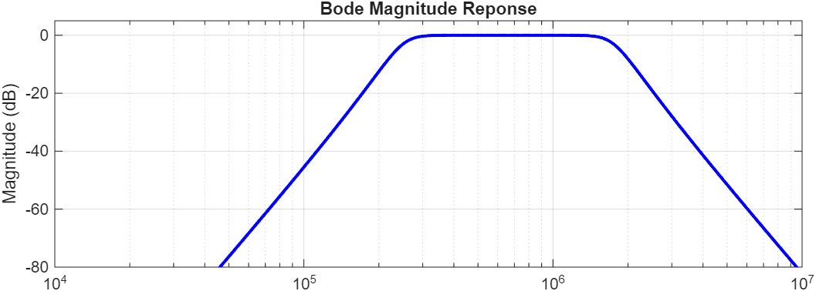
Bode Phase:
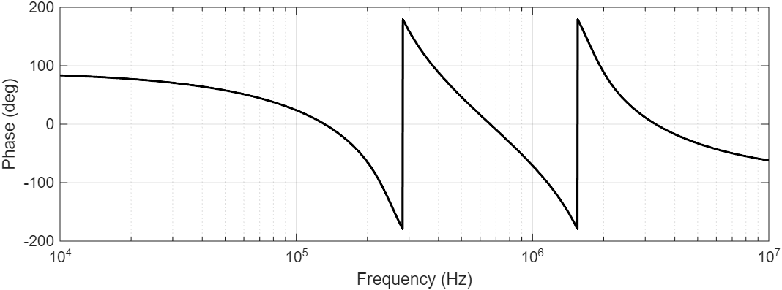
Upper Cutoff (fc2): 1750.00 kHz
Center Frequency (fo): 661.44 kHz
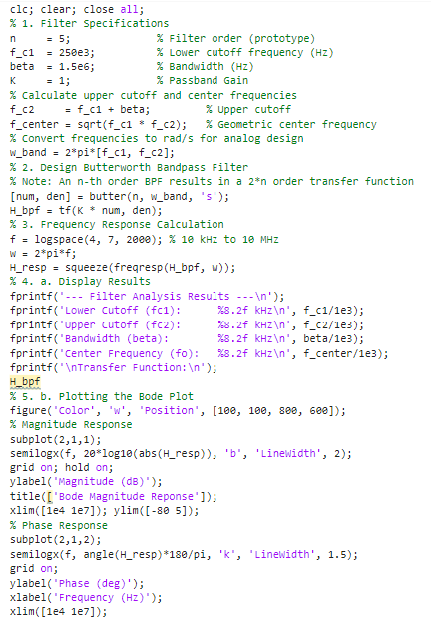
Q3:
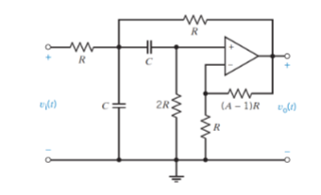
A: Bandpass, either shorts to ground or blocks input at extrema.
B: V+ = V- = Vo * (R/(A-1)R) = Vo * R/RA = Vo/A

(V1 – Vin)/R + (V1-Vo)/R + V1sC + (V1 – Vo/A)sC = 0
V1/R – Vin/R + V1/R – Vo/R + V1sC + V1sC – VosC/A = 0
V1(2/R + 2sC) = Vin/R + Vo/R + VosC/A
V1(2/R + 2sC) = (Vin + Vo)/R + VosC/A
2V1(1+sCR/R) = (A(Vin + Vo) + VosCR)/RA
V1 = $\frac{A\left(V_{in}+V_{o}\right)+sCRV_{o}}{2A\left(1+sCR\right)}$

